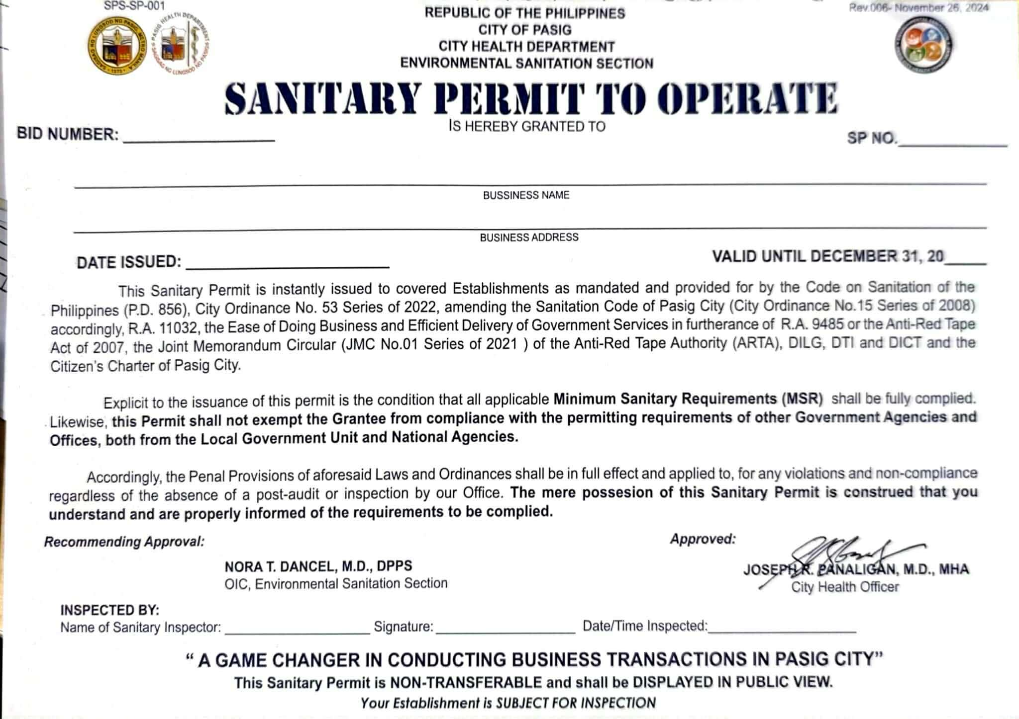
{year_no}
{sp_number}
{business_address}
{date_issued}
{bid_number}
{inspector_name}
{business_name}
{date_time_inspected}

