|  |
| --- |
| Subject: |
| Application to robotics & IOT |

|  |
| --- |
| Document title: |
| **Automated Greenhouse System (Mockup)** |
|  |

|  |  |  |  |  |
| --- | --- | --- | --- | --- |
| Prepared by: |  |  |  |  |
| Name |  | M&M |  | 15/02/2023 |
| Course |  | 4ºA |  | Date |
|  |  |  |  |  |
| Reviewed: |  |  |  |  |
| Name |  |  |  |  |
| Prepared by: |  |  |  | Date |

|  |  |  |  |  |  |  |
| --- | --- | --- | --- | --- | --- | --- |
| File name: |  | Date: |  | Edition: |  | Nº pages: |
| **M&M.pdf** |  | **15/02/2023** |  | **1** |  | **10** |

**Documentary control**

|  |  |
| --- | --- |
| Authors | Miguel Vilanova Fenollar  Miguel Monge Rodríguez |
| Project Name | Automated Greenhouse System (mockup) |

**Version control**

|  |  |  |  |
| --- | --- | --- | --- |
| Version | Changes | Description | Date |
| 0.1 | Template: Cover, Documentary Control | First version of the document | 15/02/2023 |
| 0.2 | Introduction | Added the Introduction, objectives, motivation details | 18/02/2023 |
| 0.3 | Planification | Added the Planification details | 19/02/2023 |
| 0.4 | Design | Added the Design phase details | 28/02/2023 |

* N/A = Not applicable

Index

Introduction 4

Planification 5

Determine the requirements 6

URD 6

Risk planning 7

Hardware 11

Select sensors and actuators 11

Design physical model 11

Software 12

Design NodeMCU interface 12

Develop control algorithm 12

Develop the software 12

References 14

Figures

1: Gantt Project, file attached. 5

2: NodeMCU e-diagram 9

3: Node Red interface example 10

4: MQTT Explorer (MQTT broker portable) 10

Tables

i: URD 6

ii: Risk Planning 7

# Introduction

We intend to create and implement an automated greenhouse system that optimizes plant growth, maximizes resource efficiency, and promotes sustainability. By integrating sensors, actuators, and control algorithms, we aim to create an intelligent system that can adjust the environmental conditions in real-time to meet the changing needs of the plants.

1. Sensors collect data: The sensors placed inside the greenhouse collect data on the environmental conditions such as temperature, humidity, light, soil moisture, and CO2 levels.
2. NodeMCU collects and sends data: The NodeMCU board, which is connected to the sensors, collects the data and sends it to the cloud-based platform, Node-RED, using Wi-Fi connectivity.
3. Node-RED processes the data: Node-RED is a visual programming tool that can process the data received from NodeMCU in real-time. It can analyze the data and trigger certain actions based on pre-defined conditions. For example, if the temperature in the greenhouse is too high, Node-RED can activate the cooling system.
4. Data storage and analysis: The processed data from Node-RED is then stored on a Raspberry Pi. The Raspberry Pi can be used to analyze and mine the data for valuable insights, such as identifying patterns in the growth of the plants, optimizing resource usage, and predicting future growth.

By using NodeMCU, Node-RED, and Raspberry Pi, you can create an automated greenhouse system that is both intelligent and efficient. The system can help you optimize the growth conditions for plants, reduce resource usage, and increase productivity.

Ultimately, our goal is to create a sustainable and efficient automated greenhouse system that can serve as a model for future agricultural practices. We believe that by combining technology, innovation, and ethics, we can create a better world for both plants and humans.

# Planification

* Design: This phase involves defining the objectives of the project and designing the hardware and software components. It starts on 13/2/23 and ends on 10/3/23.
* Building and Testing: This phase involves building the physical model of the automated greenhouse system, integrating the sensors and actuators, and programming the software. It starts on 13/3/23 and ends on 21/4/23.
* Sensor Testing and Feedback: This phase involves testing the sensors and collecting feedback through Telegram. It starts on 10/4/23 and ends on 21/4/23.
* Project Documentation: This phase involves documenting the project history and the state of the art of the automated greenhouse system. It starts on 24/4/23 and ends on 5/5/23.
* Final Assignment: This phase involves the final assignment submission. It takes place on 8/5/23.

1: Gantt Project, file attached.

## Determine the requirements

We can use humidity sensors to monitor the soil moisture levels of the plants. This can help to determine when to water the plants and avoid overwatering or underwatering.

Use the temperature sensor to monitor the temperature inside the greenhouse. This can be used to adjust the temperature based on the needs of the plants and optimize growth conditions.

Use the NodeMCU board to collect data from the sensors and send it to the cloud-based platform, Node-RED. We can process the data and trigger certain actions based on pre-defined conditions.

We can use a Raspberry Pi or a cloud-based database to store and analyze the data collected from the sensors. This can help to identify patterns and trends in plant growth and optimize resource usage.

Finally, we need humidity sensors to monitor the humidity levels inside the greenhouse. To adjust the humidity based on the needs of the plants and prevent plant diseases or pests.

### URD

|  |  |  |  |
| --- | --- | --- | --- |
| ID | Requirement | Description | Priority |
| 0 | Temperature Sensor | Measures temperature inside the greenhouse | High |
| 1 | Humidity Sensor | Measures humidity inside the greenhouse | High |
| 2 | Soil Moisture Sensor | Measures soil moisture levels of the plants | High |
| 3 | CO2 Sensor | Measures CO2 levels inside the greenhouse | Low |
| 4 | Lighting Controls | Adjusts the intensity and duration of light for the plants | High |
| 5 | Irrigation System | Delivers water to the plants based on their needs | Medium |
| 6 | Ventilation System | Regulates air flow and temperature inside the greenhouse | Medium |
| 7 | NodeMCU + Wi-Fi Mod | Collects data from the sensors and sends it to the cloud-based platform | High |
| 8 | Raspberry Pi or Cloud | Stores and analyzes the data collected from the sensors | Medium |
| 9 | Node-RED Platform | Processes the data received from the sensors and triggers certain actions based on pre-defined conditions | High |

i: URD

### Risk planning

It's important to anticipate potential difficulties and develop contingency plans to address them.

|  |  |  |  |
| --- | --- | --- | --- |
| ID | Risk | Contingency Plan | Difficulty |
| 0 | Sensor malfunction or inaccurate readings | Regularly calibrate and test the sensor, have backup sensors available | Low |
| 1 | Sensor malfunction or inaccurate readings | Regularly calibrate and test the sensor, have backup sensors available | Low |
| 2 | Sensor malfunction or inaccurate readings | Regularly calibrate and test the sensor, have backup sensors available | Low |
| 3 | System failure or power outage | Have a backup power source available, manually adjust the lighting if necessary | Low |
| 4 | System failure or overwatering/underwatering | Backup irrigation components available, manually water the plants if necessary | High |
| 5 | System failure or inadequate air flow | Backup ventilation components available, monitor the temperature air flow manually | High |
| 6 | Wi-Fi or connectivity issues | Monitor connectivity, have backup communication methods available | Low |
| 7 | Data loss or corruption | Regularly back up the data, have backup storage solutions available | High |
| 8 | System failure or programming errors | Regularly test and debug the system, have backup programming solutions available | Low |
| 9 | Sensor malfunction or inaccurate readings | Regularly calibrate and test the sensor, have backup sensors available | Medium |

ii: Risk Planning

Design

## Hardware

### Select sensors and actuators

Based on the plant requirements, we will select the appropriate sensors and actuators. For example, we might use temperature and humidity sensors, irrigation actuators, lighting controls.

### Design physical model

We will create a 3D model of the automated greenhouse system, including the layout of the sensors and actuators, and the positioning of the plants. This will help us visualize the system and ensure that it meets the objectives and plant requirements.

## Software

### Design NodeMCU interface

We will design the NodeMCU board interface that will collect data from the sensors and control the actuators. This might involve selecting the appropriate Wi-Fi module and programming the board to communicate with the cloud-based platform, Node-RED.

NodeMCU is a open source IoT platform. It includes firmware which runs on the ESP8266 Wi-Fi SoC from Espressif Systems, and hardware which is based on the ESP-12 module. The term "NodeMCU" by default refers to the firmware rather than the development kits.

The firmware uses the Lua scripting language. It is based on the eLua project and built on the Espressif Non-OS SDK for ESP8266. It uses many open-source projects, such as lua-cjson, and spiffs.

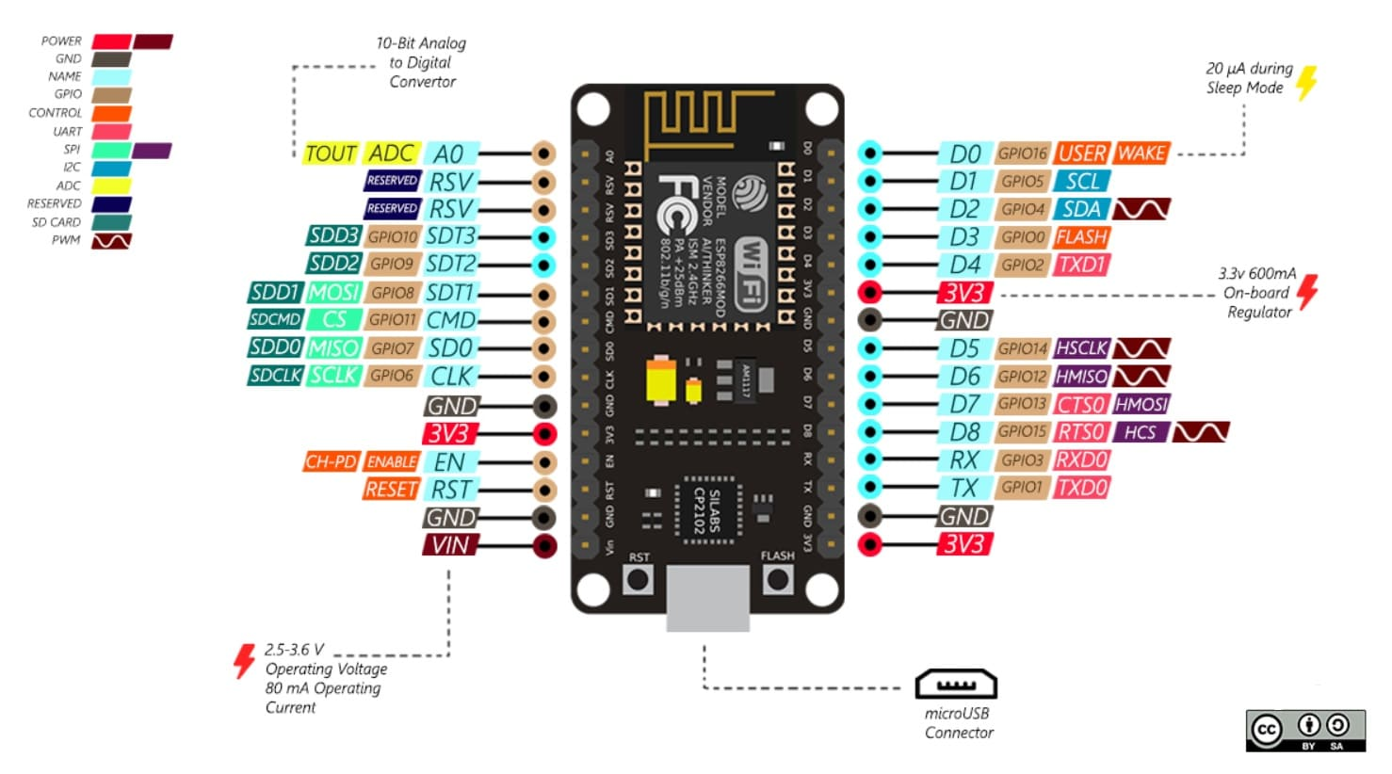

2: NodeMCU e-diagram

Node-RED is a programming tool for wiring together hardware devices, APIs, and online services in new and interesting ways. It provides a browser-based editor that makes it easy to wire together flows using the wide range of nodes in the palette that can be deployed to its runtime in a single-click.

It was developed by IBM and is now an open-source project. It is primarily used to integrate different IoT devices and services and can be used to process and visualize data streams in real time.

Node-RED uses a visual programming language called "flows" to allow users to wire together code blocks, called "nodes", to perform a task. It is often used in conjunction with hardware such as Raspberry Pi and other microcontrollers, as well as cloud-based services like AWS and Azure.

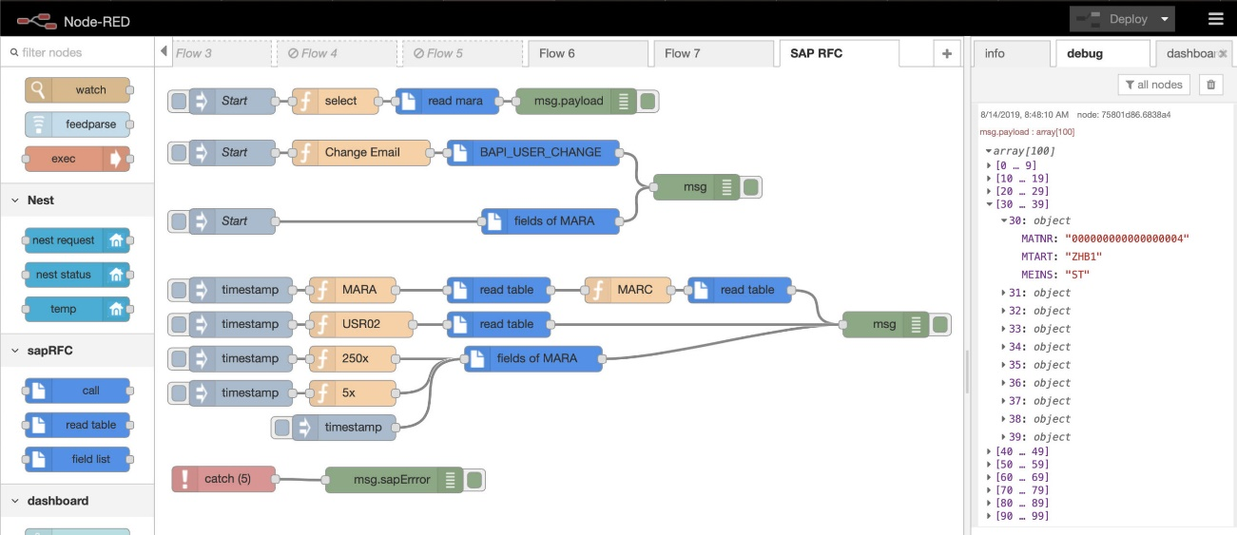

3: Node Red interface example

MQTT (Message Queuing Telemetry Transport) is a lightweight publish-subscribe messaging protocol that is used to send messages between devices. It was designed to be used with low-power devices and constrained networks, such as those found on the Internet of Things (IoT).

In MQTT, there are two main components: the message broker and the clients. The message broker is responsible for receiving all messages and distributing them to the clients that are subscribed to the topic. The clients can be both publishers and subscribers, meaning they can both send and receive messages.

One of the main benefits of MQTT is that it uses a publish-subscribe model, which allows devices to send and receive data without the need to constantly poll the server. This makes it a good choice for applications where power consumption is a concern.

MQTT is a widely used protocol in the IoT and is supported by many devices and platforms, including Node-RED, which makes it easy to integrate with other systems.

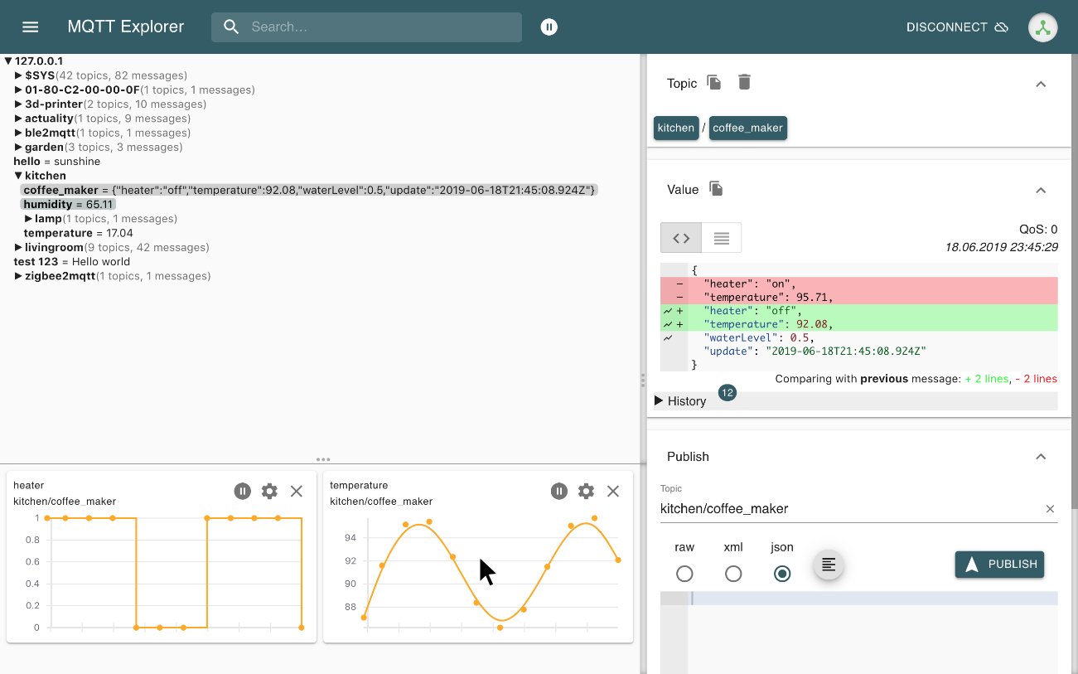

4: MQTT Explorer (MQTT broker portable)

### Develop control algorithm

We will develop the control algorithms that will adjust the environmental conditions based on the data collected from the sensors. This might include using fuzzy logic or other machine learning techniques to optimize resource usage.

### Develop the software

Finally, we will develop the software components, including the Node-RED platform and the data storage and analysis tools. This will allow us to process and analyze the data collected from the sensors and provide insights into the growth and efficiency of the plants.

*By following these steps, we can ensure that the design phase of the automated greenhouse system is thorough and well-planned, and that it meets the objectives and plant requirements. This will set us up for success during the building and testing phase.*

# Building and Testing

## Buy & Check

## Building the 3D mockup

## Programming

# Testing

# State of Art (Professional Approach)

Conclusions

# References

**No hay ninguna fuente en el documento actual.**