Ibogaine Mesodosing Week One:
From Numbing Habits to Small Acts of Self-Respect

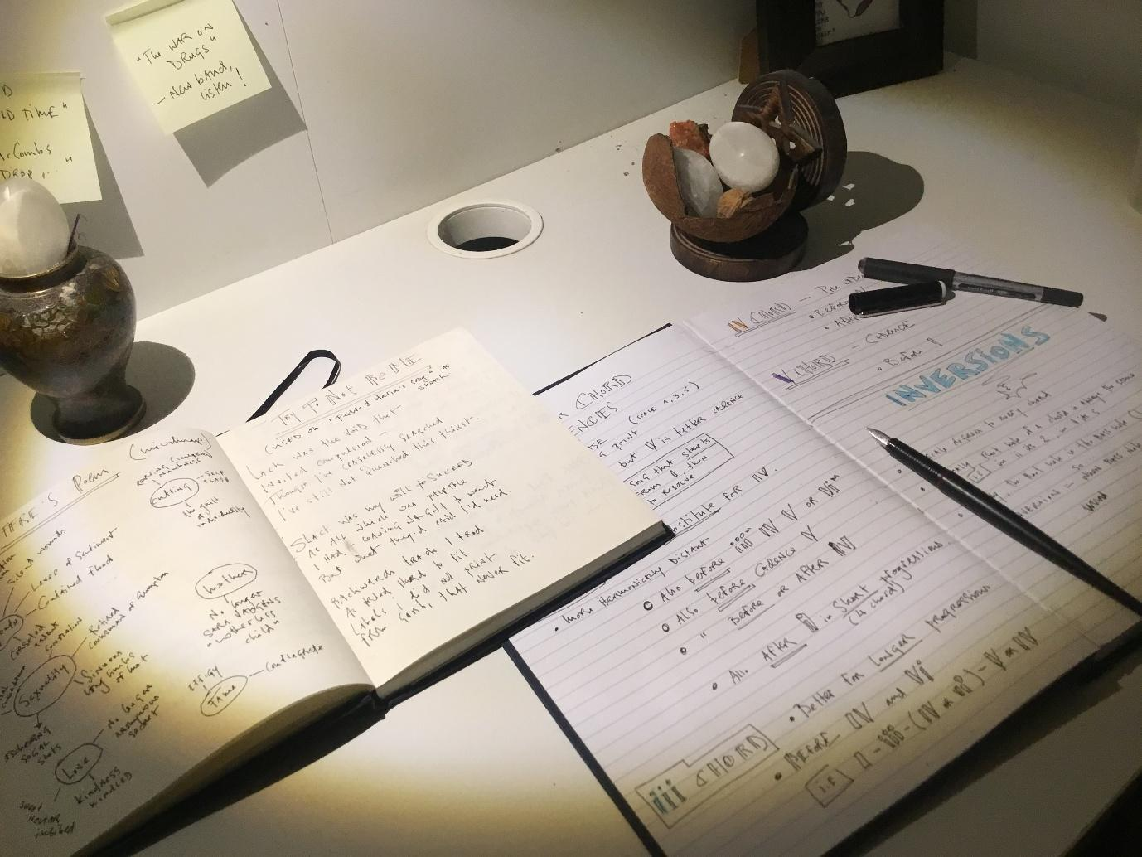
SEO TITLE: Ibogaine Mesodosing Week One: From Numbing Habits to Small Acts of Self-Respect
META DESCRIPTION: A personal ibogaine mesodosing diary: how gentle daily drops, journalling and small rituals began to loosen ten months of numbness and burnout.
SLUG: ibogaine-mesodosing-week-1
KEYWORDS: ibogaine mesodosing, ibogaine microdosing, iboga micro-dosing, ibogaine meso-dosing journal, ibogaine tincture, mesodosing with ibogaine tincture, meso dosing with ibotincture, ibogaine meso dosing for alcohol cravings, ibogaine mesodosing for shame and guilt, ibogaine mesodosing for nervous system regulation, ibogaine mesodosing for burnout and self-worth, ibogaine microdosing experience, plant medicine integration and mesodosing.

11111.Introduction
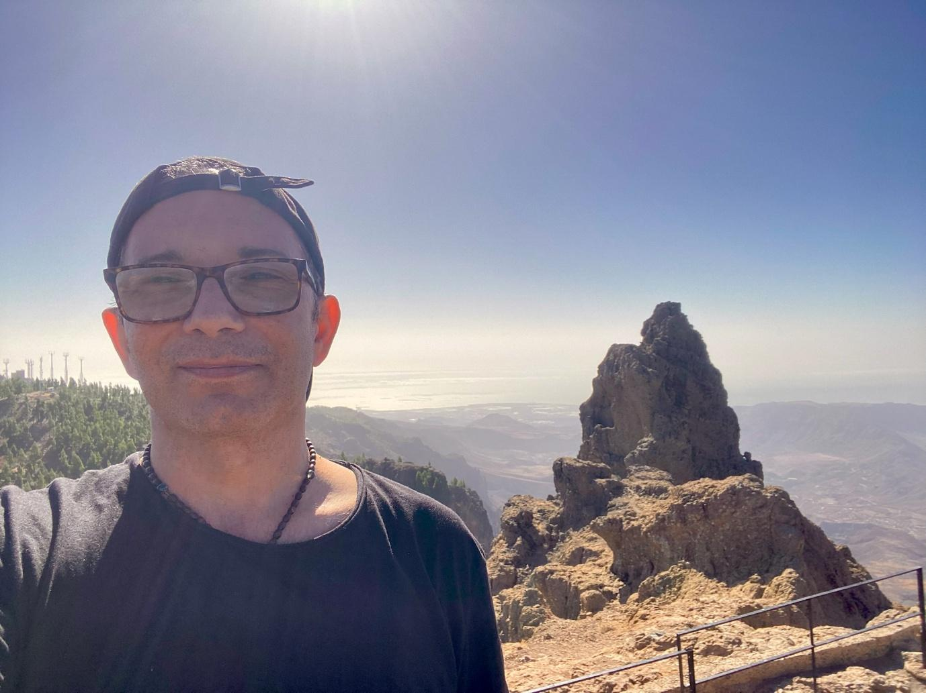
Hi, I’m Pedro. What you’re about to read is a month of my life told in real time, taken from private pages I never originally planned to publish: a very personal ibogaine mesodosing journal.
In October 2022, I had my first medically assisted flood dose at Tabula Rasa Retreat, in Portugal, shortly after I started working there with Alvaro and the rest of the team.
Earlier this year, I hit another rough patch, but this time I chose a quieter path with Ibotincture, exploring ibogaine mesodosing rather than a second full flood dose.
I wrote these blogs for two reasons.
First, to show how meso-dosing with ibogaine can open a progressive and much deeper understanding of why we do what we do, and how small, steady shifts begin to stack.
Second, because shame and guilt only thrive in secrecy. Bring them to light, and their grip loosens.
Sharing my journals took guts, so I won’t pretend it doesn’t feel exposing to place these pages in public. But if honesty helps even one person feel less alone, it is worth the discomfort.
Let me be clear about one thing, though: this is not a manual, and it is not a sales pitch.
It is my own lived experience of using a powerful plant medicine like ibogaine to turn the volume down on the noise long enough to hear what actually needs care.
You will not find neat answers here. What you will find is a record of imperfect days, better choices, a few stumbles, and the slow return of self-respect.
If these entries resonate, let them do what they did for me. Let them remind you that change is hard, incremental work, but also far more rewarding than staying stuck.
If reading nudges you toward one kinder decision today, then publishing these pages was the right call.


22222.Wednesday 7th May 2025 – Mesodosing Day 2
20 drops Ibotincture — 13:00 pm.
- What intention am I setting for how I meet my morning and the noise in my head today?
- I will notice my urges to numb and choose one simple practice that keeps me present.
- How will I honour self-respect?
Note: Yesterday I took 15 drops.
The world feels less unsafe today than it did yesterday.
I’m wondering if this is the placebo effect of simply knowing I am walking hand in hand with ibogaine again since my first treatment at Tabula Rasa Retreat in 2022.
I’m very curious to see how ibogaine tincture affects my compulsion to numb, be it through alcohol, pornography, food or binge-watching series.
15:00 pm -- 5 drop booster.
When showering just now, managed to do about 30 seconds cold shower at the end. It felt amazing. I will try to do the same again tomorrow as part of my new routine.
Q: Am I saying yes to the projects of Transilience Health, Mesodose and Ibogenics because I passionately want it, or to prove to myself and Alvaro I’m not a failure?
While it is true that I do often fall into the trap of external validation, I think the instinctive pull I am feeling to say yes is more deeply aligned.
Many of my past life-choices, professionally speaking, have been the result of “Oh well, why not” or, even worse, “I don’t see any other option”; not to mention all the times I took on jobs suggested by others.

Evening Reflection
I spent most of the day giving my sister real presence and emotional support before, during and after her decisive appointment with the oncologist.
- What is different about how I feel supporting my sister now vs. the past?
For the first time, I was able to sit through the day and the task of emotional support from a place of love and grounded presence instead of a state of repressed anger and “poor me” victimhood.
Managed to make space for her and her feelings instead of dissociating and tuning out as usual, excessively and compulsively numbing with compulsive phone use, or stealing Xanax from her supply.
But the important thing about our dynamic was that I was able to call her out on a type of comment I would normally let slide. It was uncomfortable to do, but I upheld my boundary.
This is incredibly new for me, and a small, but significant win.

- What was different about my day for me?
- Less shame. Less guilt.
- A bigger-picture, more holistic and compassionate acknowledgement of the rough patch I’ve been through in the past 10 months, as if ibogaine mesodosing is gently loosening the stories that kept that shame and guilt in place.
- No need for pornography.
- No need to binge-watch series just to numb.
- I still drank, and I’m still having a few beers as I write this.
What I mean to say is that for the first time in the last 10 months, my spirit and body are beginning to want to stop drinking.
And, even though I am still drinking beer tonight, I feel it is the ember of a habit rather than an active need.
Evening Mantra
Today I return to myself.
I do not have to shrink to be loved.
I do not have to numb to survive.
I do not have to carry what was never mine.
I bless the spirit of Iboga for walking beside me.
And I bless my own soul for speaking, finally, in its own voice.
I am not here to pacify others.
I am here to live truthfully, and well.
Today, I speak gently.
I say No when it is true.
I say yes when it’s whole.
I say enough, because I am.

33333.Thursday 8th May — Mesodosing Day 3

9:00 am — 15 drops Ibotincture
- I will meet tiredness with gentle pacing and still choose one meaningful task.
- How will I keep my evening for writing and rest instead of numbing?
- I choose to plan tomorrow with care and honour an early night.
Woke early to go meet with R______ (a potential psychedelic therapy client) and hardly slept at all (just about 3 hours).
With 15 drops of Ibotincture one doesn’t feel the ibogaine effect, I find, or at least I don’t. At this dose, it feels more like an ibogaine micro dosing experience.
Tomorrow I will try 18 drops.
Evening Reflection
Today’s mood was good, but I was very tired.
Also, there was significantly less shame around the fact I drank last night, I imagine not only because of the Iboga.
After dinner with my sister, I stayed up late to have enough time to journal, not compromising on time needed to process each day.
Tonight, though, I’m turning in early.
How did the Ibotincture guide me today: softly or strongly?
Softer than yesterday
- reduced anxiety and less shame
- increased ability to break state, especially regarding my imposter syndrome / performance wound (work related), regarding the conversation with R______.
- I felt the usual pull of my unworthiness loop but told myself I am allowed to receive money for my time and effort.
- Today was the third day I did not wake and numb with series, YouTube or pornography
What inner peace or clarity, however small, emerged today?
- A reassurance that I am actually enough, and worthy just as I am.
- That I have started to reclaim agency in my life,
- That I am beginning to pave the road which allows me to step into leadership by being accountable to myself and others.

44444.Friday 9th May — Mesodosing Day 4
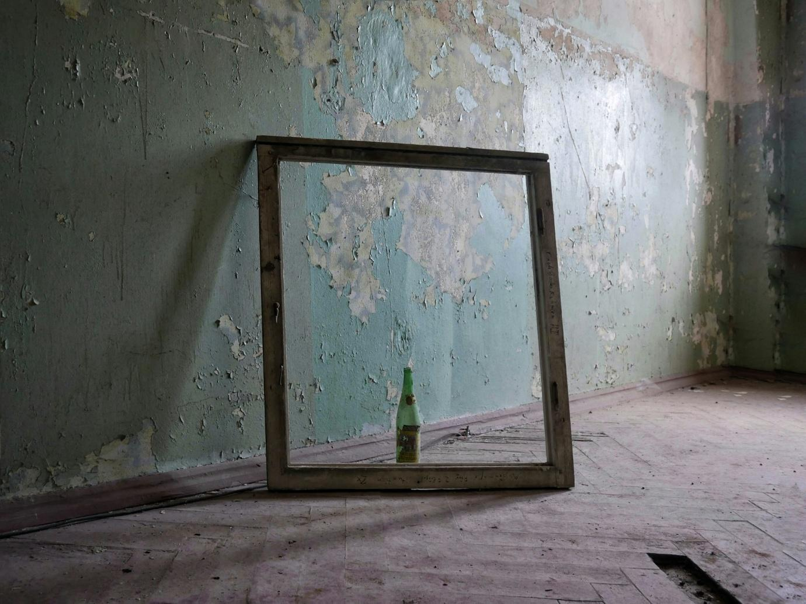
8:30 — 18 drops Ibotincture
- What intention do I set for clarity and courage today?
- I will return to my body with a simple ritual of care.
- How will I relate to urges around alcohol with curiosity and choice?
What is my emotional state as I begin this day?
Feeling excited for what the day will bring. A certain and increased clarity around the meaning of the last 10 months, and why all the emotional things I went through were necessary.
When what we consider to be the safety structures in our life all seem to implode, and we stand before an insurmountable wall of grief or loss, we are being asked to stop and ponder who we wish to become in the imminent season of change about to unfurl.
I now see that it was only by virtue of the freeze state I slipped into that I came to realize who I didn’t want to be: someone trapped in fear.
What is one action I can take to slowly step back into my abandoned self-care routines?
To stand naked and vulnerable before a full-length mirror as I apply my psoriasis cream and treat my sore, blemished skin, practising gentleness with each act. To make a ritual of it. To treat both my mind and body with greater kindness.
Mirror Gazing Skin-Care Mantra
I am here.
I am whole.
This body is my story, and I touch it with love.
I do not need to be flawless to be worthy of devotion.
Every scar, every patch, every line — they belong.
I belong.
I am allowed to take up space, even in healing.

After Skincare Ritual
Just finished my mirror gazing ritual. Also managed to have a 1 min long cold shower before that.
Mesodosing with ibogaine tincture seems to be removing the difficulty around tasks which shouldn’t be as difficult as they ordinarily feel.
Evening Reflection
Today was also important in the sense that I didn’t feel like drinking.
When I was walking past the supermarket, I didn’t feel the impulse to buy alcohol, and I caught myself wondering if this was ibogaine meso dosing quietly softening my alcohol cravings.
That in itself is very new.
Where before there was anger behind the choice to be sober, there was just now a quiet contentment of “No, I’m good as I am.”

55555.Saturday 10th May — Meso dosing Day 5
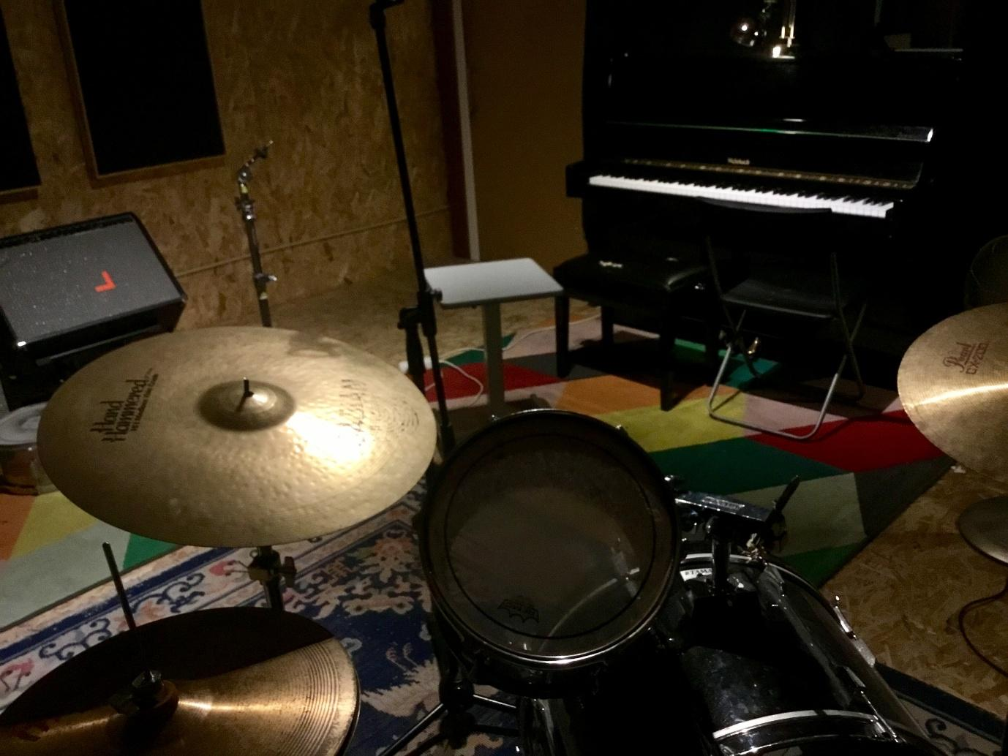
10am - 18 drops of Ibotincture
- I will let care arrive as rhythm, not duty.
- What one act of presence will I commit to when resistance shows up?
- How will I speak to myself with trust today?
Let this be the day after the turning.
The day where resistance bowed to rhythm.
The day where care returned not as duty, but as a song hummed quietly by the soul.
Later am meeting N____ to go to my rehearsal studio and play drums while he does his guitar-god thing (which he does so well).
Evening Mantra
Today, I chose presence over resistance.
I tended to my body not as a problem, but as a prayer.
I stepped into the small sacred acts of being alive, and they met me with unexpected ease.
I am proud of who I was today.
I am becoming someone I can trust.

66666.Sunday 11th May — Meso-dosing Day 6

9:00 am — 15 drops Ibotincture
- How will I protect space for self-care after stimulating days?
- I will meet dopamine-seeking habits with structure and kindness.
- What did I really need at the end of yesterday that I didn’t give myself?
Yesterday I got so euphoric with our music & jam session, that once I got back at 7 pm, I bought wine, and then after finishing that went to the gas station to buy a couple of beers.
Why?
I feel that spending the whole day with N______ may have activated the echo of our old dynamic when I was supporting him through his severe OCD. Now, he is well, and his OCD is under control, but….
It’s as if my body knows this rhythm: I give, I hold space, then I self-soothe with alcohol.
So I drank last night, and today I also started the day with porn and YouTube before anything else; my nervous system was trying to stabilize with the familiar after a day that left me unanchored, reaching for dopamine self-soothing, which is exactly the kind of pattern I hope ibogaine meso-dosing for nervous system regulation can slowly shift.
Good to know that I was able to name and spot a trigger, even if only after it happened.
I will remind myself that there are other ways to self soothe without drinking.

77777.Monday 12th May — Mesodosing Day 7
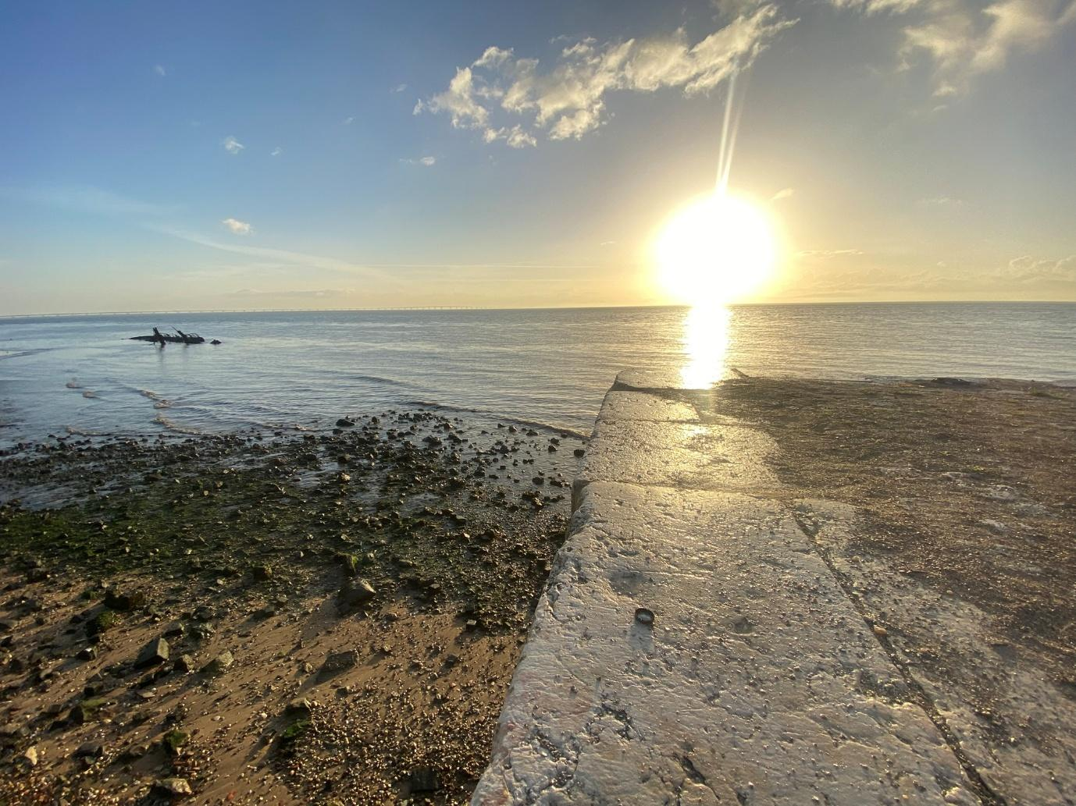
7:00 am — 15 drops of Ibotincture
- I will take the river walk as a choice to create from calm.
- How will I loosen the story that I must earn my right to rest?
- What simple cue will I use when morning anxiety tries to keep me at the desk?
My emotional state as I begin today is one of optimism (medium happiness), but at the same time, vigilance and forward focus (medium anxiety).
Intention for Today’s Journey: Since much of yesterday’s mood was around my soul-weary fatigue of living under the pressure to earn my right to exist through output and constant proving (even though in a creative, musical context), I wish to change my script about this with gentleness.
Because of my anxiety and my need to “get things done,” I seem to always have a worrying fear that prevents me from going on my 1-hour walk by the river.
Is this not a quiet, persistent form of nervous system hijacking?
It seems that my morning anxiety keeps me close to my desk and says “If I don’t start producing soon, I’ll fall behind. I’m already late. I need to earn my right to rest later by sacrificing presence now.”
Regardless of this voice, I am going for my morning river walk now.
Evening Mantra:
Today, I walked not to escape the work,
But to return to the one who creates with clarity.
The river-walk is not a delay;
It is the place where my worth detaches from quantity and perfection.
I am not here to prove my value through how much I produce,
But to create from a place that remembers I already have value.
Each step is a quiet refusal to let fear dictate my rhythm.

P.S. Click here to read Week 2 of my month meso-dosing with ibogaine.

