
Multi-Threaded Web Server with IPC and Semaphores

Technical Report

Authors:
Alan Marques (125046)
Miguel Sousa (125624)

Sistemas Operativos
Introduction

The objective of this project is to design and implement a concurrent Web Server using C as the programming language. Developed for the Operating Systems course, the server is capable of handling multiple simultaneous client connections efficiently. This solution combines Multi-Processing and Multi-Threading to maximize troughput and responsiveness.

The server implements a subset of the HTTP/1.1 protocol, supporting standard methods such as GET and HEAD.

The primary goal was to build a server that is not only functional but also scalable. With the key functional requirements being a concurrency architecture, where a Master Process forks N Worker Processes (4 by default) and those workers create thread pools with M threads each (10 by default), the Master accepts connections and distributes them to the workers via a bounded buffer; HTTP compliance, handling correctly GET and HEAD requests, including proper MIME type detection and Content-Lenght calculation; a robust logging system that writes to a single file without race conditions or interleaving, verified using Helgrind; a statistics dashboard that displays metrics in real-time and the ability to handle high loads and shut down gracefully.
System Architecture

This server combines the stability of Multi-Processing with the effeciency of Multi-Threading. The system is composed of three hierarchical layers: the Master Process (responsible for connection acceptance and load distribution), the Worker Processes (created via fork() by the Master) and the Thread Pools (responsible for handling the actual HTTP request processing concurrently).

The Master is basically the coordinator, it forks N workers, listens on the TPC port and accepts incoming client connections (accept()) and distributes the client file descriptors to worker using the Round-Robin algorithm to ensure equal load distribution.

Since the Master and Workers run in separate memory spaces, they cannot simply pass variables, for this reason this system uses UNIX Domain Sockets as an IPC channel. The Master passes the actual file descriptor to a Worker using the sendmsg() system call.

Each Worker acts as a container for a Thread Pool. When it receives a file descriptor from the Master, the main thread acts as a local producer. It pushes the socket FD into a shared Queue located in shared memory.

The threads act as the consumers, they block on a semaphore waiting for work, when a connection is enqueued
Implementation Details

- Feature 1: Connection Queue (Producer-Consumer via IPC)

The connection management system implements a two-stage Producer-Consumer pattern to efficiently move file descriptors across process boundaries and distribute work to threads.

Since the Master and Worker processes run in isolated memory spaces, they cannot share socket file descriptors through variable assignment. So this solution uses UNIX Domain Sockets to fix this. During initialization, the Master creates a pair of connected sockets for each worker using socketpair(), when the Master accepts a new client connection, it does not process it. Instead, it uses a custom send_fd() function wrapping the sendmsg() system call. The Master selects which Worker receives the connection using a Round-Robin algorithm.

Inside each Worker lies a bounded queue responsible for buffering requests before they are picked up by threads. This queue is implemented in shared memory to allow access by the main thread (producer) and the worker threads (consumers). The connection_queue_t struct contains an integer array, along with head and tail indices.

To prevent race conditions, access to the queue is controlled by three synchronization primitives: empty_slots (semaphore), the main thread waits on this before adding a connection. If the value is 0, the thread knows no space is available; filled_slots (semaphore), initialized to 0, worker threads block on this semaphore, when the main thread increments it a sleeping worker thread wakes up to process the new request; mutex, a binary lock that protects the critical section where the head and tail indices are modified, ensuring that two threads never dequeue the same slot simultaneously.

Master forking the workers:
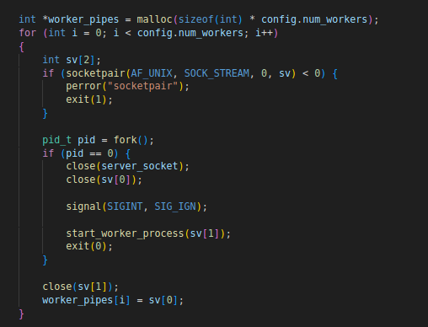

- Feature 2: Thread Pool Management

- Feature 3: Shared Statistics

To provide real-time visibility into the server’s performance across multiple isolated processes, a centralized statistics tracking system was implemented using shared memory.

The system tracks the following key performance indicators in real-time: total requests, bytes transferredm active connections, HTTP status codes and average response time.

Since multiple threads across mutiple thread across multiple processes may attempt to update these counters simultaneously, there is a high risk of Race Conditions. For that reason a binary semaphore (stats->mutex) is initialized within the shared memory block to act as a cross-process lock, before modifying any statistic, a Worker thread performs a sem_wait() on this mutex. It updates all relevant counters within a single critical section and then releases the lock with sem_post().

To vizualize this data, the Master process spawns a dedicated Stats Monitor Thread upon startup. This thread runs and infinite loop that sleeps for a fixed interval, when it wakes up, it acquires the statistics lock to ensure it reads a consistent snapshot of the data. It calculates derived metrics and prints a formatted summary to the console before releasing the lock.

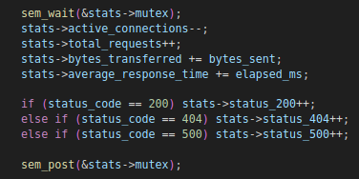
- Feature 4: Thread-Safe File Cache

- Feature 5: Thread-Safe Logging

A logging subsystem was implemented that adheres to the Apache Combined Log Format. Given that multiple thread across multiple processes generate logs simultaneously, ensuring data integrity and preventing performance bottlenecks were primary design goals.

The system enforces Mutual Exclusion for disk I/O. A dedicated binary semaphore (log_mutex) is initialized in shared memory. No thread can write to log buffer or file without first acquiring this lock.
When a thread logs a request, it formats the string locally on its stack, it acquires the log_mutex, copies the string into the global buffer, if the buffer is full, it triggers a flush to disk, if not it releases the lock immediately.

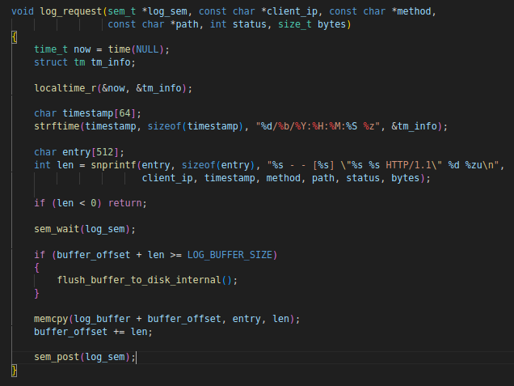
Performance Analysis

