
Multi-Threaded Web Server with IPC and Semaphores

Design

Authors:
Alan Marques (125046)
Miguel Sousa (125624)

Sistemas Operativos

Architecture Diagram

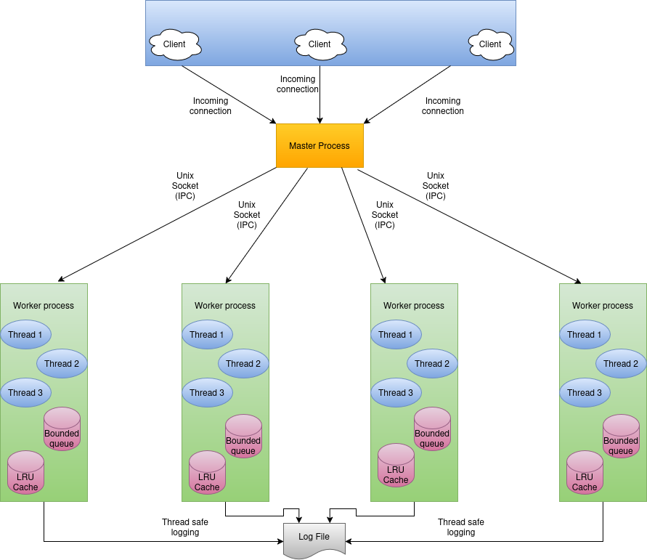

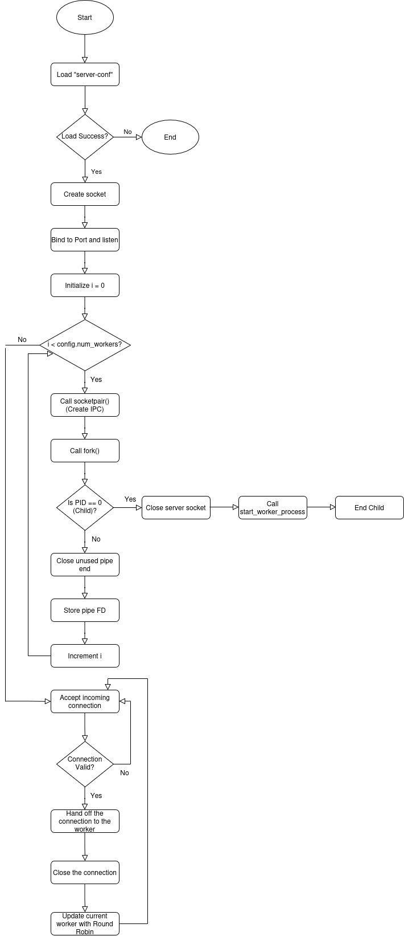
Feature 1 (Master Process) Flowchart

Feature 2 (Thread Pool Management) Flochart
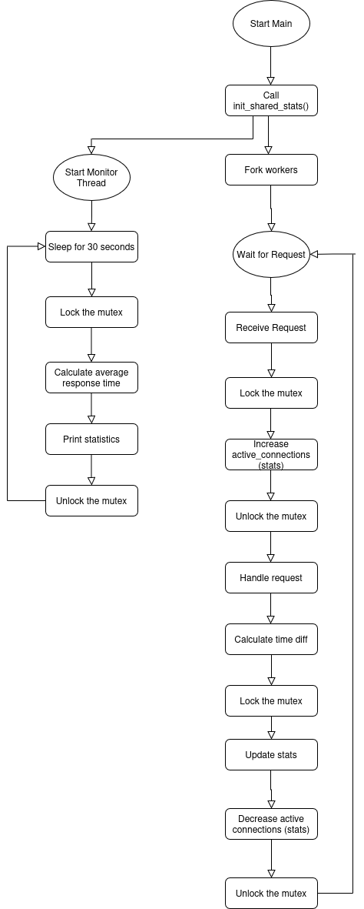
Feature 3 (Shared Statistics) Flowchart

