Report_Exercise

Escola Nacional de Saúde Pública

Miguel Vaz

16 de setembro de 2023

# Introduction

This is a smart report generated with R on the date 16 setembro 2023. We used hypoxia as datset . In this report we will combine what we have learnt so far in the R course.

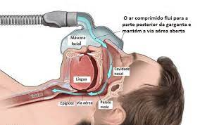

## Running Code

When you click the **Render** button a document will be generated that includes both content and the output of embedded code. You can embed code like this:

[1] 2

# Methods

## Study Design and Data Source

This study employs a retrospective analysis design using the Heart Failure Dataset from MLDataR. This dataset is an open-source, publicly available resource that compiles data from heart failure patients, offering comprehensive insights into clinical, demographic, and laboratory features that may be associated with heart failure outcomes.

## Data Collection

The Heart Failure Dataset from MLDataR was downloaded and parsed into a format amenable to our analysis pipeline.

We created a logistic regression model, with the following equation $xy=s$

$$E\left(Y_{i}\right)=β_{0}+β_{1}AGE_{i}+β_{2}SEX_{i}+β_{3}BP_{i}+β_{4}CHOL_{i}+ϵ_{i}$$

# Results

## Descriptive Statistics

Our data set as 281 patients with a mean age of 47.2925267

|  | | | **Smoking** | |  |
| --- | --- | --- | --- | --- | --- |
| **Variable** | **N** | **Overall**, N = 2811 | **No**, N = 1401 | **Yes**, N = 1411 | **p-value**2 |
| female | 281 | 201 (72%) | 105 (75%) | 96 (68%) | 0.2 |
| age | 281 | 48 (40, 55) | 45 (36, 53) | 51 (44, 57) | <0.001 |
| sleeptime | 281 | 8 (1, 27) | 4 (1, 16) | 13 (3, 37) | <0.001 |
| cpap | 281 | 178 (63%) | 86 (61%) | 92 (65%) | 0.5 |
| 1n (%); Median (IQR) | | | | | |
| 2Pearson's Chi-squared test; Wilcoxon rank sum test | | | | | |

## Model

# A tibble: 3 × 7  
 term estimate std.error statistic p.value conf.low conf.high  
 <chr> <dbl> <dbl> <dbl> <dbl> <dbl> <dbl>  
1 (Intercept) 0.304 0.553 -2.15 0.0312 0.101 0.889  
2 age 1.04 0.0122 3.12 0.00179 1.01 1.06   
3 as.factor(smoking_yes… 0.924 0.265 -0.299 0.765 0.548 1.55

The data contains 3 observations of the following 7 variables:

* term: 3 entries, such as (Intercept) (n = 1); age (n = 1); as.factor(smoking_yesno)Yes (n = 1) (0 missing)
* estimate: n = 3, Mean = 0.76, SD = 0.40, Median = 0.92, MAD = 0.17, range: [0.30, 1.04], Skewness = -1.57, Kurtosis = -1.50, 0 missing
* std.error: n = 3, Mean = 0.28, SD = 0.27, Median = 0.26, MAD = 0.37, range: [0.01, 0.55], Skewness = 0.20, Kurtosis = -1.50, 0 missing
* statistic: n = 3, Mean = 0.22, SD = 2.68, Median = -0.30, MAD = 2.75, range: [-2.15, 3.12], Skewness = 0.84, Kurtosis = -1.50, 0 missing
* p.value: n = 3, Mean = 0.27, SD = 0.43, Median = 0.03, MAD = 0.04, range: [1.79e-03, 0.76], Skewness = 1.72, Kurtosis = -1.50, 0 missing
* conf.low: n = 3, Mean = 0.55, SD = 0.46, Median = 0.55, MAD = 0.66, range: [0.10, 1.01], Skewness = 0.06, Kurtosis = -1.50, 0 missing
* conf.high: n = 3, Mean = 1.17, SD = 0.34, Median = 1.06, MAD = 0.26, range: [0.89, 1.55], Skewness = 1.23, Kurtosis = -1.50, 0 missing

# A tibble: 2 × 7  
 term estimate std.error statistic p.value conf.low conf.high  
 <chr> <dbl> <dbl> <dbl> <dbl> <dbl> <dbl>  
1 (Intercept) 0.614 0.0408 15.0 7.46e-38 0.534 0.695  
2 as.factor(smoking_ye… 0.0382 0.0577 0.663 5.08e- 1 -0.0753 0.152

The plot bellow is the relationship between age and bmi by heart disease

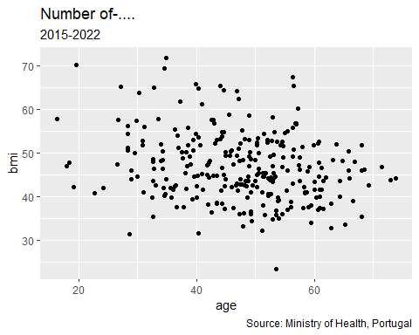

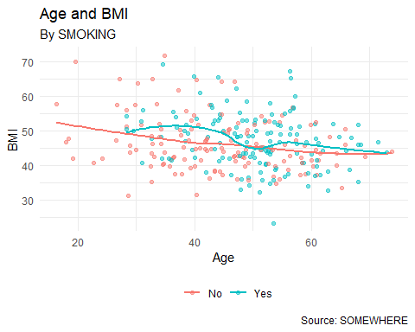

# Discussion

Resting ECG, when relevelled to “Normal”, shows two categories LVH (Left Ventricular Hypertrophy) and ST (ST wave abnormality) are not statistically significant in predicting heart disease. This means the odds of heart disease do not significantly change with these specific ECG results as compared to a normal ECG result (1).

# References

1. Vaz M, Silvestre S. Alzheimer’s disease: Recent treatment strategies. European journal of pharmacology. 2020;887:173554.