Table I. Species count information collected from underwater visual surveys in Cocos Island Costa Rica. Values are shown as the mean count of individuals observed in a week (sampling unit).

|  |  |  |  |  |  |  |
| --- | --- | --- | --- | --- | --- | --- |
| Species | Common name | Trophic category | Model | Mean Count | SD | Max Count |
| Carcharhinus limbatus | Blacktips sharks | Top predator | Bernoulli | 0.17 | 0.34 | 4.5 |
| Aetobatus narinari | Eagle rays | Meso-predator | Bernoulli | 1.52 | 1.87 | 21.66 |
| Marbled rays | Taeniura meyeni | Meso-predator | Negative Binomial | 19.02 | 15.11 | 155 |
| Carcharhinus galapagensis | Galapagos sharks | Top predator | Negative Binomial | 0.8 | 1.35 | 11.16 |
| Sphyrna lewini | Scalloped Hammerhead Sharks | Top predator | Negative Binomial | 83.36 | 91.49 | 1125 |
| Mobula birostris | Manta rays | Filter feeder | Bernoulli | 0.13 | 0.26 | 4.5 |
| Mobula spp. | Mobula rays | Filter feeder | Negative Binomial | 0.35 | 0.93 | 17.33 |
| Carcharhinus falciformis | Silky sharks | Top predator | Negative Binomial | 0.36 | 2.05 | 42.1 |
| Carcharhinus albimarginatus | Silvertip sharks | Top predator | Negative Binomial | 0.19 | 0.46 | 4.46 |
| Galeocerdo cuvier | Tigersharks | Top predator | Negative Binomial | 0.2 | 0.45 | 5 |
| Cheloniinae | Sea turtles | Prey | Negative Binomial | 1.04 | 1.09 | 7.16 |
| Rhincodon typus | Whale sharks | Filter feeder | Negative Binomial | 0.004 | 0.1 | 0.9 |
| Triaenodon obesus | Whitetip reef sharks | Meso-predator | Negative Binomial | 71.71 | 42.11 | 350 |

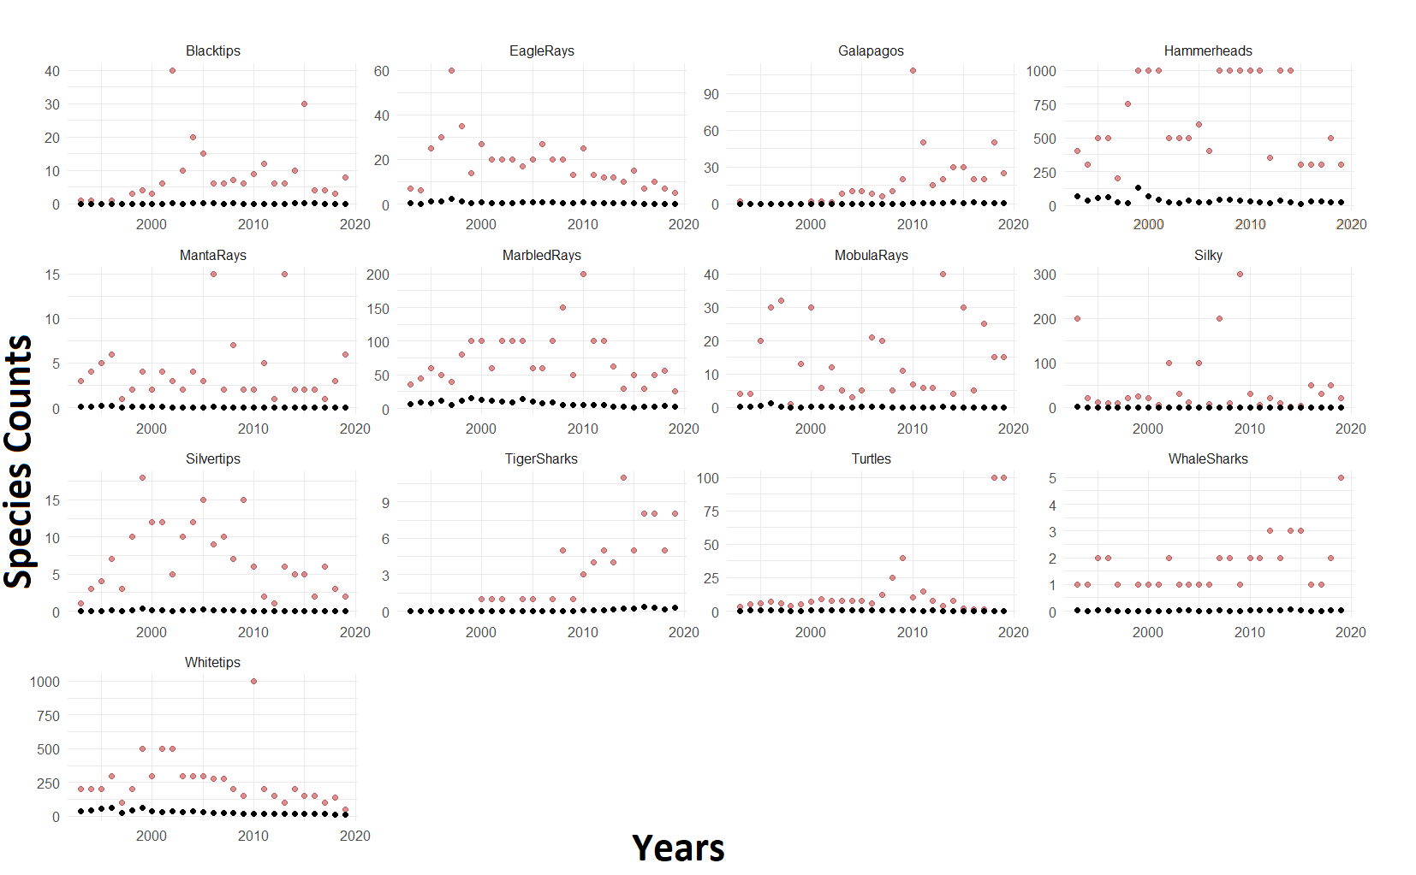

Figure 1. Mean (black dots) and maximum (red dots) count of Species by year in Cocos Island. Note that Blacktips, Galapagos and Tiger shark counts were not originally recorded in the database.

.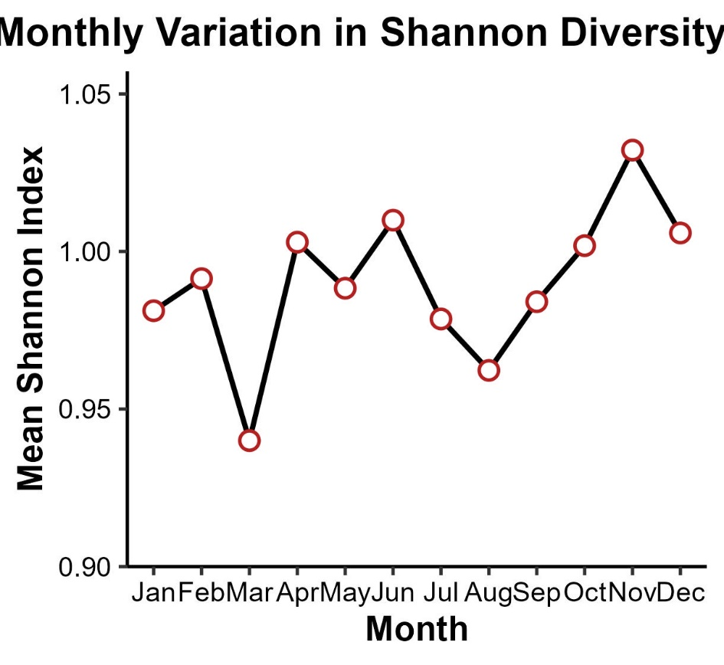

Figure 2. Monthly variation of the Shannon Diversity Index in Cocos Island. Each point representing the average diversity for a given month.

Figure 3. Bray-Curtis dissimilarity percentages between consecutive months

Table II Diversity and Network linear models



Figure 4. Correlations between mean abundances of elasmobranch species in Cocos Island. Darker colors signal positively proportional correlations, lighter show negatively proportional correlations. Correlation values are shown as numbers and mirror colors in the heatmap.

Figure 5. Model estimates vs actual values for the Bayesian models. Red dots represent the difference between expected and observed values. Black lines represent the standard error of differences. Positive values mean predictions were higher than actual observations and vice versa.



Table III. Model covariate results. Interactions were considered significantly if their posterior distribution did not cross 0. Significant results are shown with an asterisk.

Figure 6. Cocos Island diving site locations.

Figure 7 Network Strength over time by season and site. Dashed (green nodes) line shows network strength for the wet season. Solid line is for the dry season. Sites are shown as headers. Note that most sites show similar trends to the average network strength plot in the manuscript. Noticeable differences are observed in certain sites. I lack the knowledge of local structure and reasons for these differences

Figure 8. Sensitivity analysis outputs for species covariates. Model was re-run for all species removing turtles as a covariate. No significant changes in coefficient were observed.

Figure 9. Sensitivity analysis output for time effects. Models were re-run using data from 2014 to 2019. Overall trends remained the same, but most interactions lose strength and significance. 18 out of 86 significant species interactions remained the same between both models

Table IV. Significant species effects that remained between the complete model and the model using data from 2014 to 2019

|  |  |
| --- | --- |
| Species model | Effect remaining |
|  |  |
| Blacktips | Eagle rays |
| Eagle rays | NA |
| Galapagos | Eagle rays, Manta rays, Mobula rays, Tiger sharks |
| Hammerheads | Blacktips, Turtles, Whitetips |
| Manta rays | NA |
| Marbled rays | Blacktips, Manta rays, Mobula rays, Whitetips |
| Mobula rays | NA |
| Silky | NA |
| Silvertips | NA |
| Tiger sharks | NA |
| Turtles | Blacktips |
| Whale sharks | NA |
| Whitetips | Backtips, Hammerheads, Manta rays, Marbled rays Mobula rays |