FORMATIVA BACK-END MIGUEL BERTANHA TAVARES DE OLIVEIRA

GET –
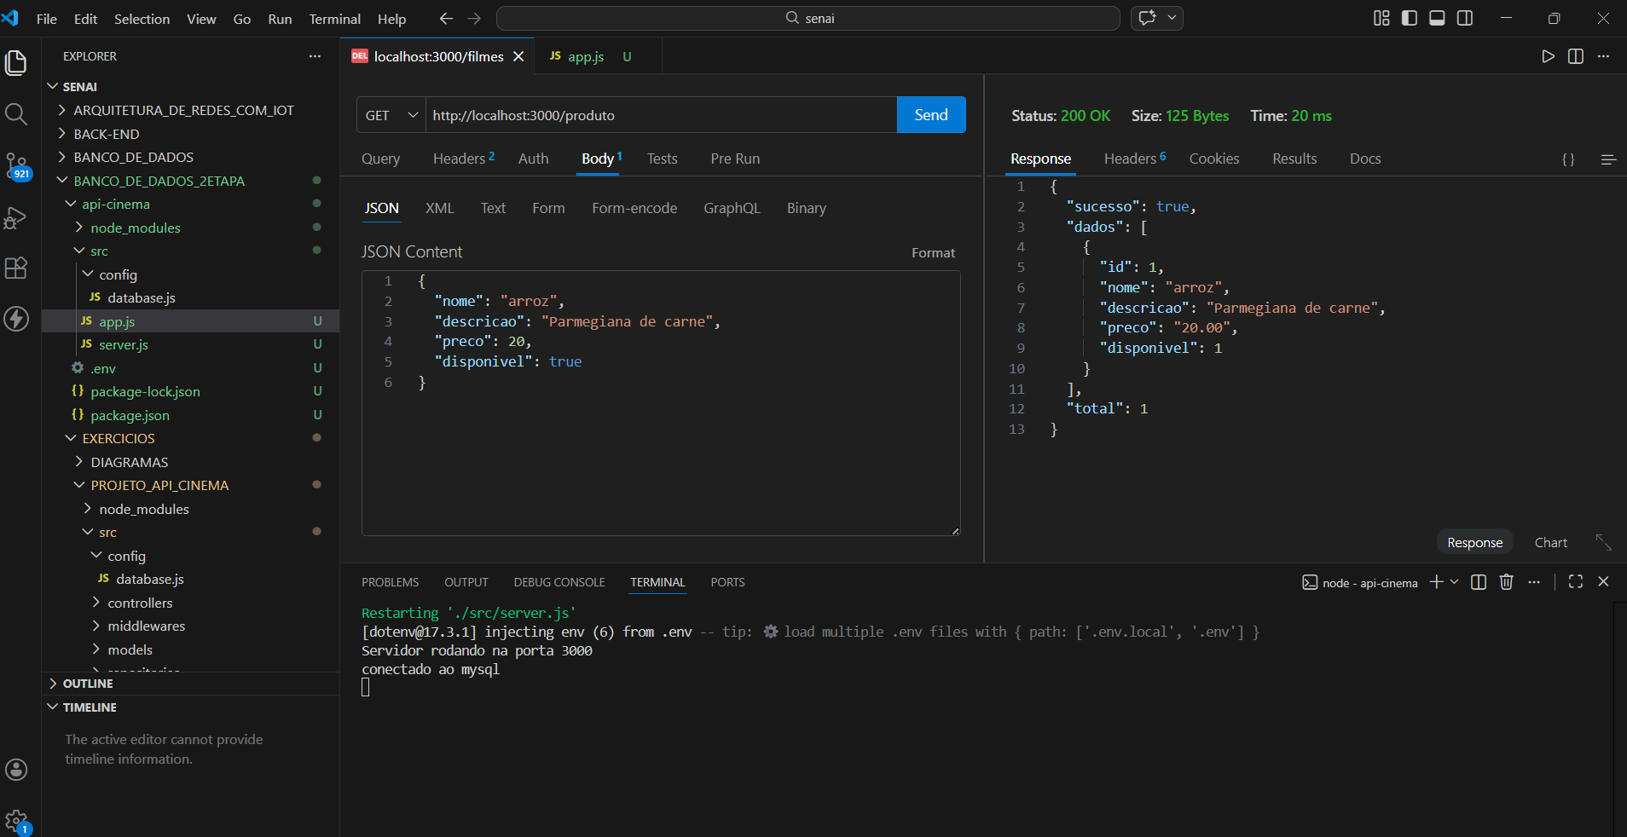

GET:ID –
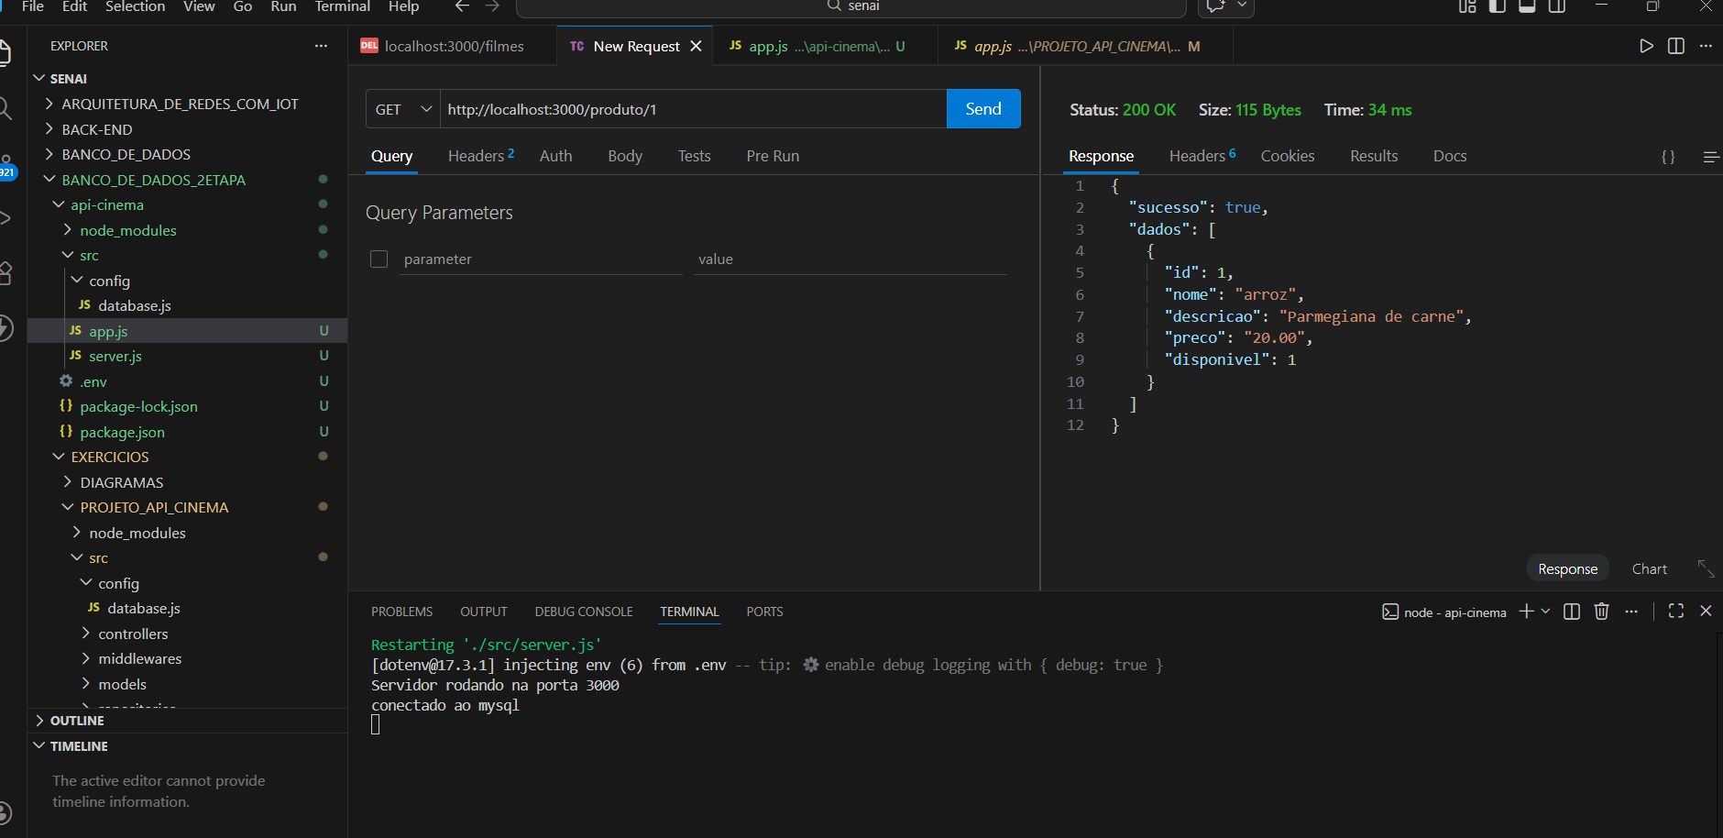

POST –

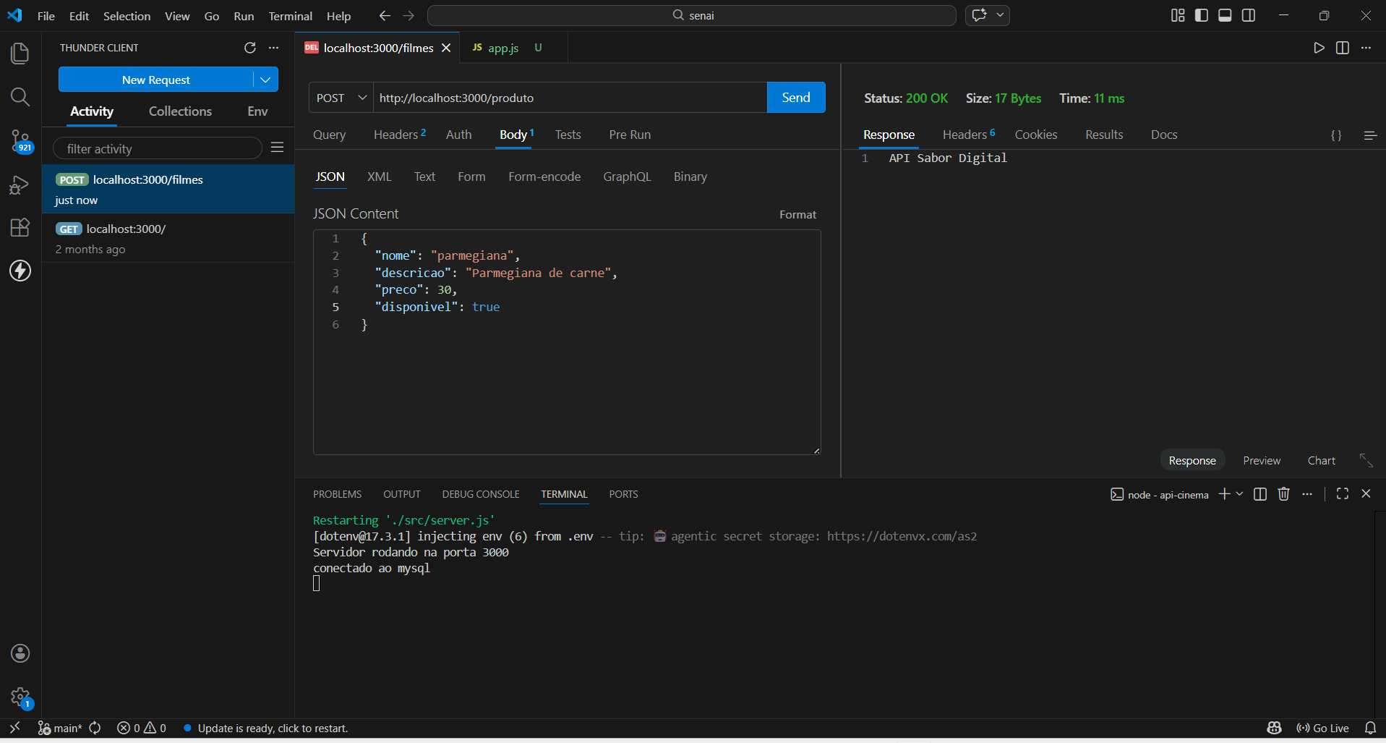

PUT –
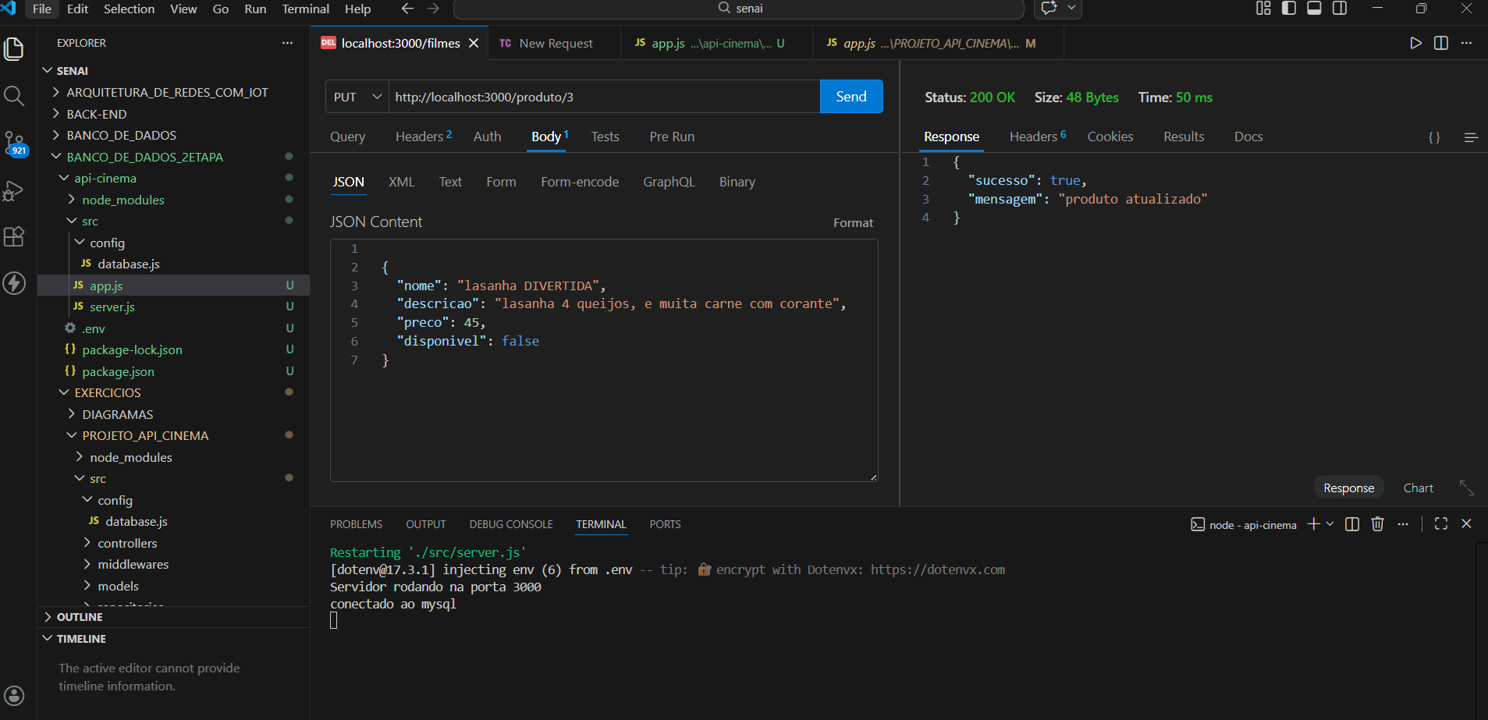

DELETE –

