MIGUEL BERTANHA TAVARES DE OLIVEIRA

12 COLUNAS – MOBILE
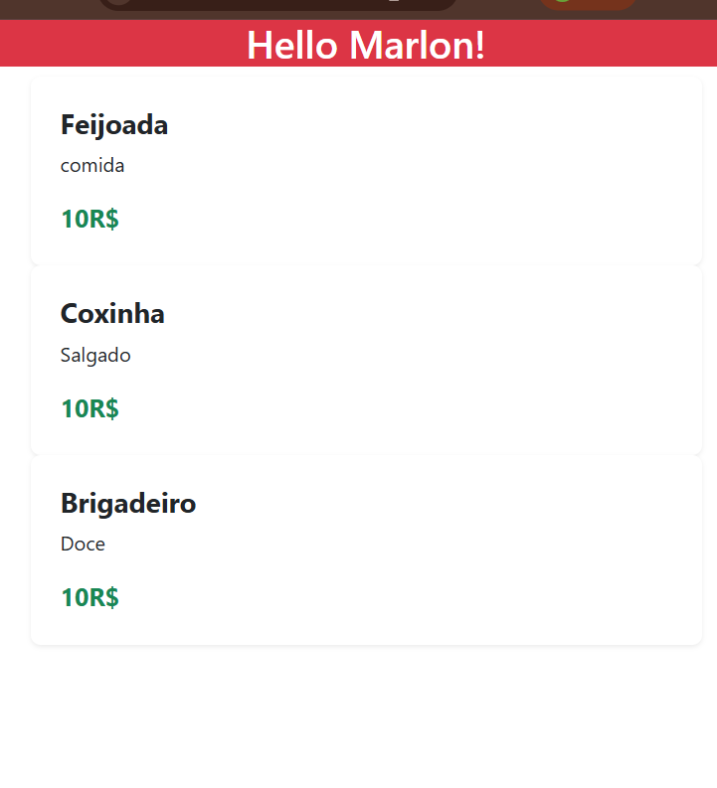

6 COLUNAS – TABLET
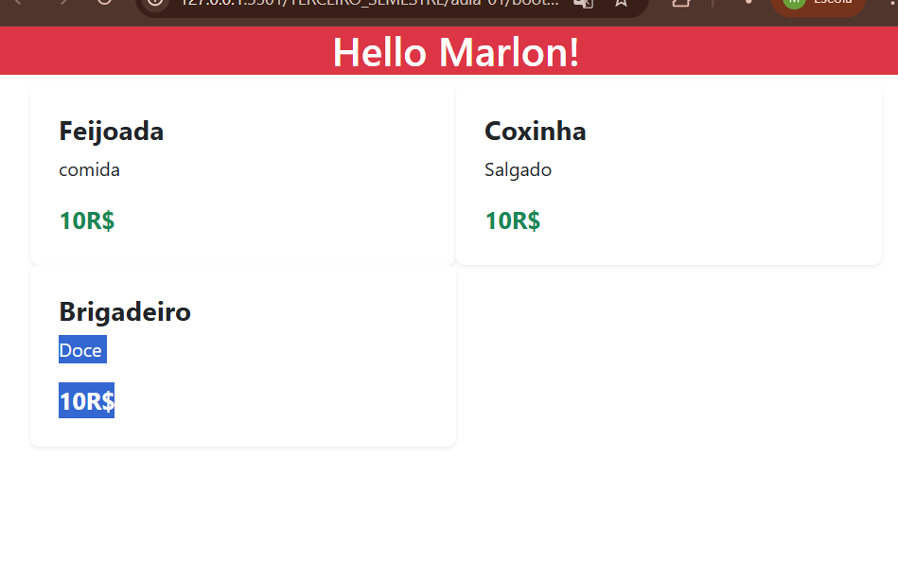
4 COLUNAS – DESKTOP
