Shortlisting Applications

Objective
This guide is intended to show you how NHS Jobs can help you shortlist a number of applications.

Introduction
The features on NHS Jobs can be used to support reviewing applications by the recruiting manager alone or by a number of reviewers supporting the recruiting manager. See “Reviewing Applications” for information on this.

Once all applications have been reviewed either by yourself, as the recruiting manager, or with the assistance of a number of reviewers, you will have in front of you a set of applications with a combination of shortlist/reject recommendations. If you used the score card to support the review, the list of applications will include score information for each application.

The recommendations and scores can then be used to identify the best applicants to shortlist and those applicants to reject. Information on the recommendations and scores can be viewed via the screen or downloaded into a CSV file.

Shortlisting applications

Where to start
To shortlist applications:
- Go to the applications list for the vacancy, select the ‘Finalise shortlist ’ link in the left navigation menu.

Overview
The ‘Finalise shortlist’ page provides a list of the applications ‘In Review’ along with the scores and recommendations from the reviews completed. The initial presentation provides a summary of the recommendations and an average of the total of the scores recorded.
In the example below two reviews have been completed, including the use of the score card, with both reviewers recommending to shortlist.

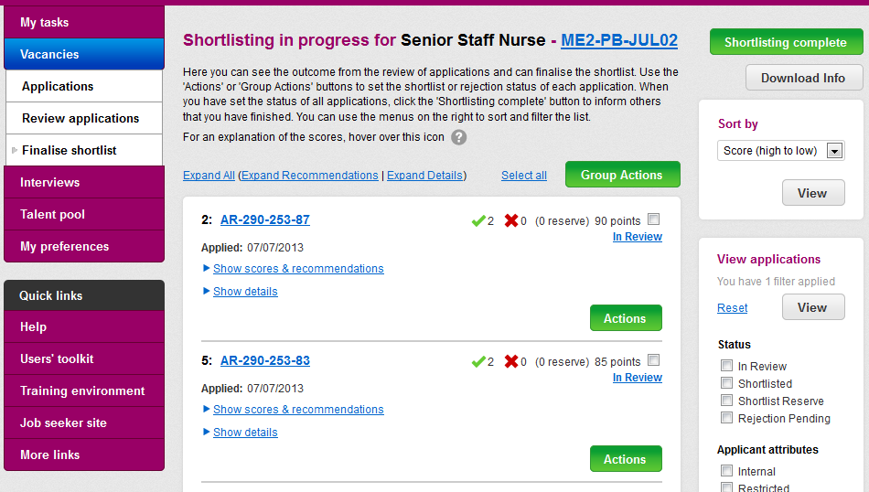

How to view the recommendations
In the ‘Finalise shortlist’ page the recommendation of the reviewers is summarised using the tick and cross icons. In the two applications shown above, both reviewers have recommended that the applicants are shortlisted.


The green tick icon indicates a shortlist recommendation and the red cross icon a reject recommendation.

In the example below, the last two applications show that both reviewers have recommended that the applicants are rejected. The application marked as ‘1:’, at the top of the list below, shows one reviewer recommending to shortlist and one to reject.

A third option of ‘Shortlist reserve’ can be used in reviewing and in shortlisting’. This provides an ability to identify good candidates that did not come within the top number of applications that you are intending to shortlist and invite to interview. You can use the filter on the right hand of the screen to hide or show your reserve applications. When an application is flagged as ‘Shortlist reserve’ you can click the ‘action’ button to see options to reject the applicant or add them to the shortlist.

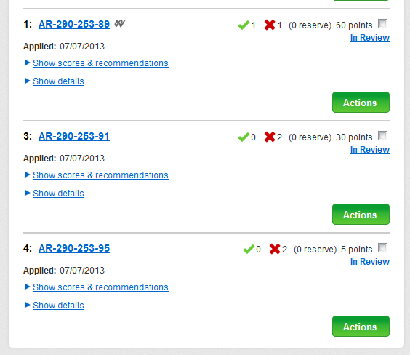

The list of applications is presented in list of average total score descending by default. You can use the ‘Sort by’ selection on the right to change the order the list is presented in.

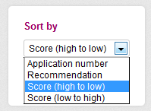

The scores and recommendations for an application can be viewed by clicking on the ‘Show scores & recommendations’ link.

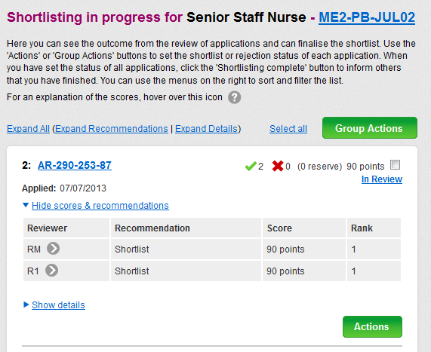

The recommendation and score from each reviewer is listed. The identity of the reviewer can be seen by hovering over the icon. The rank number identifies where in the list of applications this particular application came for the reviewer.

The details of the scoring for an application can be viewed by clicking on the ‘Show details’ link.

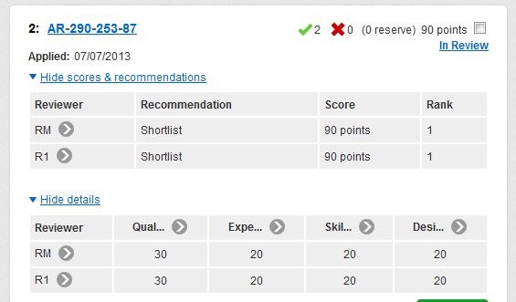

The score for each category in the score card is presented in the grid. In the example above the standard score card had been used, therefore the four default categories are listed (Qualifications, Experience, Skills and Knowledge and Desirable). The score shown in each category is the value selected on the score card multiplied by 10, in the case of the standard score card. Where an organisation’s own score card is used, the multiplication factor may be adjusted by the weighting factor identified when the score card was set up by the system administrator.

The scores and recommendations and/or the score details for all applications can be expanded and viewed by clicking on the ‘Expand All’, ‘Expand Recommendations’ or ‘Expand Details’ as required.

It is possible to get a CSV of all the recommendations, scores and details by selecting the ‘Download Info’ grey button at the top right of the page.

How to shortlist an application
Click on the ‘Actions’ button for the application and then select the relevant action option.

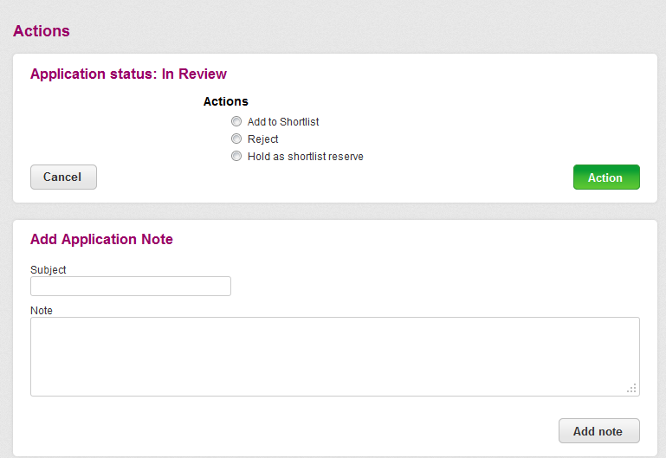

When selecting ‘Reject’ the system will combine and store the rejection reasons recorded during the reviews, so it is not necessary to enter a reason at this stage.

A note can be added against the application, for internal use by the recruiting manager and recruitment team and for future reference.

Alternatively, to process a number of applications at once, select the relevant applications and then the ‘Group Actions’ button. Select the relevant option and the ‘Action’ green button. All selected applications will then be changed to the chosen status.

Once all the applications have been identified as ‘shortlisted’, ‘rejected’ or in the ‘shortlist reserve’ and you are satisfied with the outcome, click on the ‘Shortlisting complete’ button to indicate that the activity is completed.



Selecting ‘Shortlisting complete’ triggers an email from the system to the recruitment officer for the vacancy, so that the recruitment team are aware and the remaining recruitment activities can continue.

Once the ‘Shortlisting complete’ selection has been made on a set of applications for a vacancy, the unsuccessful applicants will be able to see, when they next log into their NHS Jobs account, the indication of where their application is in the process will have changed to ‘Unsuccessful’. Applicants that have been shortlisted will still see that their application is ‘Submitted’ until they have been invited to interview.

