

Community Healthcare Safe and Secure handling of Medicine Workbook



Index

Introduction to Workbook Page 1

Training

Procedure for administering medication Page 4

Self – administration of Medication Page 5

PRN (As required medication)

Non-prescribed Medications

Errors Page 6

Returning Medication to Pharmacy
.
Side effects/reactions Page 7

Storage of Medication

Records

Repeat Prescriptions and the elderly

Storage of Medication

Records

Repeat Prescriptions and the elderly

Support for the elderly to obtain their medicines

Hospital discharge Page 8

Read the Label

Medicine Administration Page 9

Assessment Page 20

References Page 21

Introduction to Workbook

The purpose of this workbook is to ensure that the individual service users receive their medication and treatments:

- In the correct manner

- Are given the right dose

- At the right time

- All relevant documentation is completed in accordance with Organisational Medicines in Wiltshire Community Healthcare Units - Safe and Secure Handling Policy

In ordinary life, adults take care of their own medication; this involves not only taking them properly but also storing them correctly. We should strive where practicable to enable service users to self medicate.

Where a service user is unable to self-medicate, it is recognised that it is not always possible for staff to obtain the service users consent. If a person refuses medication it must not be administered disguised in food or drink. The situation must be discussed with the GP and senior nurse.

Only with the service user’s permission can the GP be approached when a service user is not taking prescribed medication. (If permission is not granted then the carer should encourage the service user to inform the GP)

Staff will strive to ensure that service users have clear information, in terms they understand, about prescribed medication, its likely benefits and any possible side effects, to enable service users to make informed choices about their medication.

Training

Whenever possible, patients should be responsible for self administration of medication; however there are times when this must be carried out by a care worker. The administration of medication by health care support workers (HCSWs) and assistant practitioners (APs) is a critical element of the delivery of the overall strategy to help meet the performance targets of the local health economy. The role of the HCSW and AP administering medication offers the opportunity to introduce higher level practice within a framework to ensure safety is paramount. The safe administration of medication will maximize the benefits to the patient and avoid causing harm. This will ensure the optimal use of resources to enhance patient care.

The Care Quality Commission (2009) highlights that:

‘The following descriptions define what assisting with medicines means and what administering medicines means:
- When a care worker assists someone with their medicine, the person must indicate to the care worker what actions they are to take on each occasion.
- If the person is not able to do this or if the care worker gives any medicines without being requested (by the person) to do so, this activity must be interpreted as administering medicine.

Care workers may administer prescribed medication (including controlled drugs) to another person with their consent, so long as this is in accordance with the prescriber’s directions (The Medicines Act 1968). This is called ‘administering medication’. However, when medication is given by invasive techniques, care workers will need additional specialist training’.

The registrant (delegant)

All registrants must comply with WCHS delegation policy when delegating any activity. Nurses and midwives must also comply with the NMC Code delegating effectively and obtaining consent before beginning any treatment or care. All nurses and midwives must comply with the NMC Standards for medicines management (2008). All standards apply, however the following are particularly applicable to this document:

Please note that all medications belong to the service user and that you are safekeeping them on their behalf. All directions for administration of medications must be adhered to according to the pharmacist or manufacturers instructions. All staff will need to check and administer or supervise the giving of medicine to some service users. It is the responsibility of the line manager to ensure all staff members are appropriately trained in the safe handling, administration and effects of medication.

Competency to administer medication should be assessed annually using the Skills for Health Competency framework. If a procedure for administering medication e.g. giving eye drops has not been carried out by a member of staff in the past 6 months or if at any time the staff member no longer feels competent then the senior nurse must supervise the procedure and re-assess competency.

Procedure for administering medication

Health care support workers (HCSW’s) and Assistant practitioners (AP’s) must refer to the individual care plan before administering any medication..

The following must be checked before administration:
- Name of service user
- Date
- Name of medication
- Dosage
- Time to be given
- Route
- Expiry date

Medication should be administered from the cassette/blister pack to the individual service user, using a medicine pot/egg cup/spoon etc.

All medication must be clearly labelled and have all dosage instructions. If medication is labelled ‘take as directed’, the prescriber or pharmacist should be contacted to ensure that the prescription is amended so that future supplies have dosage instructions and these instructions are recorded.

If using blister packs/cassettes check if other medication needs to be given e.g. short term treatment (i.e. antibiotics), liquids or creams.

Service users should be observed to ensure the medication has been taken. If medication is refused this must be documented and medicines must be signed for immediately after administration. Medicines must be placed back into the locked cupboard or other safe place in the person’s home immediately after administration.

Assistance must be given to the service user to ensure the most appropriate/palatable form of medication is available. Advice can be sought from the pharmacist or GP. Many tablets are available in liquid form for patients who have difficulty swallowing.

The appropriate medical practitioner should review medication at least annually and the service user encouraged to discuss the course of treatment and any concerns. Where medication is prescribed in a variable dose, the exact dose, date and time administered must be recorded. In the event of any error in the medication supplied, the senior nurse and pharmacy should be contacted immediately and arrangements made to rectify the mistake.

Self – administration of Medication

All service users should be encouraged to administer their own medication to the extent that they are able and can do so responsibly. People living in their own homes should be encouraged to store medicines in a safe place. If appropriate a risk assessment should be carried out and reviewed as required.

PRN (As required medication)

When staff administer ‘as required’ medication, details must be recorded. DO NOT EXCEED THE MAXIMUM DOSE WITHIN 24 HOURS, which is recorded on the Drug Administration Sheet or manufacturers instructions. In the event of a person receiving the maximum dose of PRN medication in a 24-hour period, the GP must be contacted for advice in case the person requires further treatment/medication. Any advice received must be written in the notes/MAR sheet and countersigned by the GP at the next visit.

All PRN medication should have information on the pharmacist label clearly stating the recommended dose, frequency and maximum dosage per 24 hours. This information should be matched by identical information in the PRN section of the service users MAR sheet. Some brief indication of under what circumstances ‘as required’ medication must also be included on the drug administration sheet/care plan. Frequent use of PRN medication may indicate the need to review a service user’s plan of care and current medication regime.

Non-prescribed Medications
OTC OR OVER THE COUNTER MEDICATION IS SPECIFICALLY EXCLUDED FROM THE MEDICATION POLICY- STAFF ARE REMINDED THAT THEY DO HAVE A DUTY OF CARE IF THEY SUSPECT THAT OTC MEDICATIONS ARE NOT BEING USED PROPERLY.

Many non-prescribed or ‘over the counter’ medications contain medication which can have serious side effects if taken by a person with certain medical conditions or if taken with other medication. Service users have the right to purchase and take the same ‘over the counter’ medications as anyone else. However, staff should ensure that service users are aware of any potential side effects by advising them to ask the pharmacist or contact their GP before taking such medication.

If staff have reason to believe that a service user has or is about to take medication, which will be of harm to them, they should seek the advice of a GP immediately and inform the line manager appropriately.

Errors

An error is the mis-administration of medication, this includes giving the wrong dose, giving the medication at the wrong time, giving it to the wrong person, omitting medication or failing to sign the medication sheet. All medication errors must be reported to the senior nurse immediately. Other appropriate records must also be completed. In all incidents the GP should be contacted immediately. The senior nurse will follow up all medication errors and on occasions errors may be addressed via the disciplinary policy. Forms RM1 or equivalent must be completed and returned to the Clinical Governance Manager at the Great Western Hospitals Foundation Trust (GWH).

.
Returning Medication to Pharmacy

Medication must never be disposed of via the household waste/sewage system.
All unwanted medication must be returned to the pharmacy by the patient or family..

Side effects/reactions

Staff should be aware that some medication can have side effects and may alter the emotional, mental or physical state of the user. If staff suspect that a service user is experiencing such an effect they should contact the GP or senior Nurse for advice.

Storage of Medication

All medication must be clearly and appropriately labelled. Medication requiring chilled storage may be held in the fridge in an appropriate container.
Records

HCSW’s must sign the medication sheet.

Repeat Prescriptions and the elderly

Many elderly people have difficulty understanding what is written on the repeat prescription forms. Furthermore, they may not always remember to take their medicines regularly, which can result in differing quantities of medication being stored in the home and some medicines running out before others. Consequently, this may mean the service user has to return to the surgery for prescriptions more frequently for one or two items. This can be inconvenient for the service user and significantly increases the workload for the GP surgeries.

Support for the elderly to obtain their medicines

Home care staff have a vital role to play in supporting the elderly with many aspects of daily living. This includes helping them to obtain their medicines on a regular basis. If you think that a service user may be experiencing difficulties with their medicines, one good idea is to check the regular medicines which are being taken, against the list on the repeat prescription form. Medicines listed which are not easily found at the service user’s home, may mean that some medicines:

- have been stopped by the doctor as they are no longer required
- have been stopped by the service due to a lack of understanding
- have been stopped due to an unpleasant side–effect.

If all the medicines on the list are present in the home, but quantities vary, this may indicate that the service user does not always take the medication regularly. They may be forgetful and require additional support when taking their medicine. If the service user is willing for you to contact the GP surgery to let the doctor know of any problems, this would be an excellent course of action to take. If the doctor is informed of the situation s/he is in a much better position to plan and possibly alter the service user’s therapy in the future.

Hospital discharge

Elderly service users can become very confused after a stay in hospital. They are often discharged and sent home with a bag full of medicines, often containing a mixture of medication started in hospital and longer-term medication, which they have been prescribed by their GP. The hospital discharge summary listing the discharge medicines is often given to the service user and it is important that this information reaches the surgery as soon as possible.

After hospital discharge it is a good idea to contact the pharmacy that normally supplies the service user’s medicines. They will be able to contact the surgery to confirm the correct medication the service user needs to take in the future. They will also be able to make any changes to the repeat prescription form for the future.
It is important to check that the service user uses the latest version of the repeat prescription form, which will list any new medication prescribed during the hospital stay.

Read the Label
In conclusion, it is useful to know what information can be gained about a service user’s medication from the dispensing label on the pack. Many clues about whether a service user is able to comply with their therapy, and whether they are taking and ordering their medicines correctly, can be gained from looking at the dispensing labels on the packets. If the date of dispensing is more than two months old, and there are many tablets or capsules still inside the pack, the service user may be experiencing difficulties with taking their medicines. This may be linked to problems with ordering medicines. If you think a service user is experiencing problems with their medicines, you need to report this to the senior nurse in charge, who may need to discuss it with the service user’s GP and their pharmacist. The care plan may need to be revised accordingly.

Generic or Brands
One thing which many people find confusing about medicines is their names! Most medicines have two names – the generic or chemical drug name, and a second brand name given to the medicine by the manufacturer. Most drugs are prescribed by their generic name, but the actual packet in the home may bear both the generic name and the brand name. Usually it is only the generic name that appears on the dispensing label. A simple way of thinking about these names is to think about baked beans. Baked beans is the generic name for the product but the beans may come in a can labelled by the brand name e.g. Tesco, Heinz etc. For drugs, the generic name is usually the longer of the two names and is often written in smaller letters below the brand name

e.g. PIRITON (brand name)
Chlorpheniramine maleate (generic name)

Ventolin (brand name)
Salbutamol Sulphate (generic name)

STEMETIL (brand name)
Prochlorperazine maleate (generic name)

The Clinical Commissioning Group (CCG) will make the decision regarding what medication can be prescribed.

Stock levels must be kept to a minimum and any out of date tablets, creams, liquids or drops must be returned to the pharmacy for disposal again by use of the consent for destruction of unwanted or discontinued medicines form. Where expiry dates are not apparent seek advice from the pharmacist. he issue date of creams etc does not always correspond with the start date. All creams, liquids, drops etc must therefore be marked with the opening date and the date by which they should be used. Expiry dates should be checked on administration. In the event of a medication that cannot be accounted for the line manager must be informed immediately.
Medicine Administration

General rules for administering medicines
When giving medicines to patients it is important to consider the following:
- Check the patients identification
- Check patients prescription sheet P2
- Be certain that the right medicine is to be given to the right patient
- Be aware of the patients care plan
- Check that the label on the medicine is clear and you understand the instructions on it.
- Check the expiry date of the medicine
- Check the patient is not allergic to the medicine before it is given
- Contact the doctor or your manager immediately if there are any reasons not to give the medicine, if the patient has a reaction to the medicine or if the medicine is no longer suitable for the patient
- Make a clear and accurate record of all medication administered withheld or refused by the patient as soon as it is given.

Routes of administration:
- Oral
- Sublingual
- Rectal (specific training required)
- Topical
- Parenteral – intramuscular, subcutaneous (specific training required)

Oral Medicines
Oral medicines are medicines that are taken into the body through the mouth. They can be solid, liquid or aerosol forms.

Solid dosage forms can be:
- Tablets
- Capsules
- Soluble or dispersible tablets
- Sustained-release (slow-acting) tablets or capsules. These may have SR, MR or LA in the name of the medicine. These tablets should be swallowed whole while sitting down or standing up with plenty of water.
- Enteric-coated tablets and capsules (these have EC or EN in the name of the medicine). These should be swallowed whole with plenty of water. Antacids should not be given within one hour of these tablets.
- Buccal or sublingual tablets. These are designed to dissolve between the cheek and the gum or under the tongue. They are given this way to stop them being broken down in the stomach or to get them into the blood quicker. Check the instruction leaflet carefully.

Handling tablets and capsules
Avoid handling tablets directly as it can be unhygienic and some tablets are harmful to touch. Tip the tablets out into the cap or pop them out into a small container to give to the client.

Taking tablets and capsules
If the tablet is not intended to be dissolved in the mouth, then:
- The tablet should be taken sitting or standing
- Swallow with plenty of water (or other cool liquid)
- Look for extra instructions on the pharmacy label, e.g. take with food.
Some medicines should be taken before or after food and some should not be taken with milk or antacids. For further instructions look at the pharmacy label or the patient information leaflet.

Liquid dosage forms can be:
- Syrups
- Suspensions – these contain medicines that do not dissolve in water. These need to be shaken vigorously before use and given straight away. If the medicine is left then all the active ingredients will settle to the bottom.
- Solutions
- Mixtures – this is any liquid than is taken by mouth
- Linctuses
- Sugar-free liquids
- emulsions

It is important to shake all liquids before giving them to patients to make sure they are well mixed.

Taking liquids
Liquids should be measured accurately using a 5ml-medicine spoon, an oral medicine syringe or a medicine measure. An ordinary teaspoon is not necessarily a 5ml spoon. Some antibiotics may react with milk drinks or antacids e.g. Gaviscon.

Topical medicines
These are medicines that are applied directly to the skin e.g. creams and ointments. Some of these medicines have a local effect, meaning they are working where you rub them in. Examples of these types of medicines are antibiotic creams for infections of the skin and steroid creams like hydrocortisone for eczema and dermatitis. Some of these medicines go through the skin into the blood stream to work all around the body; these include anti-inflammatory gels like Voltarol or Movelat and patches that are applied to the skin like nicotine replacement patches and hormone replacement patches. The skin can be used as a route to administer medicines as it sometimes means the dose of the medicines needed is lower, or it only needs to go to a particular bit of the body.

When you are applying creams it is important to have good hygiene to prevent the spread of infection and to keep the cream sterile. This includes washing your hands before and after the application and wearing gloves during the procedure. It is recommended that gloves be worn so you don’t get the cream going through your skin when you are rubbing it in. Washing hands also reduces the risk of getting the medicine through your skin.

If in doubt about how to administer a medicine, contact your local community pharmacist, or the PCT Prescribing Adviser

KEEP ALL MEDICINES OUT OF THE REACH OF CHILDREN

How to Use Creams and Ointments

- Wash your hands and put on a pair of disposable gloves.
- If the cream has not been used before, pierce the protective foil with the spike in the lid. The date the cream is opened should be written on the tube. Jars of cream should be disposed of one month after opening and tubes three months after opening.
- Ask the patient to expose the part of skin the cream is to be applied to.
- Make sure the area is clean and free from moisture. If there is any residue from the previous application then gently cleanse and dry the area.
- Measure the appropriate number of fingertip units for the area to be covered (see chart). If too much is taken out of the tube or jar, do not try to put it back in; just wipe on a clean piece of gauze and dispose of it. Returning cream can cause contamination and infection.
- Apply the cream to the skin and gently rub in.
- Re-apply any dressings
- Ask the patient to re-dress
- Dispose of any old dressings
- Remove gloves and wash your hands.
- Creams should not be used immediately before or after bathing.

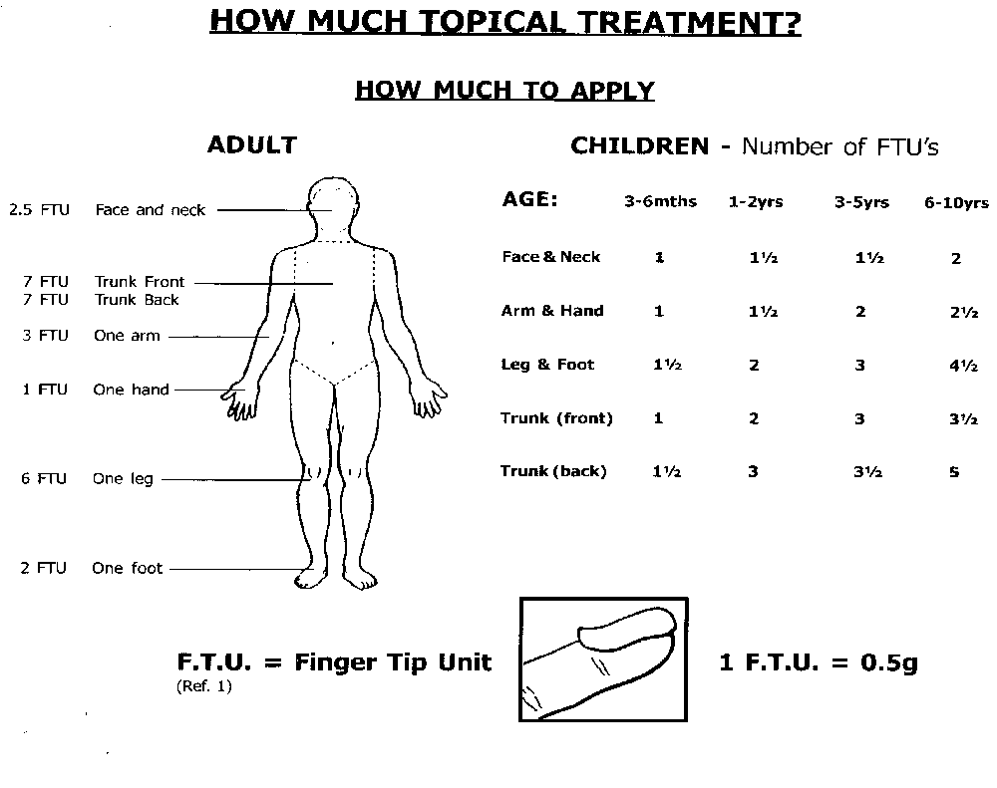
If you have any questions about your cream, ointment or any other medicines, your pharmacist can help

KEEP ALL MEDICINES OUT OF THE REACH OF CHILDREN

How to Use Ear Drops

- Warm the ear-drop bottle by holding it in your hands for a few minutes. Shake the bottle well.
- Unscrew the cap of the bottle and draw some liquid into the dropper.
- Ask the client to either lie on their side or sit down and tilt their head over so that the ear that needs the drops is facing upwards.
- Gently pull their earlobe upwards, away from their neck, and squeeze the correct number of drops into the ear.
- Ask the client to keep their head tilted for about five minutes so that the drops can spread into the ear.
- They can then straighten head and wipe away any extra liquid with a clean tissue.
- Replace the cap on the bottle.
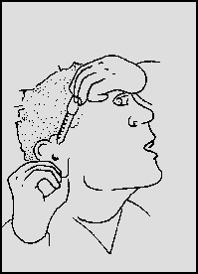

- Store the ear-drops in a cool, dark place.
- You must use the ear-drops for the full length of the treatment course, even if the client’s ear feels better. If you stop too soon, their ear problems may return.
- While the client is using ear-drops, TRY NOT TO GET WATER in their ear. Be careful when washing their hair and they should not go swimming until the course is finished.
- When the course of treatment is finished, return any leftover drops to your pharmacist for disposal.

EAR DROPS DO NOT KEEP
If you have any questions about your ear-drops or any other medicines, your pharmacist can help
KEEP ALL MEDICINES OUT OF THE REACH OF CHILDREN

How to Use Eye Drops

- Wash your hands.
- Ask the client to sit down so that you can see what you are doing.
- Remove the top from the bottle.
- Avoid touching the dropper tip against the client’s eye, eyelashes, or any other surface.
- Ask the client to tilt their head back and look upward. Gently pull their lower eyelid down.
- Hold the dropper above the eye and squeeze one drop inside their lower eyelid.
- Release the lower eyelid and encourage the client to blink a few times to make sure the whole of the eye is covered by the liquid.
- Wipe away any excess with a clean tissue.
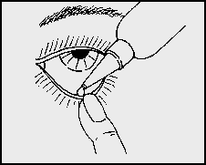
- If you need to put in more than one drop, or if you are using another type of eye drop, then you should wait for a few minutes before putting the next drop in. If you do not wait then the first drop may be washed out by the second before it has had time to work.

Eye-drops have been tested to make sure that they are free from germs when you receive them. In order to keep them in good condition, follow these simple rules:
- When not in use, keep the bottle tightly closed in a cool, dark place.
- If the dropper is separate, DO NOT put it down on any surface.
- DO NOT allow the dropper or dropper nozzle to touch the client’s eye or your fingers.
- NEVER lend eye-drops to anyone else. Do not use the same bottle of eye-drops for more than on client.
- Eye drops should not be used for longer than four weeks. This is because they can become dirty and infected. Write the date that you open the bottle on the label so that you will know when to throw them away.
- The client SHOULD NOT wear contact lenses until the course of eye-drops is finished, unless you have been told otherwise.

EYE-DROPS DROPS DO NOT KEEP
If you have any questions about your eye-drops or any other medicines, your pharmacist can help
KEEP ALL MEDICINES OUT OF THE REACH OF CHILDREN

How to Use Eye Ointment

- Wash your hands.
- Ask the client to sit down so you can see what you are doing.
- Unscrew and remove the top from the eye ointment tube.
- Ask the client to tilt their head back and look upwards. Gently pull their lower eyelid down.
- Hold the tube above their eye, but DO NOT let it touch the eye or eyelashes.
- Squeeze about 1cm of ointment along the INSIDE of the lower eyelid. Get the client to close their eyes and blink several times to allow the ointment to spread over the surface of the eye.
- Wipe away any excess ointment from the eyelid or eyelashes using a clean tissue.
- When they open their eye, their vision may be blurred. Reassure them that blinking will clear this.

TELL THE CLIENT NOT TO RUB THEIR EYE
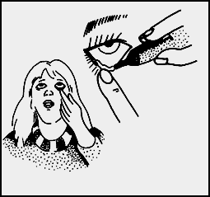
- Replace the cap on the tube.

Eye ointment has been tested to make sure that it is free from germs when you receive it. In order to keep it in good condition, follow these simple rules:
- When not in use, keep the eye ointment in a cool, dark place.
- DO NOT allow the tube to touch the eye or your fingers.
- NEVER lend the eye ointment to anyone else. If more than one client is using the same type of ointment, each client should have his or her own tube. These should be clearly labelled.
- Eye ointments should not be used for longer than four weeks. This is because they can become dirty and infected. Write the date you opened the tube on the label so that you will know when to throw it away.

EYE OINTMENT DOES NOT KEEP
- If you are using eye-drops as well as eye-ointments, you should use the drops first. Leave a gap of at least five minutes between using the drops and using the ointment. The client SHOULD NOT wear contact lenses until the course of eye ointment is finished unless you have been told otherwise.
KEEP ALL MEDICINES OUT OF THE REACH OF CHILDREN

How to Use Liquid Oral Medicines

- Check you have the right liquid for the right patient and it is to be given at the right time
- SHAKE THE BOTTLE.
- Remove the lid.
- Pour the medicine from the side away from the label, so that drips do not obscure the instructions.
- Measure the correct dose according to the label with a 5ml-medicine spoon or a measuring cup. It is best to do this measurement at eye level and the measuring cup should be placed on a flat, level surface.
- Recap the bottle.
- Give the patient the medicine to take.
- If the patient is elderly they may find it difficult holding a spoon steady, so a measuring cup would be easier to use.
- Give the client a glass of water to wash the medicines down with.

LIQUID ORAL MEDICINES DO NOT KEEP AS LONG AS TABLETS
Check the bottle for an expiry date; if none, discard medicine six months after the date of dispensing.

If you have any questions about this or any other medicines, your pharmacist can help
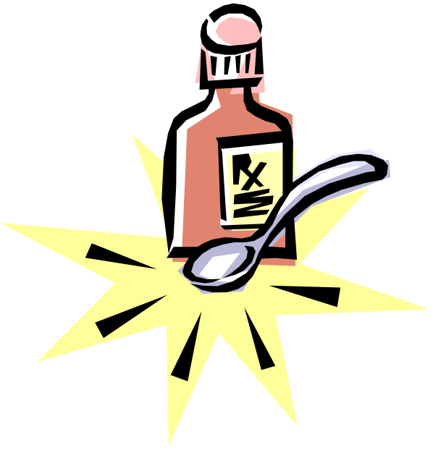

KEEP ALL MEDICINES OUT OF THE REACH OF CHILDREN

How to Use Nose Drops

- 1. Ask the client to blow their nose gently, so that it is clear.
- Wash your hands.
- Unscrew the top of the bottle and draw some liquid into the dropper.
- Ask the client to sit down and tilt their head back.
- Hold the dropper just above their nose and put the correct number of drops into each nostril.
- DO NOT let the dropper touch the inside of the client’s nose.
- Ask the client to keep their head tilted back for two to three minutes to help the drops run to the back of your nose.
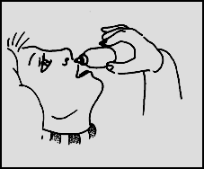
- Replace the top on the bottle.

- Store the nose drops in a cool, dry place.
- The client SHOULD NOT use their nose-drops more often or for longer than they have been told. Some nose-drops must only be used for a short time and will stop working if used for too long.
- If you are putting the drops into a child’s nose, it may be easier to make the child lie across your knee with his head hanging down.
- When the course of treatment has finished, return any leftover drops to your pharmacist for disposal.

NOSE-DROPS DO NOT KEEP
If you have any questions about your nose-drops or any other medicines, your pharmacist can help

KEEP ALL MEDICINES OUT OF THE REACH OF CHILDREN

How to take tablets or capsules

- Check you have the right medicine for the right patient and it is to be given at the right time.
- Some medicines are best given before food and others are best taken after food. This should be indicated on the pharmacy label.
- Some medicines need to be swallowed whole, as they are designed to release the medicine slowly, or because they have a special coating to protect the stomach. Follow any instructions on the pharmacy label carefully.
- Make sure the patient has a glass of water for taking with the medicines, to aid swallowing. Hot drinks should not be used as it can scald the patient and can melt some capsule coatings.
- Place the correct number of tablets or capsules into a measuring cup or tumbler, taking care not to touch the tablets.
- Give the cup to the patient and ask them to swallow the tablets. It is best to wash the tablets down with about half a glass of water.
- If the patient has difficulty swallowing tablets, they should be placed as far back on the tongue as possible and then washed down with water.
- If there are difficulties with swallowing tablets, check with the pharmacist if there are alternative forms of the medicine which could be prescribed e.g. liquids, soluble tablets, or multiples of smaller tablets.

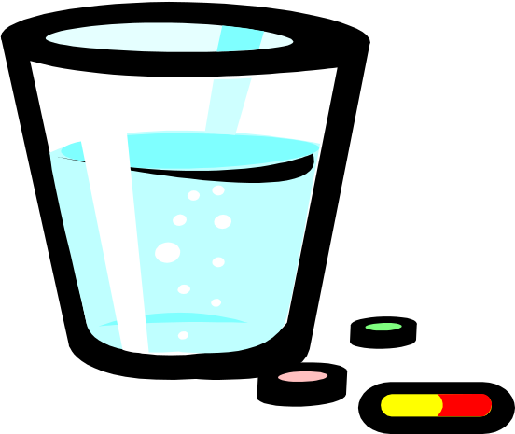

If you have any questions about your tablets, capsules or any other medicines, your pharmacist can help

KEEP ALL MEDICINES OUT OF THE REACH OF CHILDREN

How to Use a Nebuliser

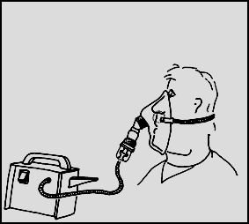

WHAT IS A NEBULISER ?
A nebuliser is a device that is used to administer a solution of drug in the form of a fine mist for you to inhale. The pump (compressor unit) forces air through the liquid (drug solution) in the drug chamber (nebuliser chamber). This changes the liquid into a fine mist, which you breathe in through a mask or mouthpiece.

FILLING THE NEBULISER
- Plug the compressor unit into the mains. Connect the tubing from the compressor unit to the bottom of the nebuliser chamber.
- Unscrew the top of the nebuliser chamber. Open the vial of drug solution by twisting off the top. Measure out the correct amount of drug solution and pour into the nebuliser chamber. (The doctor may have told you to use all the contents of entire vial).
- Check with the doctor or pharmacist before mixing two or more drug solutions in your nebuliser chamber.
- Sometimes you may need to dilute the drug solution. If your doctor has recommended that you dilute the solution, add the required amount of normal saline. DO NOT dilute the drug solution with water. You need around 4-5ml solution in the nebuliser chamber for it to work properly.
- Screw on the top of the nebuliser chamber and attach the facemask or mouthpiece to the top of the chamber.

USING THE NEBULIZER
- Ask the client to sit up, well supported, in a chair or in bed and keep the nebuliser chamber upright.
- Place the facemask over their mouth and nose and place the strap over their head; alternatively, if they use a mouthpiece it is placed between their lips.
- Switch the compressor unit on and encourage the client to breathe in and out as normal. The client should relax whilst using their nebuliser, perhaps by watching television.
- Whilst the nebuliser is in use, small drops of drug solution may form on the sides of the nebuliser chamber. You can knock these droplets back into the drug solution by gently tapping the side of the nebuliser chamber with your fingernail.
- When the nebuliser starts to 'splutter' the treatment has finished - this will take between 10 and 20 minutes. A small amount of solution may be left in the nebuliser at this stage, but this is normal.
- Switch off the compressor unit and disconnect the nebuliser chamber from the tubing.

CLEANING A NEBULISER
- Each time you use it, wash the nebuliser chamber in warm soapy water and then rinse thoroughly with clean water. Do not use a brush to clean the nebuliser chamber as you may damage it.
- Reconnect the nebuliser chamber to the tubing and blow air from the compressor unit through it for a few seconds. This will dry the nebuliser chamber and tubing. Disconnect the nebuliser chamber from the tubing and allow it to dry completely. Disconnect the tubing from the compressor unit.
- Once a week, rinse the nebuliser chamber with a dilute solution of Milton or a special nebuliser cleaner. Rinse the nebuliser chamber with clean water and then dry as before.
- Make sure you check your tubing regularly for kinking or holes as these may affect the performance of the nebuliser. Tubing should be replaced every six months or so.
- A nebuliser chamber should last for around four months before you need to replace it. If it is taking longer than normal to nebulise the drug solution, it may be that you need a new nebuliser chamber. Ask your pharmacist to order one for you.
- You should not normally use an oxygen cylinder to drive your nebuliser.

IMPORTANT! If the client does not get the usual relief from their symptoms by using your nebuliser, call a doctor at once.

KEEP ALL MEDICINES OUT OF THE REACH OF CHILDREN

Assessment

Assessment questions are located on Training Tracker

http://smnhst.trainingtracker.co.uk/

References

- Registrants working as Health Care Assistants (HCAs) or other non-registered support roles. (https://www.rcn.org.uk/hcas-and-aps

- Supervision, accountability and delegation of activities to support workers:
https://www.rcn.org.uk/professional-development/accountability-and-delegation

3. Nursing and Midwifery Council :
http://www.nmc.org.uk/globalassets/sitedocuments/nmc-publications/revised-new-nmc-code.

4. Nursing and Midwifery Council Standards for Medicine Management http://www.nmc.org.uk/standards/additional-standards/standards-for-medicines-management/?wb48617274=85B0168F

5. This policy was constructed with reference to:-
.. Minimum Standards for Domiciliary Care and the UKHCA Administration of Medication Policy. ... with the administration of oral medication http://www.riseway.co.uk/westminster_homecare/homecare/200… · DOC file · Web view

6 The NSF for Older People https://www.gov.uk/government/publications/quality-standards-for-care-services-for-older-people

7. National Minimum Standards and Regulations. ... 'Care Homes for Older People: National Minimum Standards ... 'Domiciliary Care: National Minimum Standards
http://www.tsoshop.co.uk/bookstore.asp?FO=1256047

8.The Royal Marsden Clinical Nursing Procedures 9th Edition http://www.rmmonline.co.uk/

9. Skills for Health http://www.skillsforhealth.org.uk/services/item/146-core-skills-training-framework

10. Waste Policy intranet http://gwh-intranet/

11. Incident Management Policy intranet http://gwh-intranet/

12. Standards for Better Health webarchive.nationalarchives.gov.uk

