
Academy use only:
Mandatory Training
Up to date:

2018 Nursing & AHP band 6 Traineeship
Application form

The completed form should be e-mailed rachel.may@gwh.nhs.uk by 30th November 2017 - alternatively, post to The Academy, Lower Ground Floor, Great Western Hospitals NHS Foundation Trust, Marlborough Road, Swindon SN3 6BB.

1. Applicant details

Title: First name:________ Surname:_________________

Job title: ____________________________________

Dept: _____ Directorate:____________________

Work address inc postcode: Great Western Hospital, Marlborough Rd Swindon SN3 6BB_
_________________________________________________________________________

Work tel. no. _______________ Work e-mail:___________

Mobile no: _________________________
(if no work mobile please give personal, in case we need to contact you at short notice)

Hours worked per week:_________ Grade _________________________

2. In approximately 500 words, please tell us why you are interested in completing the ward manager Traineeship. What qualities, knowledge and skills do you hope to bring to the Band 6 Trainee role?

3. To be completed by your Manager:

Name of manager: Job title:

Manager’s tel. no: Manager’s email address:

Manager’s work location:

- Why are you supporting this training? Please provide a brief rationale.

- As the manager, I have agreed with the applicant:
  - Identified study leave (see section 2)
  - Mandatory Training up to date

- As the manager, I understand I am responsible for ensuring training is attended and that the Trainee must also be released to complete 6 days of job shadowing

Manager’s signature: _______________________________________________________

The traineeship is a course delivered alongside you existing role. There is no guarantee of a post once the course is completed but you will have gained valuable skills and knowledge that we hope will allow you to successful apply for a post of your choosing in the future.

TRAINING AGREEMENT

Name |  | Tel/Ext number
Job Title |  | Cost of course
Course Title

Venue/Supplier
Date of course |  | End of Course
End of Return of Service Contract

- In return for Great Western Hospitals NHS Foundation Trust paying all or some of the training expenses in connection with my course of study, I will repay the Trusts investment as set out below

- Leaving before course completion or within 4 months = 100% payback.
- Failure to submit course assignments resulting in course failure = 100% payback
- Failure to attend course or complete course = 100 % payback
- Leaving between 4 and 8 months of course completion = 75% payback.
- Leaving between 8 and 12 months of course completion = 50% payback

- In the event of my death, or if I leave GWH on the grounds of redundancy or permanent ill health, I understand I will not be required to repay any training expenses.

- I understand that I may submit an extenuating circumstances form. If my circumstances are deemed to be exceptional then the return of service may be waived.

- I agree that the Director of Finance and IT may deduct any money I owe the Trust in accordance with this agreement either from my salary or from any superannuation refund or from any money due to me or held on my behalf by the Trust or from a combination of any of these sums. This is without prejudice to the Trust’s other rights to recover any amount due.

Signature of learner: |  | Date :
Print Name:
Signature of Manager: |  | Date :
Print Name:

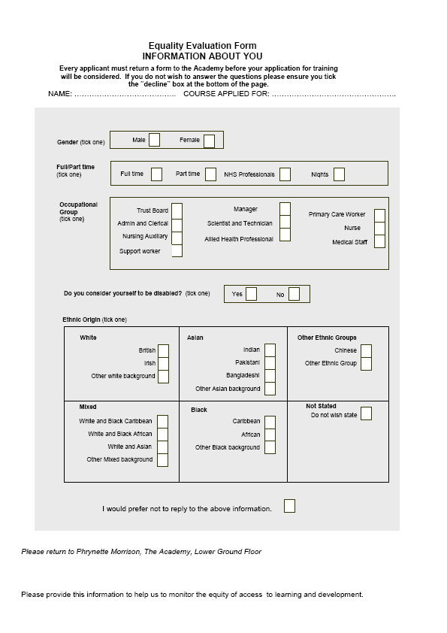

Please return to Rachel May, The Academy, Lower Ground Floor
Please provide this information to help us to monitor the equity of access to learning and development

