Indications for Use
The Trinova mattress is a 3 cell, dynamic air mattress, suitable for patients:
- At high risk of pressure ulcer - Waterlow scale above 20 and
- Who have an existing Ulcer grade 3.or 4 and
- Under 40 stone or 254 kg

NB If your patient does not meet the criteria above, you can still use clinical judgement and request the mattress.

Risks and Hazards
Mattress will not perform as well if bed sheets tucked in, as this can cause “hammocking”

Ordering
Contact the Equipment Library on x4446.

You will need to provide the following details:
- Patients name
- Ward/Dept
- Waterlow score as recorded on Crescendo
- Weight of patient

Pre-use checks
Before using the mattress, check to see if it:
- is clean and intact
- has both the mattress and Patient Management Unit (PMU)
- is the correct type of mattress for the patient

PMU Buttons
 | Normal Mode  Mattress cells inflating and deflating (cycling)
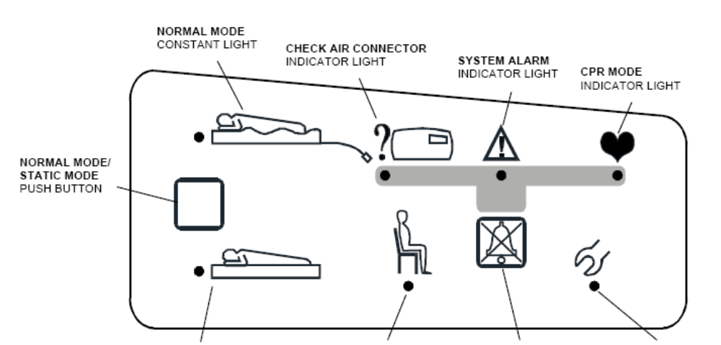 | Check Air Connector indicator
CPR mode
The air connector is in the CPR position and the mattress is deflating
System Alarm
The red light will flash and an audible alarm will sound if there is a system fault
Fast Inflate Mode
Static Mode – mattress not cycling
 | Cushion connected
Audible alarm
Press to silence the alarm
 | Service required indicator

Set Up
- Remove the bedding and the mattress
- Place the Trinova mattress on top of the bed mattress
- Secure the straps to the moving parts of the bed frame
DO NOT Secure the mattress to the:
    - headboard
    - footboard
    - bed frame
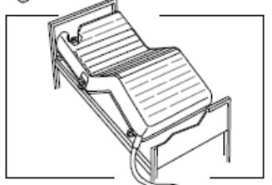
- Connect the mains lead and secure using the cable clamp
- Hang the power unit on the end of the bed or place on the floor
- Connect the air pipe connector and turn to the green “Normal” position
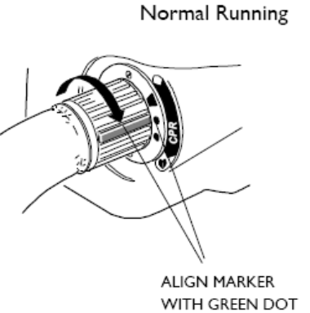
- Plug in the PMU and switch it on
  - The mattress will alarm 6 times and all lights will illuminate
  - The Static light will flash and continue flashing while the mattress inflates. This will take approximately 30 minutes
  - The Normal light will illuminate once the mattress has inflated and there are no faults found.
- Once the mattress has inflated, check the securing straps
- Make the bed up, ensuring that the sheets are not tucked in
- The bed is now ready for the patient

Profiling and knee breaking
If you intend to profile the bed:
- Loosen or release the securing straps
- Change the bed to the required position
- Re-secure the straps

Transport Mode
If you need to move the bed with the mattress still inflated, or in the event of a major mains failure:
- Turn the air connector to the Transport position (white dot) and disconnect
- The amber Check air connector indicator light will flash and an audible alarm will sound
- This will stop the mattress deflating
- Stitch off the power unit and cancel the alarm

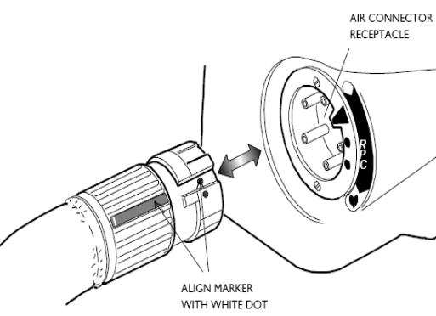

CPR
In the event of a cardiac arrest:
- Turn the air connector to the CPR position, aligning the red dots
- Do not disconnect
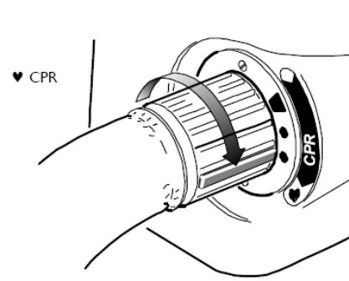
The mattress will immediately begin to deflate, allow CPR

NB: If the cardiac arrest occurs whilst the bed is in Transport mode, then ensure the air connector is disconnected from the PMU, then turn the air connector to the deflate position.

Deflation
- Switch off the power unit and silence the alarm
- Disconnect from mains
- Disconnect air pipe and turn to deflation position
- Remove the power unit from the bed
- Remove the securing straps
- Roll up the mattress and leave to be collected
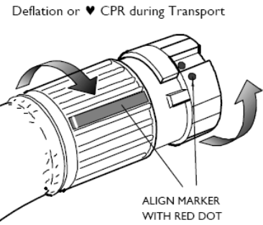

Cleaning and Decontamination
This is carried out between patients. Leave the mattress to be collected by the Equipment Library staff, who will then take the mattress down to be decontaminated.

DO NOT give the mattress to another patient.

If there is a split on the mattress, please clean it up and wipe the mattress down with a SaniCloth.

If the mattress is contaminated or the patient has a known infection, please bag the mattress and ask to for it to be collected.

Storage
All dynamic mattresses should be returned to the Equipment Library. They will then be cleaned and decontaminated, ready for the next patient.

Maintenance
The dynamic mattresses are serviced on an annual basis. All repairs are carried out by the Equipment Library.

Alarms and Alerts
No light on the PMU
- Check the power unit is plugged in
- Check that the power unit is switched on

Check air connector indicator light
Check the air connector is connected and turn to Normal position

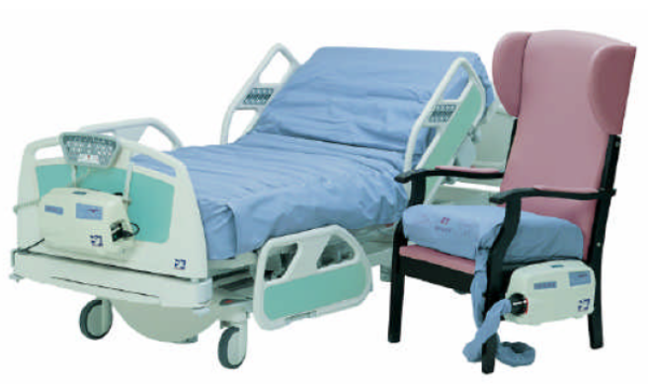
Trinova Mattress
QUICK GUIDE
In the guide:
- Indications for use
- Risks and Hazards
- Ordering
- Pre-use checks
- Set up
- Profiling and knee breaking
- Moving the bed
- CPR
- Deflation
- Cleaning and decontamination
- Storage
- Maintenance
- Alarms and Alerts

For further information:
Contact the Medical Device Trainer on x4448 or
Tissue Viability Nurse on x4555

Go to the intranet: Departments/Medical Device Training
Version 1.0 May 2009
4TRG-QRG-009

