Indications for Use
The Viaclin mattress is a 2 cell, dynamic air mattress, suitable for patients:
- At high risk of pressure ulcer - Waterlow scale above 20
- Who have an existing Ulcer grade 1 – 2 or who have had a history of pressure ulcers
- Who are unable to re-position themselves easily
- Under 28 stone or 178 kg

NB If your patient does not meet the criteria above, you can still use clinical judgement and request the mattress.

Risks and Hazards
Mattress will not perform as well if bed sheets tucked in, as this can cause “hammocking”

As the mattress sits on top of a standard hospital mattress, care should be taken if cots sides are in situ.

This mattress is not suitable for use on the Ultra Low beds.

Ordering
Contact the Equipment Library on x4446.

You will need to provide the following details:
- Patients name
- Ward/Dept
- Waterlow score as recorded on Crescendo
- Weight of patient

Pre-use checks
Before using the mattress, check to see if it:
- is clean and intact
- has both the mattress and power unit
- is the correct type of mattress for the patient

Set Up
- Remove the bedding from the mattress
- Place the Viaclin overlay on top of the bed mattress
  - The printed end flap should be at the foot end
  - Tuck the two end flaps under
- Secure the overlay straps to the moving parts of the bed frame
DO NOT Secure the mattress to the:
    - headboard
    - footboard
    - bed frame
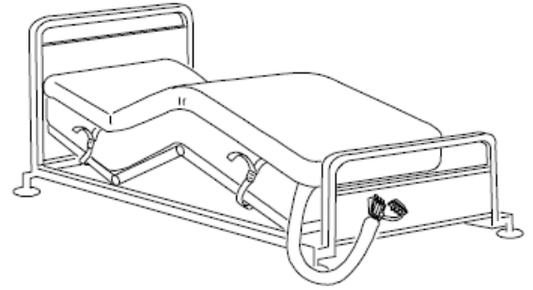
- Hang the power unit on the end of the bed or place on the floor
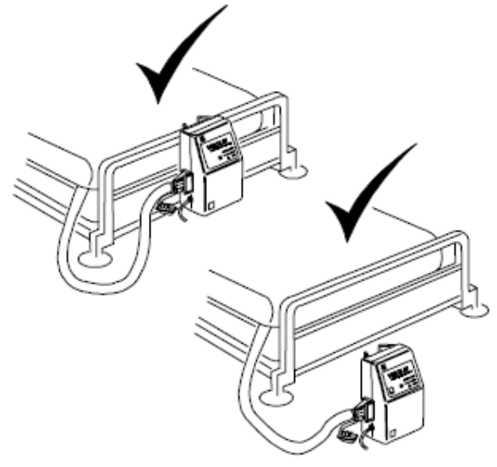
- Connect the air pipe CPR handle to the power unit, with CPR label uppermost
- Plug in the mattress and switch it on
  - The mattress will go through a self test
  - The amber light will flash and continue flashing while the mattress inflates. This will take approximately 20 minutes
  - The light will then go green once the mattress has inflated and there are no faults found.
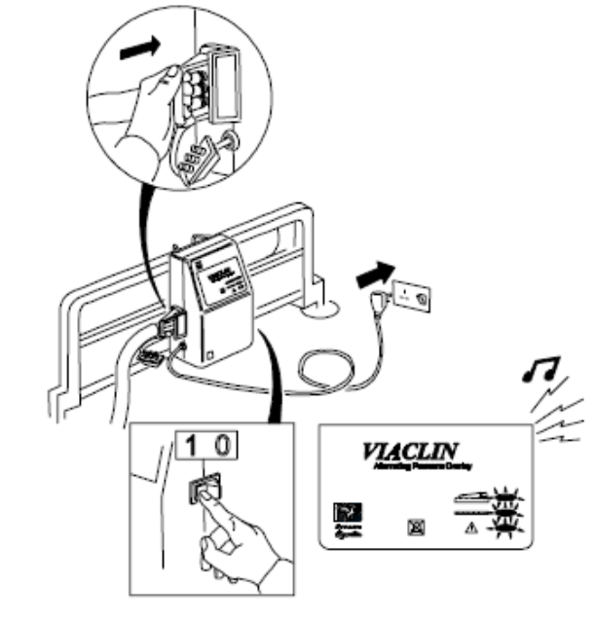
- Once the mattress has inflated, check the securing straps
- Make the bed up, ensuring that the sheets are not tucked in, or if tucked in, this is loosely done
- The bed is now ready for the patient

Profiling and knee breaking
If you intend to profile the bed:
- Loosen or release the overlay securing straps
- Change the bed to the required position
- Re-secure the straps

Moving the bed
If you need to move the bed with the mattress still inflated, or in the event of a major mains failure:
- Disconnect the CPR handle from the power unit
- Quickly connect the transport connector to the CPR handle
- This will stop the mattress deflating
- Stitch off the power unit and re-set the power down alarm
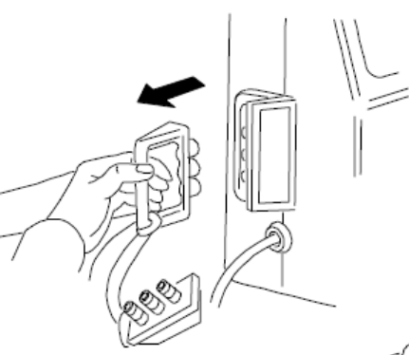
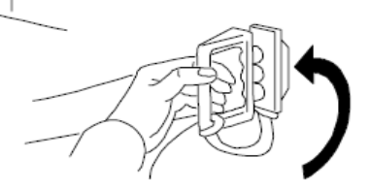

CPR
In the event of a cardiac arrest:
- Disconnect the CPR handle from the power unit
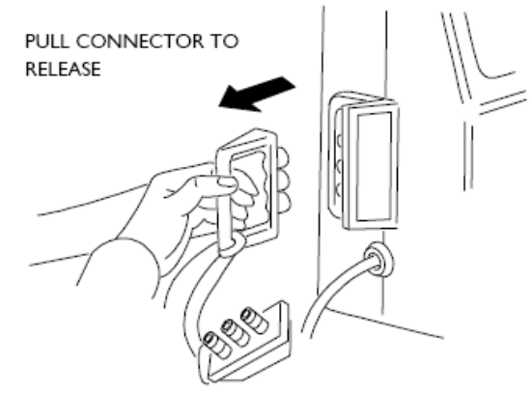
The mattress will immediately begin to deflate, allow CPR

NB: If the cardiac arrest occurs whilst the bed is moving and the CPR handle is connected to the transport connector, then remove the CPR handle

Deflation
- Switch off the power unit and silence the alarm
- Disconnect from mains
- Disconnect air pipe
- Remove the power unit from the bed
- Remove the securing straps
- Roll up the mattress and leave to be collected

Cleaning and Decontamination
This is carried out between patients. Leave the mattress to be collected by the Equipment Library staff, who will then take the mattress down to be decontaminated.

DO NOT give the mattress to another patient.

If there is a split on the mattress, please clean it up and wipe the mattress down with a SaniCloth.

If the mattress is contaminated or the patient has a known infection, please bag the mattress and ask to for it to be collected.

Storage
All dynamic mattresses should be returned to the Equipment Library. They will then be cleaned and decontaminated, ready for the next patient.

Maintenance
The dynamic mattresses are services on an annual basis.

Minor repairs are carried out by the Equipment Library.

Alarms and Alerts
No light on the power unit
- Check the power unit is plugged in
- Check that the power unit is switched on

Status light RED and alarm sounding, or alarm sounding but no lights
- Turn the mains switch on the power unit off and on again
- Check to see if the power unit is plugged in and the plug is switched on
- Check the air connection between the power unit and the mattress

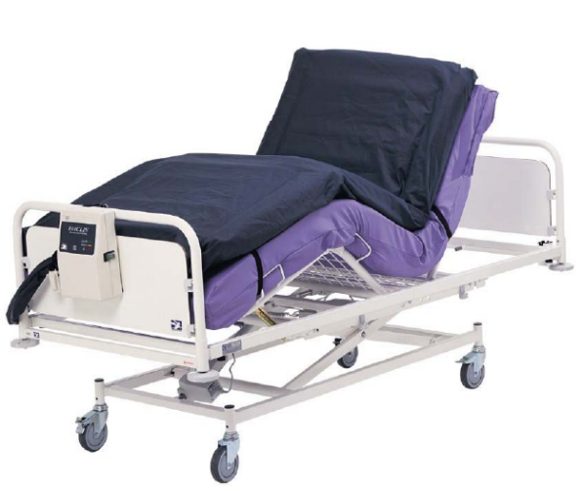
Viaclin Mattress
QUICK GUIDE
In the guide:
- Indications for use
- Risks and Hazards
- Ordering
- Pre-use checks
- Set up
- Cleaning and decontamination
- Storage
- Maintenance
- Alarms and Alerts

For further information:
Contact the Medical Device Trainer on x4448 or
Tissue Viability Nurse on x4555

Go to the intranet: Departments/Medical Device Training
Version 1.0 May 2009
4TRG-QRG-009

