Clinical Guideline for
Immediate Management of
Major Upper GI Bleeding

Document Number: 4AAU-GDL-020
Sponsor: Consultant AAU
Date Created:
Version: 1.0
Status: Approved
Date Approved: 20/07/2009
Next Review Date: 01/07/2010
Approved By:

Mild or Moderate bleed: Rockall 0-1

Blood pressure and pulse normal. No postural drop in BP.
Insignificant co morbidity.
Patients normally < 60.

Admit to a general ward. Admission bloods (MEDA + GP & Save) and arrange endoscopy by Fax 4241. If stable they can eat and drink until they need to be starved prior to endoscopy. They need iv access and consent for endoscopy taken.
Very low risk young patients can safely be discharged.

Severe:

Patients usually > 60 years old.
Pulse > 100. Postural drop in blood pressure > 20 mm Hg.
Hb < 10 g.
Significant co morbidity.

It is vital to establish whether bleed is likely to be venous (variceal) or arterial (peptic ulcer) as management is quite different.

History Alcohol, Hepatitis B/C, IV Drug user, NSAIDS, Aspirin
Old Notes Previous investigations, Family History, Known varices, Occupation
Exam Features of chronic liver disease

Major Acute Upper GI bleed

True haematemesis (fresh red blood) or malaena or both. It takes 60 ml of upper GI blood to produce melaena.
Hypotension – Sys BP < 100 / Tachycardia – Pulse > 100

High risk patients – Elderly / Cardio-respiratory disease / other Co morbidity. Below age of 60 mortality is < 5% over age 80 mortality > 20%.

Generic Initial Resuscitation

- Monitored bed : (Ideally HDU/AAU or if monitor not required Neptune ward is the preferred ward) particularly for variceal bleeding.
- Urgent Bloods – MEDA, Clotting, X Match 6 units, ABG.
- 2 x large bore cannulae for venous access.
- Immediate fluid replacement : Saline initially unless significant liver disease present, then cross-matched blood.
- Catheterise and monitor hourly urine output in high risk patients and those with cardiac disease
- Protection of airway if appropriate. Oxygen if sats < 90% (watch for signs of encephalopathy or aspiration pneumonia.
- Monitor BMs stat, qds if liver disease suspected.
- Inform surgical team.
- NBM until patient haemodynamically stable and endoscopy performed.
- Record prognostic index – See Rockall Scoring in appendix
There is little evidence to support the use of IV PPI until after endoscopy. Most patients can take oral Omeprazole 20 mg or Lanzoprazole fast tab 30 mg
- Patient should be starved.
- Monitor SOS score at least hourly.

Endoscopy

- Ensure patient is haemodynamically stable
- Inform endoscopy dept of situation as early as possible (Fax request form to 4241 & call Ext 4127 or 4062)
- If after hours – Contact endoscopist if on call. Fax request form to department out of hours.
- If bleeding from ulcer – 80 mg omeprazole IV stat, followed by IVI 8mg/hour for 72 hours – until able to to take PO PPI
- Notify Surgical team of outcome. If endoscopy cannot be arranged notify surgical registrar that patient is admitted.

Arterial Bleed Confirmed

Consider:
H Pylori eradication if appropriate.
Proton Pump inhibitor. Omeprazole 40 mg od.
Removal of NSAIDS / Aspirin / Warfarin

If patient rebleeds or endoscopic therapy is unsuccessful discuss with surgical registrar on call.

Patients who are haemodynamically stable may eat and drink 4-6 hours post endoscopy.

Proven or suspected variceal bleeding

An episode of bleeding is clinically significant when there is requirement for 2 unit transfusion within 24 hours. Systolic BP < 100, postural drop > 20, Pulse > 100.

A) Resuscitation as outlined above. Correct coagulopathy. Low threshold for central line. Consider ICU.

B) Endoscopy early for confirmation of diagnosis and if confirmed – For banding or sclerotherapy

C) Pharmacological Intervention

- Glypressin – 2mg bolus IV followed by 2mg 4-6 hourly for max 48 hours
- If bleeding not controlled – consider; Octreotide 50mcg/hr IVI for max 5 days

D) It is crucial to protect airway and prevent aspiration particularly in patients with uncontrolled bleeding,
encephalopathy or aspiration pneumonia.

E) Sengstaken – Blakemore Tube (Ideally inserted by expert)
For use where above strategies have failed
(Kept in fridge until ready to use in DDU or in Resus
They are stiffer and easier to insert when cold)

  - Intubate + sedate

  - Ensure balloons are fully deflated and well lubricated with aqua gel

  - Advance tube until inserted to hilt – if any doubt that tip of SB tube in stomach, check position with CXR or image control – there is a radio-opaque marker at tip of tube
  - Inflate GASTRIC balloon with 300 mls water

  - Withdraw SB tube until slight resistance is felt – Tape tube to Pt face
DO NOT USE WEIGHTS to apply more traction tube

  - Inflate OESOPHAGEAL balloon to 40mmHg (can be measured with manometer from ITU) if bleeding continues

  - Aspirate oesophageal channel every 30 mins

  - Check position of tube with CXR

  - Deflate all balloons after 24 hrs – Re-endoscope ASAP

F) Antibiotic prophylaxis (sepsis / Spontaneous bacterial peritonitis)

Augmentin 625 mg tds PO or 1.2 gm IV if unable to take oral medication, continue for 7 days.

G) If bleeding still uncontrolled;

Refer to tertiary centre (Birmingham / Southampton) for

- TIPPS – transjugular intrahepatic porto-systemic stent shunt
- Oesophageal transection

The Rockall Score

This scoring system combines clinical information and endoscopic findings and helps to identify the risk
of rebleeding and mortality in patients admitted with acute upper GI bleeding. Patients with a score of
0, 1 or 2 can safely be discharged early (usually 2 days). See guidelines section for advice on care.

Score | 0 | 1 | 2 | 3 | Total
Age | <60 years | 60-79 years | > =80 years
Co-morbidity | None |  | Heart failure,  IHD or major  co-morbidity | Renal failure, liver failure or disseminated malignancy
Shock | systolic BP>100  pulse< 100 | systolic BP>100  pulse >=100 | systolic BP<100

Initial score at admission

Signs of recent bleeding | None/ dark spot |  | Blood in GIT, adherent clot, visible or spurting vessel
Diagnosis | Mallory weiss tear  or no lesion | All other diagnoses | Malignancy of upper GI tract

Total Rockall score post-endoscopy

References

1. Effect of intravenous omeprazole on recurrent bleeding after endoscopic treatment of bleeding
peptic ulcers. Lau J. Y. W. et al NEJM 2000 343 (5) 310-316

2. Risk assessment after acute upper gastrointestinal haemorrhage. Rockall T.A. et al GUT 1996
38 (3): 316-21
3. Selection of patients for early discharge or outpatient care after acute upper gastrointestinal
haemorrhage National Audit of acute upper gastrointestinal haemorrhage. Rockall T.A. et al
Lancet 1996 347 (9009) : 1138-40
4. Khuroo et al NGJM 1997 336

5. UK Guideline on managment of variceal haemorrhage June 2000 (BGS)

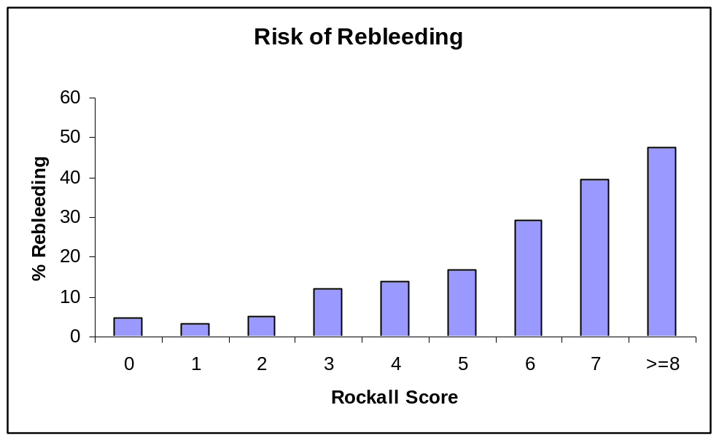
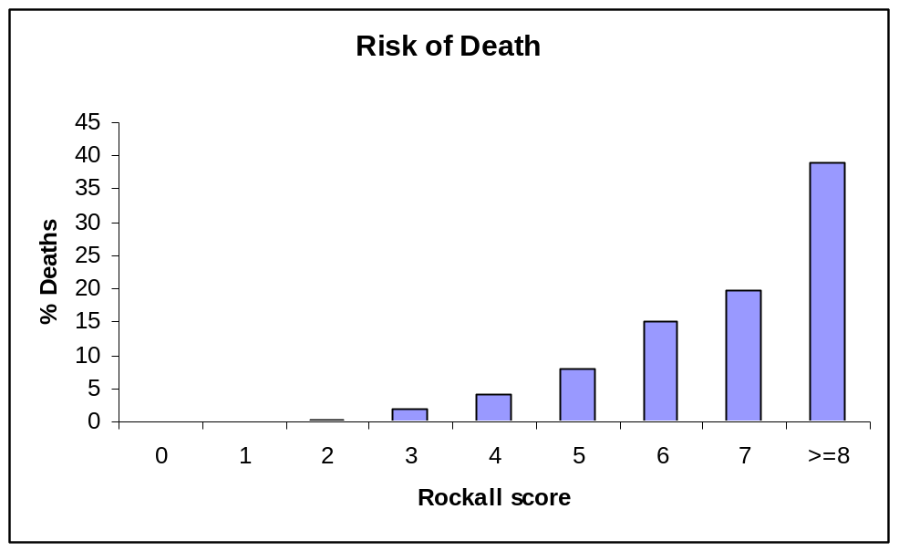
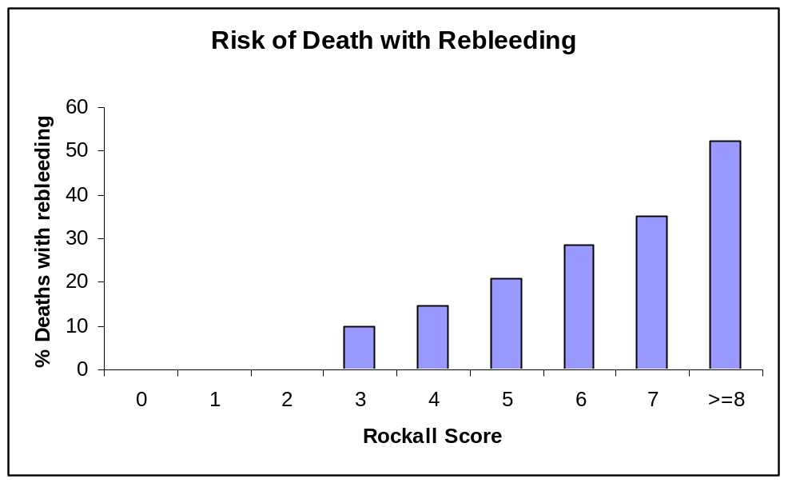

CONSENT for Endoscopic procedures

Doctors on AAU are often asked to Consent patients for Emergency Endoscopic procedures. These are mostly patients with Acute Upper GI bleeds (presenting with Haemetemesis +/- Melaena) or presenting with Dysphagia.
A patient has the right under common law to give or withhold consent prior to medical treatment. Clinician must respect the need to maintain the autonomy and self determination of patients.
The Consent form is a legal document. Consent for an Endoscopic procedures should be an INFORMED CONSENT. General Medical Council’s guidance on informed Consent is as follows:
“Patients must be given sufficient information, in a way that they can understand, to enable them to exercise their right to make informed decisions about their care”.

Doctors with no Gastroenterology experience may not have sufficient information to obtain an informed consent, e.g. explaining the risks and benefits, alternatives to the procedure and details of procedures including endoscopic treatment and complications.

Even though OGD is very safe procedure, there are serious risks. They are rare they should be mentioned to patients as part of the informed consent.
Patients giving consent must have mental capacity.

If they can consent, talk about the following issues
- What is an OGD (in simple English)
- Why they need the procedure
- Talk about possible Local anaesthetic throat spray +/- sedation
- Risks of the procedure (risks of sedation + endoscopic examination)
- Possible treatment options during Endoscopic procedures +/- taking biopsies if required.
- Be prepared to answer the “Treatment of complications (bleed/perforation if it does happen)
- Talk about alternatives if it is an OGD for dysphagia

Points to remember
- Just to mention that the risks of “SERIOUS” bleeding or perforation with OGD is 0.05% (1/2000)
- Patients should be nil by mouth for 4 hours and haemodynamically stable before proceeding to endoscopy.
- Make sure that INR and platelet count is normal before arranging any Endoscopic procedure.

Acute Upper GI Bleeding Referral Date and time

Please keep patient NBM from midnight or time of referral

and fax to extension 4241 or take to Endoscopy Unit

Patient details/addressograph

Ward Referring doctor

Consultant Bleep number

Haematemesis please tick IV access please tick

Melaena please tick Consent please tick

FBC Clotting (if coagulopathy suspected)

U&E BP

Score | 0 | 1 | 2 | 3 | Total
Age | <60 years | 60-79 years | > =80 years
Co-morbidity | None |  | Heart failure, IHD or major co-morbidity | Renal failure, liver failure or disseminated malignancy
Shock | systolic BP>100  pulse< 100 | systolic BP>100  pulse >=100 | systolic BP<100

Initial Rockall score at admission pre-endoscopy

Brief history/risk factors for GI bleeding? (co-morbidity, aspirin, NSAIDs,
liver disease, anticoagulants, previous ulcer disease or gastric surgery).

Total Rockall score post endoscopy = recorded by endoscopist)

PRESCRIPTION FOR HIGH DOSE OMEPRAZOLE INTRAVENOUS INFUSION
- Please only sign for the doses that are indicated.
- If evidence of active bleeding during treatment, consider stopping infusion.
- IV Omeprazole may ONLY be used for the following:
a) Patients who are haemodynamically unstable with major haematemesis and/or brisk
melaena awaiting urgent endoscopy .
b) Patients, who at endoscopy, are found to have a peptic ulcer deemed to be at high risk of
rebleeding and have had endoscopic therapy. (These are actively bleeding ulcers or non-bleeding ulcers with a visible vessel).
Patient details (addressograph) Date

Consultant
Hospital number Ward
Drug | Dose | Route | Infusion fluid | Rate/  duration | Doctors signature | Time & date | Given by | Batch numbers
Omeprazole | 40mg | IV | 100mls N/Saline | 20-30 mins
Omeprazole | 40mg | IV | 100mls N/Saline | 20-30 mins
Omeprazole | 40mg | IV | 100mls N/Saline | 20ml/hr  for 5 hrs
Omeprazole | 40mg | IV | 100mls N/Saline | 20ml/hr  for 5 hrs
Omeprazole | 40mg | IV | 100mls N/Saline | 20ml/hr  for 5 hrs
Omeprazole | 40mg | IV | 100mls N/Saline | 20ml/hr  for 5 hrs
Omeprazole | 40mg | IV | 100mls N/Saline | 20ml/hr  for 5 hrs
Omeprazole | 40mg | IV | 100mls N/Saline | 20ml/hr  for 5 hrs
Omeprazole | 40mg | IV | 100mls N/Saline | 20ml/hr  for 5 hrs
Omeprazole | 40mg | IV | 100mls N/Saline | 20ml/hr  for 5 hrs
Omeprazole | 40mg | IV | 100mls N/Saline | 20ml/hr  for 5 hrs
Omeprazole | 40mg | IV | 100mls N/Saline | 20ml/hr  for 5 hrs
Omeprazole | 40mg | IV | 100mls N/Saline | 20ml/hr  for 5 hrs
Omeprazole | 40mg | IV | 100mls N/Saline | 20ml/hr  for 5 hrs
Omeprazole | 40mg | IV | 100mls N/Saline | 20ml/hr  for 5 hrs
Omeprazole | 40mg | IV | 100mls N/Saline | 20ml/hr  for 5 hrs
Omeprazole | 40mg | IV | 100mls N/Saline | 20ml/hr  for 5 hrs
Pharmacy only | Supply |  | Dispensed by | Checked by

Once completed change to oral omeprazole 20-40mg od or lansoprazole fastabs 30mg od

Prepared by 3Ts Formulary Oct 06 Review date April 08

