Guideline on PEP for rabies
Information
Rabies is a viral (Rhabdoviridae) disease that, in humans, nearly always results in fatal encephalitis.
Humans generally become infected when virus-laden saliva is introduced into the body usually through the bite of a rabid animal (usually a dog)1. It is also possible if saliva gets directly into their eyes, nose, mouth, or a wound.

The reported incubation period for human rabies varies from a few days to more than 19 years although 75% of patients become ill in the first 90 days after exposure and infections presenting more than a year after exposure are very rare.

The initial symptoms of rabies resemble those of other systemic viral infections, including fever, headache and generally feeling unwell. There may be discomfort or paraesthesia at the site of exposure (bite), followed by symptoms of cerebral dysfunction, anxiety, confusion, agitation, progressing to delirium, abnormal behaviour, hallucinations, and insomnia i.e. furious (or encephalitic) rabies.

Once clinical signs of rabies appear, the disease is nearly always fatal, and treatment is typically supportive

What to do

Rabies is a notifiable human disease under the Public Health (Infectious Diseases) Regulations 1988

All clinicians should be aware that they must inform the CCDC from their local health protection unit (HPU) if one of their patients is suspected to be suffering from rabies

The attending clinician should also inform the relevant Consultant Microbiologist or Virologist, Director of Infection Prevention & Control and Occupational Health Department

If no treatment has been started, post exposure treatment should be started within two working days depending on the risk assessment.

Collect all relevant information from patient/ relative/ pet owner

Call Public Health England's Virus Reference Department, Colindale (tel. (020) 8200 4400) or the PHE Colindale Duty Doctor (tel. (020) 8200 6868)

Information to ask your patient before discussing with Public Health England

If the animal was a terrestrial mammal (wild or domestic), these details are needed:
- is rabies known or suspected to be present in the species in the locality?
- is the owner known and contactable?
- was the animal behaving normally at the time of the incident?
- had it been immunised against rabies?
- if the animal was a dog or a cat did it become ill while under observation?
- if the animal has died, does laboratory examination of the animal’s brain confirm rabies
- is the animal non-indigenous or imported? If imported it is important to determine the risk of rabies (no risk / low risk / high risk) in both the country of potential exposure and the country of origin of the animal
- Has the patient already started treatment aborad – if so, what is the type and name of vaccine, which schedule is being followed and what route,
- Is the patient fully immunised? Which means at least three documented doses of rabies vaccine
Risk in countries: Please see Public Health England Guidelines
https://www.gov.uk/government/publications/rabies-risks-by-country/rabies-risks-in-terrestrial-animals-by-country

Exposure
Category | Terrestrial mammal: categories of exposure (adapted from WHO)
I | Touching or stroking animals
II | Licks of the skin or other contact with saliva (eg feeding animals)  Minor scratches, bruising or abrasions without bleeding  Minor bites without breaking of the skin (covered areas of arms, trunk and legs)  All bites, licks and scratches from rodents and primates
III | Single or multiple transdermal bites or scratches, licks on broken skin  Major bites (multiple or on face, head, finger or neck)  Contact of mucous membranes with saliva (eg licks)

Bats Category | Bats: categories of exposure (adapted from WHO)
I | No physical contact:  ie no direct physical contact with the bat’s saliva or neural tissue, or the person was protected by a barrier capable of preventing such contact
II | Uncertain physical contact: (may be common with bat exposures):  ie where there has been no observed direct physical contact (with saliva) but this could have occurred (child, sleeping (or intoxicated) person)
III | Direct physical contact with bat’s saliva or neural tissue  Single or multiple transdermal bites or scratches and bruising  Minor bites without breaking of the skin (covered areas of arms, trunk and legs)  Major bites (multiple or on face, head, finger or neck)  Contamination of mucous membrane with saliva or bat droppings/urine

Treatment based on risk assessment

Recommended treatment will generally fall into five categories
  - no risk and therefore no treatment
  - vaccine and HRIG
  - vaccine only
  - vaccine and blood test 1 week after last dose
  - Observation of animal (domestic cats and dogs only)

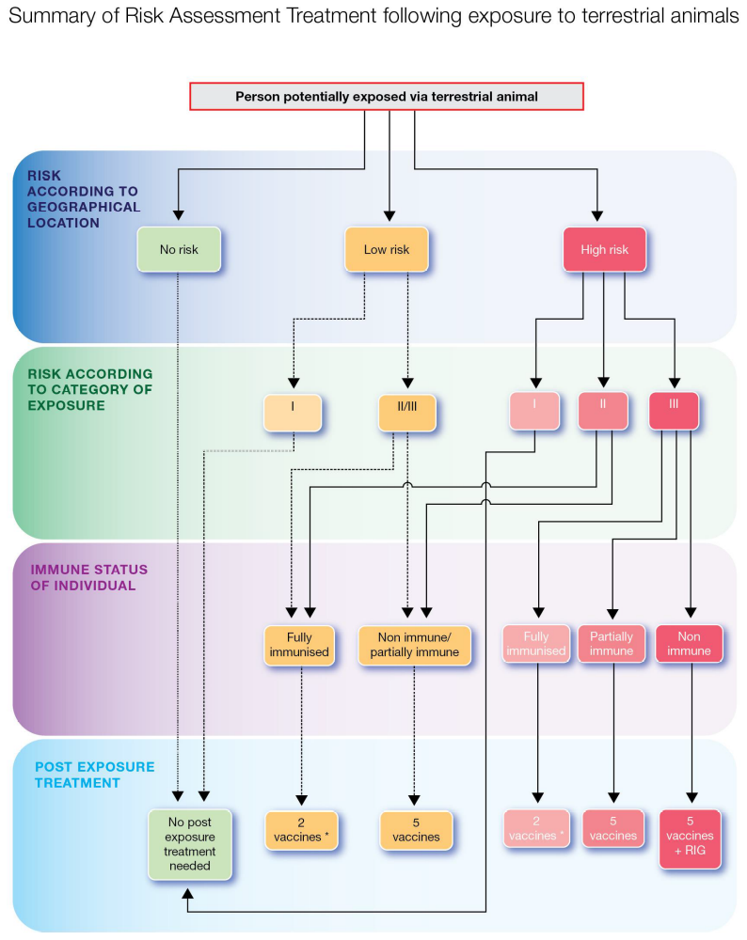

The UK schedule is 5 vaccines at the following interval 0, 3, 7, 14, 28-30 days given by the i.m. route.
Initiating rabies PET is not a medical emergency. In most cases rabies vaccine/HRIG can be mailed out for administration the next day.

For further information please see:

https://www.gov.uk/government/uploads/system/uploads/attachment_data/file/402386/Rabies_PHE_guidelines_on_postexposure_treatment_January_2015.pdf

Call Public Health England's Virus Reference Department, Colindale (tel. (020) 8200 4400) or the PHE Colindale Duty Doctor (tel. (020) 8200 6868)

