|  |  |  |
| --- | --- | --- |
|  | |  | | --- | | GWH  NatSSIPs  Update | |
| 444rw | | |  |  |
|  |

# NatSSIPs and LocSSIPs- So what are they exactly?

The new national standards from NHS England are designed to improve procedural safety and ultimately reduce Never Events.

The standards were to be adopted by all NHS Trusts from September 2016, NatSSIPs and locally developed LocSSIPs will allow organisations to standardise the processes that underpin patient safety.

Organisations should develop Local Safety Standards for Invasive Procedures (LocSSIPs) that include the key steps outlined in the NatSSIPs Document.

The NatSSIPs build on the WHO Safer Surgery Checklist and extend it to more patients undergoing care in hospitals.

## What are the steps and standards?

* Governance and audit
* Documentation
* Workforce
* Scheduling and list management
* Handovers and information at transfer
* Site marking
* Safety briefing
* Sign in
* Time out
* Sign out
* Prosthesis verification
* Prevention of retained foreign objects
* Debriefing

# Who do they apply to?

Everyone involved in invasive procedures!

# What are invasive procedures?

•All surgical and interventional procedures performed in operating theatres, outpatient treatment areas, labour ward delivery rooms, and other procedural areas within an organisation.  
• Surgical repair of episiotomy or genital tract trauma associated with vaginal delivery.  
• Invasive cardiological procedures such as cardiac catheterisation, angioplasty and stent insertion.  
• Endoscopic procedures such as gastroscopy and colonoscopy.  
• Interventional radiological procedures.  
• Thoracic interventions such as bronchoscopy and the insertion of chest drains.  
• Biopsies and other invasive tissue sampling.

It is not intended that NatSSIPs and LocSSIPs address procedures that involve the simple penetration of the skin or entry of a body cavity, such as the insertion of an intravenous line or a urinary catheter, or the use of ionising radiation, such as the taking of a plain X-ray.

# Progress with implementing NatSSIPs/LocSSIPs at GWH

## Speciality Level Self-Assessments-

All departments have been asked to undertake a self-assessment against the National Safety Standards for invasive procedures by December 2016. Part of this review required teams to identify priorities for improvement. Many areas have now completed this first piece of work and are progressing with improvements where needed. If you need any support or advice on completing your self-assessment, please contact **Daniel Boden on x5382**.

|  |  |  |  |  |  |
| --- | --- | --- | --- | --- | --- |
| Department/Speciality | Self-Assessment commenced | Self-Assessment complete | Improvement priority identified | Improvement activity commenced | LOCSSIPS drafted |
| Breast Care |  |  |  |  |  |
| Cardiology (Cath Lab) |  |  |  |  |  |
| Community Dentistry |  |  |  |  |  |
| Cystoscopy |  |  |  |  |  |
| Dermatology (Plastics) |  |  |  |  |  |
| DSU (in unit not theatre) |  |  |  |  |  |
| ED |  |  |  |  |  |
| Endoscopy |  |  |  |  | YES |
| ENT OPD |  |  |  |  | YES |
| Gynaecology |  |  |  |  |  |
| Haematology |  |  |  |  |  |
| ICU |  |  |  |  | YES |
| Main Theatres |  |  |  |  |  |
| Maternity |  |  |  |  |  |
| Ophthalmology OPD |  |  |  |  |  |
| Oral Surgery (Oral Theatres and OPD) |  |  |  |  | YES |
| PICC |  |  |  |  |  |
| Radiology |  |  |  |  |  |
| Respiratory |  |  |  |  |  |
| Rheumatology |  |  |  |  | YES |
| Shalbourne |  |  |  |  |  |

# WHO Safer Surgical Checklist Update-

Since March 2016, all departments undertaking invasive procedures have been collecting data on use of the WHO Safer Surgical Checklist.

Don’t forget it is really important to share your department’s results with your teams and at local governance meetings, to identify opportunities for improvement and keep our patients safe.

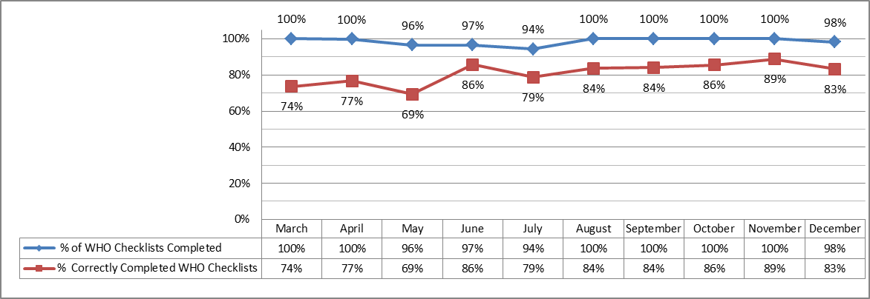Trust Wide results are reported to Patient Quality Committee and to our commissioners on a monthly basis.

# Human Factors Training-

NatSSIPs is not just about standards, it’s about culture, human factors and the way we work together. A number of Human Factor study days have been arranged which will be delivered by NHS Elect.

**Human factors training sessions booked with NHS Elect on:**

* Thursday 27th April 2017- 13:00-17:00 (Theatres Training Room)
* Thursday 20th July 2017- 08:30-12:30 (Theatres Training Room)
* Wednesday 13th September 2017- 13:00-17:00 (Theatres Training Room)
* Thursday 17th October 2017- 08:30-12:30 (Theatres Training Room)

These sessions will accommodate 15-18 staff members. If you are aware of anyone in your team that you think would find this training useful, or if you would like to attend, please contact Becky Watkins on x6407 or via email on [rebecca.watkins@gwh.nhs.uk](mailto:rebecca.watkins@gwh.nhs.uk)