

**Quality Improvement Toolkit:**

**First steps to Quality Improvement (QI)**



**Reducing harm, improving safety, embracing fresh ideas**

This toolkit aims to provide all the tools you need for your first steps towards making quality improvements. Use the tools and techniques to give your improvement project the best possible chance of success.

|  |  |  |  |  |
| --- | --- | --- | --- | --- |
| *\*DRAFT: Currently under PDSA testing (Version 1, January 2016)* | | | | |
| Version | Date | Author | Reason  for Change | Description |
| 1.0 | 28.01.16 | Beth Beynon | N/A | First draft |

 **The Quality Improvement Project Journey**

-------------------------------------------------------------------------------------------------------------------------------------------------------------------------------------------------------------------

**5: Spread and sustain**

**4: Make the changes**

**3: Plan the changes**

**2: Agree the solution**

**1: What’s the problem?**

*Tasks*

*Tools*

*Outputs*

* **Define your aim** and priority areas of focus.
* Agree a shared vision for the improvements - what will ‘better’ look like?
* Gather ideas from staff and patients.
* Get creative - generate innovative ideas for improvement.
* What is the best solution?
* What are the benefits of the solution?
* Start a **project plan**.
* Share lessons learned.
* Update your project plan/project on a page
* **Spread changes.**
* Post project review -what achievements can we celebrate and what lessons can we learn to inform future projects?
* **Sustain** ‘continuous’ QI – remember people, places, patients continue to evolve over time.
* **Test** changes using methods such as Plan Do Study Act (PDSA)
* **Document tests** clearly
* Check – have the changes achieved the improvement?
* **Measurement** - what is the data telling you?
* Pilot review – what worked well and what needs to be improved before spreading the changes?
* Task breakdown – define everything that needs to be done in an action log.
* Agree who needs to be involved.
* Agree how you will **measure** improvement
* Update your project plan.
* Create a ‘Project on a page’ to share with your stakeholders / report on progress.
* Understand the current situation.
* Identify the root causes.
* Complete a **process map**.
* Be clear about what you want to achieve (result/outcome).
* Key individuals to be involved – who are your **stakeholders**?

*Tasks*

Brainstorming

Process map (‘to be’’)

Prioritisation matrix

Pareto principle

Stakeholder analysis

Force Field Analysis

Aim Tool and SMART targets

Driver Diagram

Project Charter

Project Plan

Gantt chart

Action plan

Pareto principle / chart

Communication Plan

Run charts/ SPC charts

Family of measures

Measurement Plan

Project on a page

Run charts/ SPC charts

PDSA cycle / PDSA plan

Issue log / Risk log

Lessons learned log

Progress/status report

Project on a page

Highlight report

Spread Plan

Communication Plan

Sustaining momentum

Run charts/ SPC charts

PDSA cycle

PDSA plan

Issue log

Risk log

Lessons learned log

Progress/status report

Project on a page

Highlight report

Fish bone

5 Whys

Run charts/ SPC charts

Pareto principle

Process map (‘as is’)

Stakeholder mapping

*Tools*

* A proposed solution and its benefits.
* Identification of who needs to be involved in making the change happen and who will be impacted by the change.
* A plan to phase implementation of the changes across sites / settings.
* A plan for who, when and how to communicate with all relevant stakeholders.
* Testing and refining solutions.
* Demonstrate evidence of the changes and understand the impact.
* A plan to make the changes.
* Identified risks and log.
* A plan for who, when and how to communicate with all relevant stakeholders.
* Understand the problem and why it’s happening.
* Clarity on what you want to achieve.
* Establish a project group.

*Outputs*

**Don’t forget early involvement of stakeholders leads to a more sustainable solution**

**The Model for Improvement**

Page Content

**The model has two key parts:**

* Three fundamental questions, which can be addressed in any order.
* The Plan-Do-Study-Act (PDSA) cycle to test changes in real work settings.

The PDSA cycle guides the test of a change to determine if the change is an improvement.

[**Forming the team**](http://www.ihi.org/resources/Pages/HowtoImprove/ScienceofImprovementFormingtheTeam.aspx)

Including the right people on a quality improvement project is critical to its success. Teams can vary in size and composition, but should be built around delivery of your overall aim.

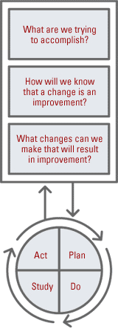[**Setting aims**](http://www.ihi.org/resources/Pages/HowtoImprove/ScienceofImprovementSettingAims.aspx)  
Improvement requires setting aims. The aim should be time-specific and measurable; it should also define the specific population of patients or systems that will be affected.

[**Establishing measures**](http://www.ihi.org/resources/Pages/HowtoImprove/ScienceofImprovementEstablishingMeasures.aspx)  
Teams use quantitative measures to determine if a specific change actually leads to an improvement.

[**Identifying**](http://www.ihi.org/resources/Pages/HowtoImprove/ScienceofImprovementSelectingChanges.aspx) **changes**

Ideas for change may come from the insights of those who work in the system, from change concepts or other creative thinking techniques, or by borrowing from others who have successfully made improvements.

[**Testing changes**](http://www.ihi.org/resources/Pages/HowtoImprove/ScienceofImprovementTestingChanges.aspx)

The Plan-Do-Study-Act (PDSA) cycle is shorthand for testing a change in the real work setting — by planning, trying, observing results and acting on what is learned.

This is the scientific method adapted for action-oriented learning.

**Implementing changes**  
After testing a change on a small scale, learning from each test, and refining the change through several PDSA cycles, the team may implement the change on a broader scale — for example, for an entire pilot population or on an entire unit.

[**Spreading and adopting changes**](http://www.ihi.org/resources/Pages/HowtoImprove/ScienceofImprovementSpreadingChanges.aspx)  
After successful implementation of a change or package of changes for a pilot population or an entire unit, the team can spread the changes to other parts of the organisation or in other organisations.

For the spreading of these changes to be successful in other areas, they first have to be tested, adapted to local conditions (i.e. the environment or patient group of the new ward or team), and tested again until the change works as well as it can in the new area and can be sustained. Only then can we say the changed has been ‘adopted’ by other areas.

**Cause and Effect (Fish bone)**

Cause and effect analysis helps you to think through the causes of a problem, including possible root causes – not just symptoms. It is only by identifying the main causes that you can permanently remove the problem.

Working through cause and effect analysis enables those involved to gain a shared insight into the problem, develop possible solutions and create a snapshot of your collective knowledge.

**When to use it**

Use this tool when you are trying to determine why a particular problem is occurring. It will help you to fully understand the issue and to identify all the possible causes - not just the obvious.

**How to use it**

**Step one: Identify the problem and consider it in detail.**

* Who is involved, when and where does the problem occur?
* Write the problem in a box and draw an arrow pointing towards it.

**Step two: Identify the major factors that where a potential cause of the problem.**

* Draw four or more branches off the large arrow to represent categories of potential causes.
* Categories could include: equipment, environment, procedures, people, communication.
* Make sure the categories are relevant to your particular problem.

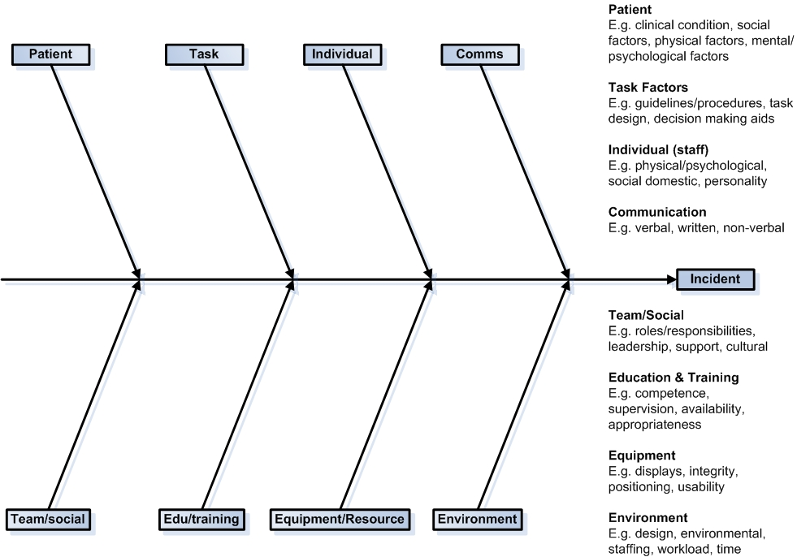**Fishbone example (tip – print off and write on this template to help guide your own analysis)**

**Step three**

Take each of the main categories and brainstorm possible causes of the problem. Explore each one to identify more specific ‘causes of causes’. Continue branching off until every possible cause has been identified. You might want to break complex causes into sub-causes. Show these as lines coming off each cause line.

**Step four**

Analyse your diagram. Depending on its complexity and importance, you can now investigate the most likely causes further. This may involve using more identification tools such as the ‘Five Whys’ tool on the next page, setting up interviews or surveys, or carrying out a process mapping exercise to help you decide whether the causes identified are correct.

**Five Whys**

The main purpose of the Five Whys technique is to constantly ask ‘Why?’ It enables the Root Cause Analysis (RCA) Investigator to delve deep into the causes of all adverse events. By progressing through the various layers of cause, the true ‘root cause’ of the problem is identified.

**How to use it**

* Decide upon your starting point. This will usually be one of your identified problems or contributory factors.
* Question each identified primary cause to identify whether it’s a symptom, an contributory factor or the root cause.
* Continuing the search for true root causes even after finding a possible cause.
* Normally this method involves five rounds of the question ‘Why?’ but the number can vary.

|  |
| --- |
| **Example**  **Problem:** A patient had the wrong leg amputated.   1. **WHY** – Patient gave consent for amputation the night before the proposed surgery to   Registrar (who was not to undertake procedure).  **2. WHY** - Amputation site marked with biro on wrong leg.  **3. WHY** – Registrar unaware of hospital policy on amputation sites being marked with  skin pencil and with body part being fully visible to Doctor.  **4. WHY** – The department had no induction procedures for new medical staff working in the  department.  **5. WHY** – Because ‘we’ve never been asked to’. |

**Five Whys – Positives of this technique:**

* Allows individual or group to drill down through the causal pathway.
* Simple and effective tool works well for both groups and individuals.

**Whys – Negatives of this technique:**

* Analysis constrained by mind set, lack of breadth and depth of thought.
* Why may need to be asked more than 5 times to get to real cause of problem.
* Specific and contained issue to drill down on is important if this tool is to work.

**Five Whys template**

|  |  |
| --- | --- |
| **Issue / problem** |  |
| 1. **Why?** |  |
| 1. **Why?** |  |
| 1. **Why?** |  |
| 1. **Why?** |  |
| 1. **Why?** |  |
| **Cause** |  |

**Process mapping**

A key element of any improvement work is to first understand how well our processes are working. Process mapping enables us to clearly and simply examine and recordour existing processes. The ultimate goal is to find out the **‘as is’**. This is what **actually happens now**, not what we think happens or what a documented process or guide/manual tells us should happen.

By breaking a process down into all its different steps (activities / tasks) and exploring **who** undertakes each step, **how**, **when** and **why**, we can start to develop ideas for improvement by:

* Clarifying roles within the process and reducing the number of staff required.
* Eliminating unnecessary steps or tasks (waste).
* Reducing delays and duplication (waste).
* Improving communication between staff/patients involved in the steps.
* Identifying and resolving obstacles that you didn’t previously know existed.

**You will need the following materials:**

* Brown paper or flip chart paper; Post-it notes (variety of colours); marker pens; and sellotape.

**How to run a process mapping exercise -** no one person can know all the steps or people involved in a process. It is essential to involve the people who do the work on a day-to-day basis.

For best results, you need multi-disciplinary team involvement. This might include colleagues from housekeeping, porterage, a health care assistant, a nurse, a doctor, a physiotherapist, an occupational therapist, a ward manager and relevant non-clinical staff (e.g. a colleague from IT).

**Tip** – if you find it difficult to get everyone together at the same time, get one or two people involved in the process and plot a first draft. Display it in a prominent area (e.g. next to a staff notice board or where staff take breaks) and invite colleagues to add to it over the next week.

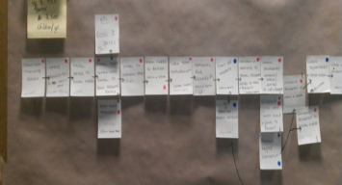

**Tip** – once you’ve mapped out the process on paper, consider producing it electronically and sharing with everyone involved.

**Getting started**

**Basic process mapping symbols**

The two most important symbols you will need are:

* A rectangle, representing an **activity or task**
* A diamond, representing a **decision point**

**Basic process map**

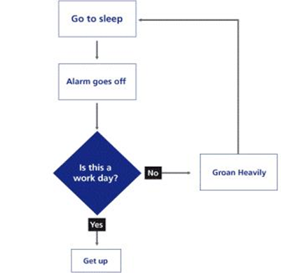

**You may also find it useful to use the following symbols to highlight:**

* Delays
* Transfer/Movement/Transport
* Storage/Filing

**To help focus the exercise and establish the ‘as is’, think about the following questions:**

* How many steps are there and what is the timescale between each step?
* Are there key decision points? How many handovers are there?
* Are there delays, bottlenecks or queues?
* Are there problems or obstacles in completing steps/tasks?
* Are there steps that don’t add value and can be changed or eliminated?
* Is there waste (e.g. completing unnecessary forms/paperwork)?

**9Cs – Stakeholder Mapping (Identification) Tool**

To make improvements to patient care and processes, you need to actively identify and engage a wide variety of people such as clinicians, administrative staff, patients and user groups.

**When to use it**

Stakeholder mapping is one of the first steps you need to take in any improvement project. It can help you avoid conflict and delays caused by inadvertently failing to involve key people.

**How to use it**

* **Step one: Assemble a group of experts on the area you are seeking to improve.**
* **Step two: Identify your stakeholders using the 9Cs.**

Get your experts to brainstorm a list of all the people and groups likely to be affected

by your proposed change using the 9Cs stakeholder identification tool below. This will ensure you consider and include all relevant stakeholders.

The list should be recorded and use as a term of reference throughout the life of the project.

**9Cs Stakeholder Identification Tool**

|  |  |  |
| --- | --- | --- |
| **Stakeholder Group** | | **List your stakeholders below** |
| **1** | **Commissioners:** those who pay the organisation to do things. |  |
| **2** | **Customers:** those who acquire and use the organisation’s products. |  |
| **3** | **Collaborators:** those with whom the organisation works to develop and deliver products. |  |
| **4** | **Contributors:** those from whom the organisation acquires content for products. |  |
| **5** | **Channels:** those who provide the organisation with a route to a market or customer. |  |
| **6** | **Commentators:** those whose opinions of the organisation are heard by customers and others. |  |
| **7** | **Consumers:** those who are served by our customers: i.e. patients, families, users. |  |
| **8** | **Champions:** those who believe in and will actively promote the project. |  |
| **9** | **Competitors:** those working in the same area who offer similar or alternative services. |  |

**Stakeholder Analysis Tool**

Once you have mapped out your stakeholders (using the ‘9Cs’ tool), you will need to analyse the list in terms of power, influence and the extent to which they are affected by your project. Stakeholder analysis enables you to identify the **influence your stakeholders have on the success of your project.**

**When and how to use it**

**Step one: prioritise your stakeholders**

* Consider each of your stakeholders in turn. Insert each name on your list into the power matrix below.
* The more important the stakeholder is to the success of the project, the more time and resources you need to devote to maintaining their involvement and commitment.
* Patients often fall into the 'inform' category. It may be helpful to take steps to increase their influence by organising them into groups or encouraging patients to become actively involved in any consultation.

**Stakeholder power matrix (four sector) template**

|  |  |  |
| --- | --- | --- |
| **High Power** | **Satisfy**  Opinion informers. Keep them satisfied with what is happening and review your analysis of their position regularly. | **Manage**  Key stakeholders who should be fully engaged through full communication and consultation. |
| **Low power** | **Monitor**  This group may be ignored if time and resources are stretched. | **Inform**  Patients often fall into this category. It may be helpful to take steps to increase their influence by organising them into groups or taking active consultative work. |
|  | **Low impact / stake holding** | **High impact / stake holding** |

**Step two: understand your stakeholders**

* The first step is to find out how your key stakeholders are they likely to feel about and react to your project. You also need to know how best to engage and communicate with them.
* Often the best way to find this out is to talk to your stakeholders direct. People are usually open about their views and happy to give feedback. Asking your stakeholders their opinions can be the first step in building a successful relationship with them.

**Step three:** **manage and** **communicate with your stakeholders**

* Once you have analysed your stakeholders, use the information to devise a Communications and Engagement Plan (the information to be given to which people, by when and how).
* Ensure all of your project team are aware of the methods to be used, by whom and when.

**Pareto Principle (80/20 rule)**

Pareto analysis (80/20 rule) is a simple technique that helps you to focus efforts on the problems that offer the **greatest potential for improvement**. Pareto’s 80/20 principle asserts that a minority of causes, inputs or effort usually lead to a majority of the results or outputs. The principle can easily be applied to the NHS e.g. 80% of a nurse’s time is spent on 20% of patients.

**When to use it**

This tool will help you to quickly identify the **major causes** of a problem so that resources can be directed accordingly. You may find it helpful to produce a Pareto Chart after you have completed a cause and effect (fishbone) diagram as this will help you identify which causes to work on first.

**How to use it**

**Step one: identify all the possible causes of your problem or issue requiring change.**

This can be done using a cause and effect (fishbone) diagram or brainstorming.

**Step two:** **collect and analyse data to verify the causes you have identified.**

Choose the most meaningful unit of measurement that relates to your problem: usually cost or frequency. Rank the causes largest to smallest i.e. compare the relative frequency of the causes.

**Step three: use your data to produce a Pareto Chart to visually display your findings.**

List the problem categories on the horizontal axis and the frequency or cost on the vertical axis.

**Step four: use your Pareto Chart to inform an action plan for your next steps.**

**Tip** - this simple visual illustration of the main causes of the problem will help to ensure that your findings are quickly and easily understood by others (see example below). Tackle the causes with the highest score or frequency first as these offer the greatest benefit from being resolved.

**Example of a Pareto Chart**

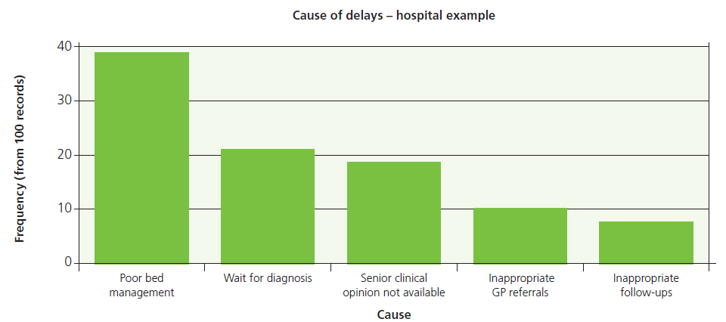

* Observing Pareto’s 80/20 rule, the above Pareto Chart shows that ‘*Poor bed management*’ contributes to 80% of delays in hospital. Focusing 20% of improvement efforts into this one area could potentially achieve the greatest impact in reducing delays.
* On a Pareto Chart, the categories contributing to 80% of the problems are often referred to as the 'vital few'. The others are labelled the 'useful many'.

**Brainstorming**

Brainstorming is a simple but fun and effective technique for generating **new change ideas and solutions** around known problems.

The technique is a useful way of engaging people in your project and works particularly well when solving people-related problems. It also works well when a problem keeps being discussed time and time again, but no effective solution is found.

**How to use it**

* **Step one:** Start your brainstorming session by establishing the purpose and topic (i.e. define the problem and any opportunities from finding an effective solution).
* **Step two:** Ask everyone in the group to call out their ideas spontaneously.
* **Step three:** Capture all the ideas on a flip chart for analyse later.

**Five key rules of brainstorming:**

1. All ideas are acceptable; judgement is ruled out until the process is complete.
2. Freewheeling is welcome: the wilder the better. Humour triggers the right brain so this really

helps to get original ideas flowing.

1. Quantity counts at this stage, not quality.
2. Build on the ideas put forward by others.
3. Every person and every idea has equal worth.

**Tips to remember for an effective brainstorming session**

* Preparation. Make sure you have the right kit: flip charts, post-its, pens, time, the right people in the room.
* Define the problem or the opportunity. Write up a statement describing this, but be careful that it doesn't suggest a solution as this will hinder idea generation.
* Stand up, shift position, move around.
* Use non-linear note taking methods - post-it notes work well.
* Aim for 20-30 ideas in 5-7 minutes.
* 100% participation is best e.g. all write on flip charts/post it notes.
* Giving people permission to freewheel doesn't necessarily mean they have   
  the learned skill to do so.
* You should not plan a brainstorming session if you already have several solutions and all you want to do is to decide which one to use; this is best done by analysis.

Once your brainstorming session(s) has generated lots of new change ideas and possible solutions, it is unlikely you will be able to implement them all at once. Use the prioritisation matrix template to weight and prioritise your ideas for improvement.

**Prioritisation Matrix**

Once you have generated a number of change ideas for your improvement project (by process mapping, brainstorming and other creative thinking techniques), you can use the prioritisation matrix tool to weight and prioritise your ideas. This will help you to decide what improvements to implement first.

A prioritisation Matrix is most useful for focusing resources when:

• You can’t do all the improvements at once.  
• You are uncertain about the best use of resources or energy.  
• You are looking towards specific improvement goals.

**How to use it** - with your project team, put your change ideas into one of the four zones (A, B, C or D) in the **Benefits versus Effort Matrix** below, scoring each one high or low.

* **A** = The benefit is high and the effort is low: **The recommendation is to 'just do it'.**
* **B** = Both the benefit and effort are high. May require further scoping /support to implement: **The recommendation is consider 'can we help?'**
* **C & D** = Any opportunities mapped to the bottom two zones offer low benefits: **The recommendation is it may not be worth looking at at the present moment.**

**Prioritisation Matrix template**

|  |  |
| --- | --- |
| **A**  **High**  **BENEFITS**  **(less waste, decreased costs, less duplication)** | **B** |
| **C**  **Low** | **D** |

**Low High**

**EFFORT (Resources, time, finances, people)**

**Communication and Engagement Plan**

Effective communication and engagement is essential in helping to drive and sustain improvement projects. Developing a Communications and Engagement Plan will help you to communicate the right things, to the right people, at the right time to get your ideas across in the most effective way.

**How to use it**

* The first step in developing a Communications and Engagement Plan is working out who you need to communicate with by using the Stakeholder Mapping and Analysis tools. This should be done during the early planning stages of your project.
* Stakeholder Mapping and Analysis will help you to identify your stakeholders’ degree of power and influence on your improvement goals. This will inform the frequency and type of communications activities i.e. whether you keep them informed or require their active engagement and support.

**Tip** – don’t assume other people (including your colleagues) will know what you know. Everyone connected to your project needs to understand what you are doing, why, when it will happen, and the impact it will have (on patients, their team and themselves).

**Communication and Engagement Plan template**

|  |  |  |  |  |  |  |  |
| --- | --- | --- | --- | --- | --- | --- | --- |
| **Project:** | | | | | | | |
| **Team:** | | | | | | | |
| **Stage of project** | **Communication / Engagement Activity** | **Communication Channels** (e.g. email, website, intranet, GP newsletter, briefing paper, Radio, TV, poster, flyers, patient forums, drop in sessions) | **Audience**  (Stakeholder Groups) | **Responsibility** | **Timeframe for communication** | **Frequency of communication** | **Communication end date** |
|  |  |  |  |  |  |  |  |
|  |  |  |  |  |  |  |  |
|  |  |  |  |  |  |  |  |
|  |  |  |  |  |  |  |  |
|  |  |  |  |  |  |  |  |
|  |  |  |  |  |  |  |  |

**Setting your project aim**

A clearly defined and specific aim is critical to the success of any improvement project. Teams make better progress when they are specific and aims are unambiguous and focused.

**Think** - How will you know if you have made an improvement unless you define what ‘***better***’ looks like and how long you think it will take to get there ***before*** you set out on your journey?

**SMART Aims**

Project aims should be **SMART** (Specific; Measurable; Achievable; Relevant; Time bound). Where baseline data is not available and your project involves collecting data on a process for the first time, try to make your aim as specific as possible. After an initial period of data collection (e.g. six or 12 months) review your aim and, using your new incite, make it SMART.

**How to define your aim**

When thinking about how much you want to aim to improve by and by when (i.e. a 20% reduction by 2020), you will need to consider a number of data sources to help you agree an improvement target with your project team which is realistic but challenging.

Where the data is available, start by **comparing your baseline data** (i.e. what practice looked like before any changes were introduced), with:

* Data on improvement **work already started** by another team or ward in the trust;
* Improvement data and improvement targets set by **other healthcare providers**; and
* Improvement data and improvement targets set by **national or international** bodies.

**SMART Aims Tool**

|  |  |  |  |
| --- | --- | --- | --- |
| **Does your aim meet these criteria?**  **Yes or No** | | | |
| **S** | **Specific** | Does your aim define your improvement area (e.g. a reduction in UTI infections) and is it specific to a particular patient population group (e.g. acute in-patients)? Make your aim as specific as possible so that it is clear to anyone with a basic understanding of your project.  Express your aim in positive terms (e.g. aim to increase positive, rather than reduce negative feedback). | Y  N |
| **M** | **Measurable** | Is your aim capable of being measured? Is data already collected? You’ll need to be able to evaluate your progress continuously and determine if you are working towards your goal. | Y  N |
| **A** | **Achievable** | Is your goal achievable? It should be challenging but realistic and obtainable with the resources and time you have available to you.  Try to remove obstacles before you start. | Y  N |
| **R** | **Relevant** | Is your aim applicable to what you want to achieve?  Is it relevant to the Trust’s vision and strategic aims? | Y  N |
| **T** | **Time bound** | Does your aim include a date that you want to achieve your target for improvement by (i.e. a date for the end of your project)? | Y  N |

**Example of a generic aim:**

* Increase patient feedback.

**Example of a SMART aim:**

* Increase patient feedback across all Trust services by 20% by March 2017.

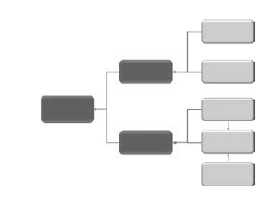**Driver Diagram**

Once you have defined your project aim, a Driver Diagram will help focus your priority areas for improvement. A Driver Diagram is also a powerful visual tool to engage stakeholders by clearly setting out what is to be achieved and the areas you have identified as most requiring improvement.

**How to use it** – primary and secondary drivers are underpinning goals that must be addressed to achieve your overall aim. Identify them by baselining the current situation and root cause analysis work. These will help you to identify where processes are not working as effectively or as reliably as they should and where focused effort could make the greatest difference on practice and patient safety.

**Driver Diagram template**

**Overall Improvement Aim Primary Drivers Secondary Drivers**

**N.B.** Secondary drivers are specific ***improvement areas***, from which you can start to plan your change ideas. Each secondary driver will contribute to at least one of your primary drivers.

They should be process changes that you think will impact the aim. They should be necessary and collectively sufficient to achieve your aim.

**N.B.** Primary drivers are high-level ***improvement* themes or topics** (e.g. Timely Recognition; Education; Equipment) that must be addressed in order to achieve your desired aim.

They should be written as straightforward statements rather than as numeric targets.

Aim for 3 - 4 max primary drivers.

**Insert your 'aim' here**

**Make it SMART**

* **Specific**
* **Measurable**
* **Achievable**
* **Realistic**
* **Timebound**

*Example aim:*

*Reduce mortality at 30 days following an admission with severe sepsis to 23% by 2018.*

*Example Secondary Driver*

*Standardised sepsis screening tool and care pathway*

*Example Primary Driver:*

*Reliable recognition and assessment*

xx

**Project Charter**

A Project Charter is a document that formally defines and authorises a project.  It clearly outlines what the project hopes to achieve and ensures that the goals of the project are unambiguous and are understood by the key stakeholders. A Project Charter is similar to a Project Brief.

**How to use it** - use the template below to develop your project charter.

**Tip** - a Project Charter can be developed by using the three key questions from the Model for Improvement. This will provide a clear and focused goal for the project.  Measures should be defined so that it is possible to demonstrate if the changes you make have led to improvement.

**Project Charter template**

|  |  |
| --- | --- |
| **Name of project:** | **Name of project lead:** |
| **Aim statement – overall goal of the project** | |
| How much and by when? | |
| **Strategic Context** | |
| How might the problem you are trying to solve align to organisational / national priorities? | |
| **Project scope** | |
| What is in the scope of the project and what is not? | |
| **Benefits to be generated / deliverables** | |
| What are the likely outcomes and critical success factors? | |
| **Proposed measures** | |
| How will you know improvements have been made from your baseline? What are your key measures to assess progress in achieving your aim? Who will be collecting your data and how/when do you plan to analyse and share it? | |
| **Project team** | |
| Who is the project sponsor (if any) and who else needs to be involved? List everyone that will contribute including their name, role and organisation. Consider time commitments for each. | |
| **Timetable** | |
| What are the timescales for this project and key milestones? | |
| **Project stakeholders** | |
| Who (and/or what) will these improvements impact on and how? Think as widely as possible. | |
| **Learning and spread (adoption)** | |
| How will any learning be captured and where, when and how will this be shared with and adopted by other areas? | |

**Project Plan**

A Project Plan is the most essential tool for any improvement project. It should clearly define and guide [delivery](http://www.qihub.scot.nhs.uk/knowledge-centre/quality-improvement-topics/project-management/delivering-a-project.aspx) of all improvement activity to achieve your overall aim within time and to budget. As your project moves from planning to implementation, you will use your Project Plan to monitor and control progress throughout the life of your project.

**How to use it**

Build on your Project Charter to complete the Project Plan template below. Use the template as a guide of what to include in your project plan, not an exhaustive list.

**Tip** - your Project Plan is a living document. Ensure you regularly review, update and monitor it.

**Project Plan template**

|  |  |
| --- | --- |
| **Name of project:** | **Name of project lead:** |
| **Aim statement – overall goal of the project** | |
| **Strategic Context**  How does your project fit with the Trust’s vison and strategic priorities? | |
| **Project scope**  What is in the scope of the project and what is not? | |
| **Approach**  How do you plan to start, initiate, implement and close your project? In what phases or stages? | |
| **Deliverables**  What improvement activities and or interventions will you deliver? | |
| **Benefits to be generated**  What are the likely benefits, outcomes and critical success factors? | |
| **Proposed measures**  What are your key measures (outcome and process) to assess progress in achieving your aim? | |
| **Project team**  List everyone that will contribute including their name, role and organisation. | |
| **Resources requirements**  What effort (hours or days), budget and staffing capacity and capability are requiring? | |
| **Dependencies**  What activity is dependent on another activity being started or completed? | |
| **Risks**  What issues could have a critical impact on the success of your project? How will you manage them? | |
| **Timetable**  What are the timescales for the overall project, deliverables and key milestones? | |
| **Action Plan**  What activities and tasks are needed to deliver the project, by when and by whom? | |
| **Project stakeholders**  Who (and/or what) will these improvements impact on and how? | |
| **Learning and spread (adoption)**  How will you capture learning? When and how will you share it to see spread of improvements? | |

**Action Plan**

Action plans are a key tool for helping you to plan how you will achieve all of your project’s deliverables and by when.

**How to use it**

When developing your action plan(s), aim to break down all the detailed tasks required to achieve each of your project’s objectives.

This will help you to ensure key tasks are not overlooked and responsibility for delivering those tasks is assigned to and shared with relevant individuals.

**Action Plan template**

|  |  |  |  |  |  |  |
| --- | --- | --- | --- | --- | --- | --- |
| **Project aim:** | | | | | | |
| **Objective one:** | | | | | | |
| **Action / task** | | **Lead** | **Resource required** | **Target date** | **Possible issues** | **Current status** |
| **1** |  |  |  |  |  |  |
| **2** |  |  |  |  |  |  |
| **3** |  |  |  |  |  |  |
| **Objective two:** | | | | | | |
| **Action / task** | | **Lead** | **Resource required** | **Target date** | **Possible issues** | **Current status** |
| **1** |  |  |  |  |  |  |
| **2** |  |  |  |  |  |  |
| **3** |  |  |  |  |  |  |
| **Objective three:** | | | | | | |
| **Action / task** | | **Lead** | **Resource required** | **Target date** | **Possible issues** | **Current status** |
| **1** |  |  |  |  |  |  |
| **2** |  |  |  |  |  |  |
| **3** |  |  |  |  |  |  |

**Measuring for Improvement**

**Why measure?**

All improvements involve change, but not all changes are improvements.

To understand if the changes we make lead to improvements, we need to

collect data to measure the processes we are seeking to improve.

To do this effectively, it is essential to start your project with a clear aim for

what you want to achieve and any improvement ideas you test are measureable.

**Moving beyond audit and compliance to quality improvement**

Measuring for improvement is different to traditional approaches of collecting data for audits or performance management.

Typically audits take a ‘snapshot’ of what something looks like at one point in time, while performance management measures often aggregate data (combine data over a period e.g. a quarter or year) and in doing so can ‘hide’ problems that exists.

* These approaches measure for ‘***judgement*’** (i.e. they aim to help managers gauge performance, however can often inadvertently conceal the real picture).
* In contrast, when we **measure for improvement** we learn how something is working as we go along by continuously observing the impact of our changes on the process.

The table below provides a summary of the key differences between collecting data for audit purposes and measuring for improvement work.

|  |  |
| --- | --- |
| **Image result for measuring for improvementAudit (judgement)** | **Image result for measuring for improvementQuality Improvement (improvement)** |
| We collect “before and after” data | We collect continuous data |
| We collect a lot of data (“Just in case”) | We collect just enough data |
| Typically little testing of solutions | Continuous testing, learning as we go |
| Implement change as a consequence of the audit | The process of measuring is integral to the change process (“plan, do, study, act”) |

**Measurement Plan Framework**

The aim of improvement work is to make services better. In healthcare that means safer, more effective, more efficient, more equitable and led by patients’ health needs. To understand whether we have reached our aims we need to define what ‘better’ looks like and measure our progress in getting there continuously.

Clear, unambiguous and relevant measures form the foundation of improvement work. Changes must be supported by reliable measures that help to demonstrate the impact of improvement.

**The importance of good quality measures for improvement**

If measures are unreliable then people can challenge any actions they oppose and delay implementation until trustworthy data is obtained.

**Family of measures**

There are three types of measures we can use for improvement projects. We call these a ‘*family of measures’*:

* **Outcome measures (OM)** – these measure the impact of your improvement work on your overall project aim (e.g. a reduction in mortality).
* **Process measures (PM)** – these measure how effectively the processes you are seeking to improve are working (number of completed risk assessments).
* **Balancing measures (BM)** –these measure the effect your improvement activities have (unintended or intended) on another part of the system or area (e.g. outpatient referrals).

**When to use a Measurement Plan**

The measures you choose for your improvement project need to be clearly defined in a simple measurement plan. Measurement plans set out a consistent and reliable methodology for collecting and using data effectively.

Producing a measurement plan will help you to ensure that everyone involved in your project understands how data will be collected, how it will be analysed and how it should be interpreted.

**Measurement Plan template**

|  |  |
| --- | --- |
| **Measure Name** |  |
| **Measure Type** |  |
| **Related Driver** |  |
| **Description** |  |
| **Rationale** |  |
| **Numerator** |  |
| **Data Source** |  |
| **Denominator** |  |
| **Data Source** |  |
| **Method of calculation** |  |
| **Collection Guidance** |  |

**Run Charts and Statistical Process Control (SPC)**

**Run charts**

When we **measure for improvement,** we collect small amounts of **‘real-time’** data regularly (for example daily, weekly or monthly) and continuously and plot the data using **run charts.**

Run charts enable us to easily display data in a way that is **meaningful** and **easy to interpret.**

Other recognised benefits of using run charts for improvement include:

* They measuring the **impact** of the changes we test over time before we spread them wider;
* They Identify if **variation** in performance observed is within the control limits expected;
* They help us to avoid making **assumptions** about what has been achieved.
* They demonstrate the improvement **wasn’t a one-off.**

Run charts are likely to be sufficient for many improvement projects but they are not as sensitive at detecting special cause variation as Statistical Process Control (SPC) charts.

**Example of a run chart**

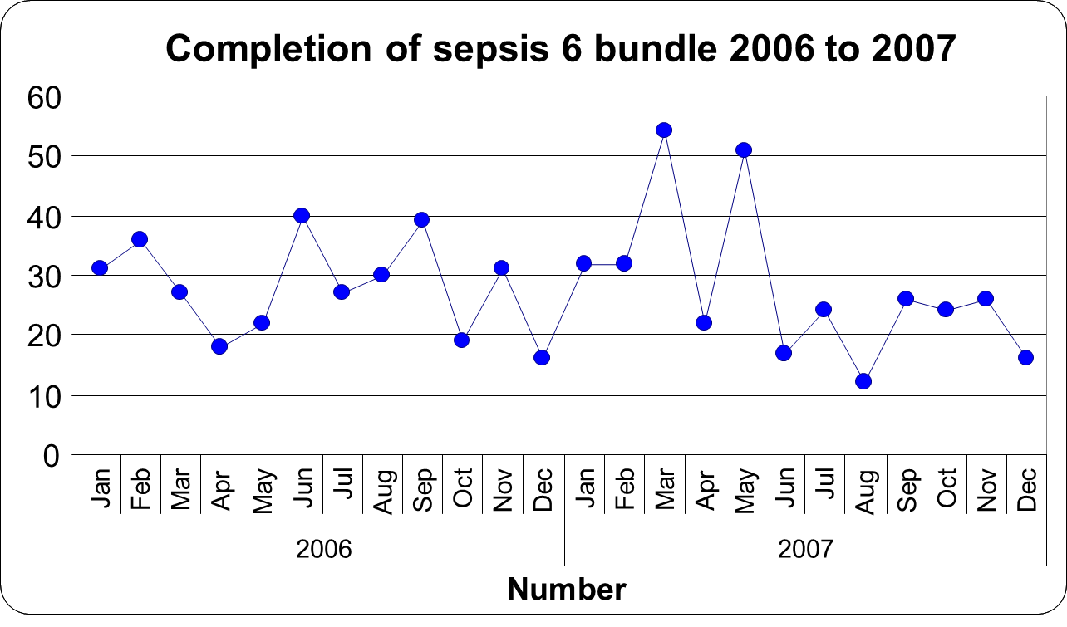

**Statistical Process Control (SPC)**

SPC is a practical statistical approach to resolving problems. It can help understand the scale of any problem and identify possible causes when used with other tools such as process mapping.

**SPC tells us about the variation that exists in the process or system we are seeking to improve.** Variation exists in all processes and there are many sources of variation in healthcare that affect patient flow, quality of care and safety. Reducing and managing this variation enables our processes to become more predictable, reliable and safer.

By understanding the types of variation in the process, we can make improvements to the process that we predict will lead to better outcomes. SPC can also then be used to see whether our predictions were correct.

**There are two types of variation you need to consider for your quality improvement project:**

* **Common cause variation** - random causes that are inherent in the system (processes) over time, affect everyone working in the system, and affect all outcomes of the system. This type of variation that is predictable and expected.
* **Special cause variation** - non-random causes that are not part of the system (process or product) all the time, or do not affect everyone, but arise because of specific circumstances. This type of variation that is unusual or unexpected.

**An example of an SPC chart:**

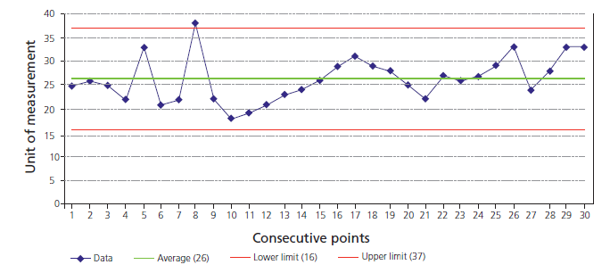

**When to use it**

* You need at least 20 data points to plot reliable SPC control limits.

**SPC rules**

* **Rule one** – any point outside of the control limits.
* **Rule two** – a run of seven points all above or all below the centre line, or all increasing or decreasing.
* **Rule three** – any unusual pattern or trends within the control limits.
* **Rule four** - The number of points within the middle third of the region between the control limits differs markedly from two thirds of the total number of points.

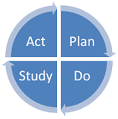**Plan, Do, Study, Act (PDSA)**

***“I want to improve my service, but don’t have time to trial changes”***

Unfortunately, when ideas are not tested, we often have to spend more time putting things right and redoing work.

Investing time upfront helps avoid costly mistakes, risks to patient safety and wasted resources.

.

New ideas should be only be introduced after **sufficient testing**

on a smaller scale has proven to have a positive effect.

PDSA cycles allow change ideas to be introduced in a small, safe

and controlled way. Introducing changes in this way results in

**less resistance** to the idea, is **less disruptive** to patients and

colleagues, and uses **less resources**.

To develop an idea into a tested improvement proposal, you may

need to perform a number of PDSA cycles. PDSA cycles can be performed **sequentially** (one after another) or **simultaneously** (at the same time).

**Sequential PDSA cycles**

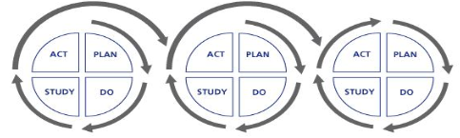With sequential PDSA cycles, the **change idea is refined with learning** from the previous cycle until it is ready for implementation.

By building on the learning from each PDSA cycle, new processes can be introduced with a greater chance of success.

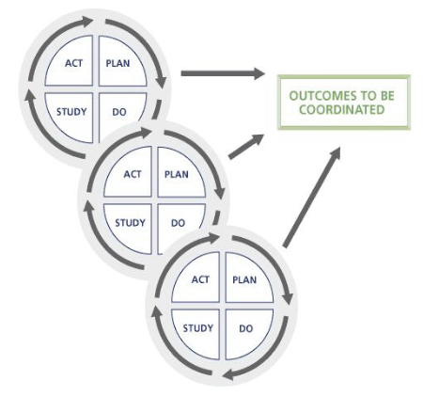**Simultaneous PDSA cycles** You might run simultaneous cycles when your **changes are more complex**, possibly involving several departments.

It is important that you **identify any interactions** between simultaneous cycles, as a change in method in one cycle may alter the impact of another somewhere else.

**Key learning points!**

* **Implementing changes through PDSA cycles can achieve successful results in a few**

**months that would otherwise have taken years.**

* **Once a change idea has been tested and implemented with a positive effect in one area, it doesn’t necessarily mean it will work in all other settings.**

Every time a change is spread to another area (e.g. to another ward or team), it should be implemented through a PDSA testing cycle to ensure it has the anticipated positive effect.

For quality improvement work it’s therefore helpful to think about ***‘adoption of change ideas’***

by other areas, rather than the traditional term **‘spread’**. Successful ideas are often spread

without successful results. Only when a change has been tested, implemented and

successfully sustained by other areas can we say the improvement has been **adopted.**

**Putting Plan, Do, Study, Act (PDSA) into practice**

**How to use it -** as you work through each stage of the PDSA cycle, consider the questions below to inform your approach and how you will use the learning to guide what you will do next.

**Tip** – no change idea is too small! PDSA can be used for one patient, in one clinic, on one day.

**Tip** – change ideas must be measurable to demonstrate if the change you make will lead to improvement.

**Plan the change idea**

**•** Define the objectives.

**•** State the scope of the PDSA

**•** What, why, who, how and when?

**•** How long will the PDSA continue?

**•** Are there circumstances when you would stop?

**•** Does everyone understand their role?

**•** How will you communicate with these people?

**•** How will you know if the PDSA is a success?

**•** What data collection methods are you using?

**•** Who will collect the data?

**•** How will you feedback to the team?

**Act upon the results of the test**

**•** Use the information you have gained!

**•** Do you need to modify and retest?

**•** Do you have enough information?

**•** Does the trial need to be longer?

**•** Can you implement the change immediately?

**•** Who do you need to share your findings with?

**•** Can other areas benefit from your knowledge?

**•** How will you performance manage the process

in the longer term?

**•** Implement the new process!

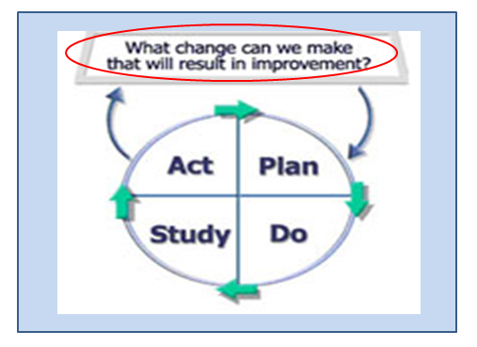

**Do - carry out the test of change!**

**•** Collect information and note any variation from

the plan, such as a change from the plan due to

complexity, lack of staff, etc.

**•** Did anything unexpected happen?

**•** Did you experience any challenges?

**•** What worked well / what didn’t?

**•** Encourage continual feedback – you may wish to

set up midpoint meetings to discuss progress.

• Motivate, reassure, encourage and support

colleagues.

**Study the results of the test**

**•** Examine your findings.

**•** Review and compare information from before,

during and after the trial.

**•** Reflect on what was learned.

**•** What did it feel like? Did staff and patients

notice an improvement?

**•** Was the process shorter or longer?

**•** Did you achieve your objective? If not, why not?

**•** What went well?

**•** What could be improved?

**Plan Do Study Act (PDSA) template (change planning sheet)**

Use the PDSA template below to guide you through the four stages in order.

|  |  |  |
| --- | --- | --- |
| **Cycle No:** | **Start Date:** | |
| **Plan**  **br912** | **What do you want to achieve?** | |
| **Who will carry out the test?** | |
| **What are you going to do?** | |
| **Where will it take place?** | |
| **When will it take place?** | |
| **What do you expect will happen?** | |
| **How will we know if our change has made a difference?** | |
| **Do:** Test the idea  **br913** | **Implement your plan and record what actually happens** | |
| **Were there any surprises? Did anything unexpected happen?** | |
| **Begin to analyse the data** | |
| **Studybr914** | **What were the results and what have we learned?** | |
| **Act**  ACTWHITE | **What action will be taken now?** | |
| 1. **Refine improvement idea and try again (retest)** |  |
| 1. **Implement it and embed the change** |  |
| 1. **Reject idea and test a new idea** |  |
| **Who completed this form:** | | **Date form completed:** |

**Risk Log**

Risks are issues, problems or challenges that have not yet happened, but have the potential to have a critical impact on the success of your project should they happen. **Proactively** identifying and managing potential risks is essential to keeping your improvement project moving forward.

When time isn’t taken to identify risks early on and put measures in place to control them, it can lead to the scope of the project having to be greatly narrowed (e.g. due to lack of budget or staff) or the project failing altogether. Planning for risks early on enables you to put preventative actions in place to minimize the risk occurring and regularly communicate with your project team and key stakeholders.

**When and how to use it**

* Use the template below to record all identified risks throughout the lifecycle of your improvement project and how you plan to manage them.
* **Tip** – using the framework to rate your risks will help you to determine where most effort should be placed for managing risks.

**Risk Log template**

|  |  |  |  |  |  |  |  |  |  |
| --- | --- | --- | --- | --- | --- | --- | --- | --- | --- |
| **ID** | **Date risk identified** | **Risk author**  (the individual recording the risk) | **Risk description**  (e.g. commercial, legal, financial, technical, staffing) | **Risk owner**  (the individual who has taken responsibility for managing the risk) | **Impact (I)**  (effect on the project if the risk where to occur)  1-Low  2- Minor  3 – Moderate  4 – Major  5 - Serious | **Likelihood (L)**  (estimate of the probability of the risk occurring)  1 – Highly unlikely  2 – Unlikely  3 – Possible  4 – Likely  5 – Highly likely | **Risk rating** (I x L) | **Countermeasure**  (the actions that have or will be taken to minimise the risk occurring) | **Date of last update**  (when the status of the risk was last checked) |
| 1 |  |  |  |  |  |  |  |  |  |
| 2 |  |  |  |  |  |  |  |  |  |
| 3 |  |  |  |  |  |  |  |  |  |
| 4 |  |  |  |  |  |  |  |  |  |
| 5 |  |  |  |  |  |  |  |  |  |
| 6 |  |  |  |  |  |  |  |  |  |
| 7 |  |  |  |  |  |  |  |  |  |
| 8 |  |  |  |  |  |  |  |  |  |
| 9 |  |  |  |  |  |  |  |  |  |
| 10 |  |  |  |  |  |  |  |  |  |

**Issue Log**

An issue is an **unplanned event** that has happened and requires **reactive** management action.  An issue might be a concern, query, suggestion, request for a change to the project’s aim or anything which might have a negative impact on the project or its scope.

**When and how to use it**

* It is important to manage issues as soon as they arise as they could have a critical impact on the success of your improvement goal.
* Use the template below to record all issues as they arise throughout the lifecycle of your improvement project and how you plan to resolve them.
* Risks documented in your risk log may later turn into an issue if the countermeasures put in place did not prevent the risk from occurring.

**Issue Log template**

|  |  |  |  |  |  |  |  |  |  |
| --- | --- | --- | --- | --- | --- | --- | --- | --- | --- |
| **ID** | **Status**  (open or closed) | **Date issue identified** | **Date last updated** | **Issue author**  (the individual recording the risk) | **Issue description**  (e.g. request for change, project off track, staffing gap, financial) | **Issue owner**  (the individual who has taken responsibility for resolving the issue) | **Priority rating**  1 – Low  2 – Medium  3 - High | **Latest update**  (the actions that have or will be taken to resolve the issue) | **Issue resolution date** |
| 1 |  |  |  |  |  |  |  |  |  |
| 2 |  |  |  |  |  |  |  |  |  |
| 3 |  |  |  |  |  |  |  |  |  |
| 4 |  |  |  |  |  |  |  |  |  |
| 5 |  |  |  |  |  |  |  |  |  |
| 6 |  |  |  |  |  |  |  |  |  |
| 7 |  |  |  |  |  |  |  |  |  |
| 8 |  |  |  |  |  |  |  |  |  |
| 9 |  |  |  |  |  |  |  |  |  |
| 10 |  |  |  |  |  |  |  |  |  |

**Lessons Learned Log**

Throughout the duration of any project there will be lessons learned. This is often as a result of issues, risks and problems and the steps that were taken to resolve them. These lessons can lead to improvements or opportunities for the future, the development of best practice, and the creation of new strategies.

In order to make the best use of the knowledge that has been generated, it is necessary to capture any lessons learned throughout the project in a Lessons Learned Log. All members of the project team should contribute to the log which should be held by the Project Manager.  The Log should be accessible to others in the organisation so that it can be used as a planning tool for future projects and the same mistakes can be avoided.

**How to use it**

Document the issues, problems, and solutions encountered on a project along with observations about processes or resources in a Lessons Learned log.

**Tip** – remember the Lessons Learned Log is an ongoing documentation of events ***as they occur***. The log should be **updated frequently** to make sure issues or problems are captured accurately and the project team can make changes following the lesson learned as soon as possible.

|  |  |  |  |  |  |  |  |
| --- | --- | --- | --- | --- | --- | --- | --- |
| **ID** | **Project Phase**  (e.g.initiation, planning, delivery, evaluation, closure) | **Problem / Issue Description**  (e.g. timescale, cost, quality, personnel) | **Lesson Category**  (e.g. ***start*** - a suggestion for improvement, ***stop*** - something that should not be continued, and ***continue*** - something that went well and should be continued) | **Lesson Learned Description** | **Action Taken** | **Date Raised** | **Raised By** |
| 1 |  |  |  |  |  |  |  |
| 2 |  |  |  |  |  |  |  |
| 3 |  |  |  |  |  |  |  |
| 4 |  |  |  |  |  |  |  |
| 5 |  |  |  |  |  |  |  |
| 6 |  |  |  |  |  |  |  |
| 7 |  |  |  |  |  |  |  |
| 8 |  |  |  |  |  |  |  |
| 9 |  |  |  |  |  |  |  |
| 10 |  |  |  |  |  |  |  |

**Project Progress Report**

Progress Reports are a tool to help you regularly and consistently communicate the status of your project to your Project Board and all other key stakeholders or groups with an interest. Use the template below to provide regular updates on achievements and work still to be done.

**Tip** – completing regular Progress Reports creates a valuable written record of your project’s life. Later you can use it as a tool to look back and decide how to improve future projects.

**Progress Report template**

|  |  |  |  |  |  |  |
| --- | --- | --- | --- | --- | --- | --- |
| **Project Name** | | |  | | | |
| **Project Manager / Lead** | | |  | | | |
| **Summary** | | | | | | |
| ***Status this period*** |  | | | ***Red*** *– considerable slippage and a significant risk that the completion date will not be met*  ***Amber*** *– a possibility of some slippage but the issues are being dealt with*  ***Green*** *– on track and should be completed by the target date* | | |
| ***Period Ending*** |  | | | ***Project Stage*** | [Initiation / Planning / Diagnostic / Delivery / Evaluation / Closure] | |
| ***Project start date*** |  | | | ***Projected completion date*** |  | |
| ***Project Description*** | | | | | | |
| *Brief details of background, objectives, scope, etc.* | | | | | | |
| **Progress Against Key Milestones** | | | | | | |
| ***Milestone*** | | ***Target Date*** | | ***Progress*** | | ***Revised Completion Date (if applicable)*** |
|  | |  | | [In progress / Complete / Not yet due / Overdue] | |  |
|  | |  | | [In progress / Complete / Not yet due / Overdue] | |  |
|  | |  | | [In progress / Complete / Not yet due / Overdue] | |  |
| **Achievements this period** | | | | | | |
| *Activities/ information of note relating to the current reporting period.* | | | | | | |
| ***Future Activities*** | | | | | | |
| *Planned activities/ information of note relating to the following reporting period.* | | | | | | |
| **Risks and Issues** | | | | | | |
| ***Risks and Issues*** | | | | ***Risk Mitigation and Issue Resolution*** | | |
|  | | | |  | | |
| **Issues Requiring Escalation or Decision** | | | | | | |
| *Significant issues that require highlighting to the Project Board or other stakeholders for a decision to be made.* | | | | | | |

**Project Highlight Report**

**How to use it** – use the Highlight Report to provide your Project Board (or other stakeholders) with a status update as your project moves from one phase or stage into another. The Highlight Report will be used to monitor phase/stage progress.

**Tip** – use the Highlight Report to advise your Project Board where potential or actual problems arise and seek their advice and/or help.

**Highlight Report template**

_____________________________________________________________________________________________________________________________

|  |  |
| --- | --- |
| **Author (s):** |  |
| **Date of issue:** |  |

**Project name:**

**Period covered:**

**Progress Chart for Key Deliverables** (**Key:** **Black** – Time estimate, **Green** – On target, **Amber** – Slightly off target, **Red** – Seriously off target)

|  |  |  |  |  |  |  |  |  |  |  |  |  |  |  |  |  |  |  |  |  |  |  |
| --- | --- | --- | --- | --- | --- | --- | --- | --- | --- | --- | --- | --- | --- | --- | --- | --- | --- | --- | --- | --- | --- | --- |
| **ID** | **TASKS** | **Aug** | | | | **Sep** | | | | **Oct** | | | | **Nov** | | | | **Dec** | | | **BUDGET** | **SPENT** |
|  |  | **1** | **2** | **3** | **4** | **1** | **2** | **3** | **4** | **1** | **2** | **3** | **4** | **1** | **2** | **3** | **4** | **1** | **2** | **3** |  |  |
| **1.** |  |  |  |  |  |  |  |  |  |  |  |  |  |  |  |  |  |  |  |  |  |  |
| 1.1 |  |  |  |  |  |  |  |  |  |  |  |  |  |  |  |  |  |  |  |  |  |  |
| 1.2 |  |  |  |  |  |  |  |  |  |  |  |  |  |  |  |  |  |  |  |  |  |  |
| 1.3 |  |  |  |  |  |  |  |  |  |  |  |  |  |  |  |  |  |  |  |  |  |  |
| **2.** |  |  |  |  |  |  |  |  |  |  |  |  |  |  |  |  |  |  |  |  |  |  |
| 2.1 |  |  |  |  |  |  |  |  |  |  |  |  |  |  |  |  |  |  |  |  |  |  |
| 2.2 |  |  |  |  |  |  |  |  |  |  |  |  |  |  |  |  |  |  |  |  |  |  |
| **3.** |  |  |  |  |  |  |  |  |  |  |  |  |  |  |  |  |  |  |  |  |  |  |
| 3.1 |  |  |  |  |  |  |  |  |  |  |  |  |  |  |  |  |  |  |  |  |  |  |
|  |  |  |  |  |  |  |  |  |  |  |  |  |  |  |  |  |  |  |  |  |  |  |

**Activities – Next week**

**Activities – This week**

**Risks and issues**

**Learning points**

**Your notes**