

**How to run a**

**Quality Improvement Project**



**A quick ‘go to guide’ for**

**frontline teams**

|  |  |  |  |  |
| --- | --- | --- | --- | --- |
| *\*DRAFT: Currently under PDSA testing (Version 1, February 2016)* | | | | |
| Version | Date | Author | Reason  for Change | Description |
| 1.0 | 12.02.16 | Philippa Johnston | N/A | First draft |
| 1.1 | 15.02.16 | Beth Beynon | Minor amendments | Minor amends and formatting booklet style |
| 1.2 | 01.03.16 | Steve Ramcharitar | Minor amends | Minor amends to content. |

**What is Quality Improvement?**

Improving the quality of healthcare is about making small changes that enable it to be safer, more effective, patient centred, timely, efficient and equitable.

“It is the combined and unceasing efforts of everyone—healthcare professionals, patients and their families, researchers, payers, planners and educators—to make the changes that will lead to better patient outcomes (health), better system performance (care) and better professional development (learning)”1

**Why are Quality Improvement (QI) projects important and how can it transform healthcare?**

Put simply these projects can:

* Improve patient safety.
* Improve the quality of patient care and experience.
* Drive efficiency and reduce cost (to release more funds for patient care).
* Allow incremental and measurable changes.
* Make a real difference to the healthcare provided on a daily basis.

**How to generate your QI project?**

When planning any improvement project, it is essential to know exactly what idea you are testing, what you aim to achieve and you will measure the improvement.

****It is safer and more efficient to initially test out any improvements on a small scale, before implementing them across the board, in-case the results are not as you had planned for.

**Tips**

* Choose a topic that you really care about.
* Use the three Model for Improvement questions to see if it could work.
* Do a baseline audit
* Use a driver diagram to set out a strategy
* Plan multiple PDSA cycles to test ideas.
* Test on a small scale.
* Only implement the idea when you are confident you have tested the different possible ways of achieving the change
* Remain focused (it’s easy to become side tracked).
* Be organised and time efficient (SMART goals).
* Enlist people who are interested in the subject or equally passionate!
* Document as you go along – this will help you in the long run.

**PDSA Model**

Four stages of the PDSA cycle:

**Plan**

What is the aim of the project? What exactly are you trying to accomplish? What changes are necessary to result in an improvement? And how will you measure the change?

**Do**

Carry out the test or change.

**Study**

Data before and after the change and reflect on what was learned.

**Act**

Plan the next change cycle or full implementation.

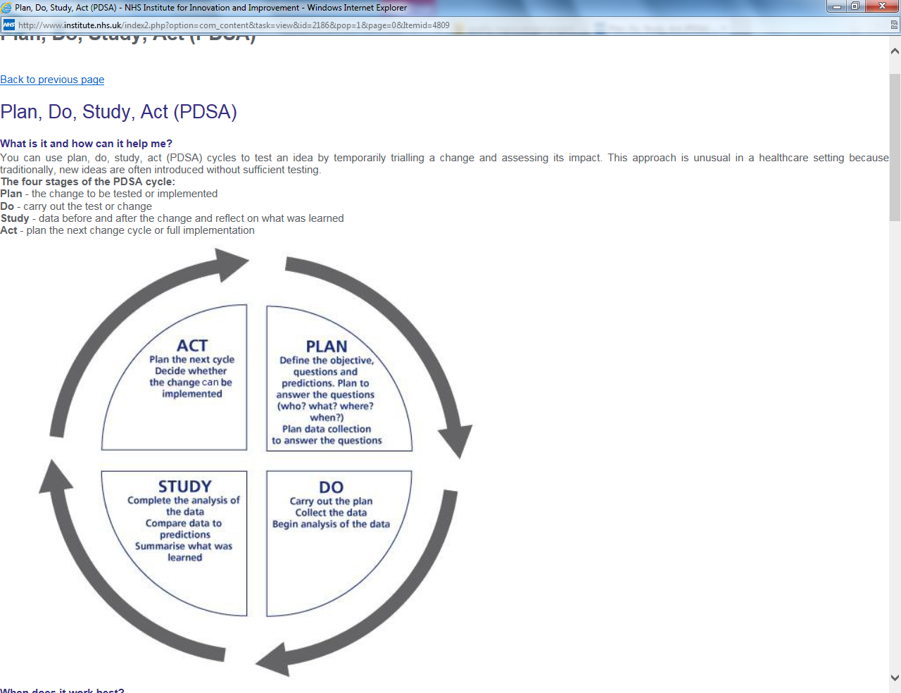

Your project might have several PDSA cycles running at the same time or sequentially.

For example if the initial change has not achieved the results you were looking for, a simultaneous alternative might be looked at.

**PDSA cycles running sequentially**

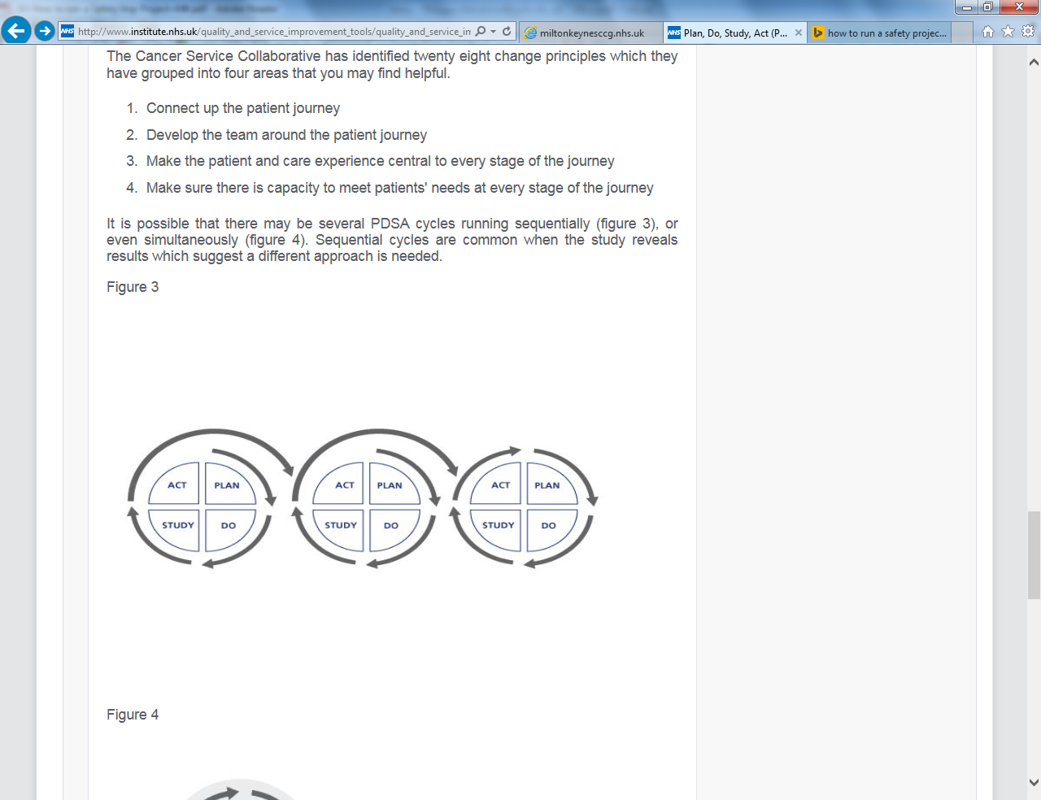

**Hunches, ideas and suggestions for change**

**Measuring your Quality Improvement**

**How do we measure the improvement produced by our small scale test of change?**

Typically we use run charts such as this:

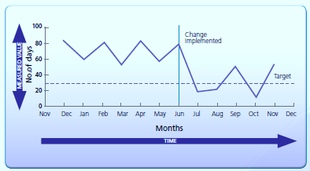

**Why do we use run charts?**

• To show how well a process is performing.

• They help determine over time when changes are truly

improvements by displaying a pattern of data that you can

observe as you make changes

**Measuring for Quality Improvement**

**What might a run chart for an improvement project look like?**

Percentage of items on ward round check list that are completed.

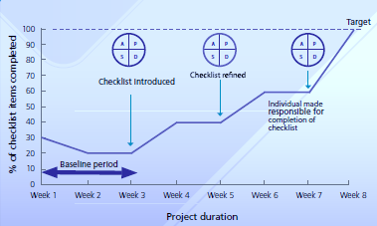

Annotate your run chart each time you make a change.

**Preparation and Progress Template**

|  |  |  |
| --- | --- | --- |
| **The three**  **Model for Improvement**  **Questions** | | |
| **Q1** | **Q1. What are you trying to accomplish?** | What am I trying to achieve? |
| **Q2** | **How will you know that a change is an improvement?** | How am I going to measure the impact?  How will I measure the baseline?  How will I set the target?  How will I measure my progress?  What will my run chart look like? |
| **Q3** | **What changes will you make that will result in an improvement?** | What improvement ideas do I have?  A small number of changes are most likely to succeed. |

**Preparation and Progress Template**

|  |  |
| --- | --- |
| **Now start your PDSA cycle** | |
| **PLAN**  Answer the questions:   * who, * what, * when, * where and * how? | Consider what the main steps are.    What improvements are you going to make?  What consequences may there be?  Could the change make something else worse?  How are you measuring it? |
| **DO** | Carry out the change.  Remember to collect your data. |
| **STUDY** | When will you review your data to see what progress you are making?  Remember to write down the learning from each PDSA cycle. |
| **ACT**  **8** | Use your learning to plan your next testing cycle or implement the change. |

|  |
| --- |
| **Who is at the meeting?**  **Mentor?**  **Date?** |
| **Objectives: What are you trying to achieve?** |
| **What test cycles have you completed?** |
| **What went well?** |
| **What obstacles did you encounter?** |

**Preparation and Progress Template**

|  |
| --- |
| **What are the next steps?** |
| **What is the run chart showing?** |
| **What were the surprises?** |
| **How did we address them?** |
| **Who should be taking these next steps and when should they happen?** |

**Example of a Quality Improvement Project (QIP)**

Examples of Quality Improvement Projects lead by Foundation Doctors at the Great Western Hospital can be viewed on Trust’s Quality Improvement Intranet pages. [Click here to view examples.](http://gwh-intranet/trust-wide/patient-safety-and-quality/500-lives/quality-improvement-coaching-and-peer-support-network/quality-improvement-toolkit.aspx)

**Background/Problem**

Junior doctors commonly make mistakes which may compromise patient safety. Despite the recent push by the NHS to encourage a “no blame” culture, mistakes are still viewed as shameful, embarrassing and demoralising events. The current model for learning from mistakes means that junior doctors only learn from their own errors.

**Data collection**

A survey was designed for all the Foundation Year 1 doctors (FY1s) at Yeovil District Hospital to understand better the culture surrounding mistakes, and the types of mistakes that were being made.

100% of the FY1s had made a mistake that could compromise patient safety. 63% discussed their mistakes with colleagues, 44% with seniors, and only 13% with their educational supervisor. Barriers to discussing mistakes included shame, embarrassment, fear of judgment, and unapproachable seniors.

**Change**

Using the results of the survey and the support of senior staff, a “Near misses” session has been introduced for FY1s once a month at which mistakes that have been made are discussed, with a consultant present to facilitate the proceedings.

The aims of these sessions are to promote a culture of no blame, feedback information to clinical governance, and share learning experiences.

**Results**

94% thought a “Near misses” session would be useful. After the third session 100% of the FY1s agreed that the sessions were useful; 53% had changed their practice as a result of something they learned at the sessions.

**Sustainability**

After discussing errors as a group we have worked with the clinical governance department, enacting strategies to avoid repetition of mistakes.

Feedback from the junior doctors has been overwhelmingly positive and we have found these sessions to be a simple, inexpensive, and popular solution to cultural change in our organisation.

Sinead Millwood (August 2014) “Developing a Platform for Learning from Mistakes: changing the culture of patient safety amongst junior doctors” BMJ Quality Improvement Programme [*http://qir.bmj.com/content/3/1/u203658.w2114.full*](http://qir.bmj.com/content/3/1/u203658.w2114.full)

**External Resources**

* Institute for Healthcare Improvement. [*http://www.ihi.org/Pages/default.aspx*](http://www.ihi.org/Pages/default.aspx)
* NHS Handbook of Quality and Service Improvement Tools [*http://www.miltonkeynesccg.nhs.uk/resources/uploads/files/NHS%20III%20Handbook%20serviceimprove.pdf*](http://www.miltonkeynesccg.nhs.uk/resources/uploads/files/NHS%20III%20Handbook%20serviceimprove.pdf)
* Francis Report 2013 - *Report of the Mid Staffordshire NHS Foundation Trust Public Inquiry (pdf)*
* Don Berwick. A promise to learn – a commitment to act (2013)[*https://www.gov.uk/government/uploads/system/uploads/attachment_data/file/226703/Berwick_Report.pdf*](https://www.gov.uk/government/uploads/system/uploads/attachment_data/file/226703/Berwick_Report.pdf)

**Internal contacts for QIP (specialty leads)**

|  |  |
| --- | --- |
| **Specialties** | **Contacts** |
| Cardiology |  |
| Respiratory |  |
| Gastroenterology |  |
| Nephrology |  |
| Neurology |  |
| DOME |  |
| ITU/Anaesthetics |  |
| General surgery |  |
| Trauma & Orthopaedics |  |
| Urology |  |

**References**

1. Batalden & Davidoff (2007) BMJ Quality & Safety Health Care 16**:**2-3 [*http://qualitysafety.bmj.com/content/16/1/2*](http://qualitysafety.bmj.com/content/16/1/2)
2. NHS institute for innovation and improvement [*http://www.institute.nhs.uk/quality_and_service_improvement_tools/quality_and_service_improvement_tools/plan_do_study_act.html*](http://www.institute.nhs.uk/quality_and_service_improvement_tools/quality_and_service_improvement_tools/plan_do_study_act.html)
3. NHS institute for innovation and improvement “How to run a safety improvement project” [*www.institute.nhs.uk/safercare*](http://www.institute.nhs.uk/safercare)

**Your notes**

____________________________________________________________________________________________________________________________________________________________________________________________________________________________________________________________________________________________________________________________________________________________________________________________________________________________________________________________________________________________________________________________________________________________________________________________________________________________________________________________________________________________________________________________________________________________________________