**CPD Training Request Form**

TT Information sent to requestor :-

Date request to be removed :-

CPD Request Rec’d :-

Thank you for applying for CPD funding. Please complete this form if you require Academy funding for a training course. The completed form should be sent to GWH Academy; [CPD.Requests@gwh.nhs.uk](mailto:CPD.Requests@gwh.nhs.uk) to CPD Administrator, The Academy, Lower Ground Floor, Great Western Hospitals NHS Foundation Trust, Marlborough Road, Swindon SN3 6BB.

|  |
| --- |
| 1. **Applicant details**   First name:_______________ Surname:__________________Job title:____________________  Ward/Dept: ___________________ Division:___________________ Band: ________________  Work address inc’ postcode: _______________________________________________________  Work tel. no. _____________Work e-mail:_______________Mobile no: ____________________  Permanent / fixed term / Bank employee (please circle) |

|  |
| --- |
| **2. Training course/event details**  Module Name: __________________________________Module Number(s): _________________  Number of Modules applied for: ______ Start date/End date: _______________________________  Cost per Module: ___________ Provider: _____________________________________________ |
| **3. Cost and application for funding**  Total cost of learning event: £ ___________ excl. VAT  How much of this are you requesting funding for? £ ___________ excl. VAT  Does this course/module form part of a degree programme? **YES / NO** (delete as applicable) |

|  |
| --- |
| **4. Why do you need to complete this training?**   1. Link to personal objectives 2. How will this learning benefit patients? 3. How will this learning benefit the service/ contribute to the Division’s Business Plan and organisation? |

**5. Divisional/ Departmental Support**

**(All expenses and study leave should be agreed before undertaking CPD activity)**

Number of study days required______Number requested______ Expenses requested________

**To be completed by line manager/ budget holder**

Is the CPD essential*?______Number of study days agreed_________Expenses agreed_______

I agree to reimburse expenses and allocate study leave (as per the CPD policy) as agreed as and expenses policy from my Department budget.

**Manager/ budget holder signature:__________________date:_________**

I agree to complete the CPD requested within allocated study leave and expenses as agreed.

**Staff member signature:___________________________date:_________**

*If CPD is deemed essential or mandatory, all expenses and study leave for attendance of learning should be supported, if desirable then this should be agreed at the manager’s discretion with the staff member.

|  |
| --- |
| **6. To be completed by the Manager:**  Name of manager: _______________________ Job title: ____________________________  Manager’s tel. no: _____________ Manager’s email address: ________________________   1. Was this training identified through the PDP formal appraisal process:      1. Why are you supporting this training? Please provide a brief rationale, including how the learning will benefit the service and link to the Division’s Business Plan. 2. As the manager, I have agreed with the applicant:    * Identified study leave    * Mandatory Training up to date    * learning will be shared with appropriate employee    * that the Academy is informed of the outcome (i.e. pass/fail/withdrawal/deferred) 3. As the manager, I understand I am responsible for ensuring training is attended, and to inform the Academy if the member of employee resigns.   Manager’s signature: _______________________________________________________  DD/DDD/Matron signature: ______________________Name:______________________ |

**Return of Service Agreement to Repay Training Expenses**

**TRAINING AGREEMENT**

|  |  |  |  |
| --- | --- | --- | --- |
| **Name** |  | **Tel/Ext number** |  |
| **Job Title** |  | **Cost of course** |  |
| **Course Title** |  |  |  |
| **Venue/Supplier** |  |  |  |
| **Date of course** |  | **End of Course** |  |
| **End of Return of Service Contract** |  |  |  |

1. In return for Swindon community services paying all or some of the training expenses in connection with my course of study, I will repay the Trusts investment as set out below

* Leaving before course completion or within 4 months = 100% payback.
* Failure to submit course assignments resulting in course failure = 100% payback
* Failure to attend course or complete course = 100 % payback
* Leaving between 4 and 8 months of course completion = 75% payback.
* Leaving between 8 and 12 months of course completion = 50% payback

1. In the event of my death, or if I leave GWH on the grounds of redundancy or permanent ill health, I understand I will not be required to repay any training expenses.
2. I understand that I may submit an extenuating circumstances form. If my circumstances are deemed to be exceptional then the return of service may be waived.
3. I agree that the Director of Finance and IT may deduct any money I owe the Trust in accordance with this agreement either from my salary or from any superannuation refund or from any money due to me or held on my behalf by the Trust or from a combination of any of these sums. This is without prejudice to the Trust’s other rights to recover any amount due.

|  |  |  |
| --- | --- | --- |
| Signature of learner: |  | Date : |
| Print Name: |  |  |
| Signature of Manager: |  | Date : |
| Print Name: |  |  |

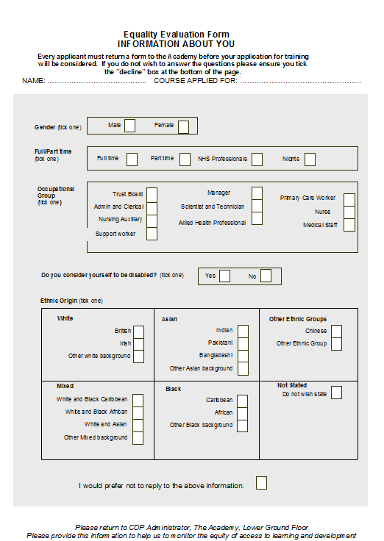

**Check list - before you send this form to the Academy:**

**Check that you have completed all sections**

**(all incomplete forms will be returned)**

**Please attach supplier’s application form completed and signed.**

**Please complete the Return of Service Contract**

**Please complete the Equality Evaluation Form**

**Ensure the form is signed by your managers (wet signature is required)**

**Ensure that your mandatory training is booked/ compliant in all areas**

Please note that this form does not mean that you are booked onto your selected course even if funding is agreed.

The Academy will chase you once after we have informed you about your Training Tracker status. If we have not had a response 3 weeks we will automatically withdraw your request.

Please allow 8 weeks’ notice to get your request actioned and funding agreed.