**Femoral Nerve Block Guidelines**

Shelley Barnes (ACCS CT1), James Mcdonald (ACCS ST3)

**Benefits**

* Improved pain management and control.
* Decreases the need for opiate analgesia and hence decrease the risks associated with these.

**Risks**

* Failure of block to work
* Allergy to agent used
* Haematoma following vascular puncture
* Intravascular injection - avoided by aspiration prior to injection of agent.
* Local anaesthetic toxicity - avoided by careful calculation of dose and watching for signs of toxicity (tinnitus, peri-oral numbness, metallic tastes, confusion, seizures, tachycardia, hypertension, arrhythmias, cardiac arrest)
* Nerve damage
* Infection of injection site

**Dosing**

Bupivacaine 40mls of 0.25% providing patient’s weight >40kg.

(This should be an adequate strength and volume for all patients over 40 kg. Please seek senior advice for patients under 40kg)

**Dilution and Concentration**

Drug concentration is expressed as a percentage (for example bupivacaine 0.25%, lidocaine 1%).

Percentage is measured in grams per 100 ml (ie, 1% is 1 g/100 ml or 1000 mg/100 ml or 10 mg per ml).

Calculate the mg/ml concentration quickly from the percentage by moving the decimal point one place to the right ie Bupivacaine 0.25% = 2.5 mg/ml, Lidocaine 1% = 10 mg/ml.

**Pharmacokinetics**

Levobupivacaine has a long duration of sensory and motor peripheral blockade of approximate 14–16 hours. Onset of sensory and motor block was 6–10 min in brachial plexus nerve blocks and longer for larger diameter nerves, the onset time of sciatic nerve block is approximately 25–30 min.1

**Performing the Femoral Nerve Block**

1. Gain informed consent as appropriate (verbal is adequate, act in best interest if consent not obtainable).
2. Position the patient correctly – supine with the affected leg positioned to allow access to the groin as much as tolerated by the patient.
3. Stand on the side that is to be blocked facing the patient.
4. Mentally draw a line between the anterior superior iliac spine and the pubic symphysis - this is the inguinal ligament.
5. The femoral nerve passes through the centre of this line. It is most superficial in the inguinal crease.

[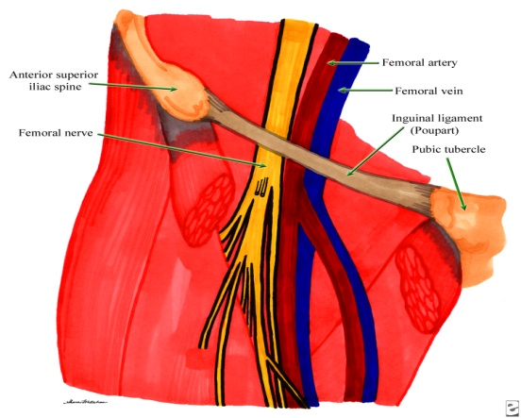](javascript:showrefcontent(%22refimage_zoomlayer%22);)

**Figure 1.**

1. Palpate the femoral pulse at the inguinal ligament and keep you finger on the pulse with your non-dominate hand.
2. Clean the skin and with a no-touch technique inserted the needle 1-1.5cm lateral to the artery at the midpoint of the inguinal ligament (the nerve divides approx 2cm below this point). The nerve is 3-4cm from the skin.12
3. Two distinct ‘pops’ maybe felt as the fascia lata and fascia ilaca are crossed.
4. Aspirate and ensure there is no blood before injecting the local anaesthetic. Stop if there is blood and reposition the needle and re-aspirating or resistance to injection (you may be inside the nerve and risk causing nerve damage).
5. Document: consent, technique, and number of passes, drug and volume used, date, time, your name and position.

**References**

1. [Crina L Burlacu](https://web.nhs.net/owa/redir.aspx?C=iYREbgYyZkmEdPXqT76dEbKiYH2exM9Iu_Vk8ow7JgISL7_QpOCNn2pMt-j0lkMEnoweuyu7Gi0.&URL=http%3a%2f%2fwww.ncbi.nlm.nih.gov%2fpubmed%2f%3fterm%3dBurlacu%2520CL%255Bauth%255D) and [Donal J Buggy](https://web.nhs.net/owa/redir.aspx?C=iYREbgYyZkmEdPXqT76dEbKiYH2exM9Iu_Vk8ow7JgISL7_QpOCNn2pMt-j0lkMEnoweuyu7Gi0.&URL=http%3a%2f%2fwww.ncbi.nlm.nih.gov%2fpubmed%2f%3fterm%3dBuggy%2520DJ%255Bauth%255D). Ther Clin Risk Manag. 2008 April; 4(2): 381–392.

**Figure 1.** [*http://emedicine.medscape.com/article/1143675-overview*](http://emedicine.medscape.com/article/1143675-overview)