|  |  |
| --- | --- |
|  |  |
| U:\Research and Development\GCP Training\Clip Art\Research 2 Clip Art.png | ***RESEARCH & INNOVATION***  **Trial Recruitment Newsletter** |
| June 2017 | Volume 2, Number 3 |
| **In This Issue**   * Message from the R&I Manager * Top Recruiting Trials This Month * Trial News * Research Training * Trial Recruitment Update   Online Resources  [**Research & Innovation Intranet Pages**](http://gwh-intranet/trust-wide/research-and-innovation.aspx)  Information for researchers at GWH  [**Health Research Authority**](http://www.hra.nhs.uk/) **(HRA)**  The HRA protects and promotes the interests of patients and the public in health and social care research  [**National Institute of Health Research (NIHR)**](https://www.crn.nihr.ac.uk/)  The NIHR provides the infrastructure that allows high quality research to take place in the NHS  [**UK Clinical Trials Gateway**](https://www.ukctg.nihr.ac.uk/home/)  Links researchers to members of the public who might be interested in participating in a trial  [**West of England Clinical Research Network**](https://www.crn.nihr.ac.uk/west-of-england/)  Oversight of NHS research in the South West region | **Message from the R&I Manager**   Dear Principal Investigators and other research active staff,  We had an above average month for recruitment in June with a total of 80. This was largely due to the IMOX and SIGNUM trials. Thanks to everybody involved.  GCP Revision 2 went live in June. This makes some important additions to the current GCP guidelines. Please make sure you read the update in this newsletter and look out for the training pack which will be issued to all PIs before the end of July.  As the holiday season is now upon us, can I ask that all PIs who have not already responded to Dr Elizabeth Price’s email send their planned annual leave dates to either Suzannah Pegler or myself as soon as possible.  If you have any feedback, please email [Catherine.LewisClarke@gwh.nhs.uk](mailto:Catherine.LewisClarke@gwh.nhs.uk)  Regards  ***Catherine Lewis-Clarke*** |

# **Top Recruiting Trials - June 2017**

# **Good Clinical Practice - Revision 2**

* **GCP Revision 2** came into force on 14th June 2017. The revision does not change the existing GCP guidelines but makes additions to them in the following areas:
  + PI responsibilities and oversight
  + Reporting requirements
  + Risk based monitoring and inspection
* A revised **GCP Training Pack** will be issued to all PIs by the end of **July 2017**.
* PIs will then need to work through the accompanying training slides and sign the **Training Log** to confirm they have done so.
* For non-PIs involved in research at GWH, GCP Revision 2 will be communicated during normal training.

# **Trial News**

* GWH was the first UK site to perform a pulmonary artery sensor implant for the CardioMEMS study. The sensor has already been shown to be effective and so this study is assessing if it will be financially viable to use them at a cost of about £20,000 per patient. The study is led here by **Dr Paul Foley**.
* GWH was the first UK site to screen a patient for the **GSK 201842** trial. This study is a Phase 2 study using Rituximab and Belimumab in combination in Sjogrens patients and is led here by **Dr Elizabeth Price**.

**Research Team News**

* **Amanda Coulston** joined R&I on 11th June from LAMU as a Research Nurse.
* **Caroline Pensotti** joined R&I on 14th June from Sexual Health as a Research Nurse.
* See the feature on the R&I Team in the latest issue of [**Staff Room**](http://gwh-intranet/trust-wide/communications/communicating-with-staff/staff-room.aspx)

**Principle Investigators Annual Leave**

* If you have not yet responded to Dr Elizabeth Price’s email, please send the dates of your planned annual leave to either [Catherine.LewisClarke@gwh.nhs.uk](mailto:Catherine.LewisClarke@gwh.nhs.uk) or [suzannah.pegler@gwh.nhs.uk](mailto:suzannah.pegler@gwh.nhs.uk)

**Research Training**

**GCP Training**

* The following GCP training opportunities are available at GWH in 2017.

**Refresher GCP**                 Monday 10th July 09.00 – 13.00

**Introduction to GCP**        Thursday 7th September 09.00 – 16.30

* These sessions will all be held in the Academy and can be booked through Donna Burnham at West of England. Please email [donna.burnham@nihr.ac.uk](mailto:donna.burnham@nihr.ac.uk)

**Standard Operating Procedures**

* PIs are reminded that all of R&I’s approved Standard Operating Procedures (SOPs) are now available on the Intranet [here](http://gwh-intranet/trust-wide/research-and-innovation/standard-operating-procedures.aspx).
* Please pay particular attention to SOP009 **Capacity & Capability** which details the process to be followed in order to activate a research study here at GWH.

**Cancer Trials Publication**

June 2017 saw the publication of 3 major cancer trials in which GWH has participated:

**STAMPEDE**

***‘Once in a career feeling’ as trial shows offering prostate cancer drug earlier improves survival’***

This was the headline following the presentation of the latest results of the **Stampede** trial at the American Society of Clinical Oncology (ASCO) Annual Meeting in Chicago. The findings were presented by the CI, Nick James. Results show that men treated with abiraterone and prednisolone plus hormones are more likely to be alive at 3 years, than those treated with hormones alone. There were 184 deaths in the trial arm compared with 262 in the standard hormone arm. The trial drug combination also reduced severe bone complications. Discussions will now take place regarding implications for practice.

52 patients have participated in this trial at GWH, with 6 patients being randomised to the abiraterone arm.

Further information can be found on the Stampede trial website <http://www.stampedetrial.org/>

and Cancer research UK website <https://www.cancerresearchuk.org/>

**TACT2**

**Tact2** was an adjuvant breast cancer chemotherapy trial. Around 4,400 patients took part in the trial with 19 patients recruited at GWH.

The trial found that the oral chemotherapy drug, capecitibine was as effective at preventing cancer’s return as the alternative regime CMF when administered following epirubicin. The patients receiving capecitibine also experienced fewer side effects and had a better quality of life. The trial also tested whether having an accelerated course of epirubicin (given every 2 weeks instead of 3) was more effective or better tolerated, but this proved not to be so.

Further information is available on the Cancer Research UK website <https://www.cancerresearchuk.org/>

**SCOT**

**Scot** was a non-inferiority randomised study designed to determine whether 3 months of adjuvant chemotherapy with OxMdG or Xelox (physician/patient choice) in Stage III/high risk Stage II colorectal cancer is as effective as 6 months treatment. 6088 patients were recruited, with 39 of these at GWH.

The study has shown that 3 months adjuvant treatment is not inferior to 6 months treatment. There are other similar trials looking at this question, so the results of all the trials are awaited.

**Trial Recruitment Update**

**Recruitment by GWH Topic Area**

This data is taken from the Edge clinical trials database. It shows all open trials and those closed trials that have recruited at least one patient in 2017/18.

Anaesthesia Trials



Cancer Trials

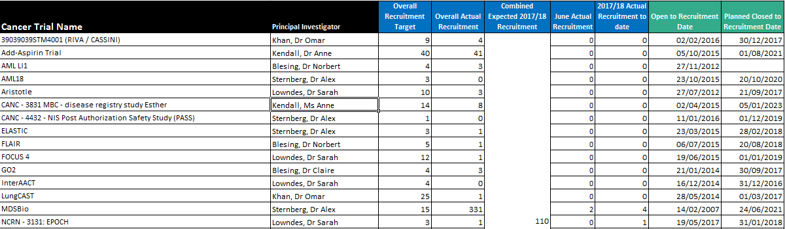

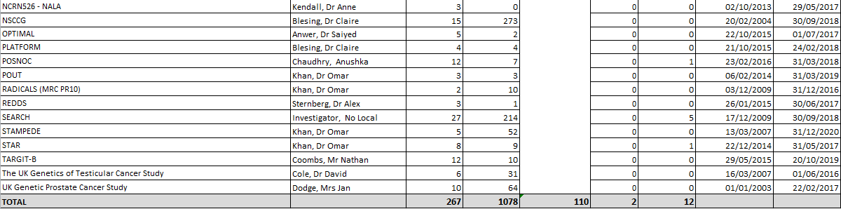

Cardiovascular Trials

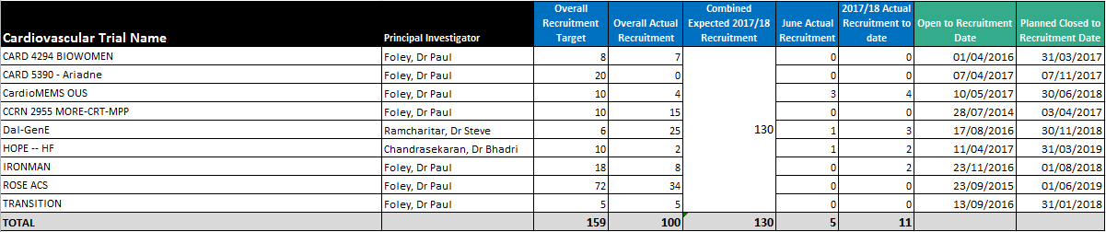

Children/Children’s Diabetes/Neonate Trials

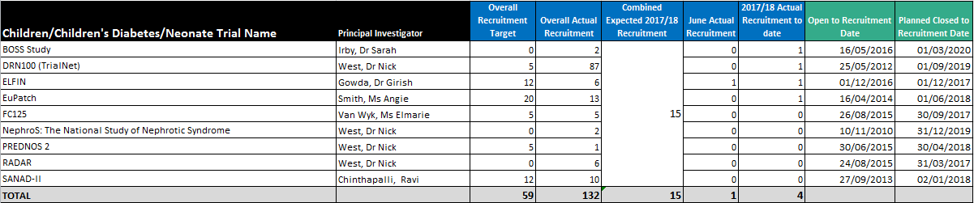

Delivery Research Trials



Diabetes/Metabolic & Endocrine Trials



ED Trials

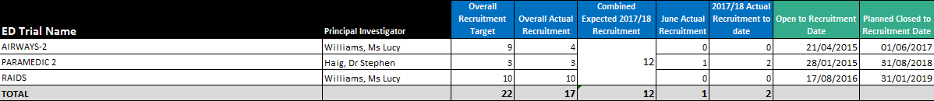

Gastroenterology Trials



Haematology (Cancer) Trials

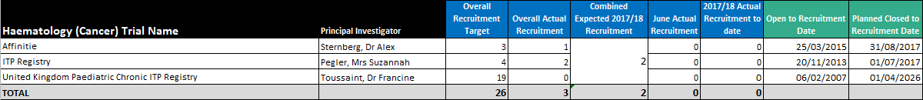

Infection Trials



Neurology Trials



Obs & Gynae Trials

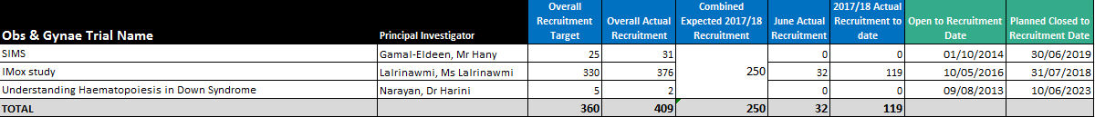

Respiratory Trials

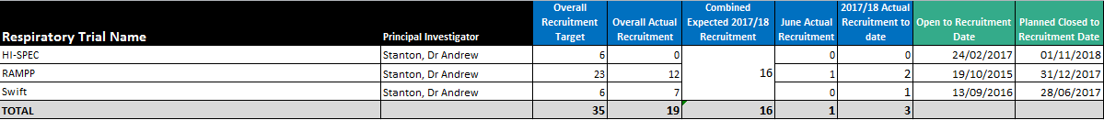

Rheumatology Trials

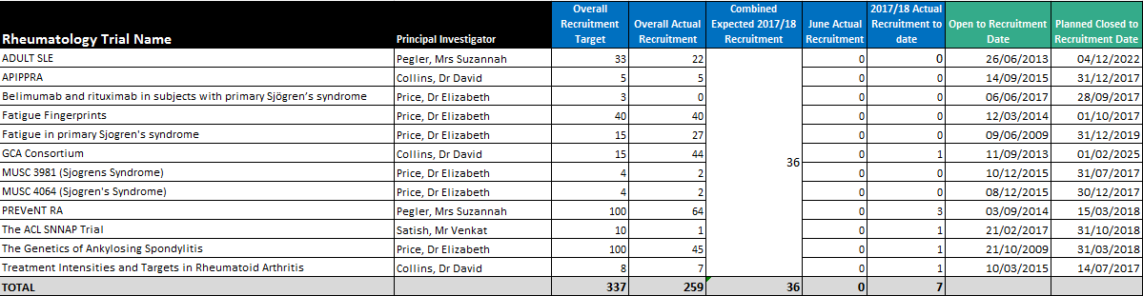

Stroke Trials

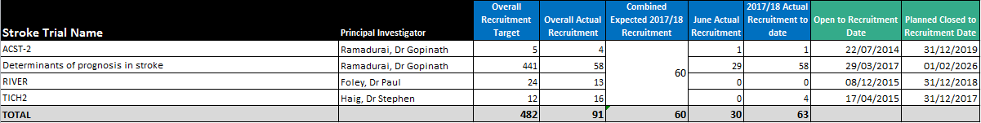

Recruitment by NIHR Classification

Key

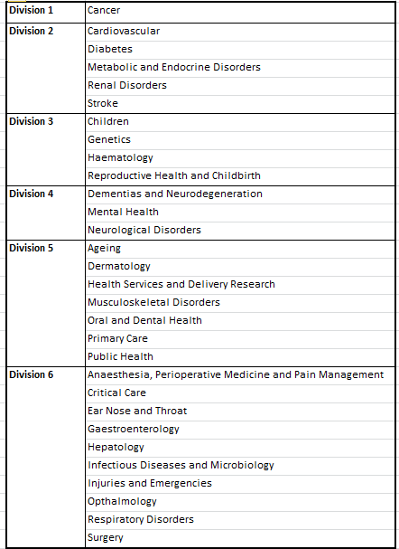

NIHR Division

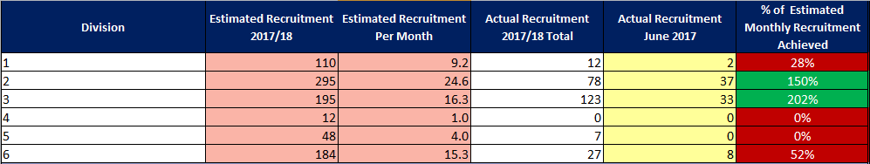

NIHR Disease Area

