|  |  |
| --- | --- |
|  |  |
| U:\Research and Development\GCP Training\Clip Art\Research 2 Clip Art.png | ***RESEARCH & INNOVATION***  **Trial Recruitment Newsletter** |
| May 2017 | Volume 2, Number 2 |
| **In This Issue**   * Message from the R&I Manager * Top Recruiting Trials This Month * Trial News * Research Training * Trial Recruitment Update   Online Resources  [**Research & Innovation Intranet Pages**](http://gwh-intranet/trust-wide/research-and-innovation.aspx)  Information for researchers at GWH  [**Health Research Authority**](http://www.hra.nhs.uk/) **(HRA)**  The HRA protects and promotes the interests of patients and the public in health and social care research  [**National Institute of Health Research (NIHR)**](https://www.crn.nihr.ac.uk/)  The NIHR provides the infrastructure that allows high quality research to take place in the NHS  [**UK Clinical Trials Gateway**](https://www.ukctg.nihr.ac.uk/home/)  Links researchers to members of the public who might be interested in participating in a trial  [**West of England Clinical Research Network**](https://www.crn.nihr.ac.uk/west-of-england/)  Oversight of NHS research in the South West region | **Message from the R&I Manager**   Dear Principal Investigators and other research active staff,  We recruited 82 patients in May versus a monthly target of 70. Well done to all.  Special mention must go to the IMOX trial; over the last few months it has consistently been the top recruiting trial at GWH, and this month exceeded its overall recruitment target of 330 patients. Thank you to everyone involved.  I would also like to thank everyone who attended R&I’s International Clinical Trials Day event on 19th May and helped to make it a great success. We had some very good feedback and I hope everybody was able to take away something positive from the day.  If you have any feedback, please email [Catherine.LewisClarke@gwh.nhs.uk](mailto:Catherine.LewisClarke@gwh.nhs.uk)  Regards  ***Catherine Lewis-Clarke*** |

# **Top Recruiting Trials May 2017**

# **Trial News**

* **Dr Bhadri Chandrasekeran** performed his first implant for the **HOPE HF** study. This study is testing if heart failure patients benefit from a pacemaker therapy called ‘His bundle pacing’.
* **Dr Paul Foley** recruited a global first for the **Cardiomems [Coast]** study, a great achievement.
* **IMOX** has exceeded the recruitment target of 330 patients. Congratulations and thank you to everyone involved!
* **Dr Elizabeth Price** has been accepted as national chief investigator for **Gileads Phase 2 Sjogrens Syndrome** study.

**Research Team News**

* **Amanda Coulston** will join R&I on 11th June from LAMU as a Research Nurse.
* **Caroline Pensotti** will join R&I on 14th June from Sexual Health as a Research Nurse.
* Look out for a feature on the R&I Team in the next issue of [**Staff Room**](http://gwh-intranet/trust-wide/communications/communicating-with-staff/staff-room.aspx)

**International Clinical Trials Day**

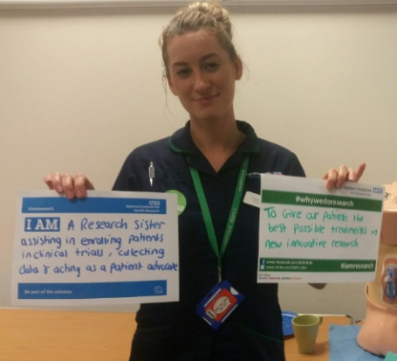 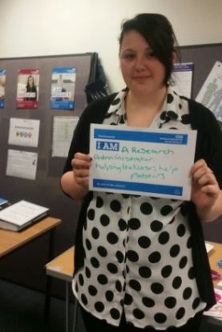 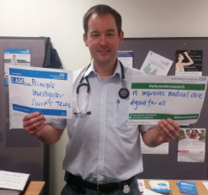

* On Friday 19th May R&I celebrated International Clinical Trials Day by holding an all-day event in the Academy. The aim of the day was to increase awareness of, and participation in, the extensive research programme taking place at the Trust. It was well attended and generated a very positive response. Thank you to everyone who came along.

**Research Training**

**GCP Training**

* The following GCP training opportunities are available at GWH in 2017.

**Introduction to GCP**        Friday 30th June 09.00 – 16.30

**Refresher GCP**                 Monday 10th July 09.00 – 13.00

**Introduction to GCP**        Thursday 7th September 09.00 – 16.30

* These sessions will all be held in the Academy and can be booked through Donna Burnham at West of England. Please email [donna.burnham@nihr.ac.uk](mailto:donna.burnham@nihr.ac.uk)

**Trial Recruitment Update**

**Recruitment by GWH Topic Area**

This data is taken from the Edge clinical trials database. It shows all open trials and those closed trials that have recruited at least one patient in 2017/18.

Anaesthesia Trials



Cancer Trials

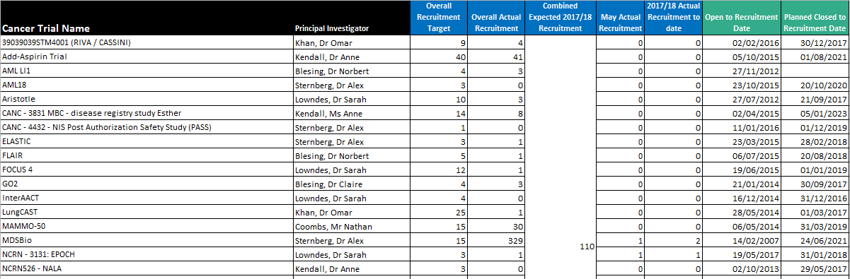

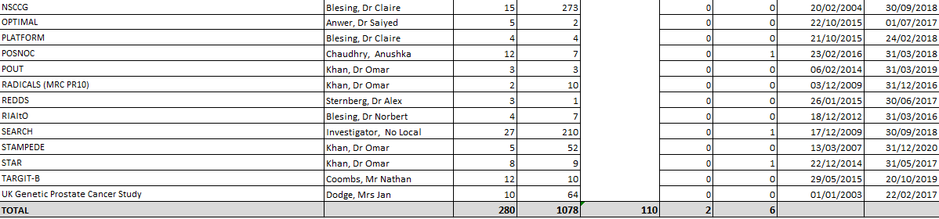

Cardiovascular Trials

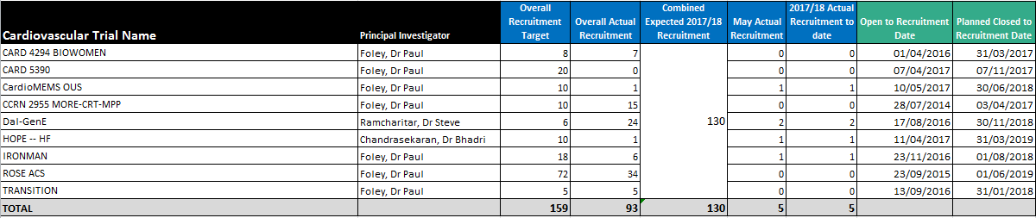

Children/Children’s Diabetes/Neonate Trials

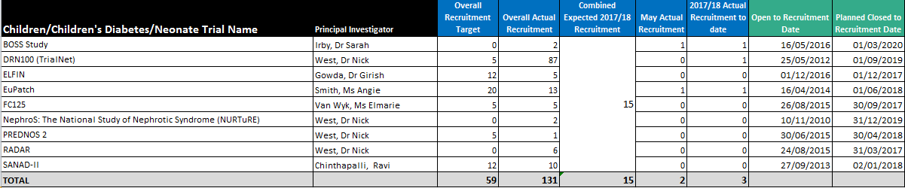

Delivery Research Trials



Diabetes/Metabolic & Endocrine Trials



ED Trials

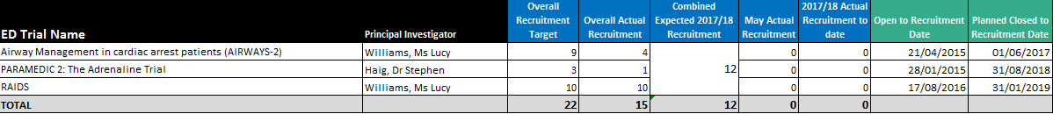

Gastroenterology Trials



Haematology (Cancer) Trials

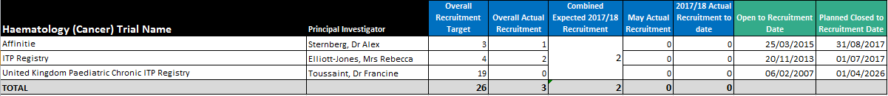

Neurology Trials



Obs & Gynae Trials

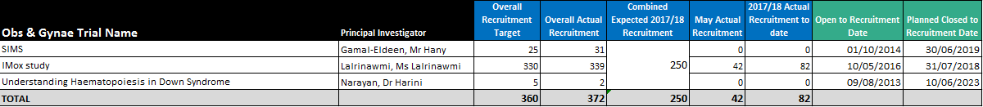

Respiratory Trials

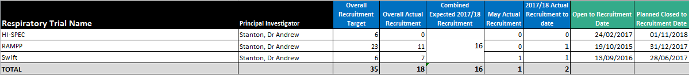

Rheumatology Trials

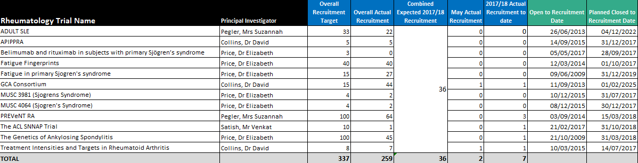

Stroke Trials

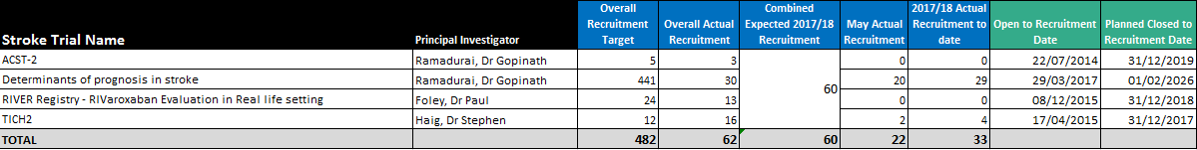

Recruitment by NIHR Classification

Key

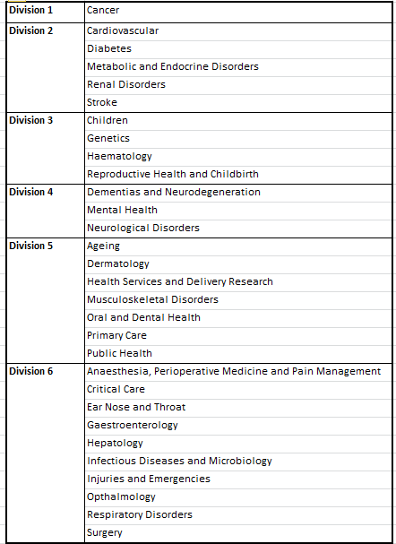

NIHR Division

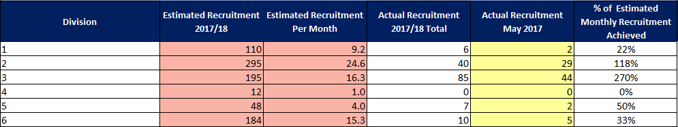

NIHR Disease Area

