|  |  |
| --- | --- |
|  |  |
| U:\Research and Development\GCP Training\Clip Art\Research 2 Clip Art.png | ***RESEARCH & INNOVATION***  **Trial Recruitment Newsletter** |
| April 2017 | Volume 2, Number 1 |
| **In This Issue**   * Message from the R&I Manager * Top Recruiting Trials This Month * Trial News * Research Training * Trial Recruitment Update   Online Resources  [**Research & Innovation Intranet Pages**](http://gwh-intranet/trust-wide/research-and-innovation.aspx)  Information for researchers at GWH  [**Health Research Authority**](http://www.hra.nhs.uk/) **(HRA)**  The HRA protects and promotes the interests of patients and the public in health and social care research  [**National Institute of Health Research (NIHR)**](https://www.crn.nihr.ac.uk/)  The NIHR provides the infrastructure that allows high quality research to take place in the NHS  [**UK Clinical Trials Gateway**](https://www.ukctg.nihr.ac.uk/home/)  Links researchers to members of the public who might be interested in participating in a trial  [**West of England Clinical Research Network**](https://www.crn.nihr.ac.uk/west-of-england/)  Oversight of NHS research in the South West region | **Message from the R&I Manager**   Dear Principal Investigators and other research active staff,  The 2017/18 recruitment year is underway and we’ve made a good start with 62 recruits in April.  I’m sure everybody will do their utmost to build on this positive start and make this a great year for Research at GWH.  It's International Clinical Trials Day in May and to celebrate, the Research and Innovation Team will be hosting a fun and informative day on **Friday 19 May**.    I’d like to invite everybody to come along to the Academy from 10am-4pm to find out more. Refreshments will be available all day.  If you have any feedback, please email [Catherine.LewisClarke@gwh.nhs.uk](mailto:Catherine.LewisClarke@gwh.nhs.uk)  Regards  ***Catherine Lewis-Clarke*** |

# **Top Recruiting Trials April 2017**

# **Trial News**

* We have had a number of studies start in the last month:
  + **HOPE-HF** a new pacing technique which involves direct bundle of his pacing. Patients who would otherwise not benefit from current pacing techniques are being invited to take part. The study coordinates visits at both the GWH and the Hammersmith hospital in London.
  + **GALACTIC** a new CTIMP study investigating the effectiveness of Omecamtiv Mercabil in patients with reduced ejection fraction heart failure.
  + **ARIADNE** is an observational trial comparing the outcomes of heart failure patients on standard care treatments with those who have been prescribed the new drug Sacubitril/valsartan (ENTRESTO).
* We have hit target for **TRANSITION** and have now seen 10 patients consented for **IRONMAN** -just 2 off the target of 12.
* **Dr Elizabeth Price** has been accepted as a National Chief Investigator for a Gilead Sjogrens Syndrome trial.

**International Clinical Trials Day**

* It’s International Clinical Trials Day in May and to celebrate Research & Innovation will be hosting a fun and informative day on **19th May** in the Academy. Come along between 10am – 4pm to find out more.
* If you would like to get involved or have any ideas about what you’d like to see at this year’s event, please email [suzannah.pegler@ghw.nhs.uk](mailto:suzannah.pegler@ghw.nhs.uk)

**Research Training**

**GCP Training**

* The following GCP training opportunities are available at GWH in 2017.

**Introduction to GCP**        Friday 30th June 09.00 – 16.30

**Refresher GCP**                 Monday 10th July 09.00 – 13.00

**Introduction to GCP**        Thursday 7th September 09.00 – 16.30

* These sessions will all be held in the Academy and can be booked through Donna Burnham at West of England. Please email [donna.burnham@nihr.ac.uk](mailto:donna.burnham@nihr.ac.uk)

**Improving Healthcare Through Clinical Research – Free Online Course**

* Sign up for the NIHR Massive Open Online Course (MOOC) ‘Improving Healthcare though Clinical Research’ which will start again on **May 22nd**
* The NIHR CRN teamed up with the University of Leeds and FutureLearn in November 2015 to develop the MOOC, which to date has seen over 18 thousand registrations from people wanting to learn more about how research can improve healthcare, from all over the world.
* The MOOC is a four week online course and is **free of charge**. Over four weeks the course includes;

·  Learning about the roles of different members of a research team

·  Hearing from people who have taken part in clinical research studies

·  The ethical and scientific principles that underpin the research process

·  Getting a better understanding of the challenges of conducting clinical research and the benefits

* This may be a useful learning opportunity for new members of staff or provide a new insight for those who have been in post for some time.  Further information can be found:
* Find out how medical treatments are discovered, tested and evaluated to improve healthcare for all on this free online course. Several members of the R&I Clinical Team have already completed it and found it very useful. To find out more and to register, click [here](http://www.nihr.ac.uk/our-faculty/clinical-research-staff/learning-and-development/national-directory/improving-healthcare-through-clinical-research.htm)

**Equipoise in clinical research**

* Find out what is meant by equipoise in clinical research and how it influences recruitment in this interview with Prof. Jenny Donovan from the University of Bristol (Business of Discovery Podcast, April 12, 2017).

<https://soundcloud.com/allangaw>

**Trial Recruitment Update**

**Recruitment by GWH Topic Area**

This data is taken from the Edge clinical trials database. It shows all open trials and those closed trials that have recruited at least one patient in 2017/18.

Anaesthesia Trials

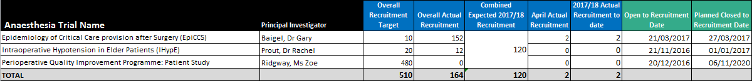

Cancer Trials

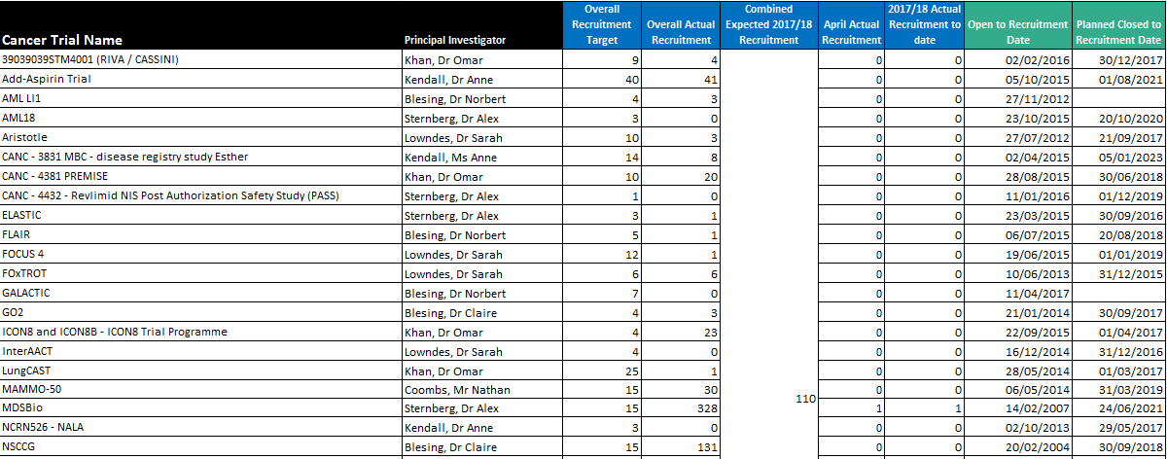

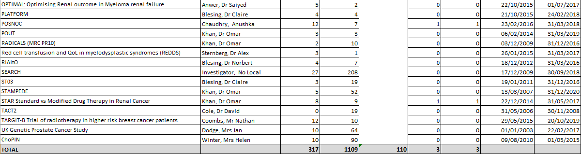

Cardiovascular Trials

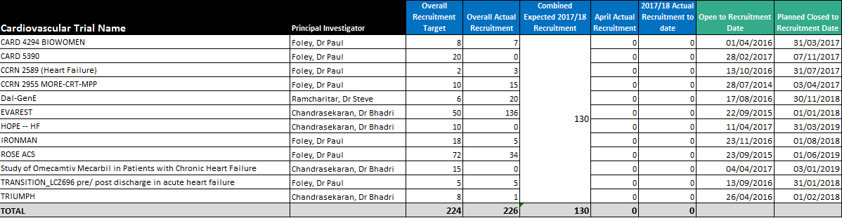

Children/Children’s Diabetes/Neonate Trials

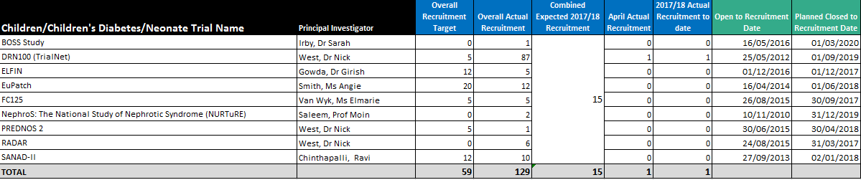

Delivery Research Trials



Diabetes/Metabolic & Endocrine Trials



ED Trials

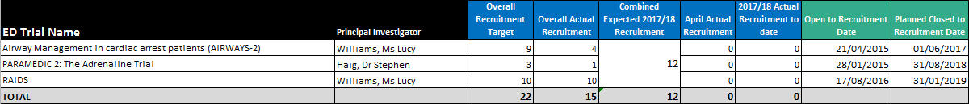

Gastroenterology Trials



Haematology (Cancer) Trials

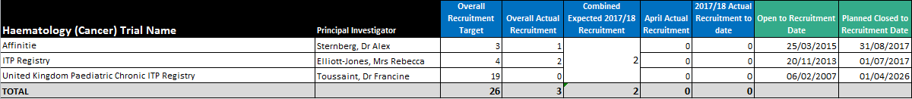

Neurology Trials



Obs & Gynae Trials

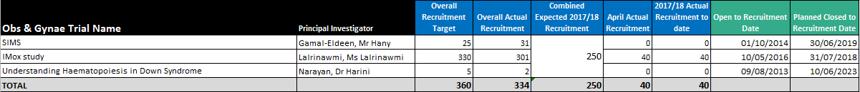

Radiography Trials



Respiratory Trials

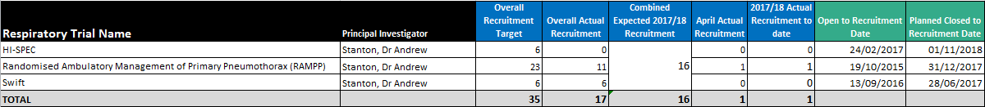

Rheumatology Trials

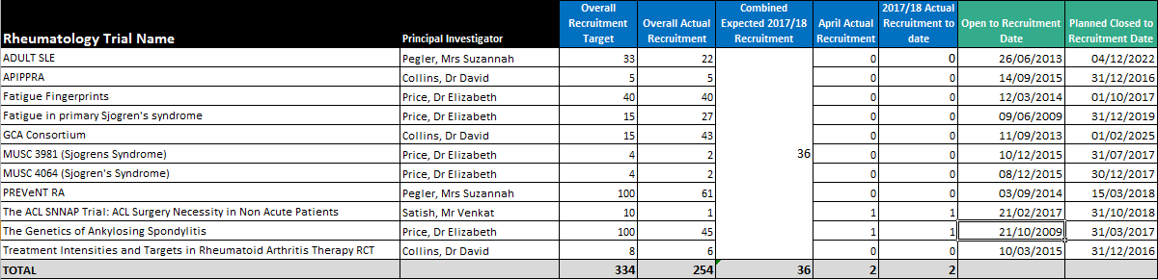

Stroke Trials

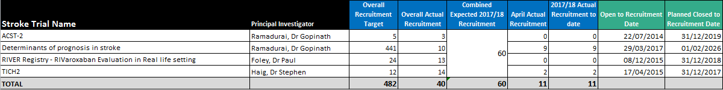

Recruitment by NIHR Classification

Key

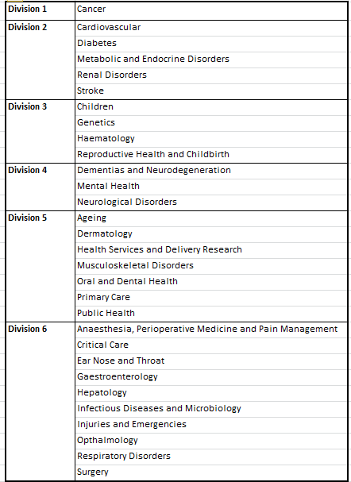

NIHR Division

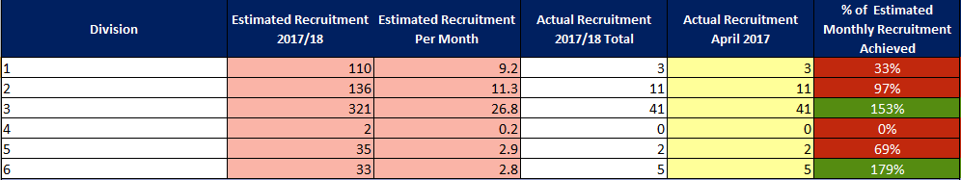

NIHR Disease Area

