|  |  |
| --- | --- |
|  |  |
| U:\Research and Development\GCP Training\Clip Art\Research 2 Clip Art.png | ***RESEARCH & INNOVATION***  **Trial Recruitment Newsletter** |
| July 2017 | Volume 2, Number 4 |
| **In This Issue**   * Message from the R&I Manager * Top Recruiting Trials This Month * Trial News * Research Training * Trial Recruitment Update   Online Resources  [**Research & Innovation Intranet Pages**](http://gwh-intranet/trust-wide/research-and-innovation.aspx)  Information for researchers at GWH  [**Health Research Authority**](http://www.hra.nhs.uk/) **(HRA)**  The HRA protects and promotes the interests of patients and the public in health and social care research  [**National Institute of Health Research (NIHR)**](https://www.crn.nihr.ac.uk/)  The NIHR provides the infrastructure that allows high quality research to take place in the NHS  [**UK Clinical Trials Gateway**](https://www.ukctg.nihr.ac.uk/home/)  Links researchers to members of the public who might be interested in participating in a trial  [**West of England Clinical Research Network**](https://www.crn.nihr.ac.uk/west-of-england/)  Oversight of NHS research in the South West region | **Message from the R&I Manager**   Dear Principal Investigators and other research active staff,  We have yet again recruited above target with 96 recruits in July. This is the fourth consecutive month that our target has been exceeded. Keeping this momentum going will ensure our annual target is met.  The 2nd August saw the release of the 2016-17 NIHR Research Activity League Table. Click [here](https://www.nihr.ac.uk/research-and-impact/nhs-research-performance/league-tables/league-table-details-2016-17.htm?ODSCode=RN3) to view this.  Overall the results are an indication that GWH is performing well, so thanks to all and please keep up the hard work.  If you have any feedback, please email [Catherine.LewisClarke@gwh.nhs.uk](mailto:Catherine.LewisClarke@gwh.nhs.uk)  Regards  ***Catherine Lewis-Clarke*** |

# **Top Recruiting Trials - July 2017**

# **Good Clinical Practice - Revision 2**

* As reported last month, **GCP Revision 2** came into force on 14th June 2017. The revision does not change the existing GCP guidelines but makes additions to them in the following areas:
  + PI responsibilities and oversight
  + Reporting requirements
  + Risk based monitoring and inspection
* A revised GCP Training Pack will be issued to all PIs by the end of August 2017.
* PIs will then need to work through the accompanying training slides and sign the Training Log to confirm they have done so.
* For non-PIs involved in research at GWH, GCP Revision 2 will be communicated during normal training.

# **Trial News**

* The site initiation visit for **SERENA** took place on 18th July and shortly afterwards GWH recruited the first patient by any UK site. SERENA is a long-term observational study to collect real life data on psoriasis, psoriatic arthritis or ankylosing spondylitis patients taking Cosentyx. It is led here by **Dr Sara Carty**.
* GWH was also the first UK site to screen a patient for the **GSK 201842** trial. This study is a Phase 2 study using Rituximab and Belimumab in combination in Sjogrens patients and is led here by **Dr Elizabeth Price**.
* GWH was the first European site to perform a pulmonary artery sensor implant for the **CardioMEMS** study. The sensor has already been shown to be effective and so this study is assessing if it will be financially viable to use them at a cost of about £20,000 per patient. The study is led here by **Dr Paul Foley**.

**Research Team News**

* **Natasha Beck** left R&I on 27th July. We thank her for all her hard work and wish her well in her new role at Bristol Royal Infirmary.

**Principal Investigators Annual Leave**

* If you have not yet responded to Dr Elizabeth Price’s email, please send the dates of your planned annual leave to either [Catherine.LewisClarke@gwh.nhs.uk](mailto:Catherine.LewisClarke@gwh.nhs.uk) or [suzannah.pegler@gwh.nhs.uk](mailto:suzannah.pegler@gwh.nhs.uk)

**GCP Training**

* One remaining GCP training opportunity is available at GWH in 2017:

**Introduction to GCP**  Thursday 7th September 09.00 – 16.30

* This session will be held in the Academy and can be booked through Donna Burnham at West of England. Please email [donna.burnham@nihr.ac.uk](mailto:donna.burnham@nihr.ac.uk)

**Trial Recruitment Update**

**Recruitment by GWH Topic Area**

This data is taken from the Edge clinical trials database. It shows all open trials and those closed trials that have recruited at least one patient in 2017/18.

Anaesthesia Trials



Cancer Trials

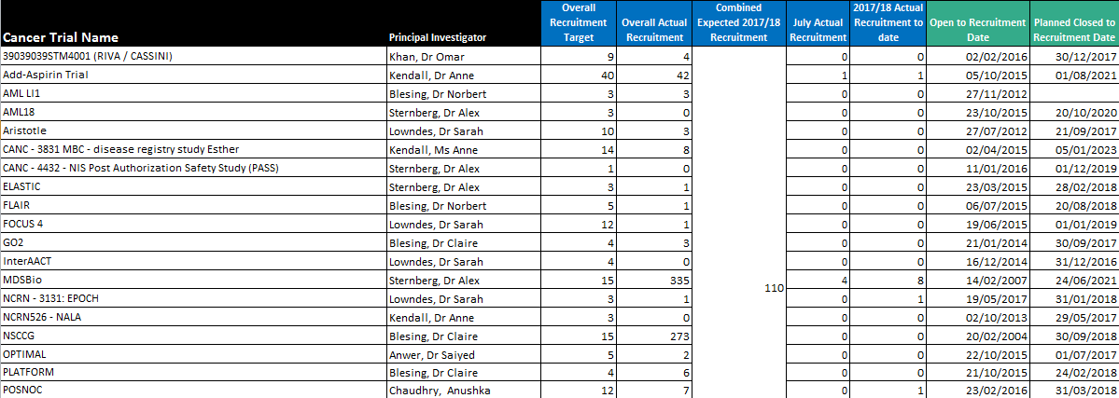

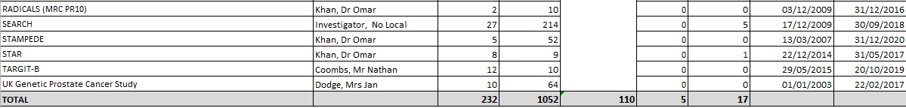

Cardiovascular Trials

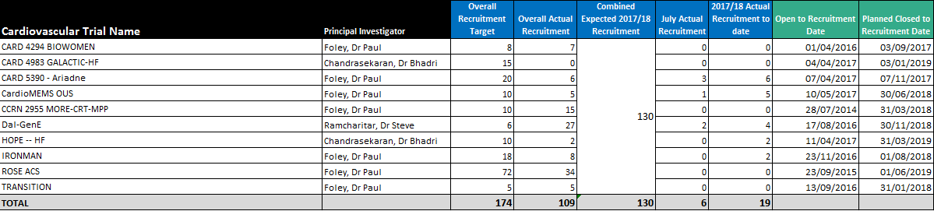

Children/Children’s Diabetes/Neonate Trials

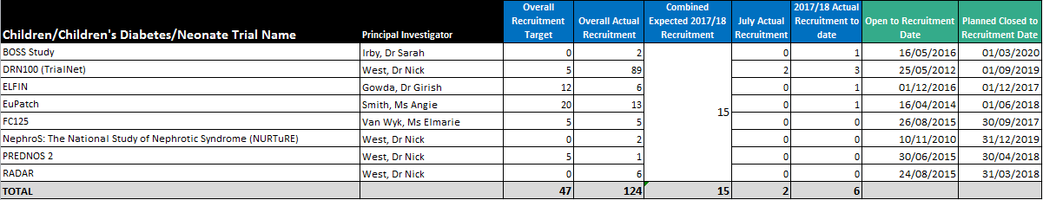

Delivery Research Trials



Diabetes/Metabolic & Endocrine Trials



ED Trials

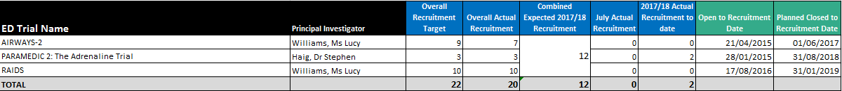

Gastroenterology Trials



Haematology (Cancer) Trials

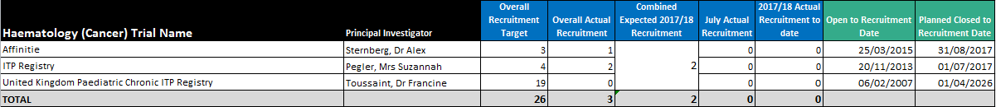

Infection Trials



Neurology Trials



Obs & Gynae Trials

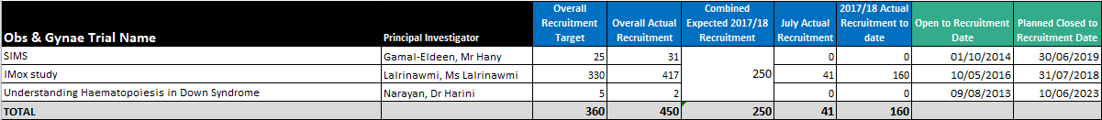

Respiratory Trials

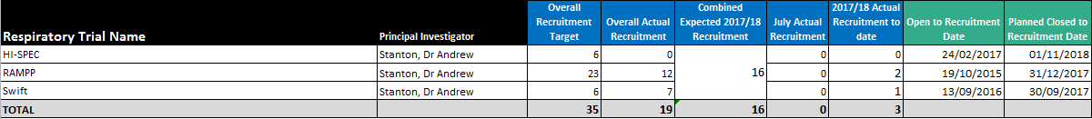

Rheumatology Trials

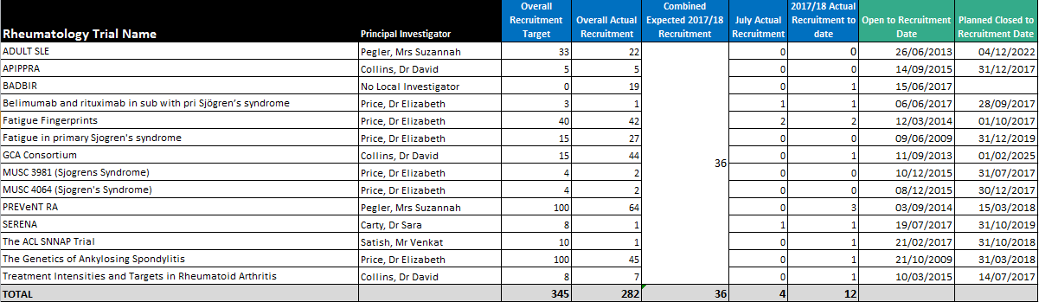

Stroke Trials

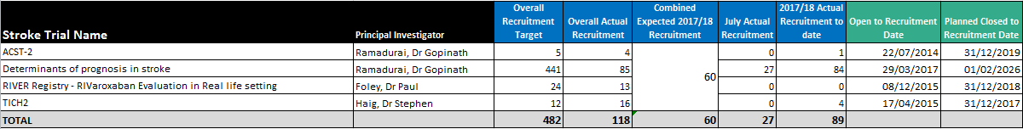

Recruitment by NIHR Classification

Key

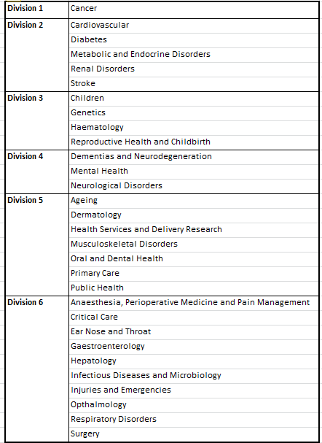

NIHR Division

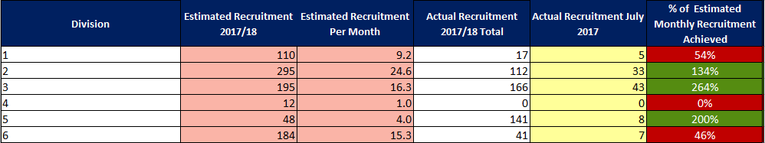

NIHR Disease Area

