# Wiltshire Health and Care: Corporate Identity Guidelines (July 2016)

### Introduction

Following these guidelines ensures we present ourselves consistently to all our stakeholders (patients, service users, visitors, members of the public, members and staff) and provides them with a clear message about the level of service and care they can expect from us, wherever they are across Wiltshire.

These guidelines must be followed when producing any printed materials or electronic media.

If you have any queries, please contact the Wiltshire Health and Care main administrative base:

01249 456565

or

[ask.wiltshirehealthandcare@nhs.net](mailto:ask.wiltshirehealthandcare@nhs.net)

### Wiltshire Health and Care Templates

Wiltshire Health and Care provided stationery templates must be used for all forms of communication. The templates that are available are listed below. If you feel these do not meet the requirements for what you need to produce, please contact the admin office above. Please do not create your own local versions, as it is important to keep a consistent approach. Electronic copies of these templates can be found on the intranet.

1. Generic Word document with follow on sheets
2. Letterhead
3. PowerPoint presentation
4. Compliments slip

### Email signatures

All email signatures should follow the template below, using Arial font, size 10, colour NHS dark grey (RGB: 66/85/99). The page colour of emails should always be white.

**<Firstname> <Secondname>**

**<Job title>**

**<Team/Service>**

<Address 1>

<Address 2>

<Post code>

Tel:  <xxxxx xxxxxxx>

Mobile: <xxxxx xxxxxx>

Email: <xxxx>

[www.wiltshirehealthandcare.nhs.uk](http://www.wiltshirehealthandcare.nhs.uk)



To change your email signature:

1. Copy the template text above, including the motif image, (highlight; right click; **Copy**).
2. Open Microsoft Outlook; click **File**; click **Options**.
3. In the window that appears, click **Mail**; click **Signatures**.

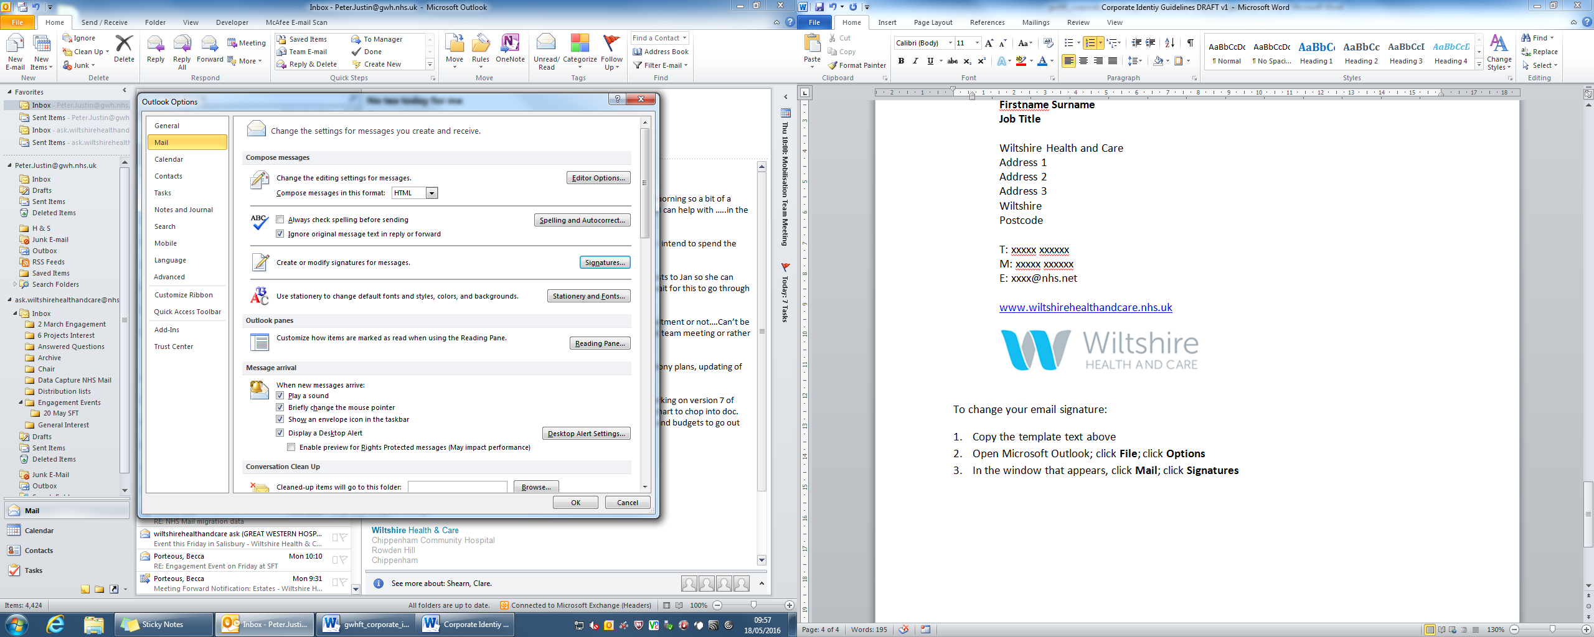

1. You will now be in the window to create and edit your email signature. Click **New** and enter a name for your signature when prompted; click **OK**. In the large empty box, right click and **Paste**. This should copy in the template text which you copied in step 1.

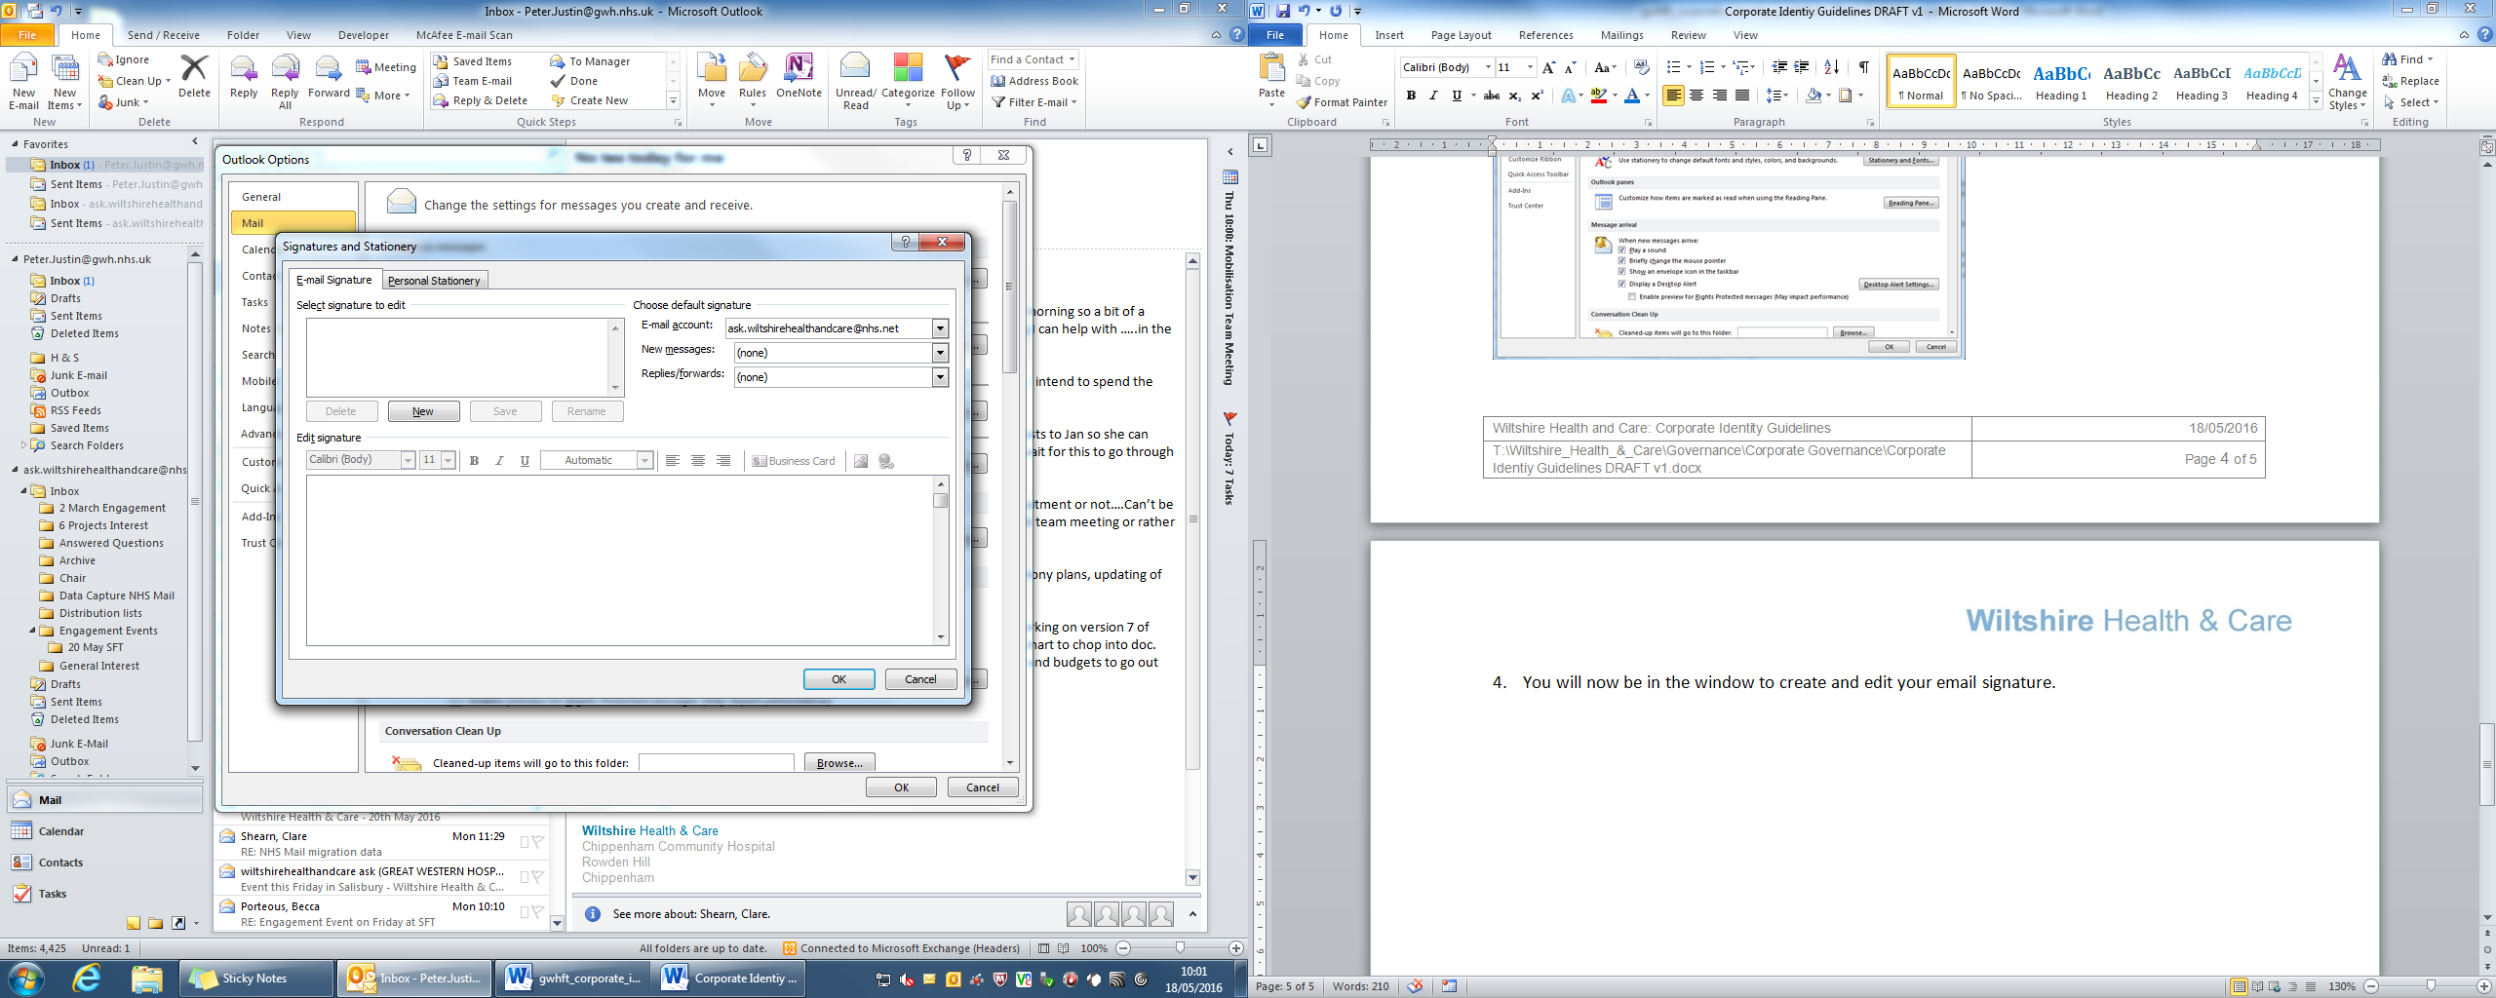

1. Now amend the template text, substituting in your own details.
2. Ensure that you use the drop down boxes to select your signature to display in **New messages** and in **Replies/forwards**.
3. Click **Save**; click **OK** on any remaining widows to return to Outlook.

### Out of office message for emails

When you are out of the office or away from a computer and therefore unable to read or respond to your emails (e.g. annual leave, planned sick leave, training day, etc), all staff should use the feature within Microsoft Outlook which automatically sends a reply to any emails received during this period.

All out of office messages should follow the template below, using Arial font, size 11, colour NHS dark grey (RGB: 66/85/99):

I am currently out of the office. I return on <date>.

For urgent issues, please contact <full name, job title, email address and telephone number of appropriate colleague>.

Otherwise, I will respond to your email when I return.

<Email signature>

To set an out of office message:

1. Copy the template text above, (highlight; right click; **Copy**).
2. Open Microsoft Outlook; click **File**; click **Automatic Replies (Out of Office)**.

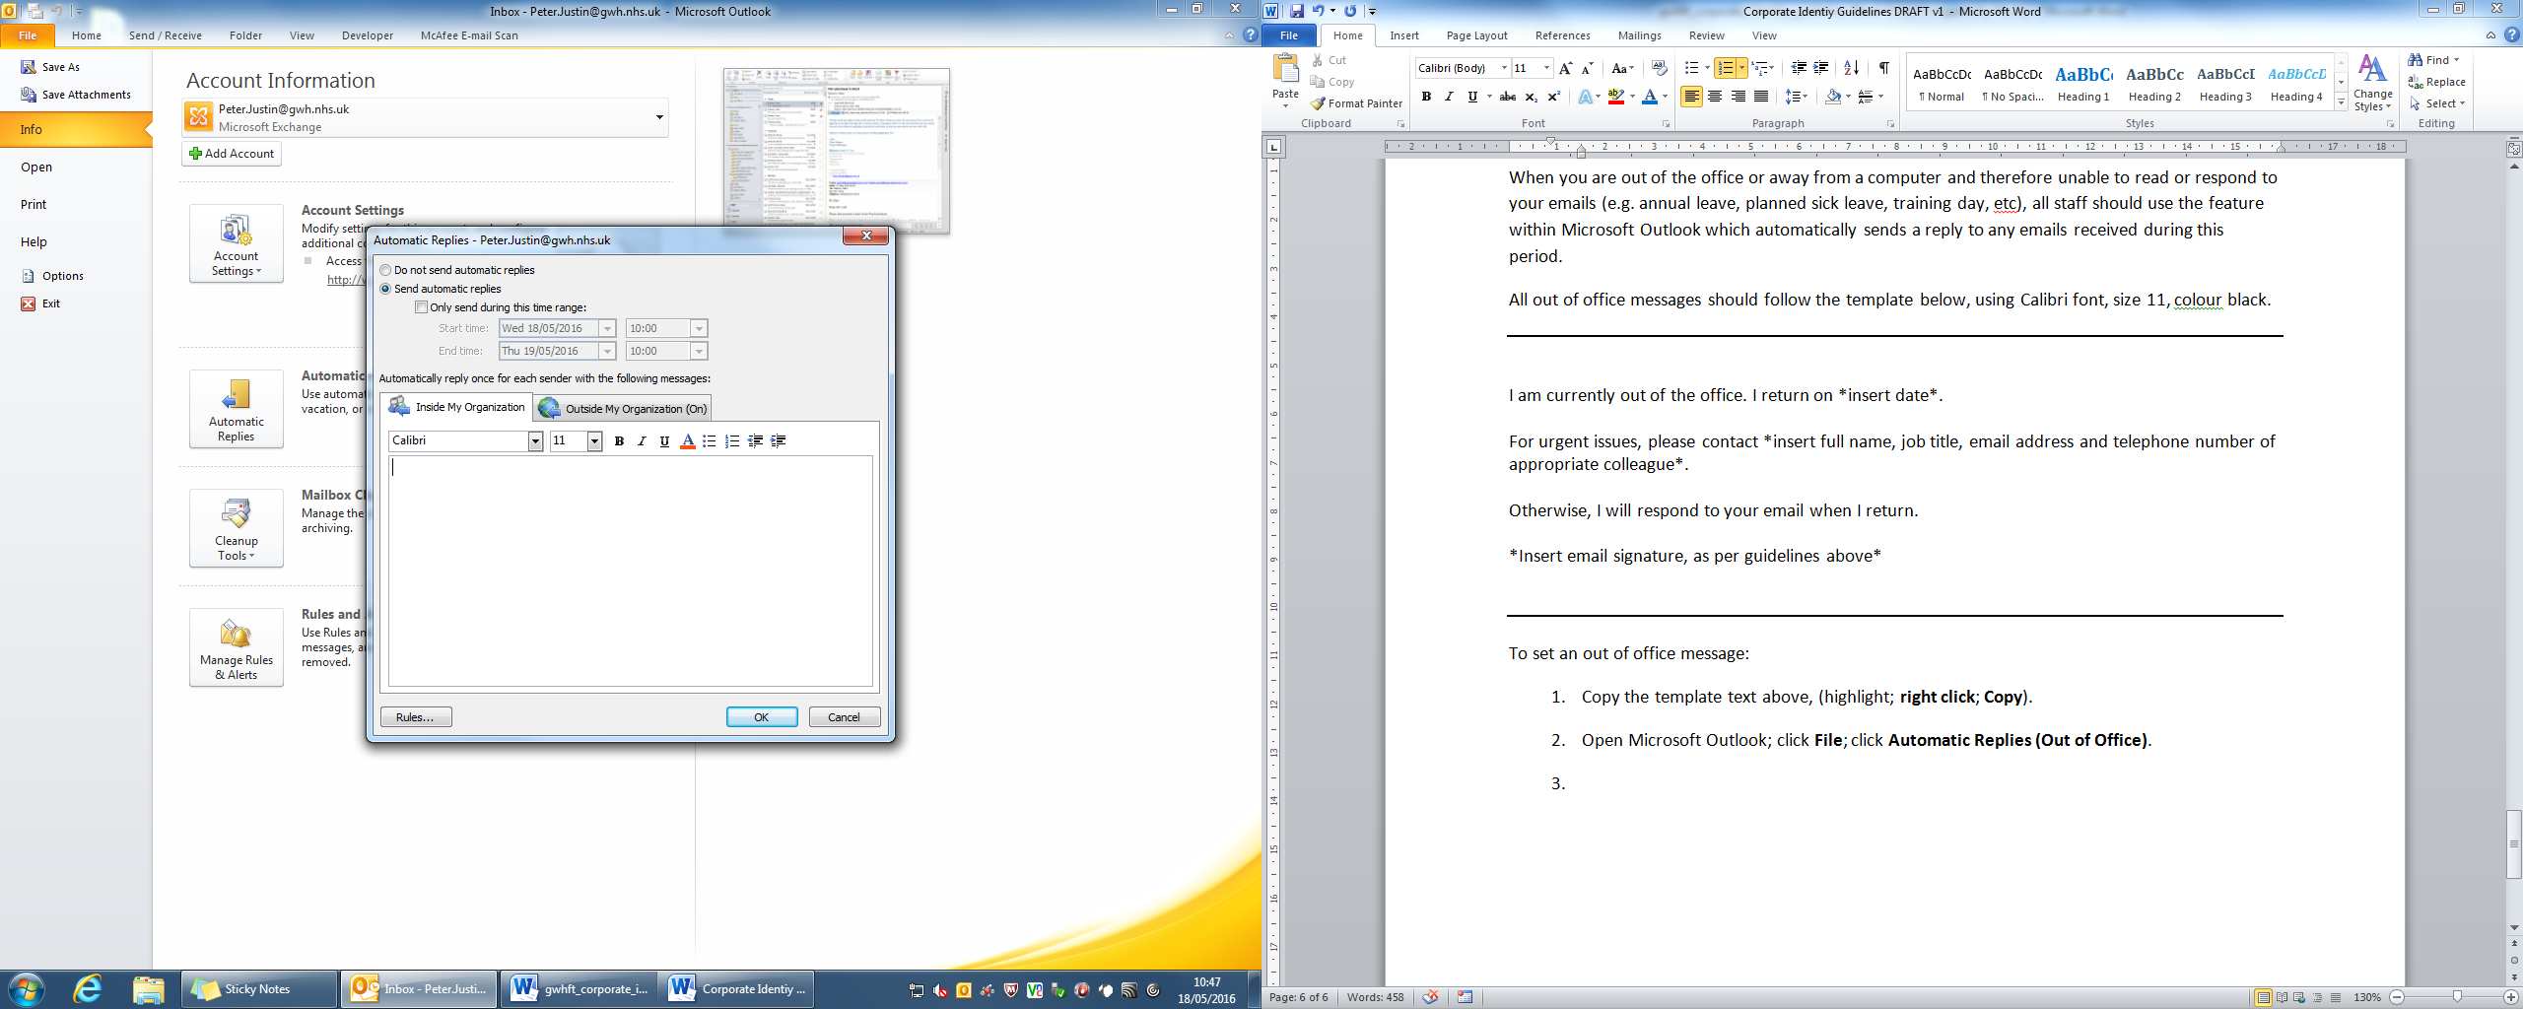

1. Click **Send automatic replies**; right click in the box and **Paste**. This should copy in the template text which you copied in step 1.
2. Now amend the template text, substituting in your own details. You should include your full email signature, as per the guidelines above.
3. Copy all of the text you have put into the box; click on the tab **Outside My Organisation**; right click in the box and **Paste**. This will ensure your message is sent to anybody who emails you.
4. Whenever possible, ensure that you have set the **time range** settings. This is the period of time you would like your automated out of office message to be sent. Using these settings ensures that the automated message does not accidentally continue to be sent after you return from leave.
5. Click **OK** to return to Outlook.

### How to Describe Wiltshire Health and Care

Wiltshire Health and Care should be written in full. The word “and” should always be used, never an abbreviation such as “&” or “+”.

Wiltshire Health and Care is an NHS partnership formed by the three local Foundation Trusts which serve Wiltshire:

* Great Western Hospitals NHS Foundation Trust
* Royal United Hospitals Bath NHS Foundation Trust
* Salisbury NHS Foundation Trust.

Wiltshire Health and Care are focused solely on delivering improved community services in Wiltshire and enabling people to live independent and fulfilling lives for as long as possible. Wiltshire Health and Care has been awarded the contract for adult community services in Wiltshire for at least the next 5 years.

When referring to Wiltshire Health and Care, do not refer to Wiltshire Health and Care as an ‘organisation’, refer instead to ‘the partnership’, as this covers both the Board decision making and the service delivery arrangements.