**Setting up NHSmail in Outlook**

For this process to work your network account (Active Directory) must be added to the **Cached_Exchange** (see ‘email arrangements information sheet’).

This facility is designed for staff that have a “one to one” relationship with their device (supplied & supported by GWH), which is where a user uses the same device all the time. A user can use multiple devices but the synchronisation will need to be done on all devices the user logs onto.

Once added to the group, your cache mode will be enabled on next logon and will start caching after you start outlook. Cache mode will allow you to access NHSmail via your Outlook client by synchronising data on NHSmail onto your local device.

This process may take some time and may slow your machine whilst the data is synchronised between the server and client. The time taken depends on how many mail items need to be synchronised and the link speed. This means it can be anything from a few seconds to hours. Subsequent synchronisation should be quicker, but again if the user uses multiple devices this can impact the time it takes.

**Open** Outlook

cid:image002.png@01D1B4F1.CA4543B0

Click on **File**

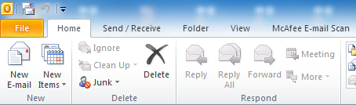

You should see the following **Page**

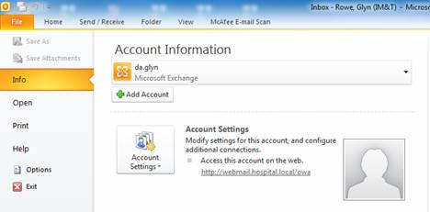

Click on **Add Account**

cid:image007.jpg@01D1B4F8.933B9660

You should see the following **Box**

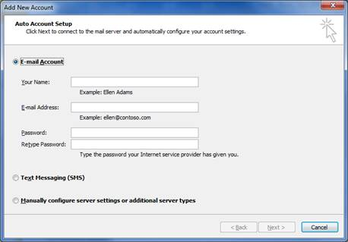

Enter your name and NHS email address into the appropriate fields

Your Name =

E-mail address = This is your personal NHS Mail address

Password = Leave blank

Retype Password = Again, leave blank

**Example:**

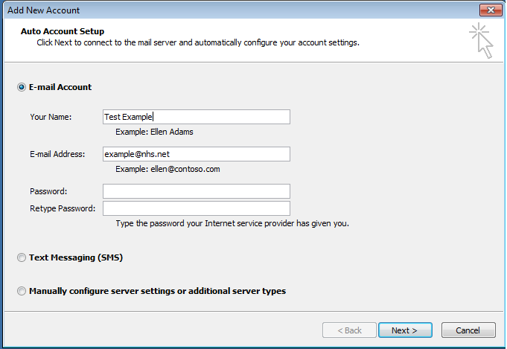

Click on **Next**

cid:image023.jpg@01D1B4F8.933B9660

You should see the following **Box**

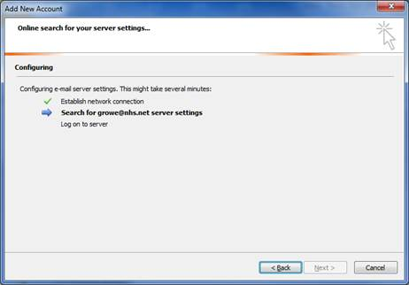

If all the information entered is correct, you should see the following **Box**

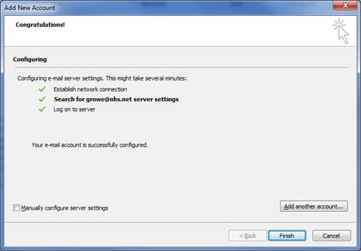

Click on **Finish** to reveal the following **Box**

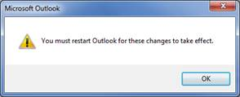

**Close** down Outlook

**Open** Outlook

cid:image002.png@01D1B4F1.CA4543B0

You will then be prompted to enter your **NHSmail** password

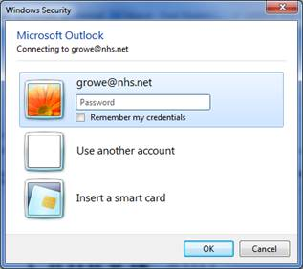

**Enter** your NHS MAIL password and click on **OK**

**DO NOT TICK ‘Remember my credentials’**.By design, the service will not remember your password, even if this option is ticked. More importantly, when using a PC running Windows 7, there is a known issue with Windows 7 meaning that if this box is ticked the password will be permanently recorded. As a result, when your password expires and you change it, the new password won’t work and you won’t be able to access your account.

When Outlook opens, on the right you will now see the NHSmail mailbox underneath your existing GWH mailbox, i.e.



Click on the arrow, to open the additional folders, i.e.

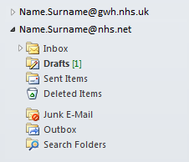

You are now setup and will be able to see in **Outlook**

* GWH Email
* NHS Email

**NHS Mail Changing Password**

The password for NHS Mail accounts expire after the mandatory 90 days.

Outlook will prompt you for login details but does not tell you that the issue is that the password has expired and therefore entering your usual password will not unlock the account.

However NHS Mail warns all staff via e-mail that states:

“your password will expire in x days”

“your password will expire in y days”

“your password will expire in z days”

You get about 10 of these.

To change the password you will need to log into the web version of NHS Mail which will give you a screen saying “password expired – enter new password”.

Note: You will not get any warning that this is the reason you can’t login using Outlook and there is no ability to change the NHS Mail password in Outlook.

**Please NOTE:**

**GWH DO NOT allow PST use in this Trust** (Outlook data files that stores your messages and other items on your computer)**.**

**Staff must NOT create PST files on local PC or Network drives.**