**Training Request Form**

This form should be completed if you require Continuing Professional Development (CPD) funding for a training course, ensuring the CPD application process below is followed.

**CPD Funding Application Process**

Learning must be identified at appraisal/supervision or team need, to ensure fair and equitable access to **very limited funds.**

Wiltshire Health and Care have access to 100 modules through the Health Education England contract with University of West of England which are effectively free but must be applied for through this process. These places will be prioritised over other training providers

Facilitating Workplace Learning is through [Elizabeth.dabner@gwh.nhs.uk](mailto:Elizabeth.dabner@gwh.nhs.uk)

**Fully completed funding application form to be received by funding panel at least 8 weeks before the course start date**

Staff member to complete funding request form

* All sections must be completed fully
* Link to personal objectives based on service need
* Link to organisational objectives ( see objectives/ service needs stated)
* How this will be shared with others ( not just at team meeting, expectation that it will be shared across other relevant teams, and evidence provided to support this e.g. lesson plan/ meeting minutes )
* Return of service completed

Must be signed by manager and sent electronically with course flyer/content/education provider details to [community.education@gwh.nhs.uk](mailto:community.education@gwh.nhs.uk)

**Administration;** Checks statutory/ mandatory compliance- contacts individual to identify gaps or returns form for completion if information missing

Recorded on spread sheet and kept for next CPD panel

* 1. Name
  2. Team
  3. Job role
  4. Title of course
  5. Provider
  6. Cost
  7. Part of degree programme
  8. Requests sent electronically to CPD panel for prior overview and vote.

**CPD panel** assess requests against

HESW module availability

NMP funds

Team or service needs

Transformational needs

Outstanding balance in CPD pot.

1. Only one module at a time to be applied for
2. **No** retrospective applications will be considered
3. No dissertation paid for
4. Course only funded, not travel or accommodation
5. Request approved or declined

Individual contacted electronically with decision and rationale.

Individual responsibility to apply to the provider stating funding source Wiltshire Health and Care once application agreed.

Administrator informs training provider of funding approval and requests invoice.

UWE database checked for funding/HESW authority request

Invoices to be raised by education provider

IR1 to be completed if cancellation of course at short notice, only if above procedure is followed.

**Panel members (tbc)**

Gabrielle Tilley

Sarah Jane Peffers

Sue Evans

Michelle Bacon

Caroline Davies

Heather Kahler

Gill Withington

Paul Mabey

Carol Langley Johnson

Helen Bailey or Sandra Burnell administrators

Plus others dependant on profession of applicant.

**Office use only:**

Mandatory Training

Compliant:

RoS complete/signed:

Equality Evaluation Complete:

**The completed form should be e-mailed, by your manager, to Helen Bailey/Sandra Burnell in the Community Training Team:** [**community.education@gwh.nhs.uk**](mailto:community.education@gwh.nhs.uk) **or posted to Community Training Team, Warminster Hospital, The Avenue, Warminster, BA12 8QS.**

|  |
| --- |
| **1. Applicant details**  Title: _______ First name: ______________________ Surname: ______________________  Job title: _________________________________________________________________  Dept: _________________________________ Directorate: _______________________  Work address inc postcode: __________________________________________________  _________________________________________________________________________  Work tel. no. _________________________ Work e-mail: ______________________  Mobile no. _________________________________  (if no work mobile please give personal, in case we need to contact you at short notice)  Grade: ____________________________  Permanent/fixed term or bank staff: ____________________ |

|  |
| --- |
| **2. Training course/event details**  **COURSE DETAILS:**  Module Name: ________________________________________________________________________  Module Number(s): ________________________________________________________________________  Number of Modules applied for: _______________________________________________  Does this course/module form part of a degree programme? **YES / NO** (delete as applicable)  Length of Course: _______________ Start date/End date: _________________________  Cost per Module: __________________ Provider: _______________________________  Please specify the number of hours/days required to undertake this learning:  _____________ Hours/days in own time  _____________ Hours/days within working hours  _____________ Total hours/days  Expected completion date of course/event: _____________________________________ |

|  |
| --- |
| **3. Cost and application for funding**  Total cost of learning event: £ ___________ excl. VAT  How much of this are you requesting funding for? £ ___________ excl. VAT  (Travel and Accommodation will not be paid for)  Does this course/module form part of a degree programme? **YES / NO** (delete as applicable)  Your Statutory/Mandatory training **MUST** be up to date, is it? **YES / NO** (delete as applicable) |

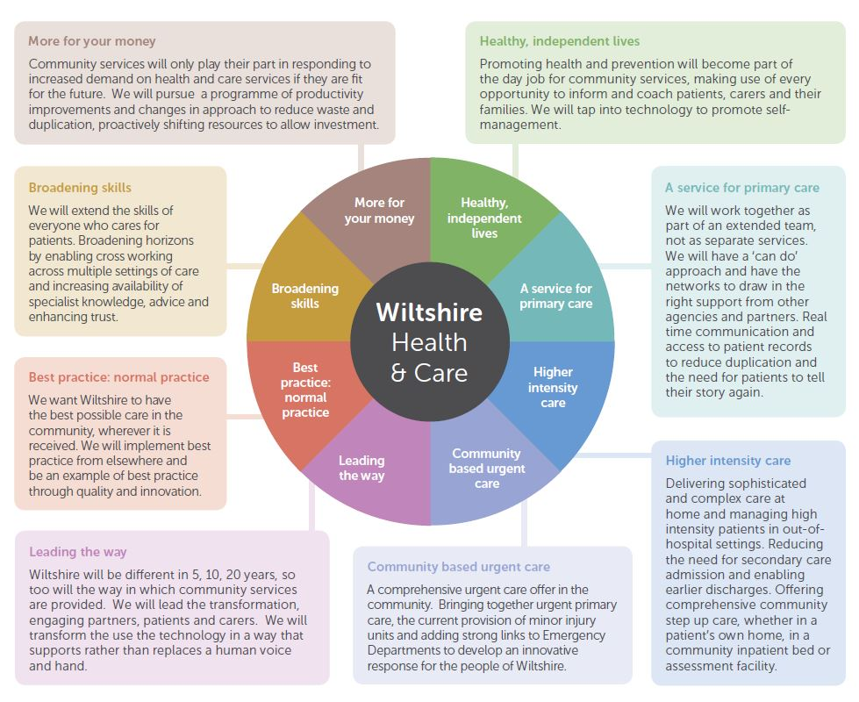

Wiltshire Health & Care will enable **people to live independent and fulfilling lives for as long as possible**.

We will achieve this through:

* working collaboratively and in partnership with others; Wiltshire residents,  commissioners, voluntary sector organisations and other health and social care providers
* ensuring home and community care is always the first option
* seeing the whole person, their story, physical, mental and social needs
* making it work every time through strong systems, technology, teamwork and trust

We have developed a programme of change which will inform our priorities. This diagram describes the main themes.

|  |
| --- |
| **4. Purpose of learning: why do you need to complete this training?**  **(please complete this section with your manager)**  PLEASE DO NOT USE ACRONYMS OR ABBREVIATIONS   1. Link to personal objectives, these must be linked to your appraisal( attach relevant copy) 2. Link to organisational/service objectives. You must show evidence of the links to the above. 3. How will you share the learning with your line manager and/or colleagues? You must be able to evidence your sharing i.e. lesson plans, minutes of meetings |

|  |
| --- |
| **5. To be completed by the Manager:**  Name of manager: _______________________ Job title: ____________________________  Manager’s tel. no: _____________ Manager’s email address: ________________________  Manager’s work location: _____________________________________________________  PLEASE DO NOT USE ACRONYMS OR ABBREVIATIONS   1. Was this training identified through the PDP formal appraisal process ( please attach relevant copy )   **YES / NO** (delete as appropriate)   1. Why are you supporting this training? Please provide a brief rationale linked to 5 year programme above. 2. As the manager, I have agreed with the applicant:    * Identified study leave (see section 2)    * Mandatory Training up to date    * learning will be shared with appropriate staff    * that the Education Department at [community.education@gwh.nhs.uk](mailto:community.education@gwh.nhs.uk) is informed of the outcome (i.e. pass/fail/withdrawal/deferred)      1. As the manager, I understand I am responsible for ensuring training is attended   **Manager’s signature: _______________________________________________________** |

**Return of Service Agreement to Repay Training Expenses**

**Wiltshire Health and Care**

**TRAINING AGREEMENT**

|  |  |  |  |
| --- | --- | --- | --- |
| **Name:** |  | **Tel/Ext number:** |  |
| **Job Title:** |  | **Cost of course:** |  |
| **Course Title:** |  |  |  |
| **Venue/Supplier:** |  |  |  |
| **Date of course:** |  | **End of Course:** |  |
| **End of Return of Service Contract:** |  |  |  |

1. In return for Wiltshire Health and Care paying all or some of the training expenses in connection with my course of study, I will repay the Trusts investment as set out below

* Leaving before course completion or within 4 months = 100% payback.
* Failure to submit course assignments resulting in course failure = 100% payback
* Failure to attend course or complete course = 100 % payback
* Leaving between 4 and 8 months of course completion = 75% payback.
* Leaving between 8 and 12 months of course completion = 50% payback

1. In the event of my death, or if I leave Wiltshire Health and Care on the grounds of redundancy or permanent ill health, I understand I will not be required to repay any training expenses.
2. I understand that I may submit an extenuating circumstances form. If my circumstances are deemed to be exceptional then the return of service may be waived.
3. I agree that the Director of Finance and IT may deduct any money I owe the Trust in accordance with this agreement either from my salary or from any superannuation refund or from any money due to me or held on my behalf by the Trust or from a combination of any of these sums. This is without prejudice to the Trust’s other rights to recover any amount due.

|  |  |  |  |
| --- | --- | --- | --- |
| **Signature of learner:** |  | **Date:** |  |
| **Print Name:** |  |  |  |
| **Signature of Manager:** |  | **Date:** |  |
| **Print Name:** |  |  |  |

Equality Evaluation Form

INFORMATION ABOUT YOU

Every applicant must return this form to the Community Training Team before your application will be considered. If you do not wish to answer the questions, please ensure you tick the ‘decline’ box at the bottom of the page. Please complete this information to help us monitor the equality of access to learning and development.

NAME: …………………………..... COURSE APPLIED FOR: ……….…………………………………

|  |  |  |
| --- | --- | --- |
| Gender  (tick one) | Male |  |
| Female |  |

|  |  |  |
| --- | --- | --- |
| Full/Part time  (tick one) | Full time |  |
| Part time |  |
| NHS Professionals |  |
| Nights |  |

|  |  |  |  |  |
| --- | --- | --- | --- | --- |
| Occupational Group (tick one) | Trust Board |  | Scientist & Technician |  |
| Admin & Clerical |  | Allied Health Professionals |  |
| Nursing Auxiliary |  | Primary Care Worker |  |
| Support Worker |  | Nurse |  |
| Manager |  | Medical Staff |  |

|  |  |  |
| --- | --- | --- |
| Do you consider yourself to be disabled? (tick one) | Yes |  |
| No |  |

|  |  |  |  |
| --- | --- | --- | --- |
| Ethnic Origin (tick one) | | | |
| White British  Irish  Other White Background |  | Black Caribbean  African  Other Black Background |  |
|  |  |
|  |  |
| Asian Indian  Pakistani  Bangladeshi  Other Asian Background |  | **Mixed** White & Black Caribbean  White & Black African  White & Asian  Other Mixed Background |  |
|  |  |
|  |  |
|  |  |
| **Other Ethnic** Chinese  **Origin** Other Ethnic Group |  | **Not Stated** Do not wish to state |  |
|  |  |

|  |  |
| --- | --- |
| I would prefer not to reply to the above information (decline) |  |