

**DIABETES**

**WORK BOOK**

**2015**

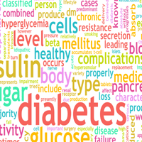

Name ……………………………………………….

Place of work………………………………….

Date completed…………………………………….

**CONTENTS**

Introduction 3

a) Aim

b) Learning made easy

c) Objective

Diabetes 5

Diagnosis 6

Aim of Treatment 9

Diabetes Medication 11

a) oral agents

b) Insulin

Low blood Glucose (hypoglycaemia) 18

High blood glucose (hyperglycaemia) and

Management of illness 21

Blood glucose monitoring 23

Food for Patients with Diabetes 24

Podiatry and Care of the feet 38

Useful Contacts 43

Websites 45

Knowledge for practice assessment 46

Evaluation `48

**Introduction**

This booklet has been designed for care home, community nursing and community hospital based staff. Registered Nurses who are employed by GWH are also required to complete the e- learning modules on Training Tracker which contains more in-depth information along with formative and summative assessments.

**Aim**

This work book is designed to update you with current knowledge and practice in caring for people with diabetes.

**Learning made easy....**

Step 1

* Follow and complete this workbook
* Submit the assessment for marking to the facilitator of your course

Step 2 - Getting help to learn

* You should contact a suitable practice supervisor/assessor within your work area, which will be able to guide and support you as you develop your knowledge.
* Formal contact with this person should be negotiated, allowing you to plan your development, review your progress, discuss and resolve any area of difficulty or uncertainty.

Step 3 - Ensuring compliance with local guidelines and professional practice

* Ensure you have accessed, read and understood your health care organisational guidelines/policies relating to Diabetes and any national guidelines that have been adapted for your clinical area

Step 4 – if you work for GWH foundation trust

Ensure the following modules are completed on Training Tracker: <http://smnhst.trainingtracker.co.uk>

* Ascensia Blood Glucose Meter –GWH staff only
* www.diabetes.nhs.uk/safe_use_of_insulin

free learning that is essential for staff that prescribe, prepare or administer)

Abbott and Neo blood glucose meters are used in community hospitals/neighborhood team.

Free Abbott and Neo Meters are available from Abbott

Contact Irena Griffiths for information regarding training and updates. -01985 224717

**DIABETES**

**What is Diabetes?**

Diabetes Mellitus is a condition in which there is too much glucose (sugar) in the blood. The glucose comes from the digestion of carbohydrate containing foods. We all need some glucose in our blood, but in diabetes it is not used properly and builds up in the blood stream.

Insulin is a hormone produced by the pancreas. It acts like a ‘key’ to open the cell and allow glucose to enter the cells so it can be used to provide energy.

In some one without diabetes their blood glucose will be between 4-7 mmols/l most of the time.

Diabetes is most common in people aged over 65 but can occur in any age group. There are over 3.8 million people with diabetes in the UK and 7 million people thought to be at high risk of developing diabetes. It is estimated that at least 1 in 10 patients will have diabetes.

Special care is required to promote the best possible health and wellbeing and to prevent avoidable complications of the disease and its treatment.

**DIAGNOSIS**

WHO (World Health Organisation) recommend

1. Diabetes symptoms plus

* a random venous plasma glucose concentration > 11.1 mmol/l   
  or
* a fasting plasma glucose concentration > 7.0 mmol/l

(whole blood > 6.1mmol/l)

* HbA1c>48
* Finger prick tests must be confirmed by laboratory venous glucose and HbA1c in all patients.

2. With no symptoms diagnosis should not be based on a single glucose determination but requires confirmatory plasma venous determination. At least one additional glucose test result on another day with a value in the diabetic range is essential, either fasting, from a random sample or from the two hour post glucose load. If the fasting or random values are not diagnostic the two hour value should be used

**Type I Diabetes**

Type 1 diabetes develops when the insulin-producing cells in the pancreas have been destroyed and the pancreas no longer produces any insulin. Type 1 diabetes usually arises in childhood or early adulthood, but can occur at any age, and accounts for about 10 % of all adults with diabetes. It is treated by daily insulin injections and by regulating carbohydrate intake.

### Type 2 Diabetes

A type 2 diabetes account for 80-85% of people diagnosed with diabetes and usually arises after age 40, and is associated with obesity and physical inactivity. The body is still able to make some insulin, but either not enough or the insulin produced does not work properly as the body has become resistant to insulin. It is treated by a healthy diet, regular physical activity and weight loss if overweight. Most people with Type 2 diabetes will also require medication to lower their blood glucose. Around half of people with Type 2 diabetes need insulin treatment within 5-10 years of diagnosis.

**Risk factors for developing type 2 diabetes**

**(The more risk factors that apply the greater the risk of developing type 2 diabetes.)**

* White ethnic origin and aged over 40 years old
* Black African, Afro-Caribbean, Chinese or South Asian ethnic origin and aged over 25 years old.
* Family history of type 2 diabetes
* Overweight (BMI > 25 kg/m2) or high waist size (31.5 inches or over in women; 35 inches or over in South Asian men and 37 inches or over in other men).
* History of high blood pressure /heart disease/ stroke
* Women with a history of polycystic ovary syndrome, gestational diabetes, or who have or have given birth to a baby over 10 pounds/4.5kg
* History of impaired glucose tolerance or impaired fasting glycaemia
* Increased risk in people taking steroid medication
* Increased risk in people who suffer from schizophrenia, bipolar illness or depression, or who have to take anti-psychotic medication

## SOME THINGS THAT DO NOT CAUSE DIABETES:

* Eating sweets and sugar does not cause diabetes, but eating a lot of sugary and fatty foods can lead to being overweight, which can cause type 2 diabetes.
* You cannot catch diabetes.
* Stress does not cause diabetes, although it may make the symptoms worse in people who already have the condition.

**Diabetes Symptoms**

Symptoms occur because the blood glucose levels are elevated. The body tries to reduce blood glucose levels by flushing the excess glucose out of the body via the kidneys, in the urine.

The main symptoms of undiagnosed diabetes are:

* passing urine more often than usual, especially at night
* urinary tract infections
* increased thirst
* extreme tiredness
* unexplained weight loss
* blurred vision
* genital itching or regular episodes of thrush
* slow healing of cuts and wounds
* increased risk of any infection

In Type 1 diabetes the symptoms tend to appear rapidly over a few days, whereas in type 2 diabetes the signs and symptoms may not be so obvious, as the condition develops slowly over a period of years and may only be picked up during at a routine medical checkup. It is good practice to screen all new patients, and any existing patients with the above symptoms for diabetes.

**Aims of treatment**

The aim of treatment is to achieve near normal blood glucose levels to prevent the above symptoms, and to reduce the risk of long term damage to the eyes, kidneys, nerves, heart and major arteries.

**Long-term complications of diabetes**

* Retinopathy (eye disease which can cause blindness)
* Damaged nerves and blood vessels can make feet vulnerable to ulceration
* Heart attacks and strokes
* Kidney disease

**Management of diabetes to maintain optimum health**

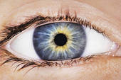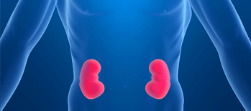

* Healthy Diet (low fat, high fibre, regulated amounts of carbohydrate)
* Weight loss advice if a person is overweight or obese
* Regular exercise (at least 30 minutes a day)
* No smoking
* Limiting alcohol intake to within UK government guidelines –3-4 units a day for men and 2-3 units a day for women
* Medication to control blood glucose, blood pressure and cholesterol levels

Each GP surgery should have a register of people with diabetes and contact them at least yearly for their annual review

In order to prevent and detect complications people with diabetes need regular (at least annual) checks of:

* + Blood pressure ( target 140/80 or below)
  + Blood tests to check kidney function and cholesterol
  + Urine test for albumin/creatinine ratio and microalbunuria
  + Blood test HbA1C (A 3 month average of blood glucose levels)
  + Weight and waist size checks
  + Foot circulation and nerve checks so that problems can be identified and treated early.
  + Eyes (retinal photograph at GP surgery and optician)

If a patient is housebound some opticians will undertake home visits.

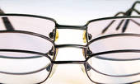

* NHS Podiatry Service is available for patients at high risk of ulceration.

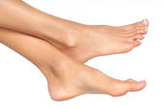

**EDUCATION GROUPS**

Regular sessions are run in all areas for people with diabetes- see contact numbers and websites at the back of this booklet for more details

**Diabetes Medication**

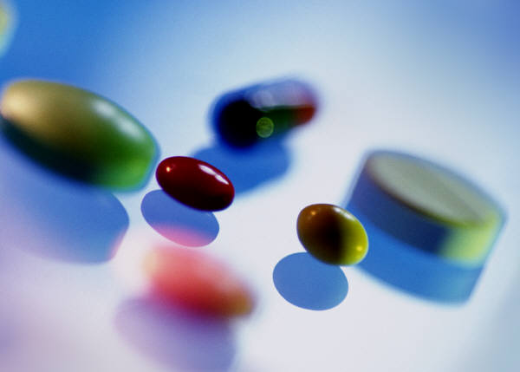

**METFORMIN (GLUCOPHAGE)**

This helps to reduce insulin resistance without the risk of hypoglycaemia. In some people it can cause gastric side effects and they may find the slow release version more tolerable.

**SULPHONYLUREAS**

e.g. Glicliazide, Glimeperide, Glipizide

Stimulates the body to make more insulin

Side effects include weight gain and hypoglycaemia

**GLITAZONES**

Pioglitizone (Actos)

Helps to reduce insulin resistance but can cause fluid retention, increased risk of fractures and bladder cancer so are not commonly used.

**GLIPTINS**

e.g.Sitagliptin, Linagliptin ,Saxagliptin

Increase insulin secretion and lower glucagon secretion.

Can cause nausea.

**SGLT-2 Inhibitors**

e.g Dapagliflozin,Canagliflozin, Empagliflozin

Increase excretion of glucose in the urine.

May also reduce weight and blood pressure.

Important to have adequate fluid intake

May cause urinary tract infections and thrush

**GLP-1 INJECTIONS**

e.g.Exenatide(Byetta), Exenatide prolonged release(Bydureon), Lyxumia(Lixisenatide) Liraglutide(Victoza)

are injectable medications that increases insulin production and can help with weight loss. Can cause nausea and bloating

Some patients may be on a combination of oral hypoglycaemic agents plus insulin or other injectable medications

**INSULIN**

[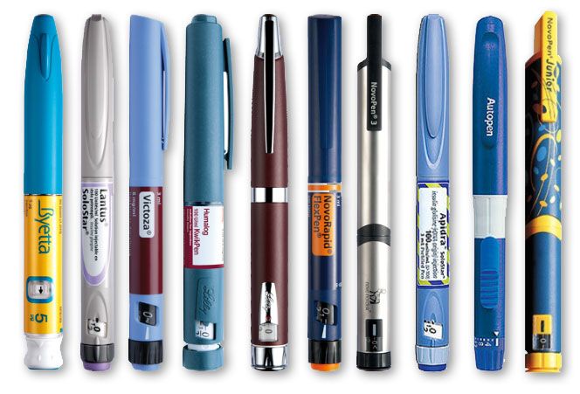](http://insulinpens.com/wp-content/uploads/insu)

* There are over 20 different types of insulin available in the UK
* Insulin is injected with either a pen device or a syringe
* Insulin doses can change throughout life depending on amongst many factors, including activity, food intake, weight, medication ,pregnancy and other illness
* Insulin dose needs are different from person to person. There is no maximum dose

**NEVER STOP USING INSULIN WITHOUT DISCUSSION WITH GP, CONSULTANT OR DIABETES NURSE SPECIALIST**

**DIFFERENT TYPES OF INSULIN**

* **RAPID ACTING**.

HUMALOG, NOVORAPID and APIDRA

Analogue insulin can be injected up to 15 minutes before eating, during the meal or up to 15 minutes after the meal. These are used as part of a basal bolus regime.

* **SHORT ACTING**.

HUMULIN S, ACTRAPID and INSUMAN RAPID

These need to be injected 30 minutes prior to a meal. These are used as part of a basal bolus regime.

* **INTERMEDIATE ACTING**.

INSULATARD, HUMULIN I and INSUMAN BASAL

These are generally taken once (but can be twice a day) along with rapid or short acting insulin if on a basal bolus regime, or with oral hypoglycemic agents

* **LONG ACTING**

GLARGINE (LANTUS), LEVEMIR (DETEMIR) OR DEGLUDEC (TRESIBA)

Analogue insulin that is given generally once a day at the same time, or twice a day as either part of basal bolus regime or with oral hypoglycemic agents

* .**PRE-MIXED**

Usually twice daily a mix of intermediate/long acting insulin and short/rapid acting insulin

**ANALOGUE MIXTURES**

NOVOMIX 30, HUMALOG MIX 25 0R 50

Given just before breakfast and evening meal

**SHORT AND INTERMEDIATE MIXTURES**

HUMULIN M3, INSUMAN COMB 25

Given 20-30 minutes before breakfast and evening meal

.

**INJECTING INSULIN**

Depending on the type of insulin needed, insulin may come in either:

* A pre-filled pen device and needle that is filled with insulin and discarded after device is empty
* A pen device and needle that has a cartridge which is changed when empty
* Some pen devices have been designed for those with dexterity or memory problems to promote independence.
* A syringe and needle that is filled with insulin from a vial

Insulin pens are very convenient and popular because they are a more discreet and portable way of injecting and carrying insulin than syringes and vials.

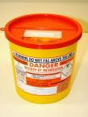 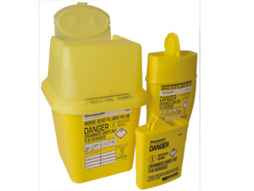

It is important to dispose of sharps safely, using a sharps bin. 0.5litre boxes are available on prescription in the community, and the local council arrange a collection service. from a resident’s own home free of charge. Note: commercial clinical waste is not included in this service.

The MHRA have found that removing insulin pen needles is the most common needle stick injury. The safest option when the patient is unable to self administer is to use an insulin syringe but if using a pen device and the patient is unable to remove the needle themselves the safest option is to use a retractable needle e.g Autoshield duo or Autocover. Some sharps boxes have a slot to grip needles so they can be unscrewed directly into the box.

**SAFE INSULIN INJECTION TECHNIQUE**

**- If person or their family unable to administer then Insulin should only be administered by registered nurses**

Spare insulin should be stored in the fridge, and once opened the vial/pen in use should be kept at room temperature in a secure location for 4 weeks, then must be discarded. It is good practice to record the day the insulin is opened to ensure it is discarded after 4 weeks.Do not let insulin freeze, as freezing destroys the structure of the insulin, so that it will not work. In very hot weather (i.e above 25 oC) and when a person is travelling in hot temperatures, it is best to keep insulin cool and safe by carrying it in an insulated travel wallet (e.g. Frio wallet) or a small, portable cool bag.

Check that the insulin about to be used is the correct one and its expiry date - do not use insulin that is out of date.

Cloudy insulin should be inverted/rolled 20 times to ensure it is thoroughly mixed before drawing up.

Best practice for optimum insulin absorption is to use a needle 4-6mm long, in order that insulin is injected into fat, if needle length is greater than 6mm, the skin should be pinched up.

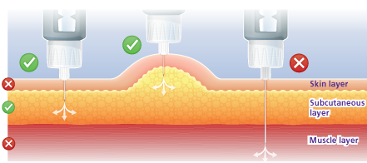

Suitable sites for injecting are the abdomen, outer thigh and buttocks, rotate sites to avoid scarring. Good practice is to record injection sites to ensure regular site rotation.

[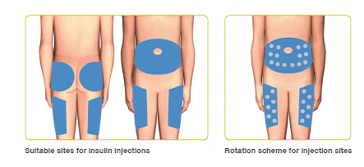](http://www.myclickfine.com/images/rotate-injectio)

The following points outline the best technique for injecting with an insulin pen device. These are guidelines common to all pen devices.

**Important:** please also take time to read the instructions supplied by the insulin pen manufacturer

1. Make sure you have a clean site and clean hands and check the injection site.

2. If the insulin is cloudy, gently invert 20 times and roll between palms of hands 10 times to fully mix it.

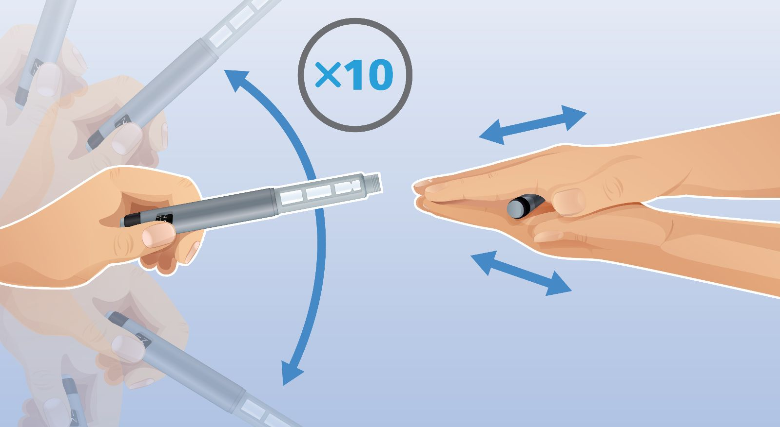

3. Place a new needle onto your pen device and screw firmly into place, but do not over tighten.

4. Remove outer and inner cap

5. Safety Check shot: set the dial to 2 units and with the needle tip pointing away from you press the dose button. You should see a bead of insulin appear at the needle tip.  Repeat if no insulin appears.( it may take several attempts if new pen/cartridge) if no insulin appears try again with a new needle

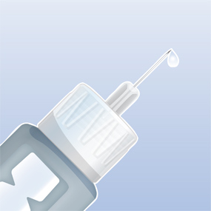

6. Dial up dose

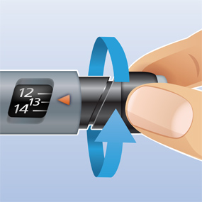

7. Hold the pen in your fist; keep your thumb away from the dose button. With the pen at 90 degrees to the skin surface, gently push the needle through the skin into the injection site. Use a lifted skin fold if necessary.

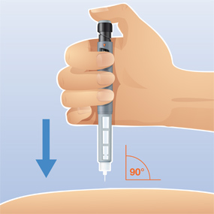

8. Push down the dose button with your thumb. Hold the needle in the injection site for a full 10 seconds* after you have finished pressing the dose button.  Then gently remove the needle from the skin.

**NEVER RESHEATH NEEDLE**

9. Remove the used pen needle and place in ‘sharps’ box ready for safe disposal.  Check what the local policy is for safe ‘sharps’ disposal in your area.

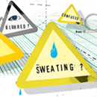

**LOW BLOOD GLUCOSE - HYPOGLYCAEMIA**

Hypoglycaemia, or hypo, means that the blood glucose is too low (below 4mmol/l).

|  |  |
| --- | --- |
| **Causes of “Hypo”** | **Signs and Symptoms** |
| Too much insulin or oral medication  Delayed meal or snack  Not enough carbohydrate to eat  Diarrhoea  Vomiting  Extra physical activity  Alcohol  Hot weather  Very hot baths/showers | Pallor  Shaking  Sweating  Dizziness  Palpitations  Feeling hungry  Change in behaviour  Headache  Confusion  Unsteadiness  Drowsiness  Loss of Consciousness |

|  |
| --- |
| **ShakyGuy-all.jpg** |



The Very Best Hypo Treatment

Treat a blood glucose level under 4mmol/L

(symptoms or no symptoms) immediately with:-



1. Either 4 Glucotabs or 5 Dextrose/Lucozade tablets

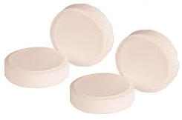Or 90 mls Lucozade original

Or 4 standard jelly babies

Or 2 glucogels.

2.    Sit and wait for 10 minutes.

1. If still feeling hypo take 2 more Glucotabs, 3 Dextrose/Lucozade tablets, 2 jelly babies or 50mls Lucozade.

4.    After 10 minutes, eat something that contains 15-20g of starchy carbohydrate such as 2 biscuits, a cereal bar or banana. If hypo occurs at bedtime have a 40g carbohydrate snack such as a large bowl of cereal or 2 pieces of toast and jam.

5.    If a hypo occurs before a meal, treat hypo as above, then eat the meal and take the normal dose of insulin (if due) at the end of the meal.

Note: Four Glucotabs contains 16g of fast acting carbohydrate which will bring up the blood glucose level (by 3mmol/L) quickly (in 10 mins).

Chocolate, milk, biscuits, fruit and even ordinary sugar are not suitable hypo treatments as they all contain either fat, fibre or fructose (fruit sugar) which slows down how quickly the glucose can get into the blood stream.

Baldwin E J Sweets, fluids and foods in the treatment of mild hypoglycaemia. Practical Diabetes International 2006 23; 5: 218-220

**Treatment of HYPOGLYCAEMIA- low blood glucose**

***IF INSULIN INJECTION DUE – GIVE AFTER EATEN MEAL INSTEAD OF BEFORE***

YES

CONSIDER CAUSES AND ACT TO PREVENT

IF AFTER 10 MINUTES BLOOD GLUCOSE GREATER THAN 4 MMOLS, GIVE STARCHY SNACK

Blood glucose

less than 4 mmols/l

Wash patient’s hands and check blood glucose

**NO**

**YES**

PATIENT RESPONSIVE

(ABLE TO EAT DRINK)

**NO**

**ADMINISTER**

**GLUCAGON**

**INJECTION IF ABLE**

CONSIDER OTHER CAUSES FOR SYMPTOMS

**YES**

RECHECK BLOOD GLUCOSE AFTER 30 MINUTES

HAVE SYMPTOMS IMPROVED AND BLOOD GLUCOSE ABOVE 4MMOLS

Hypoglycaemia suspected

Patient showing signs and symptoms of hypoglycaemia

GIVE 4-5DEXTROSE TABLETS OR 90MLS LUCOZADE OR TWO 25G TUBES OF GLUCOGEL

WAIT 10 MINUTES THEN RECHECK BLOOD GLUCOSE

IF LESS THAN 4MMOLS REPEAT TREATMENT ABOVE

**NO**

**SEEK URGENT MEDICAL ADVICE**

**HYPERGLYCAEMIA**

Hyperglycaemia is when the blood glucose level is too high. Normal blood glucose range is 4-7mmols but individual targets should be set for each person, balancing the risks of hypoglycaemia with the long term risks of hyperglycaemia. However sustained blood glucose levels of greater than 12mmols/l should be discussed with GP/practice nurse/neighborhood team/diabetes nurse specialist that is involved with person’s care.

|  |  |
| --- | --- |
| **Common causes of High Blood Glucose** | **Signs and Symptoms** |
| Too much carbohydrate  Change in physical activity levels.  Not enough insulin/diabetes medication.  Stress or worry.  Infection, injury or illness.  Steroid medication | Thirst  Polyuria  Excessive tiredness  Drowsiness  Recurrent Infections |

**NEVER STOP INSULIN OR TABLETS WITHOUT DISCUSSION WITH GP, CONSULTANT OR DIABETES NURSE SPECIALIST**

Treatment should always be taken when ill because even when not eating, blood glucose levels tend to rise.

**Monitor more often**

It is important to test blood glucose more frequently when ill.

Test blood glucose every 2-4 hours.

**Test urine or blood for ketones if person has TYPE 1 DIABETES and blood glucose above 14mmols**

Ketoacidosis is a serious condition that can occur when blood glucose levels are high and is very dangerous if not treated quickly.

**Ketone Urine testing**-

Ketostix urine test strips are available on FP10 prescription from the G.P.

Note: a trace of ketones may occur if a person is not eating

Levels of ‘1+’ and above, needs discussion with GP urgently.

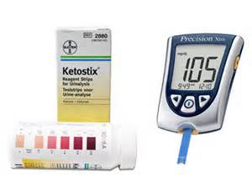

**Ketone Blood testing**

Glucomen, Optium Xceed and Freestyle Neo

meters with specific ketone strips

0-0.6 normal range

0.6-1.5 discuss with GP

**>**1.5 needs urgent referral to GP

Admission may be necessary

**MANAGEMENT OF HYPERGLYCAEMIA IN TYPE 1 AND TYPE 2 DIABETES:**

**Encourage to drink lots of water or sugar free fluids**

It is easy to become dehydrated when ill so try to encourage person to drink more water or sugar free fluids throughout the day. Even taking small sips is beneficial. Aim for 1.5-2litres of liquid.

**Rest**

**Vomiting**

If vomiting occurs for over an hour, contact GP. Vomiting may result in not being able to keep tablets down, which can cause hyperglycaemia. If taking insulin, blood glucose levels may be reduced if a meal is lost and increase risk of hypoglycaemia. Test blood glucose regularly and discuss with GP

If vomiting is accompanied by rapid deep breathing and drowsiness, dial 999 immediately.

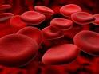**Blood glucose testing**

.

Normal blood glucose is 4-7mmol before meals

For the elderly a safe level is between 6 to 10mmol, aim for blood glucose around 8-10mmol-pre bedtime.

**When to test** – Before meal times and at bed time. Frequency will vary depending on individual, discuss with Diabetes Specialist Nurse/ practice nurse/consultant/ GP.

Remember the reading shows a “snap shot”

Glucose levels can be affected by meals, weather, medication, time of day, illness, stress as well as poor technique.

**Blood testing….how to be accurate**

* Check blood glucose strips in date
* Some machines need to be calibrated to each pot of strips, either by changing a chip or inputting a code,
* All modern machines can be checked for accuracy using quality control solution, available free from the manufacturer
* You should have training in use of meter used in your area

**Lancet devices are not to be used for multiple patients and have high risk of needle stick injury**

**SINGLE USE LANCETS SUCH AS UNISTICK 3 SHOULD BE USED**

Meters should be checked with quality control solution at least weekly, and result recorded

Also check with solution if machine dropped or appears damaged

Wash hands prior to test with warm water (yours and patient)



You should wear gloves (non sterile)

(Do not use glycerine/anti bacterial soaps/alcohol gel or wipes on the patient as they will alter blood glucose result)

Avoid first finger and thumb

Press lancet firmly against side of finger and depress, try to avoid squeezing too hard as this encourages serous fluid which can effect the result.

Dispose of lancet into sharps box

Record result in patients notes

**FOOD FOR CARE HOME RESIDENTS WITH DIABETES**

The main aims of dietary management for people with diabetes are to maintain blood glucose levels within a safe range, achieve a healthy body weight (body mass index 20-25 kgm2), and to reduce the risk of cardiovascular events (e.g. strokes, heart attacks, etc.) and other diabetes-related complications.

There is no such thing as a ‘diabetic diet’ and the dietary advice for most people with diabetes is in line with healthy eating advice for the general population. That is, to eat plenty of fruit and vegetables, wholegrain starchy carbohydrates, low fat milk and dairy foods, lean meat, poultry, fish, eggs and pulses. Foods that are high in fat and sugar do not need to be avoided, but can be eaten in moderation as part of healthy diet. Therefore residents with diabetes can be provided with similar meal choices to other residents.  
 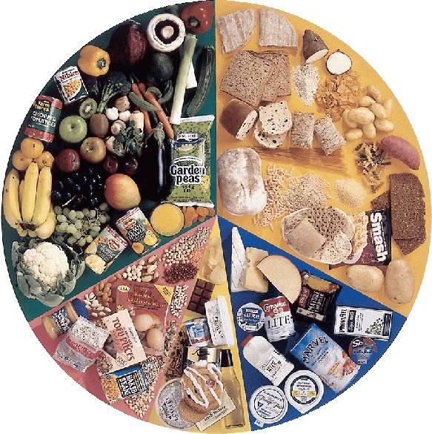

The nutritional requirements of residents in care homes can vary considerably. Some residents may be young, have a very good appetite, be overweight / obese and need to lose weight, whereas others may be frail and elderly, be underweight and have a very poor appetite. A variety of other factors can combine to affect a resident’s nutritional status and glycaemic control, including problems with communication, impaired cognitive function, poor social skills, behavioural problems, altered activity levels, coexisting physical disabilities, swallowing difficulties and side-effects of medication.  Meeting the nutritional needs of care home residents with diabetes can be a challenge and dietary recommendations should be tailored to the individual.

For residents with a learning disability or mental health problems, there may also be direct effects on body metabolism associated with having certain conditions and syndromes (e.g. Prada Willi, Downs Syndrome, Schizophrenia, etc.) which increase their risk of developing chronic conditions, such as type 2 diabetes and coronary heart disease.

Maintaining an adequate nutritional status is the main priority for residents who are underweight, have a poor appetite or have difficulties swallowing. Assessment of nutritional status using a **MUST TOOL** is mandatory for all clients on admission and should be reviewed periodically. A review of their diabetes medication treatment may be required if blood glucose control is not optimal if residents are being treated for malnutrition and needing nutritional support (e.g. oral nutritional supplements or enteral tube feeding).

**Carbohydrates and Diabetes**

Carbohydrate is the body’s preferred source of energy. All carbohydrates are broken down into glucose, which is essential fuel for the body – especially the brain. High fibre carbohydrate foods are also important for keeping a person’s bowels regular and preventing digestive disorders such as constipation.

There are two main types:

1. Starchy carbohydrates include foods like bread, pasta, potatoes, noodles, rice and breakfast cereals.
2. Sugars, which can be categorised as:
   * natural sugars e.g. fruit sugar (fructose) and milk sugar ( lactose)
   * added sugars e.g. glucose powder, table sugar (white and brown sugar), caster sugar, icing sugar, golden syrup, treacle, honey, jam and marmalade.

Sugars can often be identified on food labels as ingredients ending in –**ose** (e.g. glucose, glucose syrup, fructose, sucrose, etc.)

Another type of food ingredient that can affect blood glucose levels are nutritive or bulk sweeteners (e.g. sorbitol, maltitol, xylitol and mannitol). These sweeteners are often added to no added sugar confectionary products (e.g. sweets and chocolate) to sweeten them.

As all carbohydrates break down into glucose, the total amount of carbohydrate that a person has to eat and drink will have an effect on their blood glucose levels.

**The Glycaemic Index**

Not all carbohydrates break down into glucose at the same rate:

* Sugary drinks and foods (e.g. Lucozade, fruit juice, ordinary cola and lemonade, glucose tablets and Jelly Babies) break down very rapidly and are absorbed very quickly, so are good choices for treatment of hypoglycaemia (low blood glucose).
* Low fibre starchy carbohydrate foods such as white bread, mashed potato, Corn Flakes and Rice Krispies break down quickly into glucose and are absorbed quickly, High fibre starchy carbohydrate foods (e.g. wholegrain breakfast cereals, such as porridge and Bran Flakes, granary bread, new potatoes, noodles, pasta, Basmati rice, peas, beans and lentils) break down slowly into glucose and are absorbed slowly, so are better food choices for people with diabetes.

The Glycaemic Index (GI) is a rating of carbohydrate foods based on their overall effect on blood glucose levels. Slowly absorbed foods such as high fibre starchy foods have a low GI rating, whereas foods that are absorbed more quickly have a higher rating. People with diabetes are encouraged to incorporate more low GI carbohydrate foods into their diet to help even out blood glucose levels.

**‘Diabetic foods’**

So called **‘**Diabetic foods’ are not recommended. These foods offer no benefit to people with diabetes, are expensive and may still affect blood glucose levels as sugar is often replaced by bulk sweeteners such as sorbitol. These products may also have a higher fat content to enhance the flavour and texture, which is detrimental for cardiovascular health and if a person is overweight or obese. Small amounts of regular products such as ordinary chocolate, jam or marmalade are acceptable, provided blood glucose levels are within a safe range.

**Eat regular meals including starchy carbohydrates at each meal**

All people with diabetes should be encouraged to eat 3 meals a day with consistent amounts of starchy carbohydrate foods, and not to skip meals. This helps to control appetite and blood glucose levels, especially if a resident is on insulin treatment or is taking certain tablets for their diabetes (e.g. sulphonylurea drugs such as gliclazide). These medications actively reduce blood glucose levels, so it is especially important for these residents to have some starchy carbohydrate food at every meal in order to prevent hypoglycaemia (low blood glucose).

Some people may also need to have a starchy carbohydrate snack between meals or before bed. This will depend on the type of insulin regime and/or combination of tablets that they take – a diabetes health care professional / dietitian can advise if these are necessary or not.

Not person with diabetes is at risk of hypoglycaemia though, and people who control their diabetes with diet alone, or who take gliptins, GLP-1 injections, glitazones, SGLT-2s or Metformin, are unlikely to have hypoglycaemia. Providing unnecessary snacks for such residents could cause hyperglycaemia (high blood glucose) and unwanted weight gain, unless these are needed because of poor appetite, swallowing difficulties or because of malnutrition.

**How much carbohydrate does a person with diabetes need?**

The amount of carbohydrate that an individual needs to eat each day varies depending on factors such as a person’s age, their body weight, physical activity level and if they have any special health needs. A diabetes specialist dietitian can advise on how many portions of starchy carbohydrate foods to eat per day.

|  |
| --- |
| **Healthier starchy carbohydrate foods to eat at mealtimes:**  Breads: preferably granary, wholegrain or pita bread  Wholegrain breakfast cereals preferably porridge, Bran Flakes, Fruit and Fibre, All Bran or unsweetened muesli.  Potatoes: new potatoes are best  Rice: basmati rice is best, white or brown  Pasta and noodles: all types are suitable, white or brown  Peas, beans and lentils  **What is a portion?**  A portion is:  2 tablespoons of breakfast cereal, 1 Weetabix or 1 Shredded Wheat  1 slice of bread / toast  2 small new potatoes or half a small baked potato or 1 tablespoon of mashed potato  2-3 crackers or crisp breads  1 tablespoon of cooked rice, pasta or noodles  **How many portions?**  2-3 portions per meal (approximately 1/4 of their dinner plate) should be made up of starchy carbohydrate foods, ¼ of their plate should be protein based foods and about ½ their plate should be vegetables or salad  th?&id=HN |

|  |
| --- |
| **Healthy carbohydrate snacks (if these are needed):**  A Portion of fruit: apple, small banana, pear, orange, small handful of grapes, etc.  Plain biscuits: 2 rich tea biscuits or 1 digestive biscuit or 1 garibaldi  1 Slice of bread or toast  2 wholegrain crackers or crisp breads  Small bowl of whole grain cereal and milk  Low fat yogurt or “Diet” yoghurt (e.g. Weightwatchers, Shape, etc.) |

**Fats**

Fat contains more calories per gram than protein or carbohydrate and eating a diet high in fat can lead to weight gain.

There are two main types of fat: saturated and unsaturated (polyunsaturated and monounsaturated) fat.

Eating too much saturated fat, e.g. the visible fat on meat, full fat (whole) milk, cream, butter, cheese, lard, etc. can cause high blood cholesterol levels, which can lead to circulatory and heart problems (e.g. heart attacks and strokes).

Residents with a healthy body mass index between 20-25 kg/m2 (i.e. they are neither under- or overweight) should be encouraged to reduce their intake of saturated fat and choose unsaturated fats and oils, especially monounsaturated fat (e.g. olive oil and rapeseed oil), to reduce their cardiovascular risk.

Overweight or obese residents should be encouraged to reduce their total fat intake, as this will help them to lose weight, as well as reduce their saturated fat intake, in order to reduce their cardiovascular risk.

|  |
| --- |
| **Ways to reduce fat intake:**   * Avoid fried foods (casserole, bake, poach or microwave food instead). * Use reduced fat dairy products e.g. skimmed or semi-skimmed milk, low fat spread, reduced fat cheese, diet yoghurts. * Trim the visible fat off red meat and remove skin from poultry. * Reduce intakes of pies, pasties, pastry, sausages and burgers. * Use only small amounts of low fat salad dressings. |

Fat intake **should not** be restricted for residents who are underweight, have poor appetites or difficulty eating. See the following section ‘Feeding residents with poor appetites’ for more information.

**Omega 3**

Oily fish (e.g. mackerel, sardines, salmon (tinned or fresh), fresh tuna and pilchards, etc.) contains omega 3, a type of polyunsaturated fat which helps protect against heart and circulation problems. People with diabetes are recommended to have at least two portions of oily fish a week.

**Salt**

A high intake of salt can increase blood pressure, which in turn can increase the risk of strokes, heart and circulation problems. People with diabetes are encouraged to reduce the amount of salt they add at the table and use in cooking. Instead they are recommended to flavour their food with lemon juice, herbs, spices or.

**Fruit and vegetables**

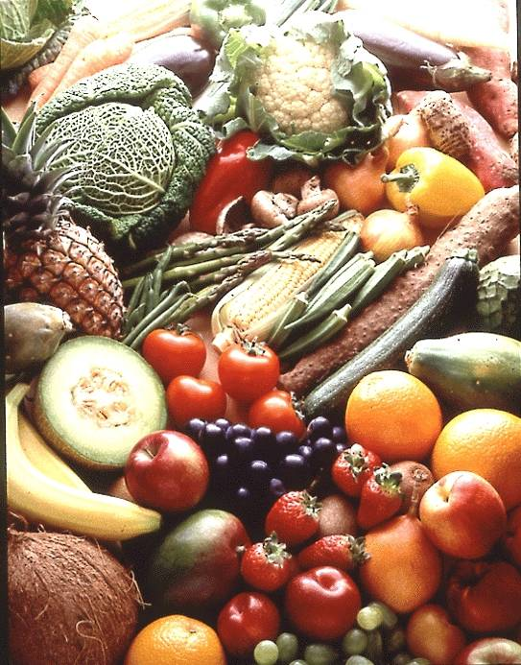

Fruit and vegetables are an essential source of vitamins, minerals and fibre. People with diabetes should aim to eat at least five portions a day. One portion is: a small glass of fruit juice or fruit smoothie, an apple, orange, pear or banana, a handful of grapes, three heaped tablespoons of vegetables or a cereal bowl of salad. As fruit contains natural fruit sugar (fructose), which can raise blood sugars, it is best if they spread their fruit portions out over the day, and do not eat more than one portion at a time.

**Adapting recipes for people with diabetes**

Although sugary foods can be consumed in moderation as part of a healthy diet for diabetes, it is possible to adapt recipes to make them lower in sugar and salt, higher in fibre and to use healthier types of fats:

* Intense (non nutritive) sweeteners such as Candarel, Sweetex, Splenda and Hermesetas can be used in cooking and to sweeten foods and drinks. However, add them at the end of cooking for the best results. It is possible to gain further information on the use of sweeteners in cooking and to request recipes from the manufacturers of these products.
* If artificial sweeteners are not being used, reduce the amount of sugar in traditional recipes by half.
* Adding high fibre ingredients to recipes can help to slow digestion and control blood glucose levels. Try adding wholemeal flour, fresh and dried fruits in place of sugar, or nuts and seeds. For example use 50% white flour and 50% wholemeal flour to make a sponge cake, pie or crumble mixture for fruit crumble.
* To adapt a recipe to be healthier for the heart, replace butter with polyunsaturated or monounsaturated margarine (e.g. olive oil spread or rapeseed oil and spreads made with these types of oils e.g. Bertolli, Flora, Vitalite, Utterly Butterly, Can’t Believe it’s Not Butter, soft Stork margarine). Low fat spreads can be used, but usually do not produce the best results due to their higher water content.
* Reduce the amount of salt added in cooking - try adding herbs, mustard, garlic vinegar and spices instead.
* Baked items (e.g. cakes, biscuits, scones, etc.) should be occasional treats for residents who are overweight or obese.

Recipes using a reduced amount of sugar or salt will not keep as long as traditional recipes, as sugar and salt are natural preservatives. To avoid wastage, freeze in portions that can be defrosted as needed – but check that the recipe is suitable for freezing first.

**Food labelling**

Looking at the food label can help you decide whether a food or food ingredient contains a high or low amount of fat, sugar and salt. Most supermarkets, food manufacturers and suppliers now display ‘traffic light’ food codes on the front of their food packet /products to help people to make more informed and healthier food choices. These codes will tell you if a product has a low content (green), medium (amber) or a high content of sugar, fat or salt (per 100g):

|  |  |  |
| --- | --- | --- |
| **High (per 100g)** | **Medium (per 100g)** | **Low (per 100g)** |
| > 22.5 grams of sugar | >5.0-≤22.5 grams of sugar | ≤5 grams of sugar or less |
| >17.5 grams of fat | >3.0 – 17.5 grams of fat | ≤3 grams of fat or less |
| >1.5 grams of salt | >0.3-1.5 grams of salt | ≤0.3 grams of salt or less |

**Feeding Residents with Diabetes who have poor appetites**

Many elderly people living in their own homes and residents in care homes have poor appetites and are underweight. It is important to ensure that these people receive a nourishing diet, whilst still achieving optimal blood glucose control.

A ‘Food First’ approach is recommended which combines regular meals, snacks and drinks with food fortification and the use of oral nutritional supplements:

* Relax fat restriction - allow full cream milk, butter or full fat polyunsaturated or monounsaturated margarines and foods that are cooked in oil. The priority is to maintain or gain weight, over concerns about increasing blood cholesterol levels. Polyunsaturated or monounsaturated fats should not have a detrimental effect on blood cholesterol levels.
* Encourage drinks such as full cream milk between meals.
* Encourage snacks between meals (e.g. full fat yoghurts, cheese and crackers, bowl of cereal, teacakes).
* Fortify foods and drinks:
  + Add 2 tablespoons of milk powder to one pint of full cream milk (use this milk for cereals, puddings, sauces and drinks).
  + Add margarine, fortified milk or grated cheese to mashed potatoes.
  + Enrich soups by adding milk powder, extra beans, lentils or rice, or chopped meat or grated cheese.
  + Add margarine, cheese or parsley sauces to vegetables.
  + Add double cream to puddings.
  + Encourage dietary supplement drinks when necessary.

**Use of oral nutritional supplement (ONS) drinks, puddings and powders**

There are a range of oral nutritional supplement drinks, puddings and powders available for people who are malnourished or have poor appetite. Some supplement drinks are available on FP10 prescription from a G.P., whilst others are available to buy over the counter at pharmacies and in some large supermarkets. If a meal is missed, refused or not consumed, offering a supplement drink may be worthwhile.

**Oral Nutritional Supplements available**

Savoury supplements:

* Complan Soup (not on prescription) – a powdered, savoury soup added to boiling water.
* VitaSavoury (prescribable) – a powdered savoury soup added to boiling water.

Milky supplements:

* Complan (non-prescribable) - powder made up with full fat (whole) milk
* Ensure Plus / Ensure Plus Compact (prescribable)

Fruit juice style drinks:

* Ensure Plus Juce (prescribable)

Pudding style supplements:

* Ensure Plus Crème

Supplement drinks should be served cold and can be diluted with milk, diet lemonade or soda water if the flavour is too strong.

If appetite remains poor and weight loss continues, other supplements are available, such as protein and fat based supplements Calogen, Calogen Extra or Pro-Cal Shot. These are given in small volumes and do not affect blood glucose levels.

Other forms of supplements include supplement puddings and powders that are added to food.

Blood glucose levels are likely to rise after drinking supplement drinks and having supplement puddings, as they are high in maltodextrin carbohydrate, which is absorbed quickly. However they should not be stopped if a resident is malnourished, or has poor appetite, as they are required to maintain optimal nutrition. Instead the advice is to encourage the resident to sip supplement drinks slowly and if their blood glucose levels are persistently raised, their G.P or a diabetes health care professional should be consulted to advise about adjusting their diabetes medication and/or insulin regime to better match their food and nutritional supplement intake.

**Enteral tube Feeding**

The number of people who receive enteral tube feeding in the community has increased and it is now more common to find residents in the community with diabetes who have an enteral tube feed. These people will be managed by a Specialist Home Enteral Feeding Dietitian, who can review feed tolerance and nutritional status.

It is important that their diabetes is well managed and that the type, dose and timing of their diabetes medication or insulin treatment is matched closely with their enteral tube feed regime. If insulin or diabetes medication is not given at the appropriate time, if there is early initiation of the feed or delays in starting the feed, this can increase the risk of hypo- or hyperglycaemia. The feed should always be started at the specific time as recommended on the feeding regime.

If the feed has to be stopped for any reason (e.g. due to nausea or vomiting, feeding tube blockage, misplacement or removal of feeding tube, feed stopped to give other medication such as phenytoin, for physiotherapy, or for a medical procedure), it is important that their diabetes medication or insulin regime is reviewed, as continuing with their normal insulin / medication regime could cause hypoglycaemia if the feed is not running as usual.

Hypoglycaemia treatment will need to be administered via the feeding tube if the patient is nil by mouth, or is unable to swallow liquids or Glucogel safely. It is very important to give the correct amount of hypoglycaemia treatment and to flush the feeding tube well with water before and afterwards to prevent tube blockage.

**Treatment of hypoglycaemia via an enteral feeding tube**

If blood glucose level is less than 4 mmols/l, give one of the following treatments immediately via their enteral feeding tube, the aim being to provide 15-20 grams of very quickly-absorbed carbohydrate via the enteral feeding tube:

* 100ml Lucozade Energy – ensure that the tube is **thoroughly** flushed with water before giving the Lucozade Energy, as if the Lucozade mixes with any feed already in the tube, it can block the tube. Thoroughly flush the tube with water after the Lucozade Energy and before re-starting the feed.
* **15ml neat Ribena cordial drink (ensure that this is not sugar free Ribena) diluted to 30mls with water.**
* **2 Glucogel tubes – not for use via a fine bore nasogastric tube**
* 150 mls smooth fruit juice (not fruit juice with ‘bits’ in)
* 110-140 ml Fortijuce, Ensure Plus Juce or Resource Fruit (not Fortisip, Ensure Plus, Fresubin Energy or other milk based oral supplement drink)

Follow all of these treatments by thoroughly flushing the feeding tube with water to prevent blocking the tube.

Alternatively:

I.M. (intramuscular) glucagon can be prescribed and administered via injection, but not suitable if had severe hypo in the previous 24 hours or if liver disease present.

After 10-15 minutes re-check their blood glucose level. If blood glucose level is still less than 4 mmols/l, repeat hypoglycaemia treatment, and re-check blood glucose 10-15 minutes later.

**IF THE RESIDENT DOES NOT RESPOND TO TREATMENT OR BECOMES UNCONSCIOUS, CALL 999 FOR AN AMBULANCE.**

When blood glucose level is greater than 4 mmols/l and the resident has recovered, then restart tube feed, or if bolus feeding, give an additional bolus feed sufficient to give 15-20 grams of carbohydrate – the Specialist Home Enteral Feeding Dietitian or a diabetes specialist dietitian should be able to calculate how much of the feed this should be.

**Blood glucose targets for people with diabetes receiving enteral tube feeding**

There is much debate on what is an acceptable blood glucose range for people receiving enteral tube feeding in the community. The Joint British Diabetes Societies (JBDS) guideline on the glycaemic management during the inpatient enteral feeding of stroke patients with diabetes recommends a target blood glucose range of 6-12 mmols/l for people with diabetes having enteral tube feeding, in order to limit the risks associated with hypo- and hyperglycaemia.

The frequency of blood glucose monitoring needs to be discussed with their G.P. and will be dependent on whether they have a continuous tube feed, are being fed intermittently (e.g. overnight tube feeding) , or having bolus feeding. Blood glucose should always be checked prior to starting the enteral feed, 4-6 hourly during feeding and 2 hours after the feed has finished.

**Reference**

Joint British Diabetes Societies (JBDS) for inpatient care (2012) ‘Glycaemic management during the inpatient enteral feeding of stroke patients with diabetes’. NHS Diabetes ([www.diabetes.nhs.uk](http://www.diabetes.nhs.uk))

**Re-introducing oral feeding in people with diabetes receiving oral nutritional supplements (ONS) or enteral tube feeding**

When a person’s swallowing and/or appetite is improving and oral feeding is being reintroduced, and oral nutritional supplements or enteral feeding is being reduced or stopped, it is important that the resident’s diabetes medication and/or insulin treatment is reviewed by their G.P. or diabetes healthcare professional. This is to prevent them being left on inappropriate diabetes treatment regimes where they are being given insulin and/or oral hypoglycaemic agents at the wrong time of day or night, and not covering the meals, drinks and snacks, or oral nutritional supplement puddings and drinks that they are being given. Liaison with their community dietitian or Specialist Home Enteral Feeding Dietitian is also vital to make sure that their hydration and nutritional needs are being met.

**Further dietary information and recipe information**

**Diabetes UK** produces a variety of resources including cookery books, and dietary information for people with diabetes, which is available to purchase, or download free of charge from their website:

[www.diabetes.org.uk](http://www.diabetes.org.uk)

Diabetes UK have also produced evidence-based recom-mendations for the practical implementation of nutrition advice for people with diabetes in the UK. These guidelines are relevant to people at high risk of developing Type 2 diabetes and adults with Type 1 and Type 2 diabetes and can be downloaded free of charge from the Diabetes UK website:

Diabetes UK (2012) ‘Evidence-based nutrition guidelines for the prevention and management of diabetes’

[www.diabetes.org.uk/Documents/Reports/Nutritional_guidelines200911.pdf](http://www.diabetes.org.uk/Documents/Reports/Nutritional_guidelines200911.pdf)

**Feet**

**DIABETES AND NEUROPATHY**

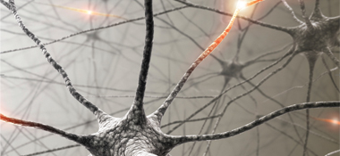

## What is Neuropathy?

Neuropathy is the reduction, alteration or loss of feeling in the feet which can result in chronic pain, tingling, pins and needles and numbness. It can be so painful that the feet feel as though they are burning and very sore and may require specialist pain management.

When attending diabetes clinic, the sensation and feeling in the feet are tested.

## Why is testing important?

Neuropathy occurs gradually and so can often remain unnoticed. The ability to sense pain and temperature may be lost and so minor breaks in the skin can remain untreated. This is particularly a problem for people with diabetes as wounds can easily become infected if left untreated.

**DIABETES AND POOR CIRCULATION**

**What is ischaemia?**

Ischaemia is a reduction in blood flow.

In the legs and feet this can result in chilblains and poor healing.

Circulation is assessed during the annual review at GP diabetes clinic.

**SIGNS AND SYMPTOMS**

Cold legs and feet

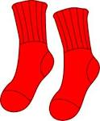Pain in the back of the leg when walking any distance

Skin may be dry and split easily

**HOW YOU CAN HELP**

**Advise patients to:**

**CHECK FEET DAILY**

**WEAR** warm tights or socks in the winter and shoes with a thick sole to insulate

**WEAR** Hosiery should made of natural fibres e.g. wool or cotton without tight elastic or garters

**ALWAYS** test the water temperature with your elbow before bathing and beware of dripping taps

**NOT** tosit too close to heaters and fires.

**NOT** touse hot water bottles or electric blankets directly close to the skin

**USE**S of moisturiser if skin is dry (NOT BETWEEN THE TOES)

**STOP SMOKING**

**TAKE REGULAR EXERCISE-**assess each individual even those chair bound can benefit from gentle exercise

**NOT to** use over the counter remedies for corn and callous removal

**REMEMBER**



Advise patients to check their feet daily. Make sure they look between the toes, at the ball of the foot and at the back of the heel. Patients may be able to do this themselves, especially if they use a mirror.

**GENERAL FOOTCARE ADVICE**

* feet should be washed daily with mild soap and water
* Dry them gently, especially between the toes. Do not rub

vigorously when drying in between the toes as this can cause breaks in the skin.

* change socks or stockings daily
* check that anti emboli stockings fit correctly
* if skin is dry apply hand cream or moisturising cream
* if skin between the toes is moist and white, after bathing apply a little surgical spirit on cotton wool to dry the skin. Do not use talcum powder as it will block the skin pores.

**TAKE EXTRA CARE WHEN BUYING NEW SHOES**

* have feet measured for width and length
* ideal shoes are low healed and adjustable with laces or velcro straps
* avoid tight stockings or socks, wear natural fibres if possible
* seamless and elastic free socks are available

**DO NOT WALK BAREFOOT**

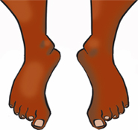

People should always wear a slipper or shoe with a strong sole or they may step on something sharp and not be aware of it!Turn shoes upside down and tip them so the toe end points up before putting them on to check for anything that may have fallen in them and for stone/ grit, check the sole to make sure nothing is stuck in it.

**KEEP FEET WARM AND DRY**

Advise patient not place feet directly in front of fires or use hot water bottles in direct contact with skin as they not feel if too hot and sustain burns.

**All patients with Diabetes should have an up to date annual Diabetes Foot Risk assessment:**

As part of annual review, trained personnel should examine patients’ feet to detect risk factors for ulceration.

Examination of patients’ feet should include:

Testing of foot sensation using a 10 g monofilament or vibration –for nerve damage.

Palpation of foot pulses - -circulation

Inspection for any foot deformity and footwear

Then feet are classified as:

**At low current risk; at increased risk; at high risk; ulcerated foot**

**(NICE 2003 and revised 2008)**

**IF YOU FIND ANY CUTS OR SORES, wash the wound, cover with a sterile, breathable dressing and contact GP practice/registered nurse or Health and Care professional council Registered Podiatrist/ Chiropodist. ( HCPC reg.) in 3-5 days if not healing or immediately if at risk or high risk patient.**

Signs for urgent review within 24 hours:

* Discharge of blood, pus or straw coloured fluid from foot, especially from calluses, corns or beneath toenails
* Swelling or throbbing pains in any part of the foot( with Neuropathy)
* Absence of pulse in foot
* Broken area in skin that has not healed after 3-5 days
* Numbness or any unpleasant prickling sensation in the feet

**IF the foot is HOT RED and SWOLLEN an emergency medical assessment is needed and may need admission.**

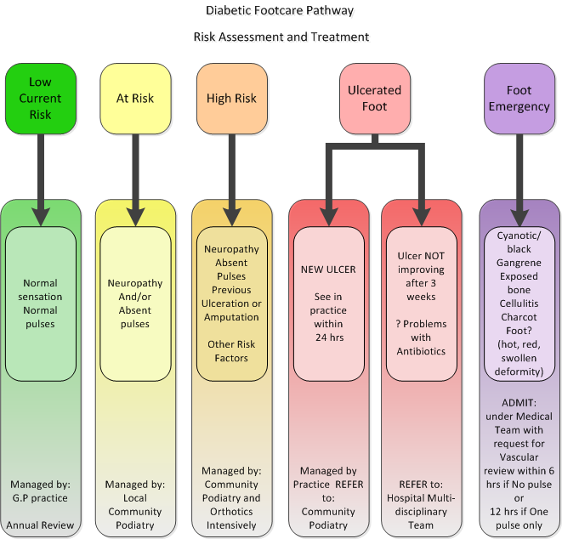

**USEFUL CONTACTS**

**The Diabetes Specialist Nursing Service** is available by phone Monday – Friday 8.30 to 4.30pm at:

Trowbridge Family Health Centre

The Halve, Trowbridge

Tel: 01225 711443

Covering: Warminster, Trowbridge, Westbury, Bradford-on-Avon and Melksham areas

Chippenham Community Hospital

Rowden hill, Chippenham

Tel: 01249 456483

Covering: Chippenham, Devizes, Malmesbury, Calne and Corsham areas

Royal United Hospital

Combe Park, Bath

Tel: 01225 824173

Covering: Bath, Saltford, Paulton and Keynsham areas

**Diabetes Centre**, Royal United Hospital 01225 824101

**The Salisbury Diabetes Specialist Nursing Team**

Diabetes Education Centre

Salisbury District Hospital

Odstock Road, Salisbury, SP2 8BJ

Tel. 01722 425176

**Areas covered by the Salisbury Diabetes Team**

South Wiltshire and North Dorset GP surgeries including Salisbury, Downton, Whiteparish, Mere, Tisbury, Shaftesbury, Gillingham, Amesbury, Durrington, Wilton, Hindon, Fovant, Tidworth and Ludgershall

**Great Western Hospitals**

Diabetes specialist team 01793 604308

**Referral to a Diabetes Specialist Dietitian**

For individual advice about the dietary needs of residents with diabetes, please ask their G.P. to refer them to their local Diabetes Dietitian. For general dietary information and advice about people with diabetes please contact

Diabetes Specialist Dietitian

Diabetes Nursing Team Diabetes Dietitians

Nutrition and Dietetics Department

Salisbury District Hospital Chippenham Community Hospital

Salisbury Rowden Hill, Chippenham

Wiltshire Wiltshire

SP2 8BJ SN15 2AJ

Tel. 01722 425176 Tel.01249 456512

Diabetes Dietitians, Nutrition and Dietetics Department  
Betjeman Centre, The Great Western Hospital  
Marlborough Road, Swindon  
SN3 6BB Tel. 01793 605149

**PODIATRY CONTACT NUMBERS**

**Royal United Hospital diabetic foot clinic** 01225 824101

**Wiltshire Podiatry Service (GWH)**

Appointments 01249 456635

**Salisbury Diabetes Foot Ulcer MDTClinic**  01722 336262

ext 4279 (Monday, Tuesdays and Fridays only)

**SEQOL Podiatry (Swindon)** 01793 428503

**BANES Podiatry** 01225 831700

**Mendip Podiatry Service**  01749 836508

**Diabetes UK Careline** 0845 120 2960

**Websites**

[**www.bathdiabetes.org**](http://www.bathdiabetes.org)

**Site run by diabetes centre at RUH, lots of information for people with diabetes and health care staff**

[**http://www.icid.salisbury.nhs.uk/clinicalmanagement/diabetes**](http://www.icid.salisbury.nhs.uk/clinicalmanagement/diabetes)

**Site run by diabetes centre at Salisbury District Hospital, information for people with diabetes and health care professionals in south wiltshire**

[www.bddiabetes.co.uk](http://www.bddiabetes.co.uk)

Injection techniques

BD medical diabetes care

[www.diabetes.org.uk](http://www.diabetes.org.uk)

General info available from

Diabetes UK

[www.rcn.org.uk/diabetes](http://www.rcn.org.uk/diabetes)

RCN diabetes nursing forum

|  |
| --- |
| Self Declaration  I declare that this is all my own work.  Name …………………………………………………………………..  Signed …………………………………………………………………. |



NAME……………………………………………………………….

Marked by ……………………………………………………………

(when all steps are completed)

Job Title ………………………………………………………………

Signed ………………………………………………………………..

Date ………………………………………………………………….

Comments …………………………………………………………………...........

......................................................................................................

…………………………………………………………………………

………………………………………………………………………….