This icon can be used to display and print your shift allocations. Bank staff can collect reference numbers from here

Click this tab to notify the Bank Office of your availability for bank shifts

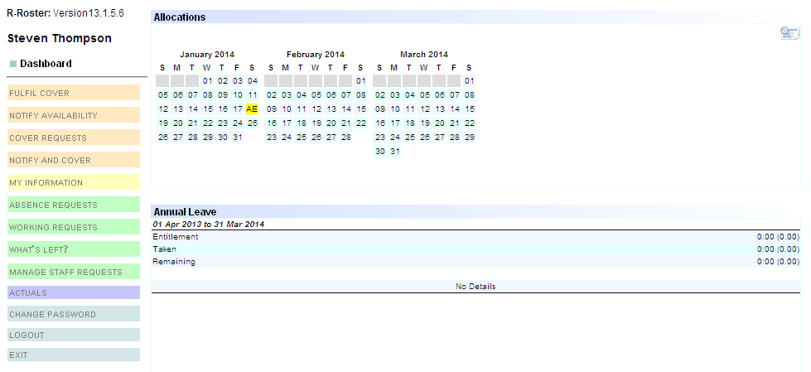

The peach tabs are specific to bank workers

The quick view calendar shows you your booked shifts over the next three months at a glance. All shifts are colour coded for your convenience.

The green tabs are specific to rostered ward staff

The Annual Leave table conveniently shows you at a glance, your entitlement, how much leave has been taken, and how much leave is remaining in hours. Annual Leave episodes appear underneath this section once booked and approved by a roster manager.

The ‘My Information’ tab can be used to view the information that Roster Pro Central records for you, such as PIN numbers, hours worked, and request data.