**NOTIFYING YOUR AVAILABILITY**

You can check the shifts you have already been booked for

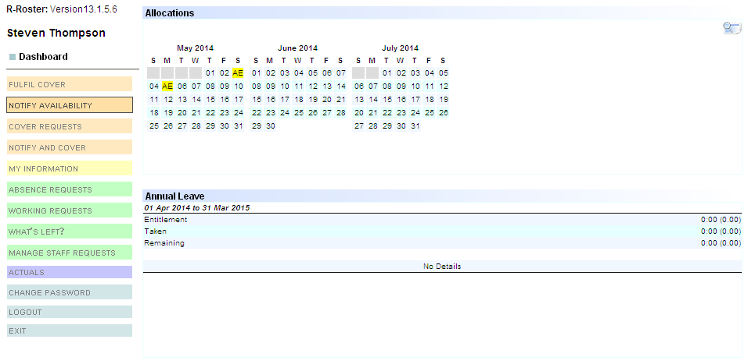

Once logged in to R-Roster, click ‘Notify Availability’

Pick the day or days that you want to work

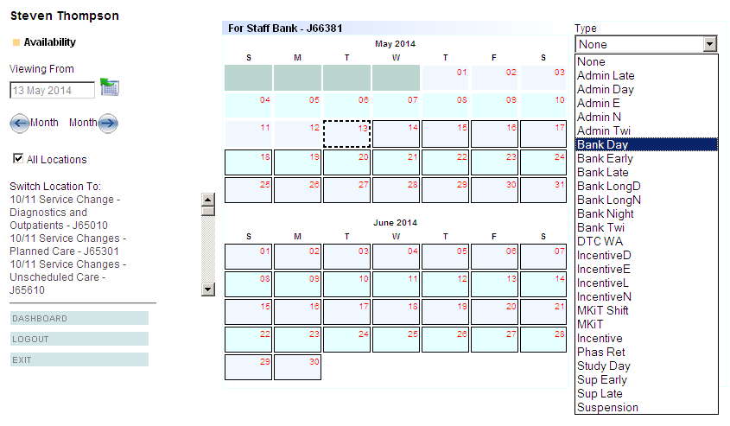

Select one of the following Bank shifts

Tick all locations, unless you want to work on a specific ward.

If you want to work somewhere specifically, select the location from the list.

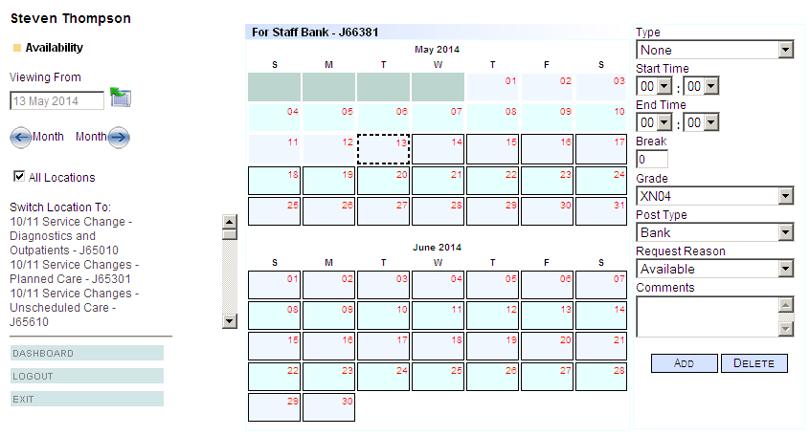

Once the shift type has been entered, the following boxes need to be completed.

Click ‘Add’ to send the notification to the bank office