**Clinical Bd6**

**Trainee Programme**

[](http://www.google.co.uk/url?sa=i&rct=j&q=&esrc=s&frm=1&source=images&cd=&cad=rja&uact=8&ved=0ahUKEwiHhdS5mcPPAhWJXhQKHSL6A1cQjRwIBw&url=http://business.liftshare.com/case-studies/great-western-hospital/&psig=AFQjCNHuiS_1-bxUgyflpgCe_il9JjbVbg&ust=1475740912643022)

[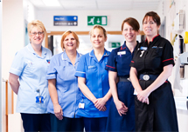](http://www.google.co.uk/url?sa=i&rct=j&q=&esrc=s&frm=1&source=images&cd=&cad=rja&uact=8&ved=0ahUKEwjZxsqfvcHPAhVHBcAKHf-7DH8QjRwIBw&url=http://aldbourne.net/community/great-western-hospital&psig=AFQjCNHHvTxeE6DCJfklq9JPNm2nP5fAFw&ust=1475681744220117)

[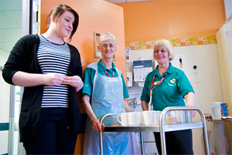](http://www.google.co.uk/url?sa=i&rct=j&q=&esrc=s&frm=1&source=images&cd=&cad=rja&uact=8&ved=0ahUKEwjIyei5mMPPAhXFOhQKHdXmAKwQjRwIBw&url=http://www.gwh.nhs.uk/support-us/volunteers/how-to-apply/&psig=AFQjCNEidS_iIOKKmTozfN9yZoqQvUSDig&ust=1475740625558867)

[](http://www.google.co.uk/url?sa=i&rct=j&q=&esrc=s&frm=1&source=images&cd=&cad=rja&uact=8&ved=0ahUKEwiW47jdl8PPAhVDWRQKHdUqBhUQjRwIBw&url=http://www.geograph.org.uk/photo/1925952&psig=AFQjCNEKS22OIHesq3mK1ZdNHShIXjOxNQ&ust=1475740262472839)

[](http://www.google.co.uk/url?sa=i&rct=j&q=&esrc=s&frm=1&source=images&cd=&cad=rja&uact=8&ved=0ahUKEwi8y-_WlsPPAhUBlRQKHefMB0EQjRwIBw&url=http://www.itv.com/news/westcountry/topic/swindon-great-western-hospital/&psig=AFQjCNGflpl-uSE2jVjn7bCMPP0L5Acz0g&ust=1475740159659976)

[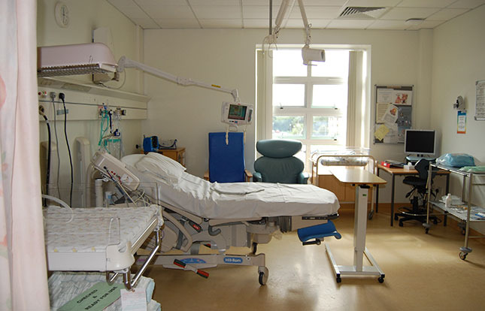](http://www.google.co.uk/url?sa=i&rct=j&q=&esrc=s&frm=1&source=images&cd=&cad=rja&uact=8&ved=0ahUKEwjK8di8vsHPAhVMB8AKHZ-qAD4QjRwIBw&url=http://www.which.co.uk/birth-choice/units/RN325-ou-the-delivery-suite-the-great-western-hospital-swindon&psig=AFQjCNEGOOIuCBd-YN6j1S_ZIlvjpzYZdw&ust=1475682020934425)

[](https://www.google.co.uk/imgres?imgurl=http://www.julesaddison.co.uk/wp-content/uploads/gwh_choir.jpg&imgrefurl=https://www.julesaddison.co.uk/2014/01/great-western-hospital-choir-launches-40-members/&docid=RQUclpLYOujwoM&tbnid=HD0BjfH4KTHEeM:&w=796&h=448&safe=active&bih=927&biw=1280&ved=0ahUKEwjg4buCvcHPAhUlK8AKHcgwAzQQMwhPKCcwJw&iact=mrc&uact=8)

**Clinical Bd6 trainee programme**

**Programme Aims**

The aim of the programme is to develop the skills and talent of our clinical staff, to enable them to successful fulfil their career aspirations and ambitions with our Trust. The programme will develop and enhance the management and leadership capabilities and confidence of our band 5 clinical staff. It will include essential operational knowledge and skills, strategic leadership skills and personal and professional development to support a future pipeline of dynamic, supportive, innovative Allied Health Professional, Ward Sisters and Charge Nurses.

**Programme concept**

The Clinical Bd6 traineeship will have limited number of places for those who pass the selection process. They will do so by demonstrating a clear enthusiasm for development into the Bd6 role; experience at band 5 level; ‘sponsorship’ and support of their manager; and ability to demonstrate understanding of the qualities and skills required to undertake the Bd6 role.

To ensure that the programme supports trainees to develop skills and knowledge and apply this knowledge in a supported way, work based learning will include shadowing, allocation of a mentor, reflective practice and theoretical elements.

**Elements of the programme:**

* Allocation of a mentor
* Minimum of 6 shadowing days
* Work based standards
* Theoretical taught programme including management skills
* Action learning
* Summative assessment

**Taught/ Classroom based Programme**

|  |  |  |  |
| --- | --- | --- | --- |
| **Date and time** | **Development activity – 3 hours each** | **Facilitator/s** | **Mentor and Trainee signature of attendance** |
| 29/05/2018  13:00 – 16:00 | **Course introduction**  training needs assessment | Rachel May |  |
| 29/06/2018  13:00 – 16:00 | **Developing & Managing Staff**  Conducting 1to1 meetings, sickness management, performance management, recruitment processes, developing staff & appraisals | Rachel May |  |
| 11/07/2018  13:00 – 16:00 | **Erostering**  Action learning set | ERoster Team TBC  Rachel May |  |
| 14/09/2018  13:00 – 16:00 | **Financial matters**  Budgets setting, CIPS, budget management  Action learning set | Finance TBC  Rachel May |  |
| 03/10/2018  13:00 – 16:00 | **Managing difficult conversations**  Action learning set | Rachel May |  |
| 08/11/2018  13:00 – 16:00 | **Audits and Matron role**  Route Cause analysis trg  Action learning set | TBC  Rachel May |  |
| 16/11/2018  12:30 – 14:00 | Celebration and evaluation |  |  |

**The Roles of Line Manager and Mentor**

|  |  |  |
| --- | --- | --- |
|  | **Line Manager** | **Mentor** |
| Outline | The Line Manager will have overall responsibility for the work place development of the trainee – the most crucial aspect of a successful traineeship. | As an expert in role of a Bd7 Clinical Manager, the mentor has the role of providing confidential support, encouragement and advice. |
| Key Responsibilities | The Line Manager will:   * design, develop and coordinate the trainee’s work experience. * Identify and set key objectives for traineeship * Take responsibility for the performance management of the trainee for the duration of the traineeship, conducting and leading performance reviews, in relation to the standards * Work with the trainee, allowing shadowing of all aspects of the Clinical Bd6 role and provide formal feedback to the trainee at least once a month * Identify robust and relevant training and development opportunities in the workplace to achieve all round professional and leadership development | The Mentor will:   * Meet regularly – at least once a month – with the trainee as part of the training programme * Provide support and expertise to the trainee * Review progress and provide constructive and developmental feedback on a timely and regular basis |
| Skills and Experience | * Must be working at a Band 6 or * Must be in the same profession as the trainee * Up to date Professional knowledge * Experience of managing staff * Demonstrable leadership qualities and skills | * Must be working at a Band 6 or above * Must be in the same profession as the trainee * Up to date Professional knowledge * Experience of managing staff * Demonstrable leadership qualities and skills |

Summative assignment

As part of your training programme you will have to opportunity to explore many aspect of leadership start to understand the relationship between good leadership and service delivery. Using reflective accounts and literature searches as an evidence base you should demonstrate your learning by writing a 500 word assignment exploring the following hypothesis:

***‘Effective leadership can ultimately influence the quality of care that patients experience’***

**Reading list**

1. Healthcare Leadership Model : the nine dimensions of leadership behaviour. - <http://www.leadershipacademy.nhs.uk/resources/healthcare-leadership-model/>

The Healthcare Leadership Model has been developed to help staff who work in health and care to become better leaders. It is useful for everyone – whether you have a formal leadership responsibility or not, if you work in a clinical or other service setting and if you work with a team of five people or 5,000. It describes the things you can see leaders doing at work, and is organised in a way that helps everyone to see how they can develop as a leader. It applies equally to a whole variety of roles and settings that exist within health and care.

1. Adair J (2002) Inspiring leadership: learning from great leaders, London: Thorogood.

**Submission date**

9th November 2018

**Submission instructions**

Email to [rachel.may@nhs.net](mailto:rachel.may@nhs.net)