# Indications for Use

The **Volumat** is a volumetric pump and can be used where:

* An infusion needs to be administered via a pump and the volume to be infused is greater than 50ml
* An accurate flow rate is required
* The type of infusion indicates it - see injectable medicines monographs on the pharmacy intranet or eMC webpages (via monograph)
* The type of patient indicates it. e.g. volume-sensitive

The **Volumat** can be used for adults and children.

The **Volumat** can be used in SCBU, however it will be specifically configured to the departmental needs. These will have PINK doors to indicate they are for SCBU only.

The **Volumat** can be used to deliver most fluids, including:

* IV Drugs
* Solutions
* Fluids
* Parenteral nutrition
* Blood (special giving set required)

It **CANNOT** be used for epidural infusions.

# Safety Features

A number of features have been built into the pump to deal with the risks and problems of volumetric pumps:

* Accuracy to +/- 2%
* Ability to view the time remaining
* Occlusion alarm settings, allowing the rapid detection of downstream and upstream occlusions
* Anti-free flow clip on the administration set
* Detection of air in line

# Pre-use checks

Before using the pump check to see if it is:

* clean
* intact
* fully charged
* has a mains plug
* has the relevant stickers: asset number and in date service sticker

# Front Display Buttons and LED Screen

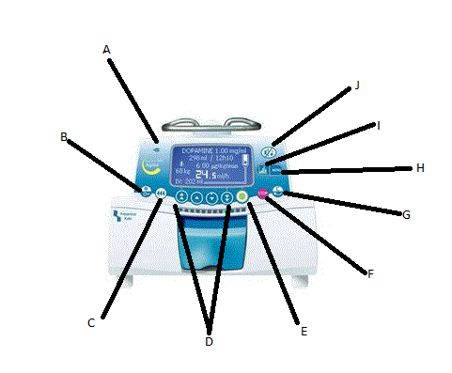

1. Mains Indicator
2. On/Off Button
3. Bolus
4. Increment Keys
5. Ok/Start/Enter
6. Stop/Pause
7. Change / Back Space
8. Menu
9. Graphic Display
10. Silence Alarm

To turn pump on/off press and hold ON/OFF key

# LED Screen

Top left moving anticlockwise:

* Pressure Level icon wheel
* Battery Level icon
* Volume Infused :VI
* Flow rate in ml/hr (large figures)
* Infusion flow drip indicator
* Total hours remaining
* Finally, Total volume to be infused

# Preparation (use a ‘pump check chart’)

* The **Volumat** must be positioned using a 5 legged pole, or fixed rail, it needs to be secured and attached correctly using the pole clamp
* The pump can operate through battery however, always attach to the mains supply under normal conditions to ensure the battery is charged at all times
* Normal Infection, Prevention and Control procedures apply i.e. hand washing, decontamination, aseptic non touch technique (ANTT)
* Select the appropriate administration set (either general or blood use)
* Prepare the infusion, checking that ALL components – giving sets, fluid etc. are in date
* Record the pump asset number on the infusion pump check chart

# Set Up - Priming the Line

* Hang the solution to be infused on a drip stand
* Remove the administration set from packet
* Close the roller clamp and spike the solution
* Squeeze some fluid into drip chamber
* Control the flow with the roller clamp and start priming the line – SLOWLY
* Check the line for air bubbles

# Set up – Installing the Giving Set

* Open the door by lifting the BLUE lever on the front of the pump
* Align the giving set tubing horizontally with the BLUE and GREEN parts corresponding to the BLUE and GREEN indicators on the pump.
* Close the door by lifting and closing the BLUE handle.
* The pump will carry out its operation checks and indicate if the giving set is positioned correctly.

# Start Up at its simplest:

* Switch on the pump
* An AUTO-TEST will automatically check the functionality of the pump – ‘smiley faces’
* Prime the line – slowly to avoid air bubbles
* Wait for the LED message to say ‘Install Set’ (see above)
* Programme the infusion using Volume / Time / Rate:
* Release roller clamp, ensure connected to patient and Press Start to commence the Infusion

# Occlusion Alarm Settings

The Occlusion Detection System measures UPSTREAM and DOWNSTREAM occlusions.

The **Volumat** has a variable occlusion pressure alarm range:

The pressure alarm setting is pre-programmed at 300mmHg for adults/children and 150mmHg for the SCBU pumps, however you can amend the setting to provide a higher or lower setting as per the patients’ individual needs.

# MENU Button

There are 10 menu functions:

* Battery life
* Macro / Micro
* Night / Day Mode
* Data Log Event
* Programmed Bolus
* Keyboard Lock / Unlock
* Pause Function
* Volume Infused (VI)
* Pressure setting
* Volume To Be Infused (VTBI)

Scroll through using the increment keys.

# Alarms and Pre-Alarm

Flashing RED lights = Main Alarm

* Sound signals emitted
* The infusion automatically stops
* A clear message will be displayed on the LED screen
* The alarm silence key is effective for 2 minutes
* When cause for alarm has been fixed the red lights will go and the infusion can be restarted

Reasons for Alarm:

* Install Set
* OCS Failed (angry faces)
* Door Opened
* Air Bubble Detected
* Pressure Increase
* End of Infusion
* Downstream Occlusion
* Upstream Occlusion
* Empty battery

Flashing ORANGE lights = Pre-Alarm

* Sound signals emitted
* The infusion will continue
* A clear message will be displayed on LED screen

Reasons for Pre-Alarm:

* Battery in operation
* Near end of infusion = **5 Mins** before
* Near end of Battery life = **30 mins** before

# Cleaning and Decontamination

This should be carried out:

* between patients
* after transportation between wards
* before returning to the equipment library
* where otherwise indicated e.g. following a spill or leakage

Use Sanicloth Detergent wipes or if needed warm soapy water and a damp cloth

Do not:

* immerse the pump in water, it is not waterproof
* use alcohol wipes where the percentage of alcohol exceeds 70%, as this damages the surface of the pump

**logo2**



**Volumat**

**QUICK GUIDE**

**In the guide:**

* Indications for use
* Safety features
* Pre-use checks
* Front display buttons
* LED Screen
* Preparation
* Set up – Priming the Line
* Set up – Installing the Giving Set
* Set up at its simplest
* Occlusion Alarm Settings
* Menu Button
* Alarms and Pre-Alarms
* Cleaning and Decontamination

**For further information:**

Contact the Medical Device Training Team on x5095 or

Bleep 1182

Training Tracker on Intranet

Version 1.0 January 2015