Offers run until 2nd November 2017

Don’t forget you will also get your 10% staff discount off this already discounted price!

**Star Gift**

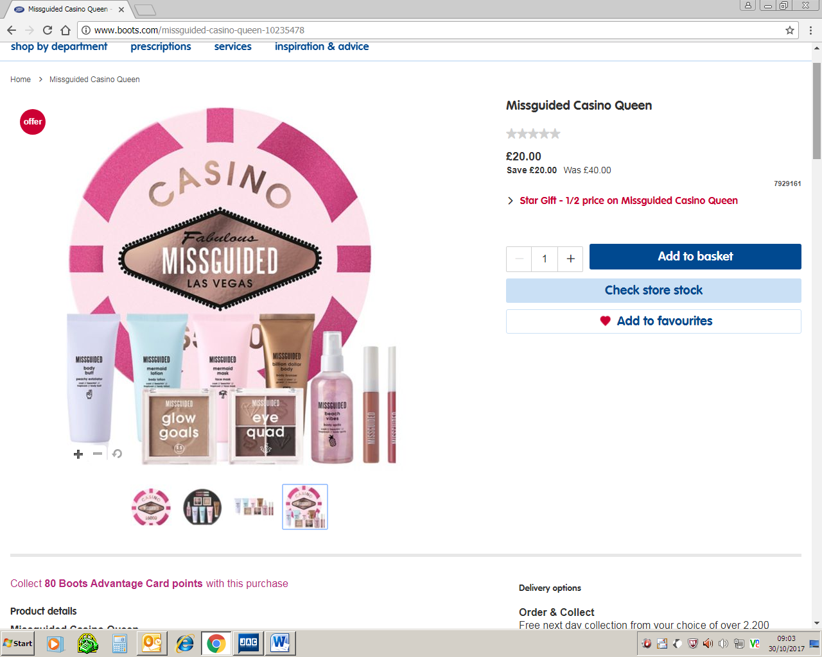

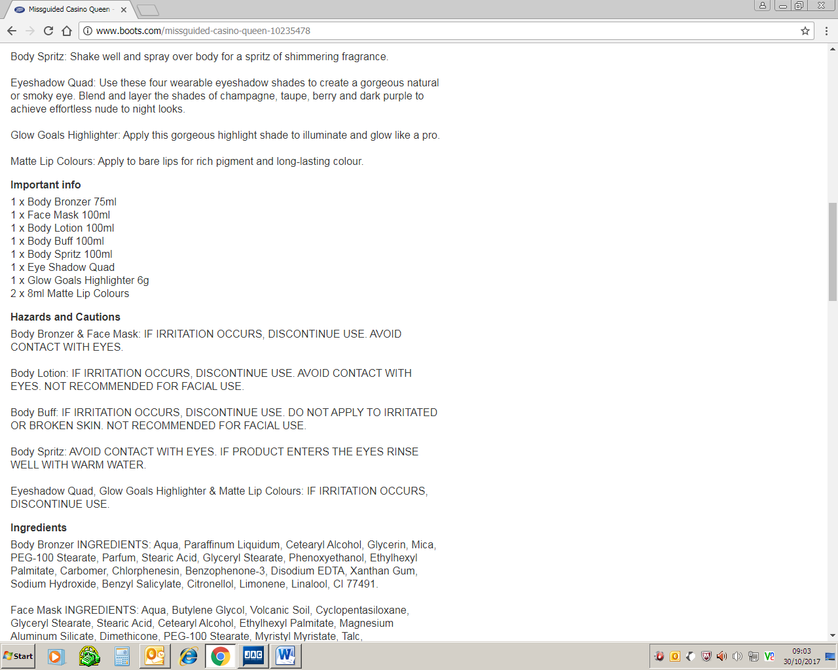

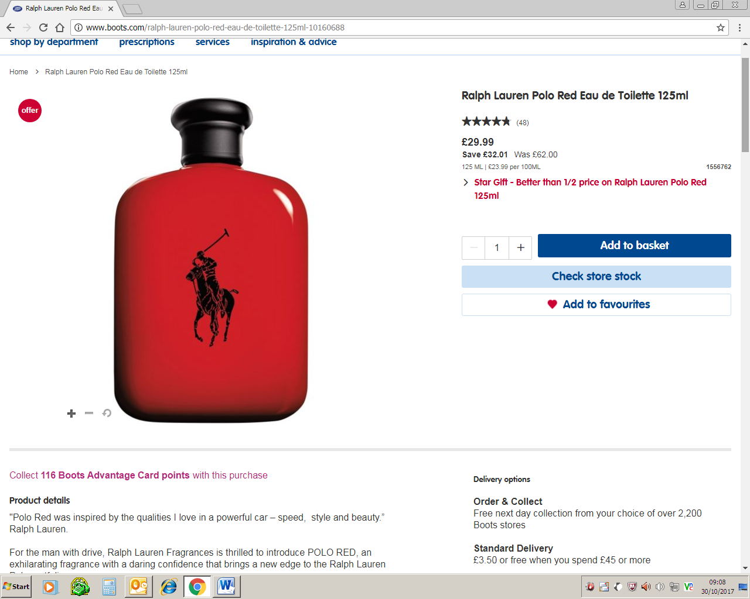

Offers run until 2nd November 2017

Don’t forget you will also get your 10% staff discount off this already discounted price!

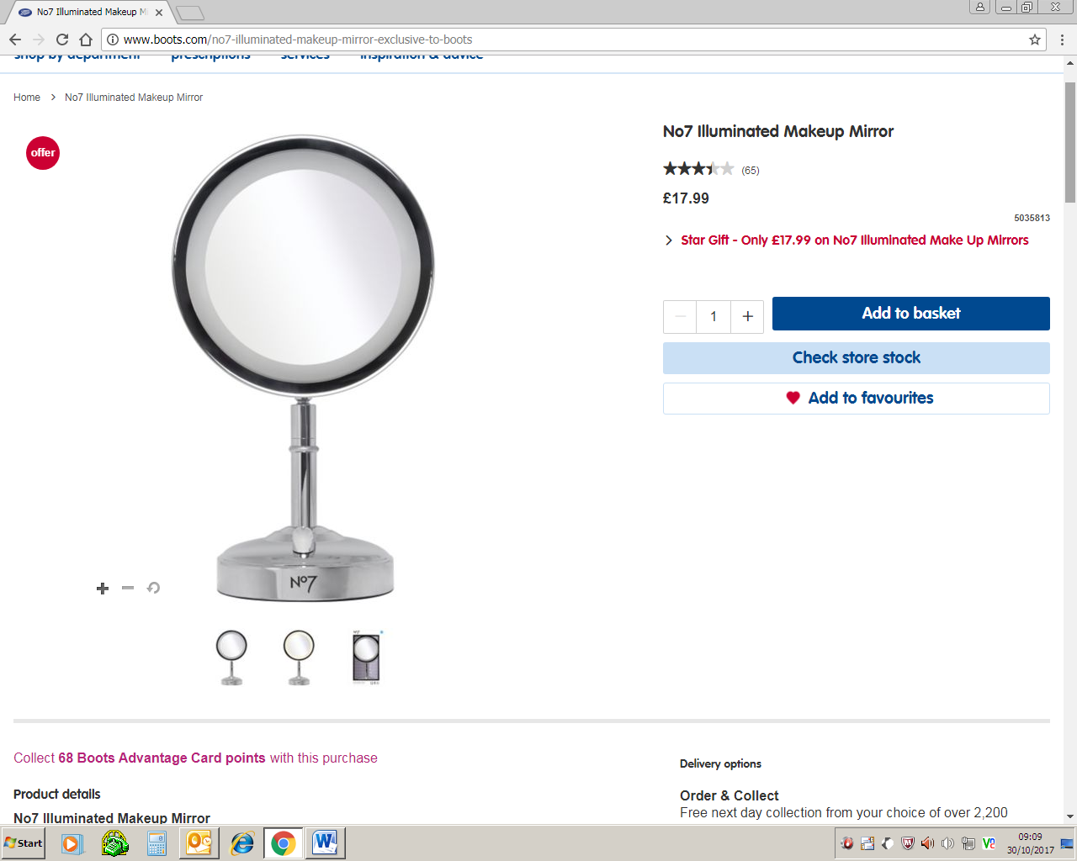

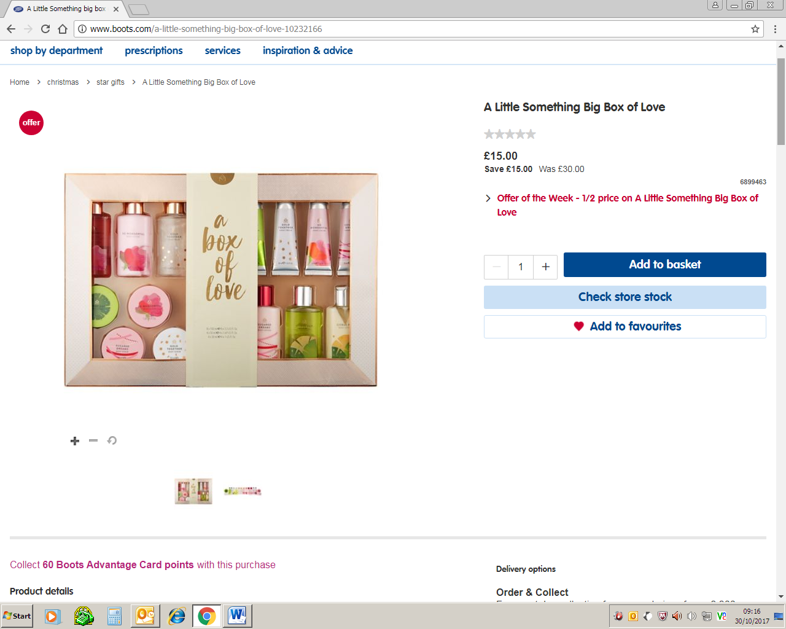

Offers run until 2nd November 2017

Don’t forget you will also get your 10% staff discount off this already discounted price!

