**Metal Detector Technique**

All metallic objects, for example jewellery, are removed and non-removable metal, for example fillings and sternal wires, are noted. Children stand upright or are held by their parents with their trunk extended (fig 1).

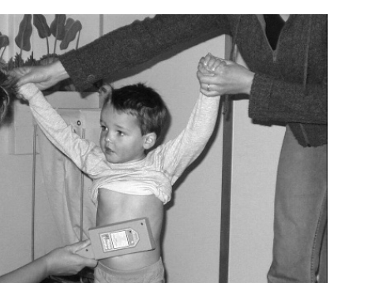

The metal detector is checked on a metallic object such as the examiner’s watch, and then passed from the level of the nasopharynx, moving caudally down the chest and abdomen to the symphysis pubis in the midline. Scan again in two more vertical lines to the left and right of the midline, so that all 9 regions of the abdomen are scanned. Finally, this is repeated posteriorly from the level of the nasopharynx to the sacrum, again in three vertical lines.

A positive signal gives a visual and auditory alarm. An oesophageal metallic foreign body is indicated by a positive signal when any part of the metal detector is above the xiphisternum, with a positive signal below this level considered indicative of location in or distal to the stomach. An equivocal signal is reported where the examiner is unable to definitely allocate the positive signal as above or below this level.