**No**

**No**

Is an alternative suitable medication available as a TTA pack? Discuss with senior clinician

Yes

Prescribe on Green FP10 prescription

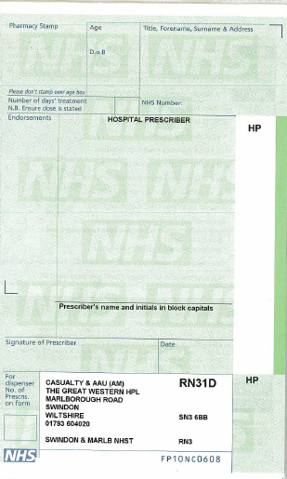

**Clinically urgent**/patient can’t come back

**Not urgent**/patient can come back when Boots open

Is the medication clinically urgent to start immediately? If not could the medication be dispensed by onsite Boots when next open?

Tell patient or relative to take prescription to external community pharmacy

Prescribe on Yellow hospital prescription

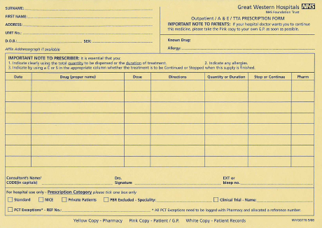

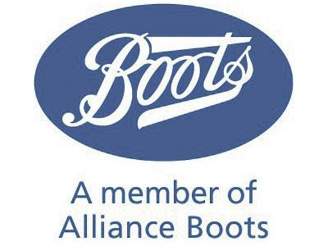

Tell patient or relative to take prescription to **on site Boots Pharmacy**

Yes

Send yellow copy of prescription to the inpatient Pharmacy

Does patient pay for their prescription?

File prescription

No

**Is the onsite Boots open?**

Boots opening hours -

Monday – Friday 9am-7pm

Saturday 9am – 2pm

No

Yes

Prescribe on Yellow hospital prescription



Dispense TTA pack from department cupboard

Is the medicine available as a TTA pack?





Yes

Supply of medication for patients to take away