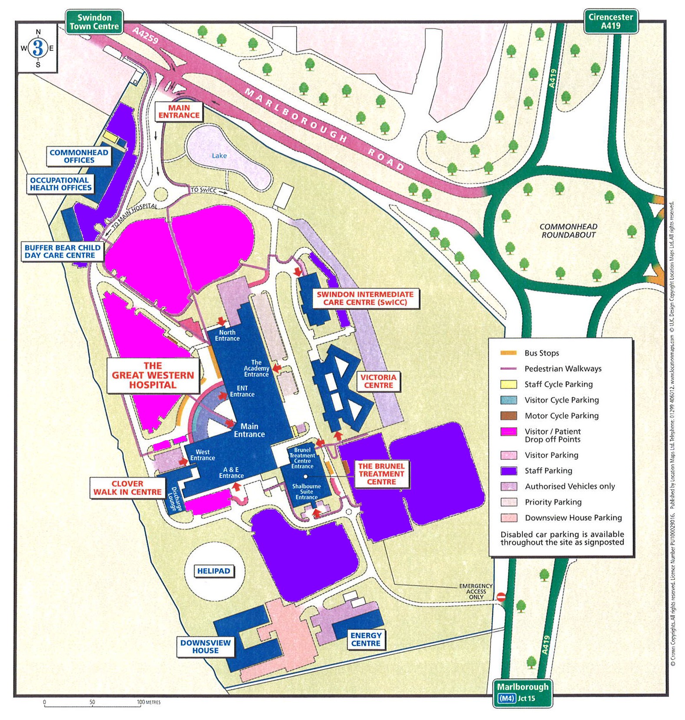

# APPENDIX 9: Student User Application Form PASS NO:

**Terms and Conditions of use and Application Form to obtain a Great Western Hospital Standard Barrier Pass**

Terms and Conditions

1. Great Western Hospital Standard Barrier Pass remains the property of Great Western Hospitals NHS Foundation Trust at all times.
2. Barrier Passes may not be transferred between individuals.
3. Passes may be used on the site to park in recognised Standard Staff parking areas at the Great Western Hospital.
4. Holders of a Standard barrier pass must notify the Student Placement Team of any changes in their circumstances that may affect their eligibility immediately.
5. Damaged barrier passes should be returned to the Student Placement Team, who will replace the pass with the remaining credit- there may be a discretionary £5 for the new pass.
6. Lost passes can be replaced by the Student Placement Team for a £5 charge.

Instructions to Applicant

* Apply only if you are a non-medical student.
* The information that you provide is essential for making a decision on any application. It will only be used for these purposes.
* Where indicated please either tick the appropriate box or enter the required information **clearly** in BLOCK CAPITALS and in either blue or black ink (illegible submissions will be returned).

**Personal Information**

Title: (Mr / Mrs / Ms / Dr / Revd/Other) (please delete as appropriate)

Forename(s):

Surname:

Contact Details:

|  |  |
| --- | --- |
| **Great Western Hospitals NHS Foundation Trust** |  |
| **University:** | **Number of days on site each week:** |
| **Student Branch:** | **Placement Start Date:** |
| **Placement Area:** | **Placement End Date:** |

**Applicant Signature**

I have read the Car Parking Policy and Procedure including eligibility criteria and conditions of use for barrier pass and have understood them. If I am issued with a barrier pass I agree to adhere to the conditions of use and I know that abuse of these conditions may lead to withdrawal of the permit and disciplinary action may be taken against me.

Signed: Date:

**Management Statement**

(This must be completed and signed by the Student Placement Manager or equivalent before the application can be processed.) I confirm that all the above information, including appended information or documentation, all of which I have initialled, is correct:

Signed: ……………………………………… Date: Name: