**Risk Register – How to Guide**

**What is the Risk Register**

The risk register is a tool for managing risks.

**Accessing the Risk Register**

The risk register is accessed from the Trust’s intranet home page. On the left hand side under Useful Links there is an option for Incident / Risk Register. Should the system ask for a user name and password, this will be the same as your normal log in details.

**Entering information onto the Risk Register**

As a general rule, we advise you to add as much information as possible, but at a minimum there is a need to complete all mandatory (orange) fields.

**Tab – Risk**

This is where you enter all the key information such as which area the risk pertains to, who assessed the risk and who is responsible for ensuring the risk is reviewed.

The tab also includes details of the risk. **The description should detail what the risk is and how this could affect the Trust (outcome). Make sure you differentiate between a hazard and a risk**. E.g. “snow” is a hazard. The risk might be “staff shortage impacting on delivery of care due to staff not being able to get to work in snow”. Another example e.g. new regulatory compliance (hazard) has not been adopted into the Trust and therefore could impact on patient safety / failure to adhere to NHSLA / CQC compliance. If you are unsure, ask for help.

Should you need to update the risk owner, assessor, handler in the future, the system allows this.

**Tab – Assessment**

You will need to assess the seriousness of the risk by ascertaining the severity and likelihood of reoccurrence. The Risk Matrix for Risk Managers is a helpful guide.

When you review the risk and update the risk score it will remind you to create a new risk version.

Any actions which still need completing, will be pulled forward to the new version, completed actions will not be visible.

**Tab – Existing Controls**

This tab is used to detail controls which are already in place which will help mitigate the risk. **It is very important this section is completed fully as this is information which will be viewed by an external assessor in the first instance.**

**Ask yourself what is already in place to help manage this risk and how good are those measures and how you know.** There are areas where you can include information about gaps in the controls and what assurances we have as to the effectiveness of the control.

The controls need to be kept up to date and reviewed as part of the review process.

A point to remember is, a completed action, may become a control. Eg the risk is staffing levels affecting patient safety. Actions are to recruit more staff and as an interim use bank staff. Therefore once bank staff have been put in place, this becomes a control.

**Tab – Actions**

**Every risk should have at least one action which will mitigate the risk.**

In some cases there is still a risk to the Trust, but we have all the controls in place and nothing more can be done. In instances like this, the action could be to review and monitor in a year. An example is we need to achieve 100% compliance on training to meet the requirement of an external monitoring body, however this is unlikely to be achieved but we do achieve 95% compliance, so we monitor to ensure the figure has not dropped etc.

On the action tab there are two sub tabs: action details and progress.

**Tab – Actions - Action Details**

Identify actions to mitigate the risk and provide clear details of what the action is.

There is space for the action lead and accountable person to be recorded. These people do not necessarily need to be the same people who are responsible for the overall risk. For example you may need HR involvement.

Set a target date for completion of those actions. It would seem sensible to make this date the same as your review date (see tab - review). As with other fields, this can be updated at a later stage when you review the risk. **Remember to always refresh the target date for completion of action. This is regularly overlooked and looks like the action is overdue.**

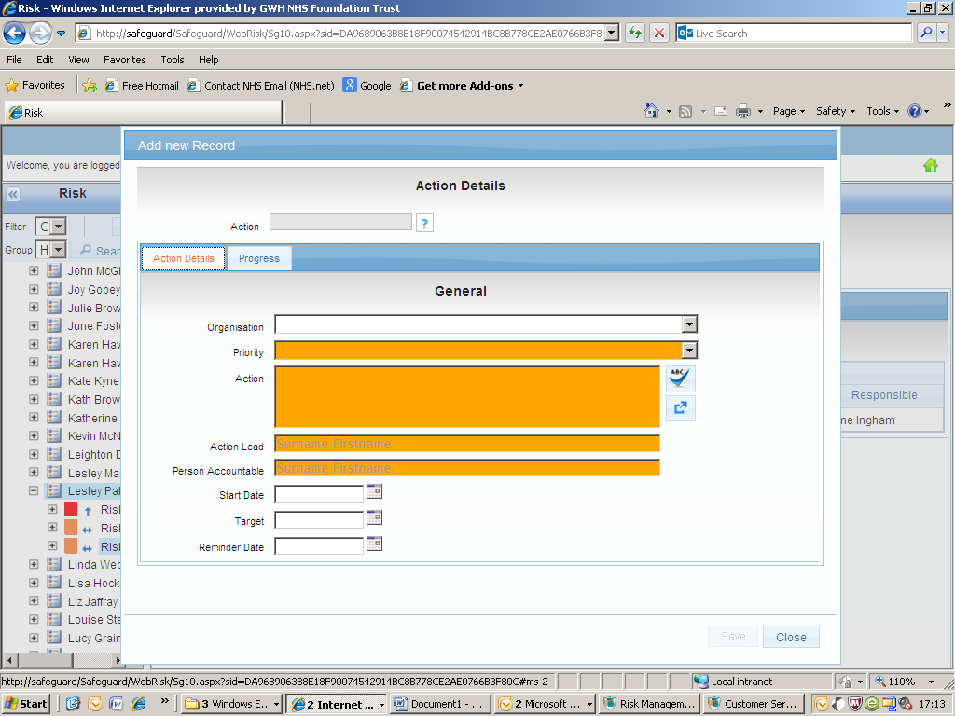

**Tab – Actions – Progress**

**You must progress your actions and this must be recorded in the progress box.**  Add new progress here. When you come to update this next time you review the action, the historic entries will drop to the box below, so you have an audit trail.

Choose the outcome to be action required.

When the action is completed, enter the date in the completed field and change the outcome to completed. Also update the progress to reflect how the action has been completed. **If you do not complete the progress box, it looks like you closed the action without having completed it.**

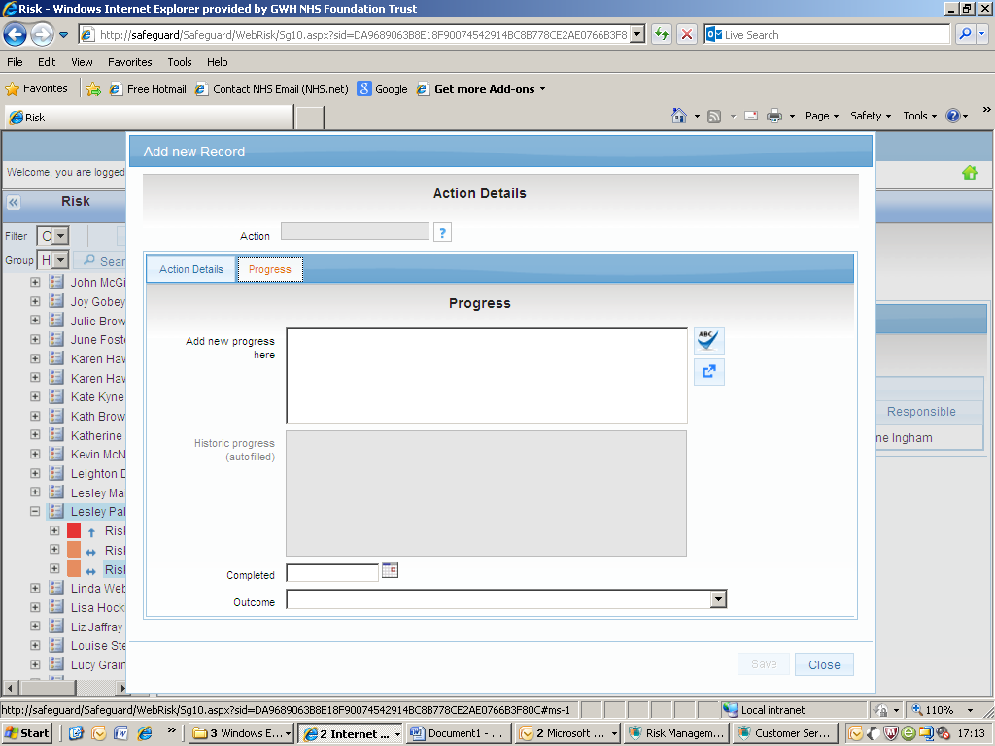

**Tab – Review**

Review the risk at the frequency set (weekly, monthly, quarterly, bi-annually or annually**). For 12+ risks this is always monthly.** After you have selected one of these options, the next review date will be automatically populated.

Each time the risk is reviewed you should select new on the review tab and enter the date and provide brief details of the review. These details should not be specific to the actions but a comment on the risk as a whole.

**When reviewing the risk you need to consider whether the control and actions are making any difference to the risk scoring. Ask yourself should the risk score be higher or lower / is the risk still relevant or should more actions be planned.** If the score is the same or changed, record this. You must include text at every review otherwise it looks like you have not reviewed the risk, but merely refreshed the review date.

If the risk no longer exists, close it but record in the risk review why this decision was made.

**Tab – Attachments**

If you think it could be beneficial to add an attachment e.g. an action plan to the risk, this can be done here. It’s important to note, that this is a hyperlink function so any attachment will only be visible to those who have access to the folder where the document is saved on the T Drive.

**Tab – Notifications**

Should you wish to let others know about the risk, you can include them on this tab. The function works in the same way as on the online incident form. This is a good audit trail of recording emails.

**Reminders**

The action owner will receive an email reminder three days before the action target date is due.

The reminders for both will continue every ten days until the risk is updated.

**If you do not have a reminder, it might be because the risk is closed, or the date of reminding has passed. This is why it is essential to update planned completion of action dates.**

**Closing the Risk**

The risk can be closed when all actions have been completed. If there are still outstanding actions the risk should not be closed.

To close the risk, go to the Risk tab, change the current status to closed and enter the date closed in the box below. **Remember to explain in the review section why you felt it was appropriate to close the risk.**

**Advice and Support**

For advice and support in using the risk register as an effective risk management tool contact

**Hayley Aplin Risk and Governance Facilitator**

Tel: 01793 605426

March 2015