**Action reminders from Safeguard when the action is closed**

To fully close an Action in the Risk Register you must select both the Completed Date cid:image009.jpg@01CFD338.82ABCC00

 and Outcome. Action closed. 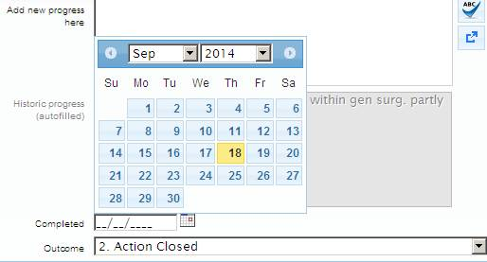

Safeguard will “believe” that an Action is still open if both conditions of closing the action are not done and as a result you will still receive reminders from Safeguard.