There is a quick and simple way to identify if your risk is overdue or not.

1. Filter on “Open Risks”
2. Select Manager as the “Group” Filter.
3. Scroll down to find your name
4. Select a risk
5. Click on the + beside the risk number to expand the risk details

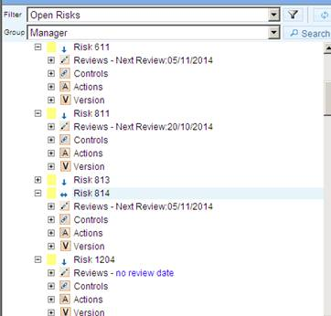

6. Drag the scroll bar to the right and the review date will be revealed

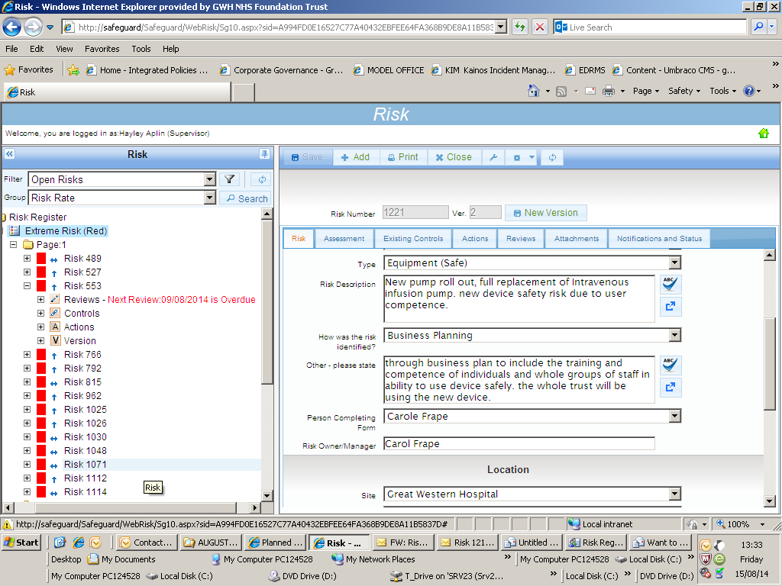

(Scroll bar found at the bottom of the filtered selection)

cid:image015.jpg@01CFB88E.D01CAA00

An overdue risk will look like the below

