**Directions to Off-Site Parking for Savernake Hospital**

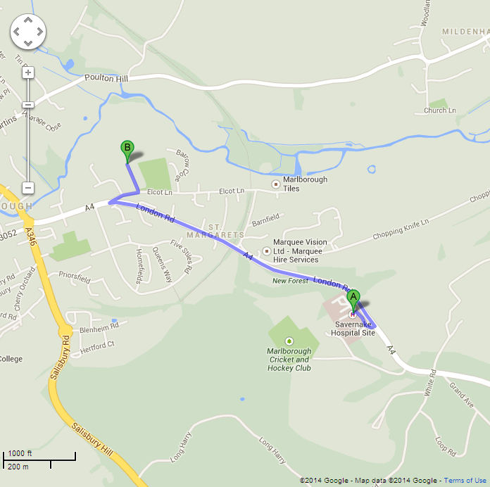

**MARLBOROUGH FOOTBALL CLUB**

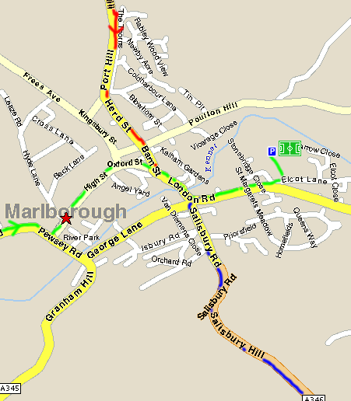

Roebuck Inn

Coming From Savernake Hospital

|  |  |
| --- | --- |
|  | |
|  |  |

**From the west**Travel along the A4 into Marlborough, continuing  through the town following signs for Hungerford. Turn Left just before the Roebuck Pub.

**From the North**Travel along the A346 from the M4 into Marlborough, and follow the signs for A4 Hungerford. Turn left just before the Roebuck Pub.

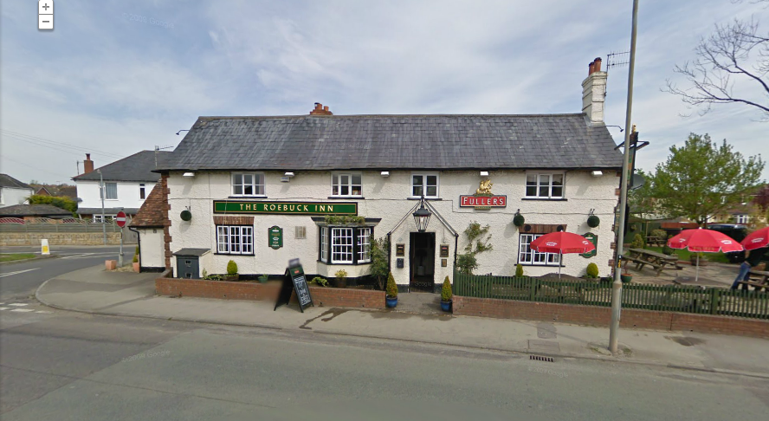**From the South**  
On entering the town, follow signs for A4, Hungerford. Turn left just before the Roebuck Pub.

The ground is down the second turning on the left.

|  |  |  |  |  |
| --- | --- | --- | --- | --- |
|  | GWH blue and black   |  | | --- | |  | |  |  |
|  |  |  |  |
|  |  |  |  |
|  |  |  |  |
|  | **Savernake Hospital Off-Site Parking** | | |
|  | **Shuttle Timetable (AM & Lunchtime)** | | |
|  | **Savernake Hospital** | **Waitrose (Bus) AM** | **Off Site Parking** |
|  | 06:30 | 06:40 |  |
|  | 06:50 | 07:00 | 07:10 |
|  | 07:20 | 07:30 | 07:40 |
|  | 07:45 |  | 07:50 |
|  | 07:55 |  | 08:00 |
|  | 08:05 |  | 08:10 |
|  | 08:15 |  | 08:20 |
|  | 08:25 | 08:30 | 08:40 |
|  | 08:45 |  | 08:50 |
|  | 08:55 |  | 09:00 |
|  | 09:05 |  | 09:10 |
|  | 09:15 |  | 09:20 |
|  | 09:25 | 09:30 | 09:40 |
|  | 09:45 |  | 09:50 |
|  | 09:55 |  | 10:00 |
|  | 10:05 |  | 10:10 |
|  | 10:15 |  | 10:20 |
|  | 10:25 | 10:30 | 10:40 |
|  |  | | |
|  | 12:20 | 12:30 | 12:40 |
|  | 13:30 | 13:40 | 13:50 |
|  | 13:55 |  | 14:00 |
|  | **Driver's Mobile 07826-914866 / Reception 01672-517200** | | |
|  |  | | |
|  | **GWH blue and black** | | |
|  |
|  |
|  | **Savernake Hospital Off-Site Parking** | | |
|  | **Shuttle Timetable (PM)** | | |
|  | **Savernake Hospital** | **Waitrose (Bus) PM** | **Off Site Parking** |
|  | 14:00 | 14:15 | 14:20 |
|  | 14:25 |  | 14:30 |
|  | 14:35 |  | 14:40 |
|  | 14:45 |  | 14:50 |
|  | 14:55 |  | 15:00 |
|  | 15:05 | 15:15 | 15:20 |
|  | 15:25 |  | 15:30 |
|  | 15:35 |  | 15:40 |
|  | 15:45 |  | 15:50 |
|  | 15:55 |  | 16:00 |
|  | 16:05 | 16:15 | 16:20 |
|  | 16:25 |  | 16:30 |
|  | 16:35 |  | 16:40 |
|  | 16:45 |  | 16:50 |
|  | 16:55 |  | 17:00 |
|  | 17:05 | 17:15 | 17:20 |
|  | 17:25 |  | 17:30 |
|  | 17:35 |  | 17:40 |
|  | 17:45 |  | 17:50 |
|  | 17:55 |  | 18:00 |
|  | **Driver's Mobile 07826-914866 / Reception 01672-517200** | | |