

**Dementia Care Pathway for Adult In-Patients (Trust wide)**

|  |  |  |  |  |  |  |
| --- | --- | --- | --- | --- | --- | --- |
| **Document No** | UC - 00001 | | | | **Version No** | 1.0 |
| **Approved by** | Policy Governance Group | | | | **Date Approved** | 31/08/16 |
| **Ratified by** | Safeguarding Adults Forum | | | | **Date Ratified** | 27/10/16 |
| **Date implemented ( made live for use)** | | | 25/11/16 | | **Next Review Date** | 27/10/19 |
| **Status** | | LIVE | | | | |
| **Target Audience-** who does the document apply to and who should be using it. | | All employees directly employed by the Trust, whether permanent, part-time or temporary (including fixed-term contract). It applies equally to all others working for the Trust, including private-sector, voluntary-sector, bank, agency, locum, and secondees. For simplicity, they are referred to as ‘employees’ throughout this policy | | | | |
| **Accountable Director** | | | | Chief Nurse | | |
| **Author/originator** – Any Comments on this document should be addressed to the author | | | | Consultant Physician, Department of Medicine for the Elderly  Head of Safeguarding and Mental Health, Matron Lead for Learning Disabilities and Dementia Care | | |
| **Division and Department** | | | | Planned Care. DOME | | |
| **Implementation Lead** | | | | Clinical Lead for Dementia  Matron Lead for Dementia | | |
| **If developed in partnership with another agency ratification details of the relevant agency** | | | | NA | | |

**Equality Impact**

Great Western Hospitals NHS Foundation Trust strives to ensure equality of opportunity for all service users, local people and the workforce. As an employer and a provider of health care, the Trust aims to ensure that none are placed at a disadvantage as a result of its policies and procedures. This document has therefore been equality impact assessed in line with current legislation to ensure fairness and consistency for all those covered by it regardless of their individuality. This means all our services are accessible, appropriate and sensitive to the needs of the individual.

**Special Cases**

Neonatal, paediatric and maternity services.



Contents

1 Instant Information Great Western Hospital (GWH) Dementia Pathway Step 1 - Admission to Hospital 3

2 Instant Information GWH Dementia Pathway Step 2 – Transfers 4

3 Instant Information GWH Dementia Pathway Step 3 – Care On Wards 5

4 Instant Information GWH Dementia Pathway Step 4 – Timely And Safe Discharge Process 6

5 Instant Information GWH Dementia Pathway Step 5 – Dying In Hospital 7

6 Document Details 8

6.1 Introduction and Purpose of the Document 8

6.2 Glossary/Definitions 8

6.3 Infection Prevention and Control 9

7 Main Policy Content Details 9

7.1 ‘This is Me’ Document 9

7.2 Medway Reasonable Adjustments Alert 9

7.3 Forget-me-not Symbols 10

7.4 Abbey Pain Scale 10

7.5 Dementia Friendly Environments (Ref 17) 10

7.6 Dementia & Delirium Screening on Admission 11

7.7 Dying in Hospital with Dementia 12

8 Duties and Responsibilities of Individuals and Groups 12

8.1 Chief Executive 12

8.2 Deputy Divisional Directors 13

8.3 Document Author and Document Implementation Lead 13

8.4 Target Audience – As indicated on the Cover Page of this Document 13

8.5 The Great Western Hospital Dementia Strategy Group & Dementia Operational Group 13

9 Monitoring Compliance and Effectiveness of Implementation 13

10 Review Date, Arrangements and Other Document Details 14

10.1 Review Date 14

10.2 Regulatory Position 14

10.3 References, Further Reading and Links to Other Policies 15

10.4 Consultation Process 16

Appendix A – Equality Impact Assessment 17

Appendix B – Quality Impact Assessment Tool 18

Appendix C – This is Me Document 19

Appendix D – Abbey Pain Scale 23

Appendix E – Abbey Pain Scale, GWH Instructions for Use 24

Appendix F – Dementia & Delirium Screening Tool 25

Appendix G– Dementia & Delirium Screening Tool 26

Appendix H – Dementia & Delirium Sections on Electronic Discharge Summary 27

Appendix I – Delirium Patient Information Leaflet 28

# Instant Information Great Western Hospital (GWH) Dementia Pathway Step 1 - Admission to Hospital

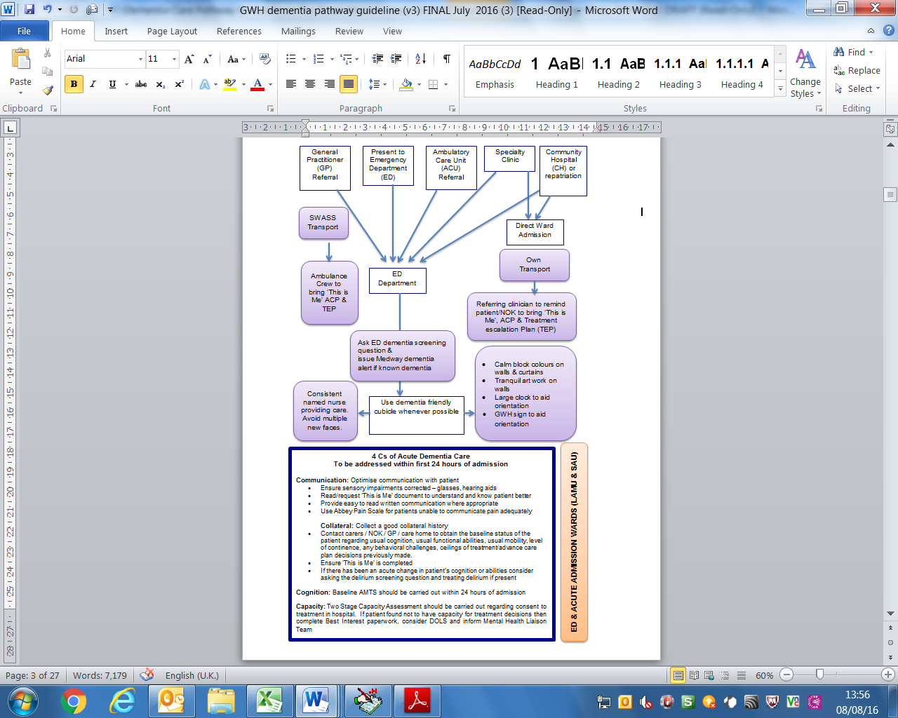

# Instant Information GWH Dementia Pathway Step 2 – Transfers

🡹 Disorientation

🡹 Anxiety & distress

🡹 Delirium

🡹 Need for close support / 1 to 1 nursing

🡹 Length of hospital stay🡻 Patient experience & satisfaction

**NOCTURNAL WARD MOVES**

**&**

**MULTIPLE WARD MOVES**

* No ward moves between 8pm-8am (unless clinically necessary)
* Avoid unnecessary ward moves
* Ensure sensory impairments corrected before transfer – glasses on, hearing aids in & switched on
* Ensure ‘Familiar Face’ accompanies patient – carer / NOK / familiar Health Care Assistant (HCA) or nurse
* Ensure ‘This is Me’, TEP, Advance Care Plan & Abbey Pain Scale accompany patient
* Ensure important documents are at the front of the medical notes: capacity assessment, best interests forms, DOLS paperwork
* Ensure ‘Reasonable Adjustments’ Alert is entered on Medway before ward transfer
* Good verbal handover should be given to the receiving ward regarding patient’s needs

Transfer to a new ward

Transfer to a different department

e.g. for investigations, procedures or clinic appointment

* Ensure sensory impairments corrected before transfer – glasses on, hearing aids in & switched on
* Ensure ‘Familiar Face’ accompanies patient – carer / NOK / familiar HCA or nurse
* Request same porter for transfer to destination and back to ward whenever possible
* Ensure ‘This is Me’, TEP, & Abbey Pain Scale accompany patient on transfers
* Take distractions in case of delays – sensory bands, items from memory box such as reminiscence books or photos
* Utilise volunteer support services such as OWLs (Outpatient & Welcome Liaison Service) in Outpatient Departments

# Instant Information GWH Dementia Pathway Step 3 – Care On Wards

**ON ADMISSION TO WARD**

**DURING HOSPITAL STAY**

* Introduce yourself to the patient and carer using a ‘Hello My Name Is’ approach
* Take a comprehensive handover from the transferring nurse
* Ask dementia & delirium screening questions within 72 hours of admission to hospital and complete further assessments as required
* Complete swallow assessment if indicated
* Complete the ‘Close support’ risk assessment if clinically indicated
* Refer to Mental Health Liaison if indicated
* If learning difficulties (LD) and dementia check if person known to LD community team
* Ensure ‘This is Me’ & Abbey Pain Scale are completed (On National Early Warning Score ((NEWS) chart) and included in the patients end of bed notes
* Ensure important documents are completed and placed at the front of the medical notes: Mental Capacity 2 Stage Assessment, Best Interests forms, DOLS paperwork (as applicable)
* Investigate if the ACP for the dying or TEP exists
* Ensure forget-me-not visible on patient ward board and behind the bed boards and on the electronic white boards where applicable.
* Check Reasonable Adjustments Alert has been entered on Medway
* Ensure you have up-to-date NOK/Carer contact details and agree contact/support arrangements
* For patients who lack capacity/invasive procedures/ ‘unbefriended’/family objections to treatment consider appointing an independent mental capacity advocate (IMCA)
* Ensure care is person centred, compassionate and promotes choice
* At least Hourly Care Rounding if patient unable to use call bell effectively
* Consider ACP and TEP discussions if appropriate and not completed and the person has capacity. Raise alert on Medway
* Provide assistance to eat and drink as required/coloured crockery/food and fluid charts
* Ensure patient has their glasses on, hearing aids in & switched on, mobility aid to hand
* Ensure patient has pain assessed regularly using the Abbey Pain Scale (on NEWS chart)
* Try to co-ordinate tests to minimise trips off the ward
* Personalise bed space with familiar objects from home
* Recognise the carer as an ‘expert’ and involve them in care planning, delivery of care and discharge planning if they wish to be included
* Facilitate the carer role in hospital by offering: open visiting/overnight stay/parking permits/recliner chair/blankets/hot drinks/access to wash facilities
* Be aware of the increased risk of mortality when in Hospital
* **Avoid unnecessary ward moves**

# Instant Information GWH Dementia Pathway Step 4 – Timely And Safe Discharge Process

**WITHIN 72h OF ADMISSION**

**DURING HOSPITAL STAY**

* Involve the patient and relative/carer as much as possible
* Gather ‘baseline’ information (Mobility/ADL’s/Equipment)
* Establish level of current and likely future carer involvement
* If patient is from a care home/nursing home establish lines of communication and if home needs to reassess the patient prior to discharge
* Refer patient to relevant agencies/support services
* Issue relevant support leaflets to patient/and/or Carer – Dementia Support (Swindon)/Dementia Advice Service (Wiltshire)
* Refer early to Discharge Assessment and Referral Team (DART) team
* Ensure capacity has been established in relation to discharge planning at clinically appropriate time
* Facilitate ‘Best Interest’ Meeting as soon as clinically appropriate, if required
* Regularly update the patient/relative/carer about discharge plans and respond to concerns
* If patient lives ‘out of area’ discuss discharge plans daily with patient flow team
* Assess for the need for a medication DOSETT box
* Ensure appropriate referrals to community services are made on discharge e.g. DN, CPN etc.
* Agree discharge plans/times/mode of transport with relative/carer
* Ensure patient is dressed in weather/season appropriate clothing on discharge
* Avoid discharge after 6 pm
* If patient discharged and carers are waiting at home ensure carers are informed patient is on their way and make sure they have the ACP/TEP with them
* Ensure dementia/delirium follow up plan is clearly documented on the Electronic Discharge Summary (EDS) and patient has received any additional written information (i.e. delirium leaflet/dementia support information)

🡹 Disorientation

🡹 Anxiety & distress

🡹 Delirium

🡹 Need for close support / 1 to 1 nursing

🡹 Risk of Infection

🡹 Risk of falls

🡻 Patient/Carer experience & satisfaction

**PROLONGED STAY IN HOSPITAL**

# Instant Information GWH Dementia Pathway Step 5 – Dying In Hospital

**6. AT DEATH & POST DEATH**

* Follow any specific cultural/religious/cultural practices where possible
* Allow the family the time they need.
* Ensure the NOK are aware of the next steps
* Provide the bereavement booklet
* Establish a plan regarding property
* Inform professionals involved in care of the death
* Perform personal care after death
* Check any wishes regarding organ and tissue donation are being addressed
* Inform Bereavement services if patient is under The Deprivation of Liberty Safeguards (DOLS)

**4. SUPPORT**

* Explain what to expect in the last few days
* Explore the needs of those important to the patient – emotional, cultural, practical, and spiritual
* Check the carers need for external organisational support
* Provide regular updates to the patient those important to them and offer opportunities for questions

**5. PLAN & DO**

* Understand any cultural, spiritual, religious needs of the patient and family
* Check preferred place of care and preferred place of death
* Ensure anticipatory medications for dying patients are prescribed
* Agree a plan for assessment of symptoms
* Explain the rationale for syringe drivers
* Agree a plan for the provision of food and fluid
* Agree a plan for medications and investigations, use abbey pain score
* Decide the ceilings of treatment, check a TEP is in place
* Formulate a nursing plan to meet agreed decisions around care, allow relative involvement if desired
* Provide practical information about the ward and hospital environment, parking, open visiting, refreshments, toilet facilities for relatives.
* Consider referral to Palliative Care Team for specialist support as appropriate.
* Avoid unnecessary ward moves, but consider patient and family wishes for a side room

1. **INVOLVE**

Patient & family in all decisions and care to the extent that they wish * IMCA

1. **COMMUNICATE**

* Establish who the responsible clinician and nurse are in care
* Communicate sensitively and clearly and at a pace that is right for the person and family
* Be aware of any ACP and TEP
* Understand the content of ‘This is Me’
* Use Best Interests framework to inform care
* Check any established preferences about organ donation
* Provide ‘Easy read’ written communication where appropriate
* Ensure sensory impairments corrected

1. **RECOGNISE**

Understand triggers for dying with Dementia:

* Recurrent infections
* Developing pressure sores/poor skin integrity
* On-going agitation/delirium
* Progressive eating difficulties/poor swallow
* Increasing immobility
* Three or more admissions in the last year
* Decision made to no longer accept treatment to reverse condition

**Instigate the Personalised Care Plan for the dying**

# Document Details

## Introduction and Purpose of the Document

Dementia is a term used to describe a syndrome that may be caused by a number of illnesses in which there is progressive decline in multiple areas of cognitive function. These include a decline in memory, reasoning, communication skills and the ability to carry out daily activities. Alongside the decline, individuals may develop behavioural and psychological symptoms of dementia, such as agitation, aggression, wandering, shouting, repeated questioning, sleep disturbance, depression and psychosis. The delivery of high standards of care in all settings for people living with dementia and their carers is a Department of Health (DH) priority (Ref 6)

It is well recognised that the United Kingdom (UK) population is ageing. The incidence of dementia increases with age with one in 14 people over the age of 65 being affected and one in six people over the age of 80 being affected (Ref 10) Demographic trends therefore predict that hospital beds are increasingly likely to be occupied by older adults with dementia (Ref 10)

Outcomes are worse for hospital in patients with dementia, compared to age equivalent patients without dementia, being treated for the same problem (Ref 10) Inpatients with dementia have longer length of stay in hospital, higher hospital mortality rates, are more likely to be prescribed anti-psychotics and have a greater likelihood of being discharged to institutional care (Ref 10) It is currently estimated the annual cost of caring for patients with dementia in hospital is £1.2 billion (Ref 10)

The purpose of this document is to combine recommendations from a wide range of sources to provide guidance on what constitutes ‘gold standard’ dementia care for hospitalised individuals. These comprehensive guidelines on dementia care are designed to be accessible to all employees to facilitate the delivery of excellent dementia care, which is standardised throughout all areas of the Great Western Hospitals NHS Foundation Trust (the Trust).

## Glossary/Definitions

The following terms and acronyms are used within the document:

|  |  |
| --- | --- |
| **<** | Under/Lower Than |
| **>** | Over/Higher than |
| **ACP** | Advanced Care Plan |
| **ACU** | Ambulatory Care Unit |
| **ADL** | Activities of Daily Living |
| **AM TS** | Abbreviated Mental Test Score |
| **APS** | Abbey pain scoring tool |
| **APS** | Abbey Pain Scale |
| **BPSD** | behavioral and psychological symptoms of dementia |
| **CH** | Community Hospital |
| **CPN** | Community Psychiatric Nurse |
| **CQUIN** | Commissioning for Quality & Innovation |
| **DART** | Discharge Assessment and Referral Team |
| **DN** | District Nurse |
| **DOG** | Dementia Operational Group |
| **DoH** | Department of Health |
| **DOLS** | The Deprivation of Liberty Safeguards |
| **DSG** | Dementia Strategy Group |
| **DSOG** | Dementia Strategy Operational Group |
| **ED** | Emergency Department |
| **EDS** | Electronic Discharge Summary |
| **FMN** | Forget-me-not |
| **GWH** | Great Western Hospital |
| **HCA** | Health Care Assistant |
| **IMCA** | independent mental capacity advocate |
| **LD** | Learning Difficulties |
| **NEWS** | National Early Warning Score |
| **NICE** | National Institute for Health and Care Excellence |
| **NOK** | Next of Kin |
| **OWLs** | Outpatient & Welcome Liaison Service |
| **PCP** | Personalised Care Plan (for the dying) |
| **SWAST** | South West Ambulance Service Trust |
| **TEP** | Treatment Escalation Plan |
| **TIM** | This is Me |
| **UK** | United Kingdom |

## Infection Prevention and Control

Standard infection prevention and control policies should be followed as per Trust guidelines for any inpatient. Please refer to the ‘Hand Hygiene and Skin Care Policy’ (including scrubbing gowning and gloving) (Ref 21) and the Standard Infection Control Precautions Policy (Ref 22)

# Main Policy Content Details

## ‘This is Me’ Document

In order to improve care and outcomes for individuals with dementia, a ‘person centred’ approach is essential. Person centred dementia care is emphasised in the National Dementia Strategy (Ref 6) and National Institute for Health and Care Excellence (NICE) Dementia Quality Standards (Ref 9 and 10) It is often difficult for patients with dementia to communicate their preferences, choices and needs to hospital employees, therefore person centre care can only be provided following detailed discussion with individuals who are well acquainted with the person living with dementia.

The ‘This is me’ booklet (See Appendix C of this document for a copy) is a booklet completed by patients with dementia, their relatives or carers which records the patient’s preferences, dislikes, habits, behaviours and routines. It enables healthcare professionals in all settings to understand each individual with dementia and facilitates the delivery of care specifically tailored to that person. In acute care settings the use of ‘This is me’ may reduce anxiety and distress, prevent delirium, improve hydration and increase nutritional intake. ‘This is me booklets’ are available in paper copy on all wards and patients are encouraged to have a copy at home that can be brought in with them should they need to be admitted to the acute Trust.

## Medway Reasonable Adjustments Alert

The Medway alert system can be used to highlight to employees that a person has dementia and may require a more individualised approach to their care. Employees can view Medway alerts by clicking on the ‘Alerts’ button on the Medway system. Employees can request that an alert be put on the system as soon as they become aware a patient has a confirmed diagnosis of dementia. This can be done through e-mailing the PAS/EPR_System_Team details of the alert. The alert will then appear every time subsequent employees log into a patient’s electronic records.

## Forget-me-not Symbols

Forget-Me-Not flowers have become a nationally recognised symbol for dementia following their introduction by the Alzheimer’s Society as part of their Dementia Friends Campaign in 2012 (Ref 9). The Trust uses the ‘Forget-Me-Not’ flower on ward boards, medical records and above patient beds as a discrete reminder to all employees that a patient has dementia and may require a more personalised approach. Forget-Me-Nots have been used throughout the Trust since 2013 and are available as plastic icons for standard ward white boards, as well as electronic icons for newer electronic ward boards since 2016. Icons can be purchased by the wards through NHS Supplies.

## Abbey Pain Scale

The Abbey Pain Scale (APS) (See Appendix D) is an observational tool which has been designed to assist in the assessment of pain in patients unable to communicate their needs, including levels of pain they may be experiencing. It was specifically designed for use in people with advanced dementia. The tool includes assessment of physiological and behavioural indicators of pain including vocalisations, facial expressions, body language, changes in behaviour and changes in physiological observations such as heart rate and blood pressure. A simple score is assigned by an experienced observer (usually a healthcare professional ) in each of these domains with an overall score generated which may suggest the presence of mild, moderate or severe pain. If appropriate, analgesia should be given and then the patient’s pain score re-assessed after a suitable time.

The preferred pain assessment is self-reporting often utilising tools such as visual analogue scales, numeric rating scales and verbal rating scales. However, such tools are not suitable for use in people with cognitive impairment. Behavioural and physiological measures can also be used to aid assessment of pain and may be more useful in those with cognitive impairment, learning difficulties or speech disorders.

It is important to note that the Abbey Pain Scale is unable to differentiate between pain and other causes of distress in people with dementia. Despite this the tool can be a valuable alternative aid in the assessment of pain in hospitalised individuals with dementia.

**Guidance for use of the Abbey pain scoring tool is included in the following documents**

1. Acute Pain Assessment and Management in Adults (Including the Abbey Pain Scale) for use with Patients who are Cognitively Impaired or unable to Communicate or Verbalise Clinical Guideline (Available on the Intranet)
2. Standard observation/NEWS charts (stored and in used on all wards)

## Dementia Friendly Environments (Ref 17)

Hospitals can be confusing, challenging and overwhelming for people with dementia. People with dementia find it difficult to orientate themselves in unfamiliar environments and have reduced physical and mental reserves to cope with the environmental challenges found in acute hospital settings. Increased length of stay, complications arising from prolonged hospitalisation, higher rates of institutionalisation and higher death rates are seen in hospitalised adults with dementia compared to equivalent hospitalised individuals without dementia (Ref 5, 6, 11, 12, and 14).

In 2003 the Department of Health commissioned the King’s Fund (Ref 17) to develop specific programmes to enhance the environment in which care is provided to patients as a means of improving patient experience. The King’s Fund project ‘Enhancing the Healing Environment’ focused on improving hospital environments for individuals with dementia (Ref 17).

Since the inception of Enhancing the Healing Environment, the King’s Fund have worked with over 250 healthcare providers on numerous projects to improve environments in which dementia care is provided. Through this work they have compiled an extensive body of evidence which demonstrates that relatively inexpensive interventions, such as changes to lighting, floor coverings and improved way-finding, can have a significant impact.

Evaluation has shown that simple environmental improvements can have a positive effect on reducing falls, violent and aggressive behaviors, and improving employee recruitment and retention.

The Enhancing the Healing Environment project has shown that it is possible to improve the quality and outcomes of care for people with dementia as well as improve employee morale and reduce overall costs by making inexpensive changes to the environment of care (Ref 17)

The Trust has been involved in making dementia friendly changes to care environments since 2013 including the refurbishment of the first dementia friendly ward (Jupiter Ward) according to the principles of the Enhancing the Healing Environment programme; creation of a dementia friendly cubicle in the Emergency Department; introduction of a programme of meaningful activities throughout the acute hospital (memory boxes, music therapy on Jupiter & Falcon wards, knitted sensory bands) as well as smaller environmental changes to fixtures and fittings throughout both acute and community sites. The use of these dementia appropriate environments and meaningful activities are encouraged throughout this guidance.

## Dementia & Delirium Screening on Admission

Early diagnosis of dementia enables earlier interventions including treatment with cognitive enhancing medications; initiation of support services for carers and commencement of advanced care planning for the future (Ref 5, 6, 10, 14) This is why the Trust screen patients on admission to the Great Western Hospital.

Delirium in hospital has been found to be associated with reduced functional recovery as well as increased mortality and institutionalization 12 months after discharge (Ref 20) Individuals who suffer with delirium are also three times more likely to develop future dementia, even in the absence of cognitive impairment prior to the episode of delirium (Ref 20)

There are well recognized risk factors associated with the development of delirium including advanced age; inter-current illness; pre-existing cognitive impairment or dementia and hip fracture (Ref 19, 20) These particular features provide clinicians with the means to easily identify ‘at risk’ individuals. Once delirium has been diagnosed or ‘at risk’ individuals identified, there are numerous simple, yet effective, interventions which may be implemented in both the treatment and prevention of delirium (Ref 19, 20)

The Trust has well established processes in place to screen for both dementia and delirium in all patients over the age of 75 who are admitted to hospital as an emergency. Patients and/or relatives must be asked the national dementia screening question *‘has the person been more forgetful in the last 12 months to the extent that it has significantly affected their quality of life?’*

Relatives must be asked a validated delirium screening question ‘*is the person more confused than normal today?’* Both screening questions must be asked with 72 hours of admission and the appropriate guidance followed according to the dementia/delirium assessment tool (Appendix F). The assessment can be undertaken by Registered Nurses or Doctors and the proforma’s are located within the ward areas printed on purple paper.

If either of the screening questions are answered positively then a clinical work up for either dementia or delirium or both should occur during the admission. The results of both screening questions, the clinical actions taken as a result of the questions and any on-going follow up arrangements must then be communicated to primary care via the dedicated dementia and delirium sections on the electronic discharge summaries (Appendix H). Anyone who receives a diagnosis of delirium must also receive a delirium patient information leaflet Appendix I). The Trust delirium patient information leaflet can be printed out from a link on the electronic discharge summary or from the T drive (Ref 8).

## Dying in Hospital with Dementia

A diagnosis of dementia is that of a progressive terminal illness; with numbers increasing as the population lives longer and diagnosis improves.

Ensuring that every person with a dementia diagnosis has a dignified, individualised death with everyone working together confidently and consistently is central to the guidance developed by NICE (Ref 15, 16, 19)

**The key elements to high quality care of the dying adult are as follows:**

* Recognising that the person is dying
* Communicating that decision sensitively and appropriately
* Involving the dying person and those important to them to the degree they wish to be involved
* Supporting the dying person and those important to them
* Supporting the person to develop an individualised plan to manage the dying process.

The plan must incorporate a negotiated plan for nutrition and hydration, monitoring and investigations, ceilings of treatment, symptom control, location of care, spirituality and the physical care they may need. Providing truly individualised care for people dying with dementia has unique challenges, as communication and loss of capacity in late stage dementia are common place. Including those important to the person and working with any Advance Care Plan are fundamental to providing the personalised care expected for all patients dying with Dementia. These principles underpin the Care Quality Commission standards for monitoring, inspection and regulation of Acute NHS Trusts

# Duties and Responsibilities of Individuals and Groups

## Chief Executive

The Chief Executive is ultimately responsible for the implementation of this document.

## Deputy Divisional Directors

All Deputy Divisional Directors are to ensure that the list of new or revised policies, competencies, clinical guidelines, strategies, plans, protocols or procedural documents published each month is on the agenda at Divisional meetings to ensure that the documents are drawn to the attention of managers and general users. All Deputy Divisional Directors must ensure that employees within their area are aware of the document; able to implement the document and that any superseded documents are destroyed.

## Document Author and Document Implementation Lead

The document author and the document implementation leads are responsible for identifying the need for a change in this document as a result of becoming aware of changes in practice, changes to statutory requirements, revised professional or clinical standards and local/national directives, and resubmitting the document for approval and republication if changes are required.

## Target Audience – As indicated on the Cover Page of this Document

The target audience has the responsibility to ensure their compliance with this document by:

* Ensuring any training required is attended and kept up to date
* Ensuring any competencies required are maintained
* Co-operating with the development and implementation of policies as part of their normal duties and responsibilities

## The Great Western Hospital Dementia Strategy Group & Dementia Operational Group

The GWH Dementia Strategy Group (DSG) will be responsible for monitoring the use and effectiveness of the dementia care pathway and will advise on changes to the guideline with respect to changes in National priorities and practises. The GWH Dementia Strategy Operational Group (DSOG) will be responsible for helping to embed any such changes into GWH practises.

# Monitoring Compliance and Effectiveness of Implementation

The arrangements for monitoring compliance are outlined in the table below: -

| **Measurable policy objectives** | **Monitoring / audit method** | **Monitoring responsibility** (individual / group /committee) | **Frequency of monitoring** | **Reporting arrangements** (committee / group to which monitoring results are presented) |
| --- | --- | --- | --- | --- |
| Use of dementia tools (This is Me documents & Forget-me-not symbols) 100% of the time | Internal Audit | GWH DSG | Annual | GWH DSG  GWH DOG  GWH Patient Quality Committee |
| Use of the Abbey Pain Scale in relevant patients with dementia 100% of the time | Internal Audit | GWH DSG | Annual | GWH DSG  GWH DOG  GWH Patient Quality Committee |
| Number of ward moves for adults with dementia – Review of monthly trend data | Internal Audit | GWH DSG | Annual | GWH DSG  GWH DOG  GWH Patient Quality Committee |
| Evidence of compliance with overarching principles of good dementia care – positive trends in relation to multiple elements of care | National Dementia Audit | GWH DSG | 3 yearly | GWH DSG  GWH DOG  GWH Patient Quality Committee |
| Compliance with overarching principles of good dementia care | Regional peer review | Southwest Regional Dementia Action Alliance | 3-5 yearly | GWH DSG  GWH DOG  GWH Patient Quality Committee |
| Trend data suggesting improved Carer experience through completion of web-based on-line Trust Carer Feedback Surveys | six monthly report | GWH Carers Committee | six monthly | GWH DSG  GWH DOG  GWH Patient Quality Committee  GWH Carers Committee |

# Review Date, Arrangements and Other Document Details

## Review Date

This document will be fully reviewed every three years in accordance with the Trust’s agreed process for reviewing Trust wide documents. Changes in practice, to statutory requirements, revised professional or clinical standards and/or local/national directives are to be made as and when the change is identified.

## Regulatory Position

Although there is no formal legislation, which necessitates the use of this guideline, the principles laid out in this document are endorsed by numerous National agencies and policies including:

* Department of Health - National Dementia Strategy (2009) (Ref 7)
* NICE Quality Standards for dementia care in hospitals (Ref 9 and 10)
* Care Quality Commission (Ref 17)
* The British Geriatric Society (Ref 40)
* Royal College of Physicians (Ref 30)
* Society of Acute Medicine (Ref 18)
* NHS Quality Outcomes Frameworks (Ref 41)
* The Alzheimer’s Society & Dementia Action Alliance (Ref 15)

## References, Further Reading and Links to Other Policies

The following is a list of other policies, procedural documents or guidance documents (internal or external) which employees should refer to for further details:

| **Ref. No.** | **Document Title** | **Document Location** |
| --- | --- | --- |
| 1 | Mental Capacity Act 2005 | T:\Trust-wide Documents |
| 2 | Mental Health Act Policy  (Policy under review 2016) | T:\Trust-wide Documents |
| 3 | Deprivation of Liberty Safeguards Policy  (Policy under review 2016) | T:\Trust-wide Documents |
| 4 | Safeguarding Adults at Risk Policy | T:\Trust-wide Documents |
| 5 | NICE Quality Standards for dementia care | <https://www.nice.org.uk> |
| 6 | DOH National Dementia Strategy | [www.gov.uk](http://www.gov.uk) |
| 7 | This Is Me Document | T:\Trust-wide Documents |
| 8 | GWH Delirium Patient Information leaflet | T:\Trust-wide Documents |
| 9 | Alzheimer’s research UK (2014) Dementia Statistics | <http://www.alzheimersresearchuk.org> |
| 10 | Department of Health (2013) – Dementia. A state of the nation report on dementia care and support in England. | <https://www.gov.uk> |
| 11 | Alzheimer’s Society (2009), Counting the cost: Caring for people with dementia on hospital wards, Alzheimer’s Society, London | <http://alzheimers.org.uk> |
| 12 | Alzheimer’s society (2013). Dementia 2013: The hidden voice of loneliness | <http://www.alzheimers.org.uk> |
| 13 | Department of Health (2009) – Living Well with Dementia: a National Dementia Strategy | <https://www.gov.uk> |
| 14 | Department of Health (2012) The Prime Ministers Challenge on Dementia. Delivering major improvements in dementia care and research by 2015. London. Department of Health | <https://www.gov.uk> |
| 15 | NICE (2006) Dementia: Supporting people with dementia and their carers in health and social care. Manchester. | <https://www.nice.org.uk> |
| 16 | NICE Quality Standards for Dementia (QS1 & QS30) (2010) | <https://www.nice.org.uk> |
| 17 | King’s Fund Enhancing the Healing Environments Project | <http://www.kingsfund.org.uk> |
| 18 | Care Quality Commission (2014)– Cracks in the Pathway: people’s experience of dementia | <http://www.cqc.org.uk/> |
| 19 | National Institute for Health and Clinical Excellence (2010), Guideline 103, Delirium: diagnosis, prevention and management | <https://www.nice.org.uk> |
| 20 | Royal College of Physicians (2006), Concise Guidance to Good Practice Number 6, The prevention, diagnosis and management of delirium in older people | https://www.rcplondon.ac.uk |
| 21 | Hand Hygiene and Skin Care Policy (including scrubbing gowning and gloving) | T:\Trust-wide Documents |
| 22 | Standard Infection Control Precautions Policy | T:\Trust-wide Documents |
| 23 | Adults (Including the Abbey Pain Scale for use  With Patients who are Cognitively Impaired or Unable to Communicate or Verbalise)  Clinical Guideline | T:\Trust-wide Documents |

## Consultation Process

The following is a list of consultees in formulating this document and the date that they approved the document:

| **Job Title / Department** | **Date Consultee Agreed Document Contents** |
| --- | --- |
| Chief Nurse | 08/06/2016 |
| Senior Nurse Patient experience and Safer Nursing Care | 01/07/2016 |
| Consultant Geriatrician | 14/07/2016 |
| Unscheduled Care Division Matron | 21/07/2016 |
| Unscheduled Care Division Ward Manager | 21/07/2016 |
| Planned Care Division Ward Manager | 21/07/2016 |
| Lead for Palliative Care | 01/07/2016 |
| Lead for Patient Flow | 14/07/2016 |
| Carer | 20/07/2016 |

# Appendix A – Equality Impact Assessment

**Equality Impact Assessment**

**Our Vision**

Great Western Hospitals NHS Foundation Trust wants its services and opportunities to be as accessible as possible, to as many people as possible, at the first attempt.

**Are we Treating Everyone Equally?**

Define the document. What is the document about? What outcomes are expected?

Consider if your document/proposal affects any persons (Patients, Employees, Carers, Visitors, Volunteers and Members) with protected characteristics? Back up your considerations by local or national data, service information, audits, complaints and compliments, Friends & Family Test results, Staff Survey, etc.

If an adverse impact is identified what can be done to change this? Are there any barriers? Focus on outcomes and improvements. Plan and create actions that will mitigate against any identified inequalities.

If the document upon assessment is identified as having a positive impact, how can this be shared to maximise the benefits universally?

# Appendix B – Quality Impact Assessment Tool

|  |  |  |  |  |  |  |  |
| --- | --- | --- | --- | --- | --- | --- | --- |
| **Purpose** To assess the impact of individual policies and procedural documents on the quality of care provided to patients by the Trust both in acute settings and in the community. | | | | | | | |
| **Process** The impact assessment is to be completed by the document author. In the case of clinical policies and documents, this should be in consultation with Clinical Leads and other relevant clinician representatives.  Risks identified from the quality impact assessment must be specified on this form and the reasons for acceptance of those risks or mitigation measures explained. | | | | | | | |
| **Monitoring the Level of Risk** The mitigating actions and level of risk should be monitored by the author of the policy or procedural document or such other specified person.  High Risks must be reported to the relevant Executive Lead. | | | | | | | |
| **Impact Assessment** Please explain or describe as applicable. | | | | | | | |
| 1. | Consider the impact that your document will have on our ability to deliver high quality care. | This document provides guidance which will allow excellent dementia care to be standardised across the Trust | | | | | |
| 2. | The impact might be positive (an improvement) or negative (a risk to our ability to deliver high quality care). | Improved employee knowledge and accessible guidance will improve delivery of high quality care | | | | | |
| 3. | Consider the overall service - for example: compromise in one area may be mitigated by higher standard of care overall. | | Excellent dementia care must be the goal in all areas of service | | | | |
| 4. | Where you identify a risk, you must include identify the mitigating actions you will put in place. Specify whom the lead for this risk is. | | | | | | No risks identified |
| **Impact on Clinical Effectiveness & Patient Safety** | | | | | | | |
| 5. | Describe the impact of the document on clinical effectiveness. Consider issues such as our ability to deliver safe care; our ability to deliver effective care; and our ability to prevent avoidable harm. | | | Standardised dementia care will facilitate the delivery of effective, safe and appropriate clinical care to patients with dementia improving overall clinical effectiveness | | | |
| **Impact on Patient & Carer Experience** | | | | | | | |
| 6. | Describe the impact of the policy or procedural document on patient / carer experience. Consider issues such as our ability to treat patients with dignity and respect; our ability to deliver an efficient service; our ability to deliver personalised care; and our ability to care for patients in an appropriate physical environment. | | | | | The emphasis on personalised care throughout the guideline will improve patient and carer experience of care throughout the Trust. | |
| **Impact on Inequalities** | | | | | | | |
| 7. | Describe the impact of the document on inequalities in our community. Consider whether the document will have a differential impact on certain groups of patients (such as those with a hearing impairment or those where English is not their first language). | | | | Standardisation of dementia care across the Trust should reduce inequalities in care provided. | | |

# Appendix C – This is Me Document

# 

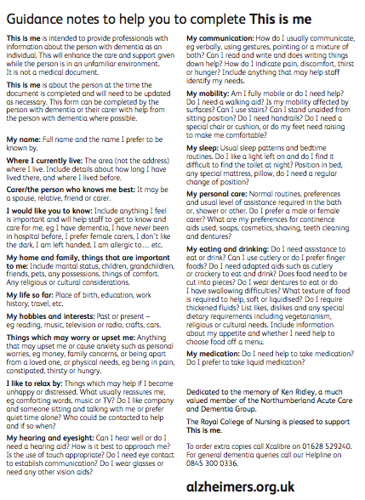

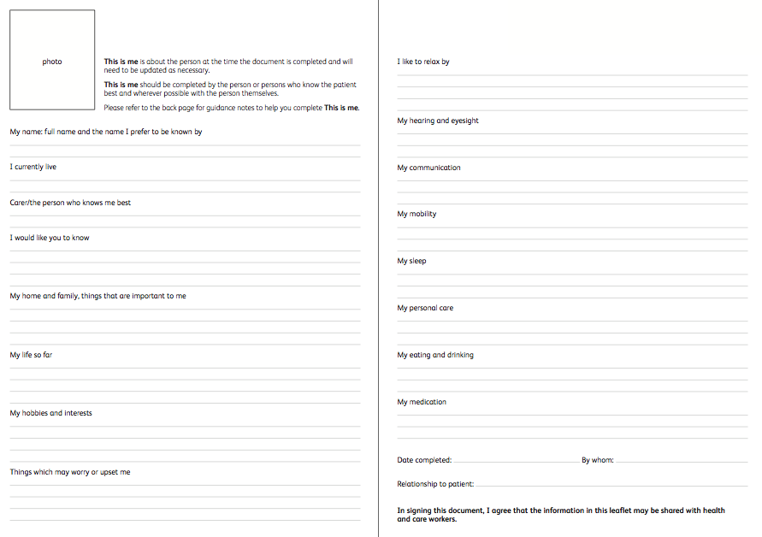

# Appendix D – Abbey Pain Scale

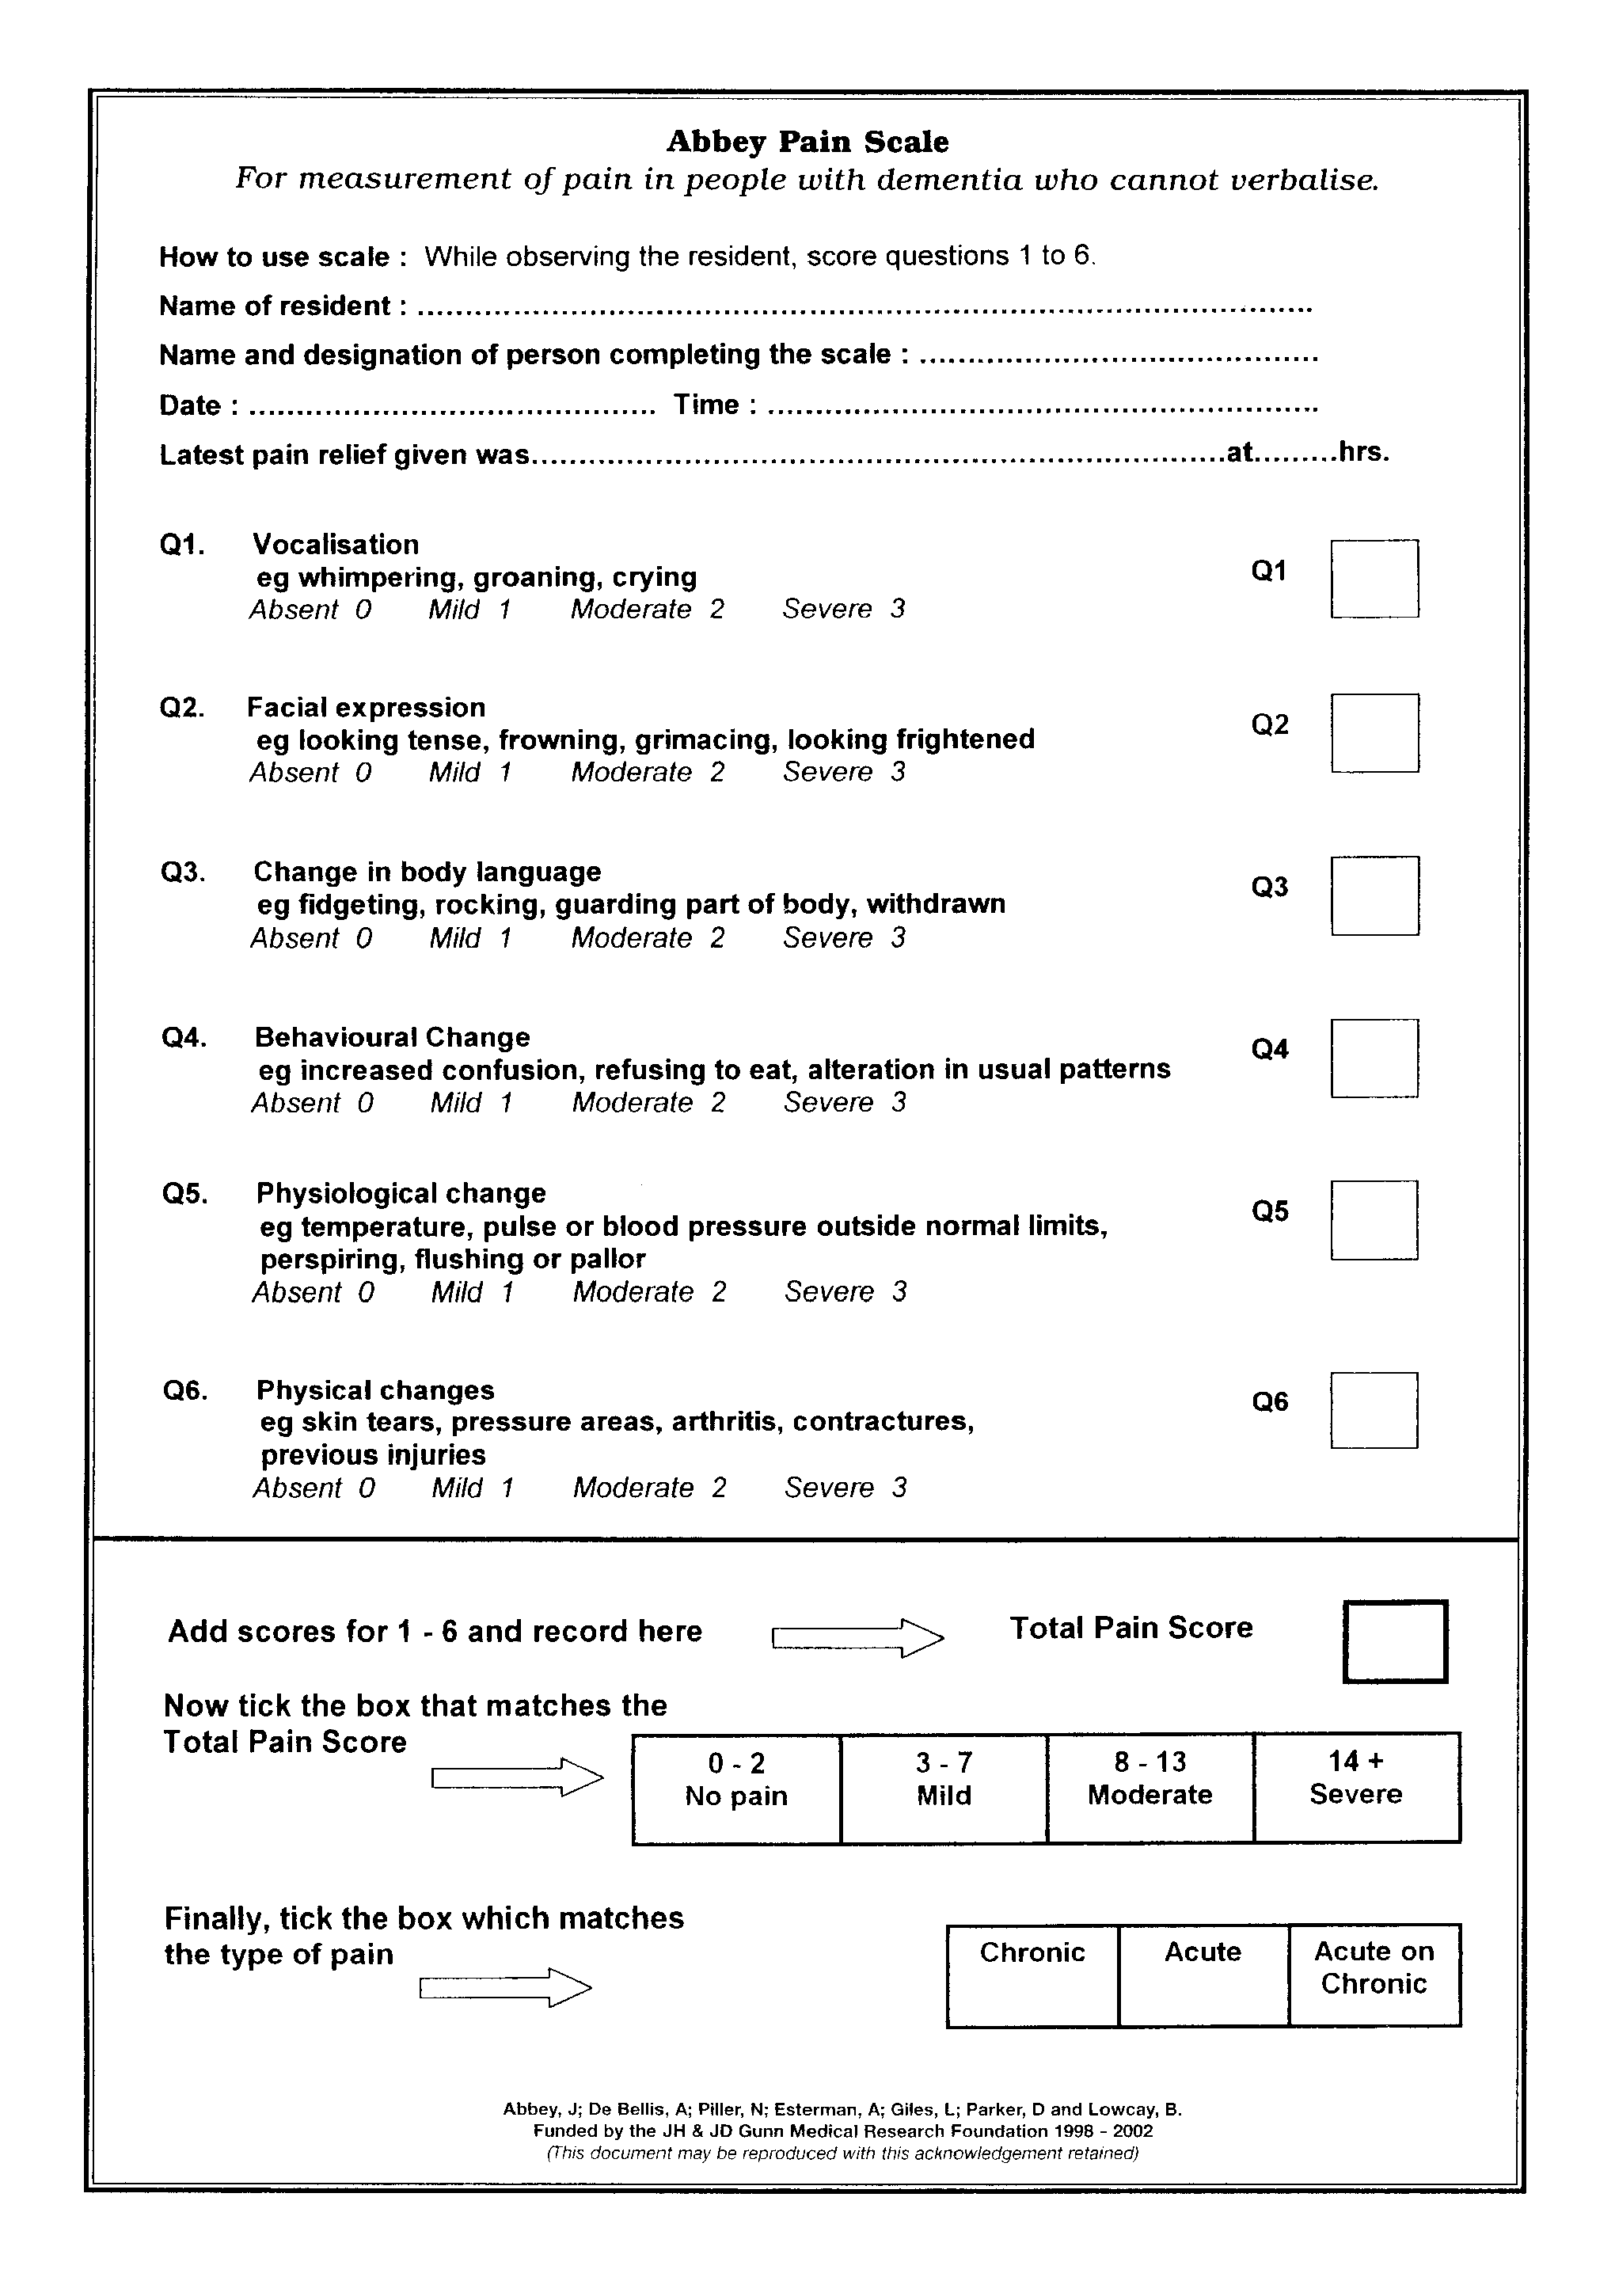

# Appendix E – Abbey Pain Scale, GWH Instructions for Use

|  |  |
| --- | --- |
| **WHO?** | |
| **Who is it for?**  It must be used for anyone who is unable to tell you if they are in pain.  Ask yourself this question. **Are you confident this person could tell you if they were in pain?** If No use the APS.  Common situations include:   * **Cognitive impairment**   **(dementia/delirium)**   * **Communication difficulties (Stroke)** * **Severe depression or psychosis** * **Learning difficulties** | **Who should use it?**  Anyone caring for the patient can initiate or use the APS including:   * **ED employees** * **Junior doctor clerking new patient** * **Post take ward round** * **Nursing employees** |

|  |
| --- |
| **HOW?** |
| 1. The APS can be found on the back of the standard observations/NEWS chart 2. Convert the APS score calculated into a standard pain score 3. Document the standard pain score on the front of the observation chart 4. If moderate or severe pain documented then issue appropriate analgesia and repeat APS in 30 minutes 5. **Watch GWH junior doctors give an online demonstration on how to use the APS available at GWH intranet dementia pages** |

|  |
| --- |
| **WHEN?** |
| 1. During routine observations 2. Pre & post any intervention which may cause that particular patient pain e.g. taking blood, washing someone with pressure sores, mobilising someone with severe arthritis 3. If there is a change in observations without an apparent cause (especially raised heart rate, raised respiratory rate or raised blood pressure) 4. If there is a change in behaviour (wandering, aggressive, withdrawn) |

# Appendix F – Dementia & Delirium Screening Tool

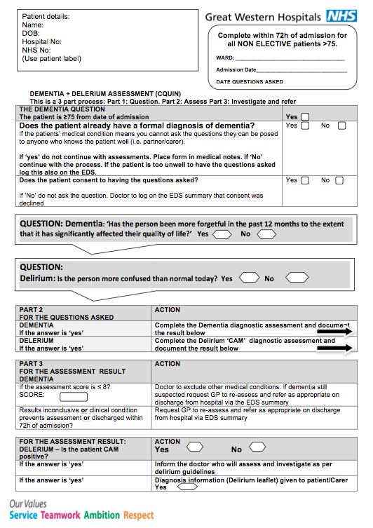

# Appendix G– Dementia & Delirium Screening Tool

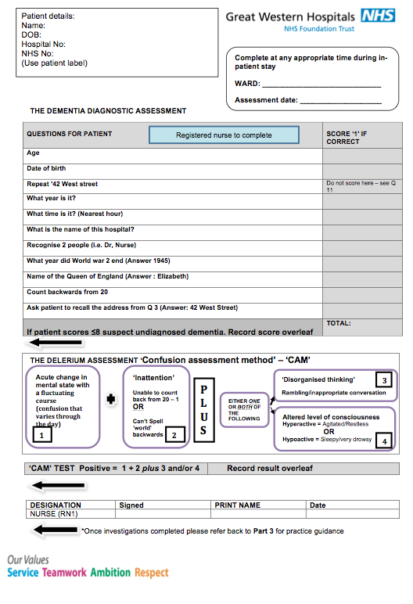

|  |  |
| --- | --- |
| **DEMENTIA QUESTION ASKED DETAILS** | |
| **Dementia Question Asked?** | |  |  |  | | --- | --- | --- | | Yes | No | Unknown | |
| |  |  | | --- | --- | | Reason Question Not Asked |  | | |
| |  |  |  | | --- | --- | --- | | Date and time Question Asked |  | http://reds/RedsApp/Images/CalendarButton.PNG | | Patient said they have memory problems | |  |  |  | | --- | --- | --- | | Yes | No | Unknown | | | | Who Answered Question? |  | | | Date Question Answered |  | http://reds/RedsApp/Images/CalendarButton.PNG | | |  |  | | --- | --- | | Reason for Answer Delay |  | | | | | |

# Appendix H – Dementia & Delirium Sections on Electronic Discharge Summary

|  |  |  |  |  |
| --- | --- | --- | --- | --- |
| **DEMENTIA ASSESSMENT DETAILS** | | | | |
| **Dementia Assessment Completed?** | | | |  |  |  | | --- | --- | --- | | Yes | No | Unknown | | |
| |  |  | | --- | --- | | Dementia Reason Not Completed |  | | | | | |
| |  |  |  | | --- | --- | --- | | Date Assessment Completed |  |  | | | | | |
| |  |  | | --- | --- | | Assessment Score | out of 10 | | | | | |
| **Follow Up By GP Required?** | | | |  |  |  | | --- | --- | --- | | Yes | No | Unknown | | |
| **DIAGNOSIS OF DELIRIUM?** | | |
| **Delirium Question Asked?** | |  |  |  | | --- | --- | --- | | Yes | No | Unknown | | |
| |  |  | | --- | --- | | Delirium Reason Question Not Asked |  | | Diagnosis Of Delirium? | |  |  |  | | --- | --- | --- | | Yes | No | Unknown | |  |  |  |  |  |  | | --- | --- | --- | --- | --- | | Diagnosed within 72 hours of admission? | |  |  |  | | --- | --- | --- | | Yes | No | Unknown | | | Has patient been given a leaflet? [Click here for leaflet](http://gwh-intranet/download.aspx?mid=36803) | |  |  |  | | --- | --- | --- | | Yes | No | Unknown | | | Plan Of Care completed? |  | | **GP FOLLOWUP - Future investigations and recommendations** | | | Review Antipsychotic Medications? | |  |  |  |  | | --- | --- | --- | --- | | Yes | No | N/A | Unknown | | | |  |  |  |  | | --- | --- | --- | --- | | Review In |  | By | GP | | | | Comments: | | |  | | | **HOSPITAL Followup - Future investigations and recommendations** | | | Review Antipsychotic Medications? | |  |  |  |  | | --- | --- | --- | --- | | Yes | No | N/A | Unknown | | | |  |  |  |  | | --- | --- | --- | --- | | Review In |  | By |  | | | | Comments: | | |  | | | | |

# Appendix I – Delirium Patient Information Leaflet

