
CONTENTS

Executive Summary | Page 2
Introduction | Page 3
Networks, Boards and Forums | Page 3
Numbers and Performance | Page 4 - 12
Activities | Page 12 - 13
The Future | Page 13
Appendix 1 – Safeguarding Adult’s Forum Action Plan 2015/16 | Page 15 - 19

Executive Summary

2015/16 has been a busy year for the Safeguarding Adult service. It has managed an increase in numbers of concerns raised, number of S42 enquiries initiated and completed and a significant increase in the number of DoLS applications received and processed.

Despite this increase in activity the service has raised awareness of safeguarding across West Berkshire by developing and engaging with a Safeguarding Service User Group, delivering awareness sessions and hosting stands at events in the local community, participated in a peer review in which our partners, providers and staff played a key role and actively supported training opportunities provided by the West of Berkshire Safeguarding Adults Board.

The Safeguarding Adults Forum developed an action plan based on the priorities of the Safeguarding Adults Board.

- Raising awareness of safeguarding adults, the work of the SAB and improving engagement with a wide range of stakeholders
- Making Safeguarding Personal
- Ensuring effective learning from good and bad practice is shared
- Developing an oversight of safeguarding activity

The Forum has progressively worked through the action plan during this reporting year and has developed plans for 2016/17. The partnership working developed through this forum was recognised in the peer review carried out by ADASS into the safeguarding function. This forum continues to develop its role as the operational arm of the Safeguarding Adults Board for West Berkshire.

The Making Safeguarding Personal initiative continues to be promoted and embedded in practice through training and monitoring, with local data indicating improvements are being made.

Performance data analysis is carried out on a regular basis. Rigorous interrogation ensures there continues to be a grasp of both current and emerging issues. The impact of a proactive approach by the Care Quality team with local providers appears to be having a positive impact on the types of safeguarding enquiries and source of risk.

The service continues to strike a balance between daily operations dealing with incoming safeguarding concerns and applications for Deprivation of Liberty Safeguards authorisations with raising awareness of safeguarding.

Introduction

Safeguarding Adults is a strategic priority for West Berkshire Council and a core activity of Adult Social Care. It is now, as a result of the enactment of the Care Act 2014, a statutory responsibility for Local Authorities as well as the assessment and authorisation of Deprivation of Liberty Safeguards.

This annual report evidences the key quarterly measures and trends used to monitor activity for Safeguarding Adults in West Berkshire to ensure risks are being identified and managed appropriately. Utilising a new set of indicators and statutory reporting requirements for 2015/16, analysis of performance has developed comprehensively across the year to produce this report.

This report also focuses on the activities of the safeguarding network in West Berkshire during the reporting year.

Networks, Boards and Forums

The Care Act 2014 required all Local Authorities to form a Safeguarding Adults Board (SAB) to provide the strategic overview and direction of safeguarding, provide governance and quality assurance to the process. This includes the commissioning of Safeguarding Adults Reviews when a person has died or been significantly harmed and the SAB knows, or suspects, that the death resulted from abuse or neglect. West Berkshire Council is a member of the West of Berkshire Safeguarding Adults Board; a tri borough Board in partnership with Reading Borough Council and Wokingham Borough Council alongside other key stakeholders including, but not exclusively, Thames Valley Police, Berkshire Healthcare Foundation Trust, Royal Berkshire Hospital Foundation Trust and the local Clinical Commissioning Group. The SAB has produced its own annual report which can be viewed on its website www.sabberkshirewest.co.uk

The West Berkshire Safeguarding Adults Forum is the local operational arm of the SAB and consists of local partners signed up to address safeguarding matters specifically in West Berkshire. The forum produces an action plan annually drawn from the priorities set by the SAB. For 2015/16 those priorities were:

- Raising awareness of safeguarding adults, the work of the SAB and improving engagement with a wide range of stakeholders
- Making Safeguarding Personal
- Ensuring effective learning from good and bad practice is shared
- Developing an oversight of safeguarding activity

In order to achieve those priorities a number of objectives were developed into an action plan and delivered by forum members.

The Service User Safeguarding Forum was formed in 2015/16, the development of which was a key objective of the Safeguarding Adults Forum action plan. This group, made up of service users with an interest in safeguarding, meet quarterly.

Volumes and Performance

Safeguarding activity

Concerns and enquiries
There were 767 safeguarding concerns received in 2015/16. The number of concerns has increased for the last couple of years. In some cases it is sufficient for the Local Authority to note the concern with no further action required. Noting those concerns that require no further action enable the Local Authority to spot trends and monitor patterns across the District. Those that require greater scrutiny or input are opened as a S42 enquiry. We monitor the % of concerns that subsequently require a S42 enquiry. This is known as a conversion.

292 s42 enquiries were opened during 2015/16, with a conversion rate from concern to s42 enquiry of 38 %. This is an increase on previous years. The increase is attributed to better recording methods and greater awareness of the safeguarding process. During the reporting year West Berkshire worked closely with its partners in South Central Ambulance Service and Thames Valley Police to improve the quality of concerns raised. This improvement is partly reflected in the increase in conversion rate recorded.

Note the change in terminology as a result of the Care Act; alerts are now referred to as concerns, and referrals as enquiries.

Table 1 – Safeguarding activity for the reporting period 2014-16
Year | Alerts/Concerns received | Safeguarding referrals/s42 enquiries opened | Conversion rate of concern to s42 enquiry
2013-14 | 543 | 148 | 27 %
2014-15 | 601 | 207 | 34 %
2015-16 | 767 | 292 | 38 %

Individuals with safeguarding enquiries

Age group and gender
Tables 2 and 3 display the breakdown by age group and gender for individuals who had a safeguarding enquiry in the last three years. The majority of enquiries continue to relate to older people - the 65 and over age group accounted for 66 % of enquiries in 2015/16. The majority of enquiries were related to female clients, 57 %, a continuation of a trend seen in the last 3 years.

Table 2 – Age group of individuals with safeguarding enquiries, 2014-16
Age band | 2013/14 % of total | 2014/15 % of total | 2015/16 % of total
18-64 | 28 % | 29 % | 34 %
65-74 | 9 % | 12 % | 15 %
75-84 | 26 % | 25 % | 23 %
85-94 | 33 % | 31 % | 24 %
95+ | 4 % | 3 % | 4 %

Table 3 – Gender of individuals with safeguarding enquiries, 2015-16
Gender | 2013/14 % of total | 2014/15 % of total | 2015/16 % of total
Male | 41 % | 38 % | 43 %
Female | 59 % | 62 % | 57 %

Primary support reason
Table 4 shows a breakdown of individuals who had a safeguarding enquiry by Primary Support Reason (PSR). The majority of individuals had a PSR of Physical Support, 37 %, although this does represent a slight drop on last year’s proportion. There was an increase in enquires where the individual has a PSR of Mental Health Support. The increasing number of those presenting to safeguarding with a PSR for memory and cognition, although the proportion of overall presentations has not changed, is indicative of a gradually ageing population locally.

Table 4 – Primary support reason for individuals with a safeguarding enquiry
Primary support reason | 2014/15 | % of total | 2015/16 | % of total
Physical support | 77 | 44 % | 100 | 37 %
Sensory support | 3 | 2 % | 4 | 1 %
Support with memory and cognition | 48 | 27 % | 78 | 29 %
Learning disability support | 30 | 17 % | 46 | 17 %
Mental health support | 10 | 6 % | 30 | 11 %
Social support | 7 | 4 % | 9 | 3 %
No support reason | 0 | 0 % | 0 | 0 %
Not known | 0 | 0 % | 5 | 2 %

Case details for concluded enquiries

Type of alleged abuse
Table 5 shows enquiries by type of alleged abuse in the last three years. Additional categories were added to the 2015/16 with the implementation of the Care Act 2014. Those additional categories were domestic abuse, modern slavery, self neglect and sexual exploitation (a derivative of sexual abuse/modern slavery and/or domestic abuse). It should be noted that more than one category of abuse can be attributed to any single concern as often incidents are complex and comprise of various elements.

The most common types of abuse for 2015/16 were for neglect and acts of omission, 22 %, and physical abuse, 19 %. Neglect and act of omission cases are attributed to the provision of care given either by a paid or unpaid carer. The category of physical abuse also includes incidents where there has been a physical altercation between two or more residents in a domestic, care home or hospital setting.

Self neglect as a defined type has now accounted for 12% of cases into which enquiries have been made. This is reasonably substantive, and is broadly as predicted at the beginning of the year. It is worth noting the threshold set for a safeguarding intervention into a case of self neglect is relatively high, including consideration of mental capacity. Those cases not meeting the threshold are passed through to adult social care teams for screening and assessment.

The Care Quality team in West Berkshire has been very proactive working in partnership with providers locally to improve standards of care. The reduction in organisational abuse is considered to be an indicator of this proactive approach taken.

Table 5 – Concluded enquiries by type of abuse
Concluded enquiries | 2013/14 | 2014/15 | 2015/16
Physical Abuse | 66 | 51 | 74
Sexual Abuse | 15 | 12 | 20
Psychological Abuse | 41 | 44 | 66
Financial or Material Abuse | 39 | 40 | 62
Neglect and Acts of Omission | 59 | 73 | 85
Discriminatory Abuse | 0 | 1 | 0
Organisational Abuse | 14 | 10 | 7
Domestic Abuse | - | - | 28
Sexual Exploitation | - | - | 1
Modern Slavery | - | - | 0
Self-Neglect | - | - | 44

Figure 1 – Type of abuse 2015/16
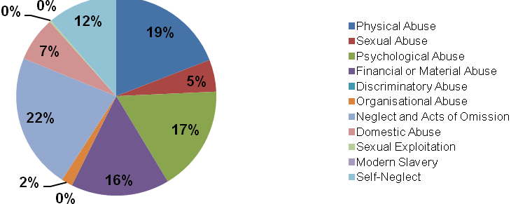

Location of alleged abuse
As with previous years the most common locations where the alleged abuse took place were a person’s own home, 66 %, and a care home, 17 %. A person’s own home consistently remains the place in which an abusive incident is more likely to occur. This demonstrates the continual need to raise awareness of safeguarding amongst all sectors of society and improving mechanisms to report those incidents.

Table 6 – Location of abuse
Location of abuse | 2013/14 | 2014/15 | 2015/16
Care home | 31 | 41 | 45
Hospital | 2 | 3 | 14
Own home | 72 | 98 | 172
Community service | 9 | 11 | 6
Other | 8 | 14 | 23

Figure 2 shows the breakdown of location of alleged abuse by source of risk. Where the alleged abuse took place in the persons own home, for the majority of cases, 73 %, the source of risk was an individual known to the adult at risk.

Figure 2 – Concluded enquiries by location of alleged abuse and source of risk for 2015/16
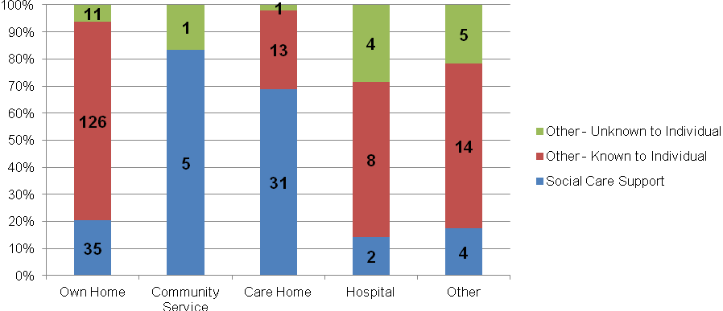

Source of risk
The majority of concluded enquiries involved a source of risk known to the individual. The social care support category refers to any individual or organisation paid, contracted or commissioned to provide social care. Figure 3 demonstrates those sources of risk captured.

Whilst 30% of source of risk attributed to the provision of social care support remains of concern the pro active provision of support from the Care Quality team gives some assurance that issues which could result in a safeguarding enquiry in such settings are being addressed at an early stage.

Figure 3 – Concluded enquiries by source of risk
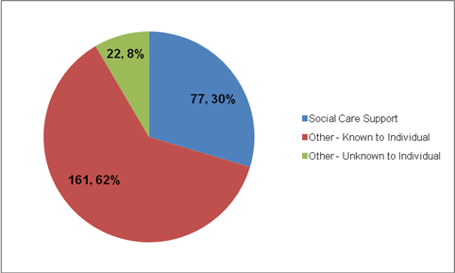

Action taken and result
The table below shows concluded enquiries by action taken and result for the last three years.

Table 7 – Concluded enquiries by result
Result | 2013/14 | 2014/15 | 2015-16
Action Under Safeguarding: Risk Removed | 6 | 11 | 88
Action Under Safeguarding: Risk Reduced | 36 | 83 | 134
Action Under Safeguarding: Risk Remains | 15 | 21 | 11
No Further Action Under Safeguarding | 65 | 32 | 27
Total Concluded Enquiries | 122 | 162 | 260

Figure 5 shows concluded enquiries by result for 2015/16. No action was taken under safeguarding in 10 % of cases, while the risk was reduced or removed in 86 % of cases.

Figure 4 – Concluded enquiries by result, 2015-16
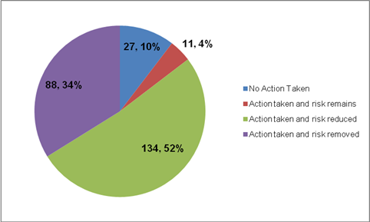

No action may be taken where the client requests that the enquiry come to an end before it has been completed. We are bound to respect the wishes of the client in the majority of cases. In a few exceptional cases the safeguarding team may need to override those wishes. For example where there is a wider public interest in pursuing an enquiry because the alleged perpetrator may pose a risk to others. It is important to recognise the service works with adults who are entitled to make choices, irrespective of how unwise those choices may seem to be, and therefore it is not possible to always remove risk.

Figure 6 shows a breakdown of the results of action taken for concluded enquiries by source of risk for 2015/16.

Figure 5 – Concluded enquiries by result of action taken and source of risk
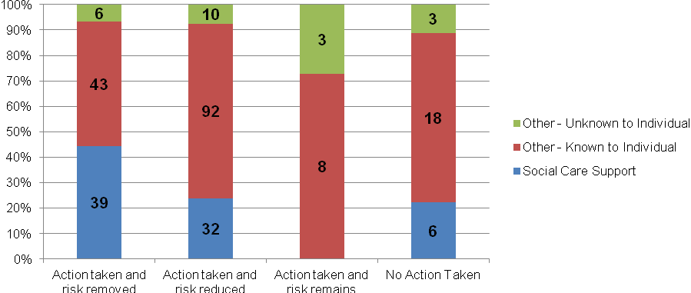

Making Safeguarding Personal

Making Safeguarding Personal (MSP) was a national industry led initiative to improve the experiences and outcomes for adults involved in a safeguarding enquiry. This initiative was adopted by the Government and enshrined in the Care Act 2014. Local Authorities are not currently statutorily required to report on MSP. Notwithstanding, West Berkshire Council has chosen to monitor performance in this key area.

Figure 6 – Concluded enquiries by expression of outcome
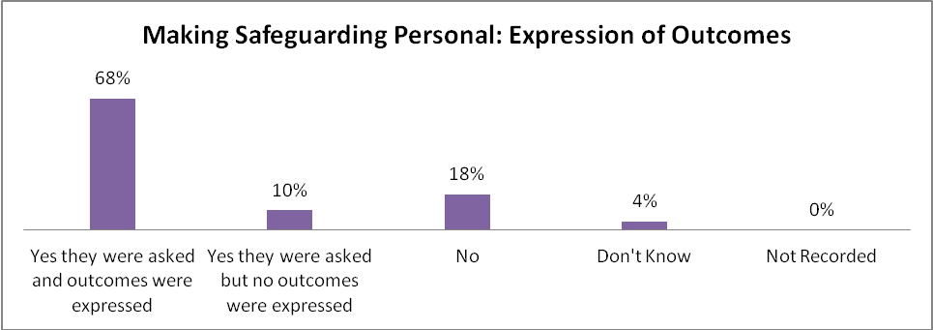

By definition, a personal response to a safeguarding incident will mean different things to different people. Therefore obtaining baseline data for outcomes has presented challenges this financial year. Figure 7 demonstrates the outcome of this challenge.

As at year end, 78% of all clients for whom there was a concluded case were asked about the outcomes they desired (either directly or through an advocate). In order to benchmark usefully, options for outcomes were included as a guide, with an additional box for free text to capture those desired outcomes and wishes that were not reflected in the options provided. Clients can choose as many outcomes as they wish and so multiple choices are normal. The option ‘to be and to feel safe’ was most frequently selected. Of those asked, 10% did not express an outcome. Whilst this is positive, there remains 22% who did not engage in this process. These cases have been subject to further scrutiny to establish the reason engagement was not achieved and where necessary lessons learned going forward.

Figure 7 – Concluded enquiries by expressed outcomes achieved.
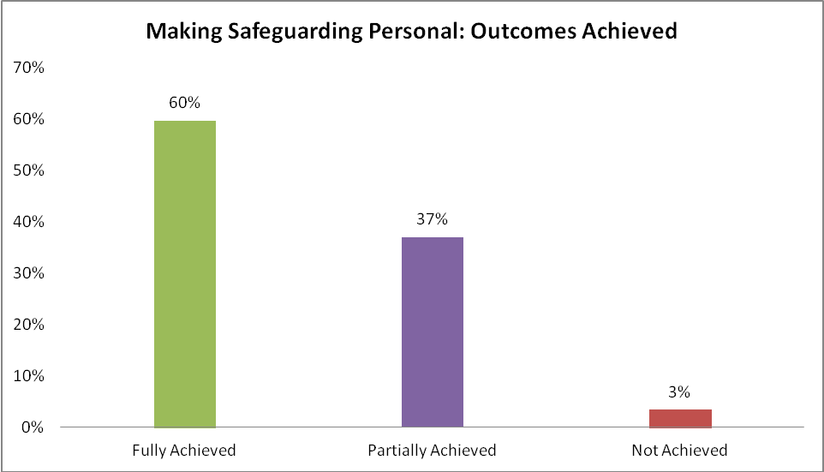

Of those who were asked and expressed a desired outcome, 60% were able to achieve those outcomes fully, with a further 37% partially achieved. We anticipate this to settle as the MSP method of working becomes more embedded in the new reporting year and aligns with the New Ways of Working in Adult Social care – a strengths based approach to working with adults who may have social care needs. In 16/17 further work will be carried out to audit the quality of the work done with service users to identify their outcomes.

Deprivation of Liberty Safeguards
The Deprivation of Liberty Safeguards (DoLS) is an amendment to the Mental Capacity Act 2005 and applies in England and Wales only. The Mental Capacity Act allows restraint and restrictions to be used – but only if they are in a person's best interests.
Extra safeguards are needed if the restrictions and restraint used will deprive a person of their liberty. These are called the Deprivation of Liberty Safeguards.
DoLS authorisations must be applied for by care homes, nursing homes or hospitals (The Managing Authority) where they believe a person is living in circumstances that amount to a deprivation of liberty and that person lacks the capacity to consent to their care, treatment and accommodation, in order to prevent them from coming to harm. They apply to the Local Authority (The Supervisory Body) whose role is to arrange for the persons circumstances to be assessed in order to determine whether to grant or refuse an authorisation for those circumstances. Those living in other settings must have their deprivation considered by the Court of Protection.

Figure 8 – Total number of DoLS applications received by outcome
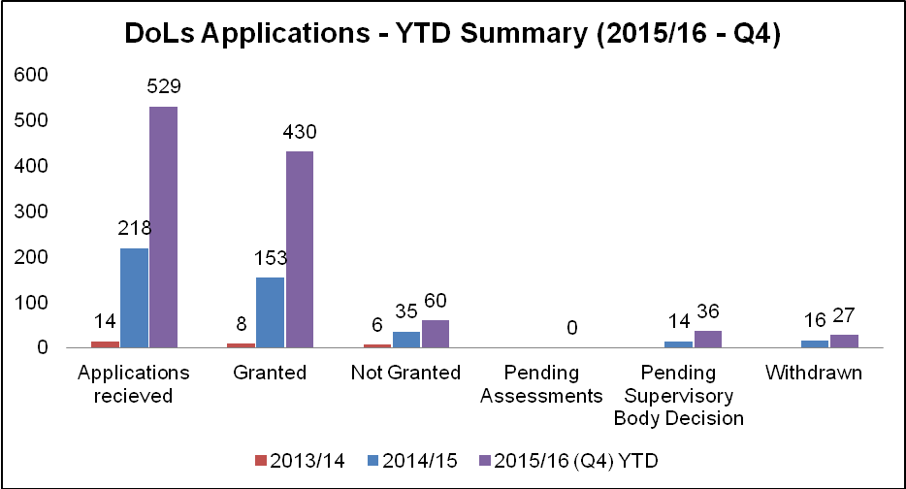

As at the end of 2014/15 there were 218 DoLS applications in total and a predicted total of 525 for cases for 2015/16. The actual final figure was 529 with 430 of those authorised, 60 not authorised (for example a person is assessed as having capacity), 27 withdrawn (for example an application from a hospital where the patient is discharged before the assessment process is completed) and 36 pending a decision as at year end. The figure of 529 represents a 142% increase of applications received in 2014/15.

The increase in West Berkshire is reflective of increases nationally following a Supreme Court judgement in March 2014 known as Cheshire West which significantly increased the scope of the scheme. It is expected the demand for 2016/17 will see a further increase of approximately 30%.

Activities

A Safeguarding Service User Group was set up In West Berkshire to provide a setting in which service users across the spectrum of adult social care needs could engage with the safeguarding team direct, share information, solve problems and increase awareness through a cascade process.

The group was consulted on a Safeguarding Adults publicity campaign planned for early 2016/17. They were integral to the development of the publicity material including posters and leaflets, commenting on language, visuals and accessibility. In addition the group developed a safeguarding alert card for people to carry with them when they are in the community. The card has been designed to support a person to ask for help from the community if they feel unsafe.

A series of talks and events were attended by members of the safeguarding team in order to increase awareness of safeguarding across a range of settings including an evening talk to the Newbury Neighbourhood Watch scheme, delivery of an interactive session on safeguarding for service users of a supported living scheme locally and a hosting a stall at the Parish Councillors Conference.

A peer review of the safeguarding adults function was conducted by the Association of Directors of Adult Social Services (ADASS). The peer review was conducted over three days in December 2015 and included consultation with staff, external partners and providers. Feedback from the review was positive. An action plan was developed as a result of the recommendations made and the actions will be carried out during the 2016/17 period.

In partnership with our fellow Safeguarding Adults Board members a series of Making Safeguarding Personal training sessions for all Adult Social Care practitioners was held across the partnership area during the reporting period. West Berkshire hosted two full days of training in Newbury. Further to this, a series of workshops on this topic for our providers is planned for 2016/17.

The service supported a joint conference for adult and children’s social care staff organised by the West of Berkshire Safeguarding Adult Partnership Board and the 3 Local Safeguarding Children’s Boards in the Berkshire West area. This conference is an annual event.

The Future

Plans for 2016/17 include the launch of the community alert cards and the new publicity campaign developed in partnership with the Service Users Safeguarding Group.

There are also plans to develop an effective feedback process for those who have experienced a safeguarding episode. It is intended the Service User Group will be instrumental in designing the tools that may be used to capture the feedback

A new action plan for 2016/17 developed by the Safeguarding Adults Forum will be carried out. This includes partnership working with our colleagues in Trading Standards to tackle scams; doorstep and online scams and to support them in raising awareness with banks and building societies of coercive tactics to get vulnerable adults to withdraw large sums. This plan can be seen at Appendix 1.

The recommendations of the ADASS peer review have been drawn into an action plan that will continue to be carried out supporting the service to improve the safeguarding experience for people through the continued development of Making Safeguarding Personal across the Council and its partners.

Appendix 1
SAFEGUARDING ADULTS FORUM
WEST BERKSHIRE

ACTION PLAN 2016/17

This action plan is drawn from the West of Berkshire Safeguarding Adults Partnership Board 2015-18 Strategic Priorities and the principles underpinning safeguarding activity. This plan is a living document and may alter according to changing priorities identified through the West of Berkshire SAPB and any local issues arising.

Priority 1 – Establish effective governance structures, improve accountability and ensure the safeguarding adults agenda is embedded within relevant organisations, forums and Boards
Objectives: | Purpose:
Support the safeguarding adults service user forum to develop the skills and capacity to review and quality assure our customer facing information and consider their recommendations in our responses. | To ensure a third party is scrutinising safeguarding adults communications, for example our web site interface, for ease of access, user friendliness and impact | Jenny Symons | 30.09.16
Develop a mechanism for routinely auditing safeguarding cases against the 6 principles, utilising the Wokingham documentation | To ensure consistent responses and interventions within the safeguarding framework are achieved across West Berkshire underpinned by the 6 core principles, and to learn from examples of good and poor practice. | Sue Brain | Ongoing
To submit the 2016/17 action plan to the Safer Communities Partnership for their information and to submit a short report at year end to advise on progress | To ensure the Safer Communities Partnership are sighted on the safeguarding adults action plan and to embed the principles and actions across multi agency settings | Susan Powell/Sue Brain | End of July 2016
To audit local providers and partners to establish how the profile of safeguarding adults is maintained within their organisations | To be assured that the subject of safeguarding adults is actively promoted and acted upon within our partner organisations | Sue Brain | 31.12.16
Priority 2 – Making Safeguarding Personal
Objectives: | Purpose:
Develop a provider appropriate MSP workshop in partnership with the Learning and Development Subgroup of the SAB and deliver those workshops throughout partner agencies | To improve understanding and knowledge of MSP; the principles and application of the concept | Safeguarding Adults Team | 31.03.17
Work with partners to develop internal resources within each agency to facilitate feedback from service users in relation to a safeguarding intervention they have experienced. | To collect information, including anecdotal evidence, pertaining to a person’s recent experience of the safeguarding process in a consistent and user friendly way. To enable the partnership to consider the anonymised data drawn from this feedback to enable any changes to procedure etc to be considered.  To use the information and evidence gathered to learn lessons and subsequently reassure people who are entering the process that their interests are of primary concern. | All forum members | 31.03.17
To provide information on a quarterly basis that can be developed into a blog currently being progressed by the Safer Communities Partnership communication process. | Share information to a wider audience about safeguarding, the personalisation agenda in safeguarding and various approached available that can be adapted to suit presenting needs. This might be themed by abuse type | Safeguarding Adults Team/Safer Communities Partnership | 31.08.16
Priority 3 – Raise awareness of safeguarding adults, the work of the Safeguarding Adults Board and improve engagement with a wider range of stakeholders
Objective: | Purpose:
Publish and promote new Pan Berkshire Policy and Procedures through Provider Forum, website and Care Quality newsletter | To increase awareness of the multi agency policy and procedures throughout the provider market and improve rates of compliance. | Safeguarding Adults Team | 30.04.16
Agencies to review and where necessary update policies and procedures for safeguarding to reflect changes to practice or process captured within the Pan Berkshire Policies and Procedures | To ensure consistency in safeguarding policy and practice across the West Berkshire area | All forum members | 31.05.16
Develop a communications strategy to share best practice and learning from SAR’s including circulation of the Forum Learning Log | To improve knowledge of best practice and share learning from local and nationally published SAR’s | MDT working group | 30.06.16
Launch the safeguarding adults publicity campaign and service user community alert cards in partnership with the safeguarding adults service user group | To improve knowledge of safeguarding adults, facilitate greater knowledge of the reporting process and provide a mechanism to develop a safety network for service users in communities across the West Berkshire district. | Safeguarding Adults Forum/Safeguarding Adults Service User Group/Safer Communities Partnership | 15.05.16
Priority 4 - Ensure effective learning from good and bad practice is shared in order to improve the safeguarding experience and ultimate outcomes for service users
Objective: | Purpose:
Develop a communications strategy to share best practice and learning from SAR’s including circulation of the Forum Learning Log and network meetings | To improve knowledge of best practice and share learning from local and nationally published SAR’s | MDT working group | 30.06.16
Develop and deliver a training programme specifically for Trading Standards and Environmental Health to support the safeguarding process and improve outcomes for people who are at risk from rogue traders and scammers | To increase the understanding of safeguarding and mental capacity within the wider workforce and disciplines within the Local Authority with a statutory function and to deliver a coordinated response to those at risk from scams and rogue trading. | West Berkshire LA/Wokingham LA training teams | 30.06.16
To work in partnership with the LA’s Principal Social Worker, Adult Social Care and key partners to develop and implement processes that improves the responses for those individuals who do not meet thresholds for a safeguarding response, yet remain at risk | To re-evaluate the pathways that exist for individuals who are not captured by traditional service referral routes and implement a process that takes account of their risk factors | TVP/Principal SW/Safer Communities/Safeguarding Team
Priority 5 - Coordinate and ensure the appropriate application of safeguarding processes across agencies
Objective: | Purpose:
Coordinate a joint process between TVP and West Berkshire ASC, including other relevant parties as required, to ensure those who have a history of wandering are identified and linked into all appropriate services as quickly as possible | To improve the outcomes for people who wander with an overall outcome to support a reduction in the number of non crime related call outs for TVP. | ASC/TVP
Promote greater understanding of the principles of coercion and control within the context of Domestic Abuse, through DASH/MARAC training, DA champion’s network and other routes. | To be assured agencies are able to identify and respond consistently and sensitively to situations of coercion and control. | Safer Communities/A2 Dominion/Safeguarding Team
Work with other agencies to improve knowledge and understanding of self neglect, thresholds and responses, by including appropriate case studies in L2 & 3 safeguarding training, sharing the national clutter index and tools available and clarifying options for support. | To ensure consistency in identifying, reporting and responding to cases of self neglect. To be assured that agencies are conversant in the different interventions available and sources of appropriate help for any clients they have concerns for. | Safeguarding Team/Sovereign Housing/WBC | 31.03.17
Develop and deliver training to professionals in the banking sector to enable them to identify financial abuse through targeting unusual transactions of elderly and/or vulnerable clients and supporting them to respond appropriately | Raise awareness of financial abuse and encourage professional responses to concerns identified when it occurs at the earliest opportunity | Trading Standards | 31.12.16
Embed requirements of the Prevent agenda in safeguarding processes through appropriate inclusion in L2 safeguarding training | To maintain knowledge about the Prevent agenda, its principles and the routes to refer. | Safeguarding Adults Team | 30.04.16

