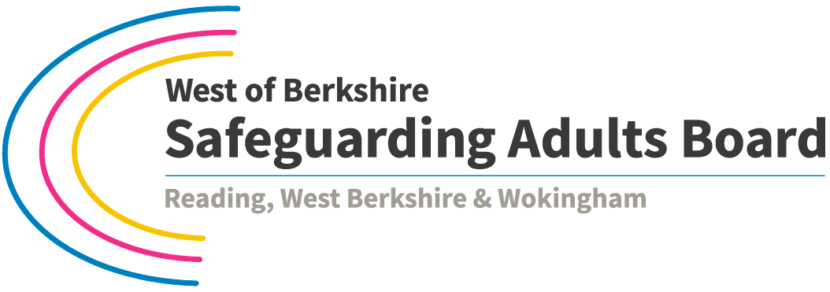

**West of Berkshire Safeguarding Adults Board Training Standards**

Agreed by West of Berkshire SAB Learning and Development Group November 2016

|  |  |  |
| --- | --- | --- |
| **Course aim** | **Learning outcomes**  *By the end of the course learners will be able to***:** | **Training delivery standards**  *Recommended minimum requirement for delivery* |
| **Safeguarding adults Level 1: Awareness** | | |
| **Audience:** All workers (paid or voluntary) who have direct contact with adults whose circumstances make them vulnerable to abuse. | | |
| To be able to respond  in accordance with Berkshire’s Multi-Agency Safeguarding Adults Policy and Procedures | Describe circumstances that can make adults vulnerable to abuse  Recognise possible indicators of abuse  Respond in line with the safeguarding procedures if abuse is found or suspected  Report and record appropriately  Recognise your duty of care including Making Safeguarding Personal to involve the individual and their view of their wellbeing  Describe the link between the multi-agency procedures and other key legislation, policies and procedures, including mental capacity, deprivation of liberty safeguards and safeguarding children  Understand the importance of professional boundaries and the consequences of breaching these  Introduce information sharing and confidentiality | Training duration appropriate to the target group; half day recommended  Training adapted to meet the learning needs of participants  Trainers have knowledge and experience of safeguarding adults  Trainers have sufficient experience and/or qualification in training delivery  Clearly defined course aims and learning outcomes communicated to learners  Record delegate attendance  Complete formal evaluation of the course |
| **Safeguarding adults Level 2: Assessment and planning** | | |
| **Audience:** Those who contribute to or lead in assessment and/or investigation of safeguarding alerts.  Delegates should have completed Level 1 training post-Care Act or be able to demonstrate equivalent skills and knowledge | | |
| To gain a working knowledge of Berkshire’s Multi-Agency Safeguarding Adults Policy and Procedures and to understand their role in making enquiries under safeguarding procedures. | Review and expand on skills and knowledge gained from Level 1  Assess when to use the procedures  Involve adults at risk and carers appropriately throughout the process including use of advocates where appropriate  Describe the stages and their role in the safeguarding process  Use a referral form, prepare a report of enquiries and record information appropriately  Identify their own and the role of others in making enquiries about allegations of abuse and the importance of preserving evidence  Expand on knowledge of mental capacity including evidencing lack of capacity through formal assessment under the Mental Capacity Act 2005 and Code of Practice where appropriate.  Demonstrate an understanding of the legal framework including Deprivation of Liberty Safeguards. MAPPA and MARAC and other key legislation  Apply and understand the limits of confidentiality and how to use the Information Sharing Protocol | As Level 1 |
| **Safeguarding adults Level 3: Making decisions and managing staff to support the safeguarding investigation process** | | |
| **Audience:** Those who manage staff and/or make decisions in safeguarding adult investigations in local authorities, health trusts and provider services.  Delegates should have completed post-Care Act Levels 1 & 2 training or be able to demonstrate equivalent skills and knowledge. | | |
| To provide managers and lead staff with thorough knowledge of Berkshire’s Multi-Agency Safeguarding Adults Policy and Procedures and an understanding of their responsibilities in managing/supporting the safeguarding adult investigation process | Review and expand on skills and knowledge gained from Level One and Two training  Demonstrate knowledge of relevant legislation  Assess safeguarding adult referrals and identify appropriate action to be taken  Involve adults at risk carers and advocates appropriately throughout the process  Identify their role and responsibility in the safeguarding adults process and in managing safeguarding adult enquiries and management of allegations  Identify the role of other professionals in the process  Co-ordinate safeguarding adult and disciplinary processes appropriate to their role and in line with organisational policies  Demonstrate an understanding of safer recruitment and selection processes  Understand the purpose of a strategy meeting and the role of the chair | As Level 1 |
| **Safeguarding adults Level 1 (Awareness) Train the Trainer** | | |
| **Audience**: Managers/ senior staff with responsibility for delivering in-house training.  Participants must have completed post-Care Act Level 1 training and have knowledge of Berkshire Safeguarding Adults Policy and Procedures. | | |
| To equip participants with the tools and knowledge to independently deliver Level 1 training approved by West of Berskhire SAB. | Gain insight on how learners retain and process new information  Learn techniques on how to present material in an effective manner  Gain knowledge on the key areas that need to be delivered  Practice using a Safeguarding Adult level 1 training pack | As Level 1 plus essential requirements:  Trainers commit to prepare and deliver training with an observation of their practice to complete the course.  Trainers adhere to the approved Level 1 training standards as above.  Signed delegate lists sent to the relevant local authority after each training event. |