**Appendix 5.3: Adult Safeguarding Decision Guide for patients with pressure ulcers**

**If the score is 15 or over refer for Safeguarding by sending this form with your safeguarding referral**

|  |
| --- |
| The threshold for referral is 15 or above.  **However this should not replace professional judgement and recording in relation to cases that come into your service.** |
| Patient has been transferred into the care of the organisation or admitted from home to your case load with significant damage and it was not possible to ascertain any information or jointly assess using the decision guide  Referral to safeguarding adults has been made by ….. Date |
| A decision guide or information to support the decision guide has been shared across the providers between **………*.( insert names and agencies***) and based on this information select option below   1. No Safeguarding referral has been made to the LA 2. The previous care provider has confirmed they have made a safeguarding referral |

**Patient name ………………………………………………………. Patient No**

|  |  |  |  |  |
| --- | --- | --- | --- | --- |
|  | **Risk Category** | **Level of Concern** | **Score** | **Evidence** |
| **1** | Has there been an unexpected  ioration in the patient’s skin integrity from the last opportunity to assess? | Progressive onset / deterioration of  skin integrity | **5** |  |
| Sudden onset / deterioration of skin  integrity with a clinical reason explanation (if a lapse in care grade above) | **0** |  |
| **2** | Has there been a recent change in  their/clinical condition that could have contributed to skin damage?  e.g. infection, pyrexia, anaemia, end of life care (Skin Changes at Life End) | Change in condition contributing to  skin damage | **0** |  |
| No change in condition that could  contribute to skin damage | **5** |
| **3** | Was there a pressure ulcer risk assessment or reassessment with appropriate pressure ulcer care plan in place and documented? In line with each organisations policy and guidance If this is a new pressure ulcer an appropriate pressure ulcer care plan would not be in place. A risk assessment would be | Current risk assessment and care plan carried out by health care professional and documented appropriate to patient needs | **0** | State date of assessment  risk tool used  score/ risk level |
| Risk assessment carried out and care plan in place documented but not reviewed as person needs have changed | **5** | What elements of care plan are in place |
| No or incomplete risk assessment and /or care plan carried out | 15 | What elements would have been expected to be in place but were not THIS IS SAFEGUARDING |
| **4** | Is there a concern that the Pressure  Ulcer developed as a result of the informal carer wilfully ignoring or preventing across to care or services | No /Not Applicable | 0 |  |
| Yes | 15 |
| **5** | Is the level of damage to the skin inconsistent with the patient’s risk status for pressure ulcer development?  e.g low risk category /grade3 or 4 pressure ulcer | Skin damage less severe than patient risk assessment suggests is proportional | 0 |  |
| Skin damage more severe than patient’s risk assessment suggests is proportional | 10 |
| **6** | **Answer (a) if your patient has capacity to consent to every element of the care plan**  **Answer (b) if your patient has been assessed as not having capacity to consent to ant part of the care plan or some capacity to consent to some but not all.** | | | |
| **a** | Was the patient compliant with the care plan having received information regarding the risk of non- compliance and documented they been explained | Patient not compliant with care plan (BHFT staff use non concordance forms) | 0 |  |
| Patient compliant with some aspect of care plan but not all | 3 |
| Patient compliant with care plan or not given information to enable them to make an informed choice. | 5 |
| **b** | Was appropriate care undertaken in the patient’s best interests, following the best interest’s checklist in the Mental Capacity Act Code of Practice? (supported by documentation, e.g. capacity and best interest statements and record of care delivered) | Documentation of care being undertaken in patient best interest | 0 |  |
| No documentation of care being undertaken in the patients best interest | 10 |
| **Total** |  | |  |  |

**Completed by:**

**Date:**

**Circle decision below:**

**Safeguarding Referral done** **Not for Safeguarding Referral**

**Appendix 5.4: Body map**

Body maps must be used to record skin damage and can be applied as evidence if necessary at a later date. If two workers observed the skin damage they should both sign the body map.

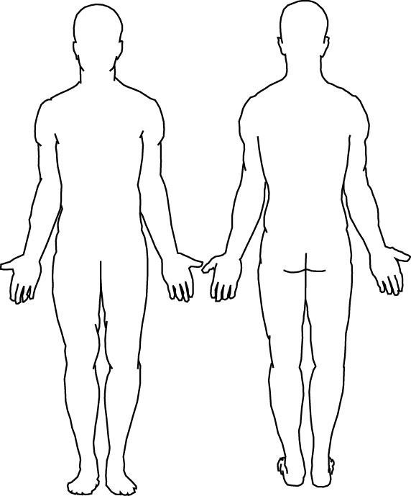

|  |  |  |  |
| --- | --- | --- | --- |
| Name of assessing  nurse (PRINT) |  | | |
| Job Title |  | Signature |  |
| Name of second assessor (PRINT) |  | | |
| Job Title |  | Signature |  |

**Patient Name: …………………………………………………………………. Patient no………………………………**