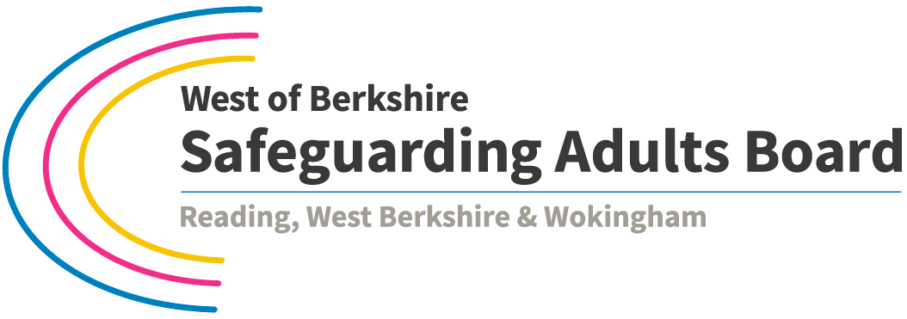

**Process for Multi-Agency Safeguarding Adults Reviews of Serious Cases**

The aim of this document is to streamline the process for carrying out a Safeguarding Adults Review for Board members, managers and practitioners, and to clarify the different roles and responsibilities of individual agencies, the Safeguarding Adults Board (SAB) and its Subgroups.

***Step 1 Notification of a case for consideration***

Refer to the decision making process outlined in the [Guidance for Multi-Agency Safeguarding Adults Review of Serious Cases](http://www.sabberkshirewest.co.uk/practitioners/safeguarding-adults-reviews/).

Complete the notification report template (Appendix 2) and send securely to the SAB Business Manager. Instead of using this template to notify the Panel, Thames Valley Police officers will use a Primary Assessment Chronology (Appendix 3) and must receive authorisation from senior officers before presenting to the SAR Panel.

Copy to the Safeguarding Team in the relevant Local Authority.

The Business Manager will forward all notifications for consideration to the Independent Chair of the Board, copy to the SAR Panel Chair.

***Step 2 Presentation at SAR Panel and Decision***

Once approved, the case will be presented to the SAR Panel by the agency that raised the notification. The Panel will:

* Review the report and decide whether the case meets the criteria for a Safeguarding Adults Review.
* Agree what type of review is proportionate and will offer the best learning.
* Identify lead agency for the Review.
* Agree a timeframe for reporting back.

SAR Panel meetings will be held quarterly, with additional panel meetings called as necessary.

The SAR Panel will consist of Board members relevant to the case. Core members will include at least a social care and health representative. Senior managers will be invited and if so wish, can delegate to the safeguarding lead, along with responsibility to make decisions.

***Step 3 Feedback***

The Panel’s decision is fed back to the Independent Chair of the SAB who will consider the Panel’s recommendation and decide whether a review should be undertaken.

The decision is fed back to the agency who initiated the notification.

CQC is informed of any review for a regulated provider.

***Step 4 Commencement of Review***

Lead agency commences the Safeguarding Adult Review and keeps the Chair and Business Manager informed of progress. The lead agency will be expected to provide management overview and administrative support for the Review.

The lead agency will provide a progress report for every SAR Panel meeting.

***Step 5 Final Report and Recommendations***

Final report is presented to the Effectiveness Subgroup which will review findings and identify multi-agency recommendations.

The final findings report and recommendations will be presented to the Board for consideration at its next meeting. The Independent Chair will call an exceptional Board meeting if required.

***Step 6 Action Plans***

Once the findings report and recommendations are accepted by the Board, recommendations will be allocated to the relevant agency for action. Action plans will be developed by the relevant agencies and presented back to the Effectiveness Subgroup.

The Effectiveness Subgroup will monitor whether an action plan has been developed. Delivery and monitoring of the action plan will be the responsibility of the relevant organisation.

***Step 7 Monitoring and Review***

All recommendations will be included in a monitoring action plan, to be kept up to date by the Business Manager.

The Effectiveness Subgroup will review the monitoring action plan at quarterly meetings, escalating issues to the Board where relevant.

***Step 8 Sharing Learning***

The lead agency will provide a summary learning document to be published on the website and shared with partner agencies for dissemination and use in training.

Oversight and Quality Subgroup will review and revise the self-assessment audit document on an annual basis to ensure it reflect findings from Safeguarding Adults Reviews.

Under the remit of the Effectiveness Subgroup, thematic audits will take place twice a year, on either a single or multi-agency basis, based on findings from Safeguarding Adults Reviews.

The Annual Report will report on Safeguarding Adults Reviews carried out within the year and what agencies have done to deliver actions and embed learning.

Version 2 August 2017

Review date August 2018



**Guidance for Multi-Agency Safeguarding Adults Reviews of Serious Cases**

**Notification of a Case for Consideration**

**Complete in as much detail as possible and send securely to:**

Natalie Madden, Business Manager for the Board at [natalie.madden@reading.gov.uk](mailto:natalie.madden@reading.gov.uk) Tel. 07718 120601

Send a copy securely to the appropriate Safeguarding Adults Team.

|  |  |
| --- | --- |
| **Report completed by:** |  |
| **Date report completed:** |  |
| **Report Audience:** | Safeguarding Adult Board (SAB) for consideration for action under the West of Berkshire Safeguarding Adults Board Guidance for Multi-Agency Safeguarding Adults Reviews of Serious Cases |
| **Purpose of report:** |  |

|  |
| --- |
| Are there any safeguarding concerns for children or other adults from this case that need to be actioned and / or shared with Local Authority adult or children safeguarding teams? If so, confirm what action has been taken: |
| **Section 1 - Summary of case:** |
| **Section 2 - Information received and Documents reviewed:** |
| **Section 3 - Evaluation of Information received and Documents reviewed:** |
| **Section 4 – Conclusions:** |
| **Signed:**  **Dated:** |