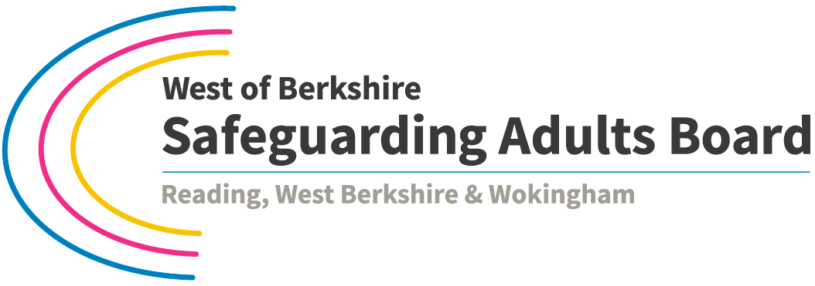

**Mental Capacity Act Week**

West of Berkshire Safeguarding Adults Board is hosting a series of **FREE** workshops to support practitioners to develop skills and knowledge in understanding and applying the Mental Capacity Act 2005.

***Places are limited so you must book a place****.*

|  |  |  |  |
| --- | --- | --- | --- |
| ***Date*** | ***Time*** | ***Session*** | ***Venue*** |
| Mon 16 Oct 2017 | 14.00 – 16.00 | **A carer’s perspective on DOLS**  Mark Neary, father of Steven Neary | Wokingham Civic Offices, Shute End, Wokingham RG40 1BN  [www.wokingham.gov.uk/contact-us/visit-us/](http://www.wokingham.gov.uk/contact-us/visit-us/) |
| Thu 19 Oct 2017 | 13.00 – 15.00 | **MCA: application in practice**  A practical workshop on applying MCA in practice.  Catherine Lawlor,  Berkshire Healthcare Trust | Wokingham Civic Offices, Shute End, Wokingham RG40 1BN  [www.wokingham.gov.uk/contact-us/visit-us/](http://www.wokingham.gov.uk/contact-us/visit-us/) |
| Fri 20 Oct 2017 | 10.00 – 12.00 | **Consent and the MCA**  An overview of the law  Steven Richards, Edge Training and Consultancy | RISC Conference Hall  35-39 London Street, Reading RG1 4PS  [www.risc.org.uk](http://www.risc.org.uk) |

**How to Apply**

The events are **free** to attend but places are limited so if you book a place and then cannot attend please give notice so the place can be offered to someone else.

**Please email your name, organisation and email address to:** [**linda.wyatt2@nhs.net**](mailto:linda.wyatt2@nhs.net)

**Linked event: this is free to attend and no need to book:**

|  |  |  |  |
| --- | --- | --- | --- |
| Wed 18 Oct 2017 | 14.30 – 16.00 | **Reading Domestic Abuse Forum**  Mental capacity and domestic abuse  Jo Wilkins, Reading Borough Council | Reading Council Chamber  Civic Offices, Bridge St, Reading RG1 2LU  [www.reading.gov.uk/civicoffices](http://www.reading.gov.uk/civicoffices) |