**BARANGAY CERTIFICATION**

**MAY M. TORRIJOS**

*Barangay Captain*

ROLAND I. ESPIRITU

Committee on Peace & Order

ARMANDO B. PARALES

Committee on Budget & Appropriation

MARILOU P. PAREDES

Committee on nutrition

Committee on Women & Children

CARLOS SJ. HERNANDEZ

Committee on Health, Sanitation & Environment

FRANCISCO C. NARIO

Committee on Livelihood

REYNALDO F. SAUL

Committee on Public Works & Infrastructures

DELIA B. TORRIJOS

Committee on Education & Culture

ROEL A. PAREDES

SK Chairman

ALLAN M. PARAISO

Administrator

MYRA H. CELSO

Barangay Secretary

MARILYN S. OLIVER

Barangay Treasurer

PHOTO

**OF INDIGENCY**

**TO WHOM IT MAY CONCERN:**

This is to certify that __________________________________________ born ____________ is a bonafide resident/voter with postal and residence address at _________________________________________ is known to be of good moral character and law-abiding citizen in the community, furthermore, that the above mention name is INDIGENT and has no fix source of income.



This Certification is issued upon his/her request for:

`**Purpose:**

Barangay Hall, Floraville Subd.

Barangay Gov. P. F. Espiritu-1, City of Bacoor Cavite

**TEL NO: 402-01-21**

Issued:

**   
  
 MYRA H. CELSO** *Barangay Secretary* Prepared and Attested

Approved by:

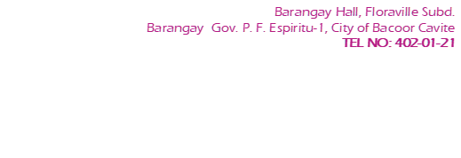**_____________________________**

**MAY MARASIGAN -TORRIJOS** *Barangay Captain*

 *Note: Valid for three (3) months from the Date of Issue. Not Valid without Dry Seal.*

Barangay Hall, Floraville Subd.

Barangay Gov. P. F. Espiritu-1, City of Bacoor Cavite

**TEL NO: 402-01-21**