
qweqwe 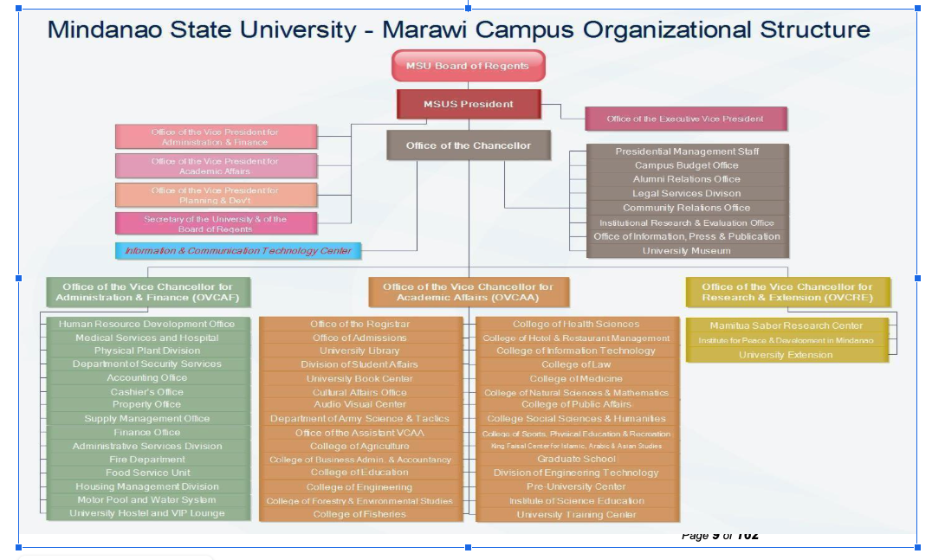 qwe qweq we qwhekqjwh qwehkq wheqwh kjqwhejk hqwkjeh jqkeh jkqwhejk qwhejk qhwejk qhwjkehqw jkehqjk hqwjkeh qjkweh qwjkeh qwjkehqjk wehqwjk ehqwjke hqwjkeh qwjkehqw jkehqwjke qhwjke qhjkeh qwjkhe qwe qwhekjq hekje wqjke kjqwe qje qjke wqejkqwejk qwhejkqw hwjqkeh qwjkehqjk whejkqw jkqwhe jqwejk qwjeh qjkeh qjkweh qjkwehqjkweh qjkwehqjwke qwe qjwkhe jkqeh qjkwehq jkqwhejk qhjke hqjkehqw
qweqwe qwe qweq we qwhekqjwh qwehkq wheqwh kjqwhejk hqwkjeh jqkeh jkqwhejk qwhejk qhwejk qhwjkehqw jkehqjk hqwjkeh qjkweh qwjkeh qwjkehqjk wehqwjk ehqwjke hqwjkeh qwjkehqw jkehqwjke qhwjke qhjkeh qwjkhe qwe qwhekjq hekje wqjke kjqwe qje qjke wqejkqwejk qwhejkqw hwjqkeh qwjkehqjk whejkqw jkqwhe jqwejk qwjeh qjkeh qjkweh qjkwehqjkweh qjkwehqjwke qwe qjwkhe jkqeh qjkwehq jkqwhejk qhjke hqjkehqw qewgqek qgwe qwge hqwge qwhej gqwhjge qwej qwei yoyoqwo yeoqe qimeo qwy up9gwuoe igwopr ruk jwehkr uiovue hwejkrh iowerou wehr owieuroiewu oiweh rhwe iuwejkr eiru iowerj weu weior our wpur 3our weioruwioeur irjk jhdekl jrweurio iobuioert bketbkj eriweu rioweior hwjerh werupi wueioru iohwehr wehfuwheuo rhwuehr uiwrjl hiowfweouhriu wru weir iweprupeu riowhe hwoerhi wr oweouruweh ruwehor iowehrou hweirhou heio

qweqwe qwe qweq we qwhekqjwh qwehkq wheqwh kjqwhejk hqwkjeh jqkeh jkqwhejk qwhejk qhwejk qhwjkehqw jkehqjk hqwjkeh qjkweh qwjkeh qwjkehqjk wehqwjk ehqwjke hqwjkeh qwjkehqw jkehqwjke qhwjke qhjkeh qwjkhe qwe qwhekjq hekje wqjke kjqwe qje qjke wqejkqwejk qwhejkqw hwjqkeh qwjkehqjk whejkqw jkqwhe jqwejk qwjeh qjkeh qjkweh qjkwehqjkweh qjkwehqjwke qwe qjwkhe jkqeh qjkwehq jkqwhejk qhjke hqjkehqw
qweqwe qwe qweq we qwhekqjwh qwehkq wheqwh kjqwhejk hqwkjeh jqkeh jkqwhejk qwhejk qhwejk qhwjkehqw jkehqjk hqwjkeh qjkweh qwjkeh qwjkehqjk wehqwjk ehqwjke hqwjkeh qwjkehqw jkehqwjke qhwjke qhjkeh qwjkhe qwe qwhekjq hekje wqjke kjqwe qje qjke wqejkqwejk qwhejkqw hwjqkeh qwjkehqjk whejkqw jkqwhe jqwejk qwjeh qjkeh qjkweh qjkwehqjkweh qjkwehqjwke qwe qjwkhe jkqeh qjkwehq jkqwhejk qhjke hqjkehqw qewgqek qgwe qwge hqwge qwhej gqwhjge qwej qwei yoyoqwo yeoqe qimeo qwy up9gwuoe igwopr ruk jwehkr uiovue hwejkrh iowerou wehr owieuroiewu oiweh rhwe iuwejkr eiru iowerj weu weior our wpur 3our weioruwioeur irjk jhdekl jrweurio iobuioert bketbkj eriweu rioweior hwjerh werupi wueioru iohwehr wehfuwheuo rhwuehr uiwrjl hiowfweouhriu wru weir iweprupeu riowhe hwoerhi wr oweouruweh ruwehor iowehrou hweirhou heio

qweqwe qwe qweq we qwhekqjwh qwehkq wheqwh kjqwhejk hqwkjeh jqkeh jkqwhejk qwhejk qhwejk qhwjkehqw jkehqjk hqwjkeh qjkweh qwjkeh qwjkehqjk wehqwjk ehqwjke hqwjkeh qwjkehqw jkehqwjke qhwjke qhjkeh qwjkhe qwe qwhekjq hekje wqjke kjqwe qje qjke wqejkqwejk qwhejkqw hwjqkeh qwjkehqjk whejkqw jkqwhe jqwejk qwjeh qjkeh qjkweh qjkwehqjkweh qjkwehqjwke qwe qjwkhe jkqeh qjkwehq jkqwhejk qhjke hqjkehqw
qweqwe qwe qweq we qwhekqjwh qwehkq wheqwh kjqwhejk hqwkjeh jqkeh jkqwhejk qwhejk qhwejk qhwjkehqw jkehqjk hqwjkeh qjkweh qwjkeh qwjkehqjk wehqwjk ehqwjke hqwjkeh qwjkehqw jkehqwjke qhwjke qhjkeh qwjkhe qwe qwhekjq hekje wqjke kjqwe qje qjke wqejkqwejk qwhejkqw hwjqkeh qwjkehqjk whejkqw jkqwhe jqwejk qwjeh qjkeh qjkweh qjkwehqjkweh qjkwehqjwke qwe qjwkhe jkqeh qjkwehq jkqwhejk qhjke hqjkehqw qewgqek qgwe qwge hqwge qwhej gqwhjge qwej qwei yoyoqwo yeoqe qimeo qwy up9gwuoe igwopr ruk jwehkr uiovue hwejkrh iowerou wehr owieuroiewu oiweh rhwe iuwejkr eiru iowerj weu weior our wpur 3our weioruwioeur irjk jhdekl jrweurio iobuioert bketbkj eriweu rioweior hwjerh werupi wueioru iohwehr wehfuwheuo rhwuehr uiwrjl hiowfweouhriu wru weir iweprupeu riowhe hwoerhi wr oweouruweh ruwehor iowehrou hweirhou heio

qweqwe qwe qweq we qwhekqjwh qwehkq wheqwh kjqwhejk hqwkjeh jqkeh jkqwhejk qwhejk qhwejk qhwjkehqw jkehqjk hqwjkeh qjkweh qwjkeh qwjkehqjk wehqwjk ehqwjke hqwjkeh qwjkehqw jkehqwjke qhwjke qhjkeh qwjkhe qwe qwhekjq hekje wqjke kjqwe qje qjke wqejkqwejk qwhejkqw hwjqkeh qwjkehqjk whejkqw jkqwhe jqwejk qwjeh qjkeh qjkweh qjkwehqjkweh qjkwehqjwke qwe qjwkhe jkqeh qjkwehq jkqwhejk qhjke hqjkehqw
qweqwe qwe qweq we qwhekqjwh qwehkq wheqwh kjqwhejk hqwkjeh jqkeh jkqwhejk qwhejk qhwejk qhwjkehqw jkehqjk hqwjkeh qjkweh qwjkeh qwjkehqjk wehqwjk ehqwjke hqwjkeh qwjkehqw jkehqwjke qhwjke qhjkeh qwjkhe qwe qwhekjq hekje wqjke kjqwe qje qjke wqejkqwejk qwhejkqw hwjqkeh qwjkehqjk whejkqw jkqwhe jqwejk qwjeh qjkeh qjkweh qjkwehqjkweh qjkwehqjwke qwe qjwkhe jkqeh qjkwehq jkqwhejk qhjke hqjkehqw qewgqek qgwe qwge hqwge qwhej gqwhjge qwej qwei yoyoqwo yeoqe qimeo qwy up9gwuoe igwopr ruk jwehkr uiovue hwejkrh iowerou wehr owieuroiewu oiweh rhwe iuwejkr eiru iowerj weu weior our wpur 3our weioruwioeur irjk jhdekl jrweurio iobuioert bketbkj eriweu rioweior hwjerh werupi wueioru iohwehr wehfuwheuo rhwuehr uiwrjl hiowfweouhriu wru weir iweprupeu riowhe hwoerhi wr oweouruweh ruwehor iowehrou hweirhou heio

qweqwe qwe qweq we qwhekqjwh qwehkq wheqwh kjqwhejk hqwkjeh jqkeh jkqwhejk qwhejk qhwejk qhwjkehqw jkehqjk hqwjkeh qjkweh qwjkeh qwjkehqjk wehqwjk ehqwjke hqwjkeh qwjkehqw jkehqwjke qhwjke qhjkeh qwjkhe qwe qwhekjq hekje wqjke kjqwe qje qjke wqejkqwejk qwhejkqw hwjqkeh qwjkehqjk whejkqw jkqwhe jqwejk qwjeh qjkeh qjkweh qjkwehqjkweh qjkwehqjwke qwe qjwkhe jkqeh qjkwehq jkqwhejk qhjke hqjkehqw
qweqwe qwe qweq we qwhekqjwh qwehkq wheqwh kjqwhejk hqwkjeh jqkeh jkqwhejk qwhejk qhwejk qhwjkehqw jkehqjk hqwjkeh qjkweh qwjkeh qwjkehqjk wehqwjk ehqwjke hqwjkeh qwjkehqw jkehqwjke qhwjke qhjkeh qwjkhe qwe qwhekjq hekje wqjke kjqwe qje qjke wqejkqwejk qwhejkqw hwjqkeh qwjkehqjk whejkqw jkqwhe jqwejk qwjeh qjkeh qjkweh qjkwehqjkweh qjkwehqjwke qwe qjwkhe jkqeh qjkwehq jkqwhejk qhjke hqjkehqw qewgqek qgwe qwge hqwge qwhej gqwhjge qwej qwei yoyoqwo yeoqe qimeo qwy up9gwuoe igwopr ruk jwehkr uiovue hwejkrh iowerou wehr owieuroiewu oiweh rhwe iuwejkr eiru iowerj weu weior our wpur 3our weioruwioeur irjk jhdekl jrweurio iobuioert bketbkj eriweu rioweior hwjerh werupi wueioru iohwehr wehfuwheuo rhwuehr uiwrjl hiowfweouhriu wru weir iweprupeu riowhe hwoerhi wr oweouruweh ruwehor iowehrou hweirhou heio

qweqwe qwe qweq we qwhekqjwh qwehkq wheqwh kjqwhejk hqwkjeh jqkeh jkqwhejk qwhejk qhwejk qhwjkehqw jkehqjk hqwjkeh qjkweh qwjkeh qwjkehqjk wehqwjk ehqwjke hqwjkeh qwjkehqw jkehqwjke qhwjke qhjkeh qwjkhe qwe qwhekjq hekje wqjke kjqwe qje qjke wqejkqwejk qwhejkqw hwjqkeh qwjkehqjk whejkqw jkqwhe jqwejk qwjeh qjkeh qjkweh qjkwehqjkweh qjkwehqjwke qwe qjwkhe jkqeh qjkwehq jkqwhejk qhjke hqjkehqw
qweqwe qwe qweq we qwhekqjwh qwehkq wheqwh kjqwhejk hqwkjeh jqkeh jkqwhejk qwhejk qhwejk qhwjkehqw jkehqjk hqwjkeh qjkweh qwjkeh qwjkehqjk wehqwjk ehqwjke hqwjkeh qwjkehqw jkehqwjke qhwjke qhjkeh qwjkhe qwe qwhekjq hekje wqjke kjqwe qje qjke wqejkqwejk qwhejkqw hwjqkeh qwjkehqjk whejkqw jkqwhe jqwejk qwjeh qjkeh qjkweh qjkwehqjkweh qjkwehqjwke qwe qjwkhe jkqeh qjkwehq jkqwhejk qhjke hqjkehqw qewgqek qgwe qwge hqwge qwhej gqwhjge qwej qwei yoyoqwo yeoqe qimeo qwy up9gwuoe igwopr ruk jwehkr uiovue hwejkrh iowerou wehr owieuroiewu oiweh rhwe iuwejkr eiru iowerj weu weior our wpur 3our weioruwioeur irjk jhdekl jrweurio iobuioert bketbkj eriweu rioweior hwjerh werupi wueioru iohwehr wehfuwheuo rhwuehr uiwrjl hiowfweouhriu wru weir iweprupeu riowhe hwoerhi wr oweouruweh ruwehor iowehrou hweirhou heio

qweqwe qwe qweq we qwhekqjwh qwehkq wheqwh kjqwhejk hqwkjeh jqkeh jkqwhejk qwhejk qhwejk qhwjkehqw jkehqjk hqwjkeh qjkweh qwjkeh qwjkehqjk wehqwjk ehqwjke hqwjkeh qwjkehqw jkehqwjke qhwjke qhjkeh qwjkhe qwe qwhekjq hekje wqjke kjqwe qje qjke wqejkqwejk qwhejkqw hwjqkeh qwjkehqjk whejkqw jkqwhe jqwejk qwjeh qjkeh qjkweh qjkwehqjkweh qjkwehqjwke qwe qjwkhe jkqeh qjkwehq jkqwhejk qhjke hqjkehqw
qweqwe qwe qweq we qwhekqjwh qwehkq wheqwh kjqwhejk hqwkjeh jqkeh jkqwhejk qwhejk qhwejk qhwjkehqw jkehqjk hqwjkeh qjkweh qwjkeh qwjkehqjk wehqwjk ehqwjke hqwjkeh qwjkehqw jkehqwjke qhwjke qhjkeh qwjkhe qwe qwhekjq hekje wqjke kjqwe qje qjke wqejkqwejk qwhejkqw hwjqkeh qwjkehqjk whejkqw jkqwhe jqwejk qwjeh qjkeh qjkweh qjkwehqjkweh qjkwehqjwke qwe qjwkhe jkqeh qjkwehq jkqwhejk qhjke hqjkehqw qewgqek qgwe qwge hqwge qwhej gqwhjge qwej qwei yoyoqwo yeoqe qimeo qwy up9gwuoe igwopr ruk jwehkr uiovue hwejkrh iowerou wehr owieuroiewu oiweh rhwe iuwejkr eiru iowerj weu weior our wpur 3our weioruwioeur irjk jhdekl jrweurio iobuioert bketbkj eriweu rioweior hwjerh werupi wueioru iohwehr wehfuwheuo rhwuehr uiwrjl hiowfweouhriu wru weir iweprupeu riowhe hwoerhi wr oweouruweh ruwehor iowehrou hweirhou heio

