The first build of the game will have the player being introduced to the fighting platformer segment where they have to navigate through hazards in the map and eliminate any enemies that keep the door(s) locked in order to proceed to the next level.

You have to bash through a variety of different enemies to pass through specific rooms, and solve minor puzzles to open doors such as locate and destroy static enemies that are scattered around the room. As you progress through the game you will be introduced to more types of enemies and every few levels you will come across a boss with unique attack patterns.

Core Game loop – A loop is a set of actions or steps that the user is repeating, using the primary game mechanics.

The Secondary Gameplay Loop – Insert higher level of goals providing the user a flow of play, the secondary gameplay supports the Core loop

The Tertiary Gameplay Loop – Advance in the story, Achievements, Character development. The tertiary game is sometimes referred to as the ‘Metagame’.

|  |  |  |
| --- | --- | --- |
| The Loops | | |
| Core Game Loop | Secondary Gameplay Loop | Tertiary Gameplay Loop |
| Navigate through rooms | Boss Battles | Achievements |
| Find the Exit / Infiltration Point | Avoid Hazards and dodge attacks. | Extra 4th Wall breaking |
| Eliminate all obstructing enemies. |  |  |
| Avoid Hazards and dodge attacks. |  |  |
| Health + Damage |  |  |
|  |  |  |
|  |  |  |
|  |  |  |
|  |  |  |
|  |  |  |

The models for the grey box are going to be box meshes for the Walls, Floor and Ceiling, plus door meshes and hazard meshes. The player and Enemies will have their own custom meshes and same with hazards, Canisters, Computers, Boss’ Presence, Switches and floating platforms.

Walls, Floor, Ceiling, Moving platforms, Traps and Hazards will all have Box Collision meshes, and the player and all normal enemies will have a capsule collision mesh, some enemies having a sphere shaped collision mesh.

Background Zone – Suggestive – having a horizon with objects that have a clear silhouette – not just a sky box, what art is designed to close of the environment.

Mid Zone– objects that are repetitive used to block out the environments, objects that can be related to fill up the area.

Near Zone – Interactive Zone – Cars, People, objects that you need to interactive with to move forward in the first build.

|  |  |  |
| --- | --- | --- |
| Creation listing | | |
| Background Zone | Mid Zone | Near Zone |
| Walls | Walls | Destructible Doors |
| Canisters | Hovering Platforms | Enemies |
| Computers | Doors | Switches |
| Boss’ Presence | Floor & Ceiling | Traps and Hazards |
| Object listing | | |
| Static objects | Dynamic objects | Interactive object |
| Walls | Canisters | Destructible Doors |
| Floor & Ceiling | Computers | Enemies |
|  | Boss’ Presence | Switches |
|  | Traps and Hazards |  |
|  | Doors |  |
|  | Hovering Platforms |  |

Existing systems – standard tool or functions that come within the software – eg. Collision boxes, particles, included libraries. (No editing just applying using standard methods)

Using the standard assets and features in Unity this will setup the first development, the third person character script needs to be edited so the character only goes forward, back, jump and crouch.

Triggered animation is required to trigger when a type of object enters an area.

Rigid body detection will play animations if a certain tag enters the trigger area.

Registering the amount of damage an object receives in order to stop all actions prematurely and flinch.

The enemy detector will determine whether certain doors can open or not.

The states of each enemy will determine what the enemy will do and what animations it will play.

Character looking and aiming at mouse will allow the character to hit anything using the Player Punching script.

Health Script gives the player and enemies limited health and additional scripts can take that away or regenerate it.

Expanded systems – is editing the standard tools provided by the software to better suit the outcome. Extending the unity editor to visually show way points to a designer.

Unique systems – The development of Scripts that are made from scratch. Example a script that is used to trigger on and off an action/animation.

|  |  |  |
| --- | --- | --- |
| Development list | | |
| Existing systems | Expanded systems | Unique systems |
| Collision boxes | Modify movement directions in character | Triggered animation |
| Particles | Animation | Rigidbody Detection to play animation |
| Sound source | Tags | Detecting damage input and interrupting all animations to flinch |
| Moving Character | Layers | Detect all enemies currently alive. |
| Trigger boxes | Tweening | States of each enemy |
|  |  | Character looking and aiming at mouse |
|  |  | Player Punching script |
|  |  | Health Script |

Sharing the load – With the above three pages filled out and compared, a person can start to theories/plan out how the process will take effect.

E.g. Tertiary Gameplay Loop are not needed at all in the first build but the knowledge of them will help the programmer plan ahead.

E.g. Background zones items can be created using the game engines standard primitive tools & the task can be assigned to anyone in the team, while the artist is creating more unique grey box items.

E.g. knowing which items will be using with the existing systems can allow the application to be done by other team members allowing the programmer to develop further with expanding systems or unique systems.

|  |  |  |
| --- | --- | --- |
| Mixing Three into One | | |
| Main Goal One: | Main Goal Two: | Main Goal Three: |
| Designed Rooms and exit for gameplay | Combat Dynamics | All scripts fully functional and bug-free |
| Models worked on with animations |  | Break that 4th wall even more |
|  |  |  |
|  |  |  |
|  |  |  |
|  |  |  |
|  |  |  |
|  |  |  |
|  |  |  |
|  |  |  |



Draw a level map of the first build making sure you are only taking from the information that is in this document.

**Skybox**

**Background Wall**

**Solid Wall**

The Camera will be following the Character in a 2D fashion, using a perspective view with 45 FOV

45°

Lorem Ipsum

???: Lorem Ipsum

1: Objective bar that describes the current state of your objective, whether it be to defeat a boss or eliminate all enemies.

2: The Health bar of your Character, Once it hits Zero your character breaks apart and automatically restarts the level.

3: Description of objective so the player knows what they are doing.

4: Chat Bar brings forth plot and liveliness as characters communicate with each other.

5: Pause menu that can be toggles to make additional adjustments and to exit to main menu.

1

2

3

4

5

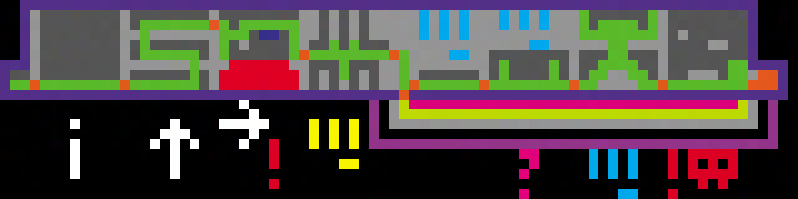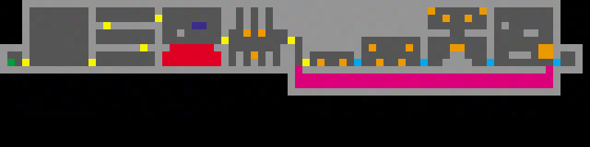

Create a copy of the level map and push the planning by adding in Game mechanics tokens, beat tokens, sight lines and other area symbols or objects.

**Game Path**

**Triggers**

**Camera View**

Create a copy of the level map and now add in the specific points of interest that the level map is intended to be used for.

**Player**

**Destructible Door**

**Hazard**

**Moving Platform**

**Enemy**

**Locked Door**

**Easter Egg**